4HRAM10

rabbits,
bits, rabbits,
s, rabbits, rabbits, ts, rabbits, rabbits, its, rabbits,
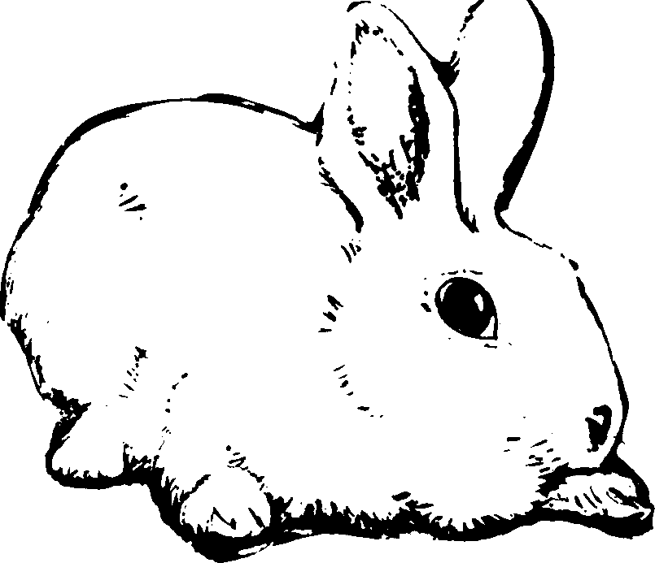
ts, rabbits, rabbits,
abits,
ts, rabbits, rabbits, rabbits, abbits, rabbits, bits, rabbits,


A messsage to you,
a 4-H member
In this rabbit project, you are going to learn how to feed, manage and show rabbits.
If you are raising rabbits for the first time, it is a good idea to start with young, purebred animals four months old.
Usually, two females (does) and one male (a buck)
of the same breed make a good beginnning
Use this manual. It has been written for you.
It gives information
you need. It tells you where to get more information.
There is a glossary of rabbit terms
that can help you with definitions of words you may not already know. There are suggestions for exhibits.
But be sure to check with your Extension Office
to make sure your exhibit meets your own county’s requirements. Keep this manual as a reference.
It is the manual for all divisions of the rabbit project so plan to use it from year to year.

A message to Parents
Raising and marketing rabbits is an ideal project for young people, especially those in urban areas
and on small farms where space may be limited.
A rabbit project lets young people experience the satisfaction of owning
a fine, purebred animal without spending too much money.
In this project your son or daughter can learn the principles of nutrition, care,grooming, breeding
and showing rabbits.
All that is needed is a place to house rabbits, feed to keep them growing, a willingness to make the project
a success and - most important of all -
your help as a parent.

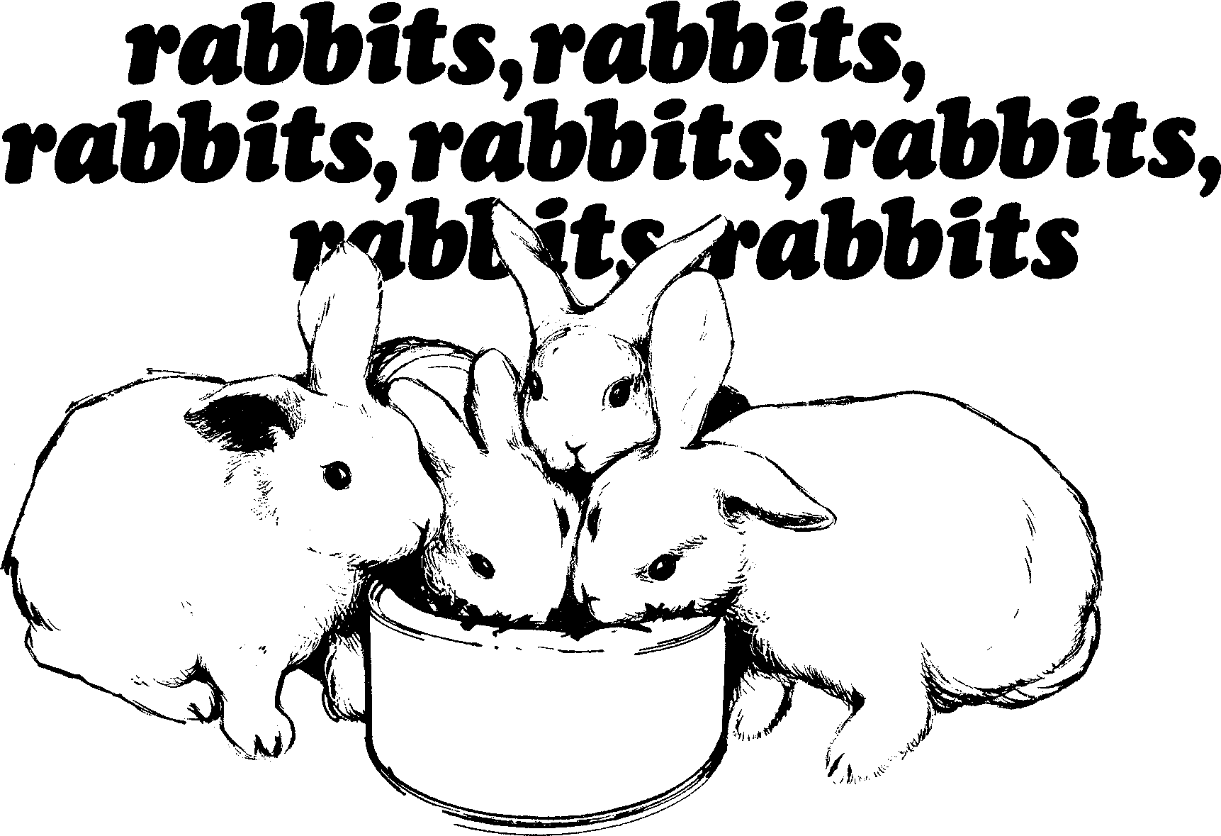

You are going to like raising rabbits if you like working with animals. Rabbits are small and clean. They respond to kind treatment. They are easy to work with and are fun to watch. Raising them can even be a way to make money.
Acknowledgement

Appreciation is expressed to the follwing people for their assistance in developing and reviewing this publication: numerous 4-H parents and Indiana rabbit breeders. Appreciation is also extended to the authors of the Color ado 4-H Rabbit Project manual, the Texas Rabbit Manual for 4-H’ers and the California 4-H Club Rabbit Project Manual. These publications provided valuable information and assistance in the preparation of this manual
It is not difficult to raise rabbits successfully. But it cannot be left to chance either. It requires careful selection, good equipment, careful sanitation and planned mating.
Visit a few good rabbitries and talk to the men and women who operate them. Look over the equipment and pay very close attention to the arrangements.

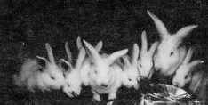
Zoologists classify rabbits as mammals. They are in the order of Lagomorpha which includes rabbits and hares. Some breeds have many varieties based on color differences and ranging in mature size from 2½ to 16 pounds. The most popular breeds for meat and fur production are the New Zealand, Champagne D'Argent, Californian, American Chinchilla, Checkered Giant, Flemish Giant and Rex. If you are raising rabbits as a hobby, you might like the Dutch and English Spot because of their variety of colors and attractive markings.

How to Chose a Breed of Rabbits
Successful rabbit raising begins with purebred stock. Generally, you should choose a breed of rabbit that you like from the stock that is available from breeders in your county or neighborhood. It is important to get your rabbits from a good rabbit breeder. The American Rabbit Breeders Association (A.R.B.A.) publications have names of breeders. If there is one close to you, plan to visit the farm and select your stock. If this is not possible, write to one.
Do not try to buy the best show specimens from breeders unless you have a lot of money to spend. Instead, get good specimens from an established and proven bloodline.
It is up to you to decide how many rabbits to buy. However, if you plan to exhibit your rabbits in a 4-H-Rabbit Show, you should begin with a trio (two does and a buck) of younger animals. Be sure to get them all from the same proven bloodline. If you do not plan to exhibit, you might decide to start with a good, bred doe and begin to build from her offspring.
When you choose your rabbits, consider these things:
- Select and buy the best doe (female rabbit) or does possible.

- Select and buy the best buck (male rabbit) possible.

- Select the does and buck from a rabbitry that has a reputation for selling top quality rabbits, that practices good sanitation and that keeps production records.

- Select your stock from a litter of rabbits that are the same size. Also consider the number of rabbits in the litter.

- Select rabbits that have the best pads on their feet and that have well-filled out loins, thighs and shoulders with dense fur undercoats.

- Always select healthy, disease-free rabbits.

Rabbits for Show
If you are planning to show your rabbits, you need to choose stock from the purebred parents of a breed recognized by the A.R.B.A. in their "Standard of

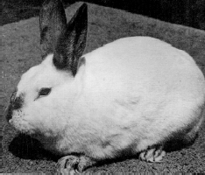
Perfection." For more information about this, write A.R.B.A., P.O. Box 426, 1925 South Main,
Bloomington, Illinois 61701.

Whether you are raising rabbits for show, for market or for fun, the principles of feeding, breeding and management are similar for all breeds. However, when you exhibit rabbits on the show table, the judge may consider slightly different points of emphasis for each breed when he makes his placings. Therefore, after you choose a breed, it is a good idea to become familiar with the standards for that particular breed.
Then you can follow a breeding program that will produce the proper type of rabbit for the respective breed.
Study the show rules, regulations and classifications carefully before taking a rabbit to show. Show rules place strict requirements on weight, color, size and age of rabbits entered. Although pedigrees are not usually required, good records make good rabbits even more valuable for show and meat production.

Rabbits for Sale
If you are planning to sell your rabbits, find out which kinds sell well in your market area before you select a breed of rabbits. Your market area may like small fryers. In this case select a smaller breed that reaches market condition quickly. Some of the best breeds for meat and fryer production are New Zealand, Champagne D'Argent and Californian.

Rabbit Breeds
Breed | Color | Approximate Mature Weight (in pounds) | Principal Uses | Size
American | Resembles the true chinchilla (Chinchilla laniger). | 9-12 | Show | Medium
Chinchilla |  |  | Meat
 |  |  | Fur
Californian | White body with dark or black nose, ears, feet and tail. | 8-10½ | Show | Medium
 |  |  | Meat
Champagne | Dark slate blue undercolor; blue-white or silver surface | 9-12 | Show | Medium
D’Argent | color with a lot of long black guard hairs. |  | Meat
Checkered | White with black or blue spots on cheeks, sides of body | 11 or over | Show Meat | Large
Giant | and hindquarters; wide spine stripe; black or blue ears
 | and nose with black or blue circles around the eyes.
Dutch | Black, blue, chocolate, tortoise, steel gray and gray; | 3½ to 5½ | Show | Small
 | white saddle or band over the shoulder carrying down |  | Laboratory
 | under the neck and over the front legs; white rear feet
 | (stops).
English Spot | White body with black, blue, chocolate, tortoise, steel | 5-8 | Show | Small
 | gray, lilac or gray spots; nose, ears and eye circles and |  | Meat
 | cheek spots; spine stripe from base of ears to end of |  | Laboratory
 | tail; side spots from base of ears to middle of
 | hindquarters.
Flemish | Steel gray, light gray, sandy, black, blue, white and | 13 or more | Show | Large
Giant | fawn. No two colors allowed on solids. |  | Meat
Netherland | Selfs, shaded agouti, tan patterned and other varieties. | 2½ | Laboratory | Small
Dwarf |  |  | Show
New Zealand | White, red or black. | 10-12 (does) | Show | Medium
 |  | 9-11 (bucks) | Meat
 |  |  | Fur
 |  |  | Laboratory
Polish | White; ruby-red or blue eyes; black or chocolate. | 3½ | Show | Small
 |  |  | Laboratory
Rex | Black, blue, Californian, castor, chinchilla, chocolate, | 7 or more | Show | Medium
 | lilac, lynx, opal, red, sable, seal, white. |  | Meat
 |  |  | Fur
Satins | Black, blue, chocolate, red, copper, chinchilla, | 8-11 | Show | Medium
 | Californian, white and Siamese. |  | Meat
 |  |  | Fur
Silver | Black, blue, chocolate or sable, with silver-tipped guard | 6½ to 9½ | Show | Small
Marten | hairs. |  | Fur
 |  |  | Meat

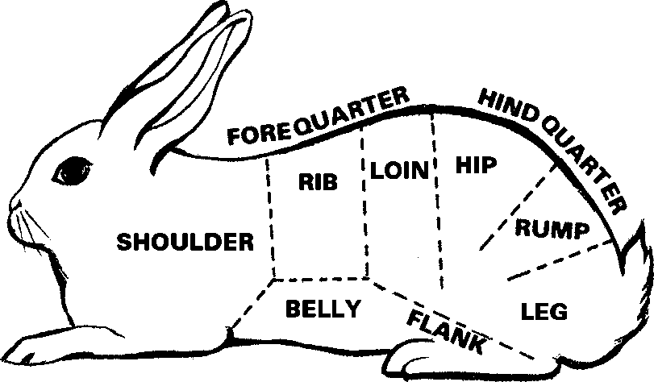
What to Look For
Once you have an idea about what breed you want, it's time to think about two things: body build and fur.

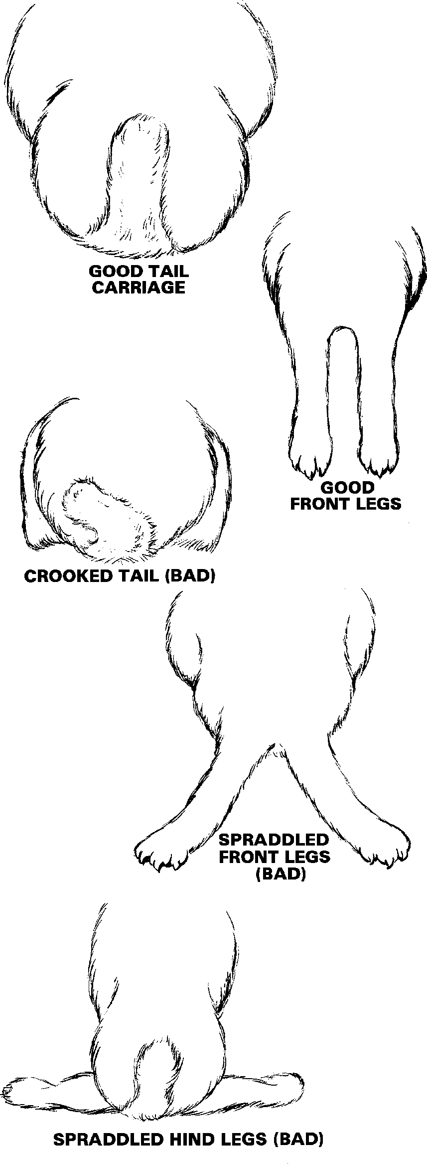
Look at Figure 1. Check to see where the hindquarters of the rabbit are located. The hindquarters are not just the hind legs, but the legs and the loin up to the first rib on the forequarters. In order to have good hindquarters, the rabbit must have a wide loin section with well-rounded and full hips. The forequarters should be full and have a good thickness of meat over the shoulders.
Good fur is another thing to think about. According to the fur standard, there are four points to check: condition, density, texture and balance.

Condition
Look for a fur that is tight. You do not want a molting rabbit. There should be no breaks in the fur, no mats of fur and no stains. The guard hairs should be supple and glossy. The fur should look alive and brilliant.

Density
Look for a good thick coat of fur all over the back, sides, chest and flanks.

Texture
The texture of the coat should not be harsh or
wire-like, nor do you want a silky coat or wooliness. Look for fur coarse enough in guard hairs to offer some resistance when you stroke the fur. Guard hairs are heavier hairs that protrude above the undercoat and protect it. The undercoat should be fine and soft.

Balance
Look for evenness and smoothness in rabbit fur. The fur should be a good length, not too long and not too short. A dense coat of short fur is better than a long thin coat. A dense coat of long fur is better than a short thin coat.

All About Housing
Before you buy any rabbits, you need a place to • The ideal cage has wire sides, with the top and house them - a rabbitry. The kind of building you front made of 14 gauge wire, 1 inch by 2 inches, or ½ need for this depends upon the location, the climate by ½ inch hardware cloth. The kind of wire you
and the money you have to spend. Whether you go choose depends mainly upon the price, availability of into rabbits in a big or small way, plan for housing - materials and rabbit size.
hutches - and equipment that lets you care for your • There are many variations in cage sizes and each rabbits with a minimum of manual labor. Care in may be used successfully. The size of the hutch feeding, breeding and handling the rabbits, as well as generally depends upon the breed of rabbit that is in cleaning the hutches and keeping the housing going to live there. Figure 2 shows a 3-hole hutch. sanitary, is very important. Keep construction of This size is quite satisfactory for this project. housing as simple as possible. Design housing so you Remember you must protect the entire outdoor cage can carry out these tasks easily. by an allweather roof with an adequate overhanging
eave, 14 to 16 inches. Rabbits must be protected Make sure the housing is designed to provide enough from dust, rain and snow.
fresh air for the rabbits. In hot weather housing needs • Figure 3 shows a suitable outdoor facility that you to provide rabbits with shade and any cool breezes can make.
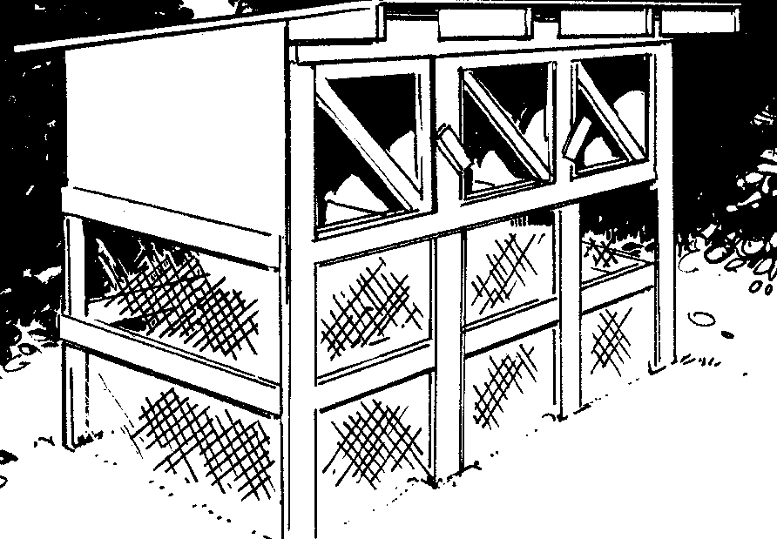
that may be available. In areas where there are strong winds and cold weather, protect your rabbit hutches by putting them in buildings that open to the south. During stormy weather, use curtains or panels to close off these buildings.

The equipment you need to raise rabbits can be very inexpensive and constructed mostly from low cost items found at home or easily available. You can make an inexpensive two or three compartment hutch out of wood with roofing materials and wire floors.
Do not use metal roofs because they conduct too much heat. (The more experienced club member may want to buy or make all wire hutches to put in a
draft-free building.)

Hutches and Cages
If you build a hutch for your rabbits, here are some things to keep in mind:
- Construct a cage for the comfort of the rabbits. Even though sunlight is an excellent disinfectant, do not let it reach your rabbits because it bleaches out fur color, except for all-white rabbits. (Bleached fur will result in faults or a cut for poor fur color by the judge at the time of showing.)
- The ideal cage has an all-wire floor. Use 14 gauge wire, ½ inch by 1 inch, since it seems to contribute least to sore hock problems. Fourteen gauge wire is strong enough to support a 12 to 14 pound mature doe and her litter in a 30 by 30 inch cage.

Figure 2
Three-hole hutch built from 8' material. Use turn button and spring-loaded latches to fasten dors closed
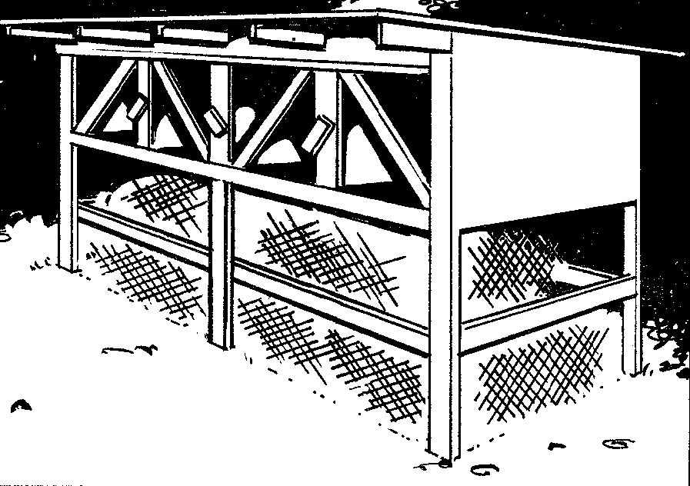
Figure 3
Four-hole hutch built from 8' material.

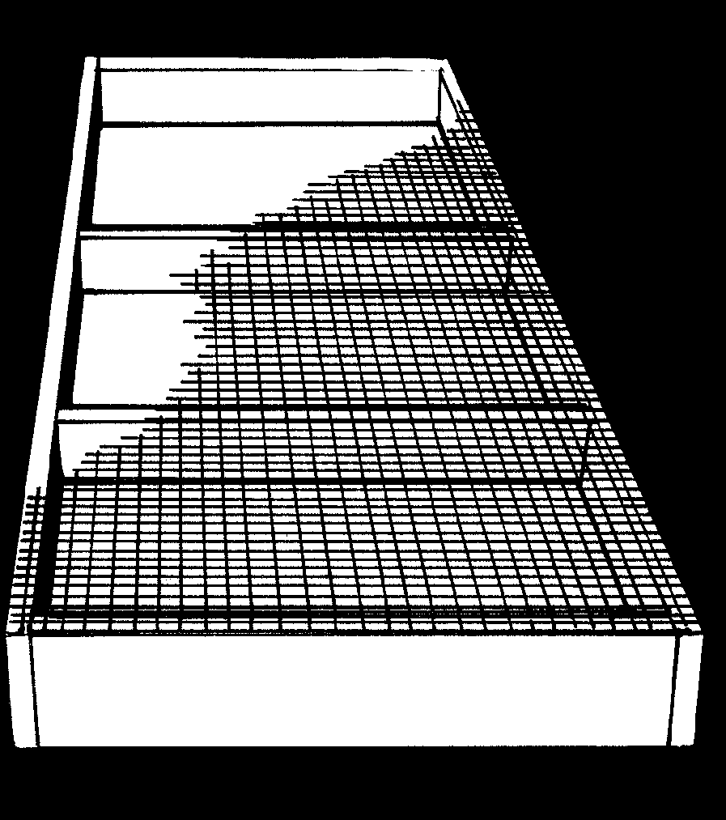
Figure 4 Cage floor for rabbits. Use 1/2" x 1", 14 guage wire 30" wide and 8" long.
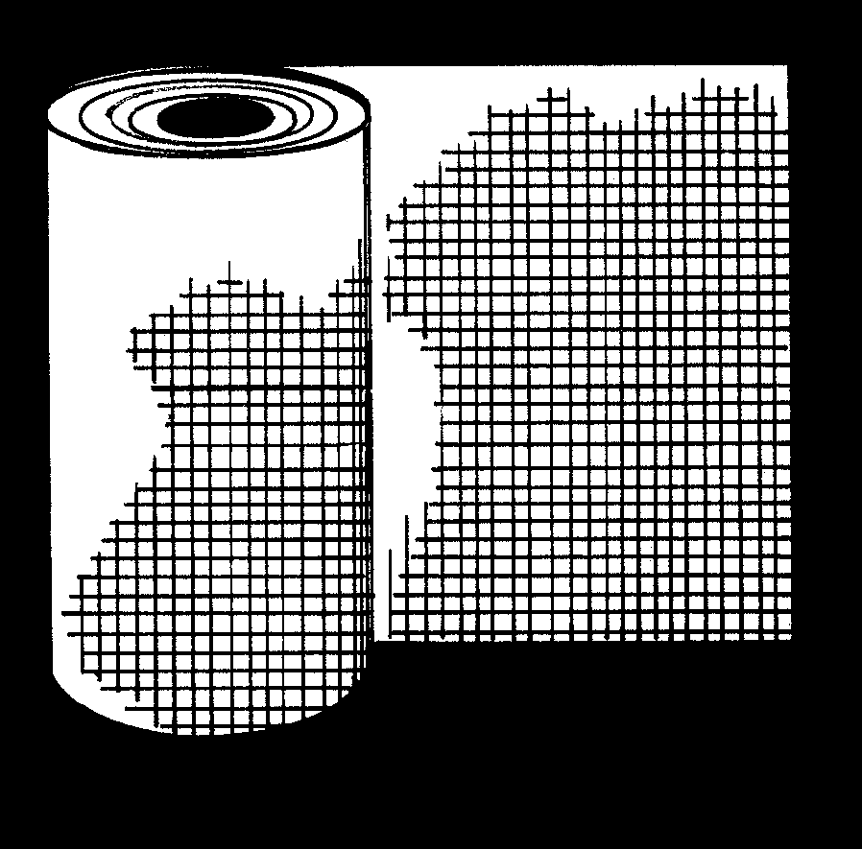
Figure 5 Use 1" x 1" or 1" x 2", 14 or 16 guage wire to protect rabbits from dogs.
Position the back and side panels of the hutch on the inside of the 2 by 4 inch cage floor bottom so that droppings and urine cannot accumulate in the corners. See Figure 4.
- Use a full sheet of plywood, 4 by 8 feet, for the roof. The back of the hutch should be one half of a sheet of plywood, 2 by 8 feet. For convenience, the cage floor should be 30 inches from the ground. Use white rolled roofing material (90 pound weight) or comparable shingles on the roof deck. Paint the sides and back or cover them with suitable all-weather material. Do not use metal roofing. It conducts too much heat.
- During cold winter periods, attach panels of s inch tempered masonite or other suitable material around the bottom of the hutch to close off the area to reduce drafts. Cold will not hurt rabbits if they are kept dry and free from drafts.
- Locate your rabbit hutch with its back to the prevailing winds and in the protection of trees. Trees should also be available to provide shade because hot weather can be a major problem for rabbits. If your backyard is not well-fenced to keep out people and animals, put a wire skirt around the bottom of your hutch to keep playful children and pets out of the manure. See Figure 5.
- Some breeders prefer the single hutch. Others build hutches with two or three tiers, one above the other. Each tier has compartments. The height of whoever takes care of the rabbits is a factor in determining how many tiers to use. Dropping boards should be used under each tier.
Here are diagrams of a low-cost, constructed rabbit hutch. Almost all of the lumber is of short lengths. A lot of scraps or odds and ends are used. The doors and dividers are bread racks, old refrigerator shelves or % inch welded wire. Small metal straps are used

- When you build semi-enclosed outdoor hutches, instead of hinges or hasps. The pen is designed to use construction grade material 2 by 4 inch, 2 by 2 handle a doe and her young. After the young rabbits inch, 1 by 6 inch and ½ inch exterior plywood. are eating on their own, the breeder can block the
nest box opening, clean the box and leave it in the sun to dry. In the winter months, the box gives added protection to the rabbit.
Note: Do not use paint on the inside of the hutch because the rabbits may chew on it and get lead poisoning.

---------------------- 8'11" !�

i
--JI-• 1_x_6 \METAL STRAP HINGE
111 I
-1- I I I
I I � I
-------......--.-' 1 ,I
2'9"
21"
--1 x 4 FACING
., ,. _".'!�-�_;-L.='_-4,r_-_t,:_-+L°_-i_t-,:_-+L°.:..t.:.tl
,I--
- --11Iii 1 --11
1 I
1x6
BREAD RACK DOOR
- - --
I
: l:
I
H
fo
0
M
M
-
Front
View
-
1....--18''
2x4 ..
a
,
,_
..
-
-
,,
I
..--12"�
----
2'9"
2'3"
-

,,
NOTE: All wire cages are satis-factory for rabbitries inside a building.
- -..,;;S-------- 3' -.1.-.:.1.
Side View
-
l

?o
M
0
M

11,
---

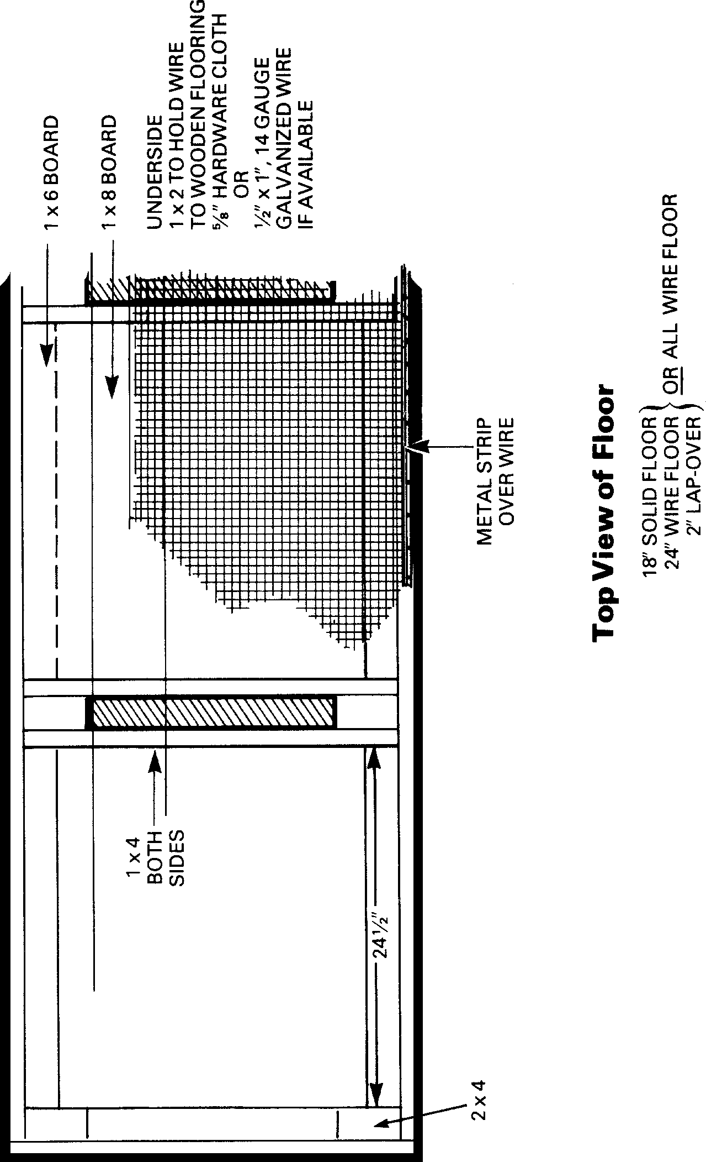

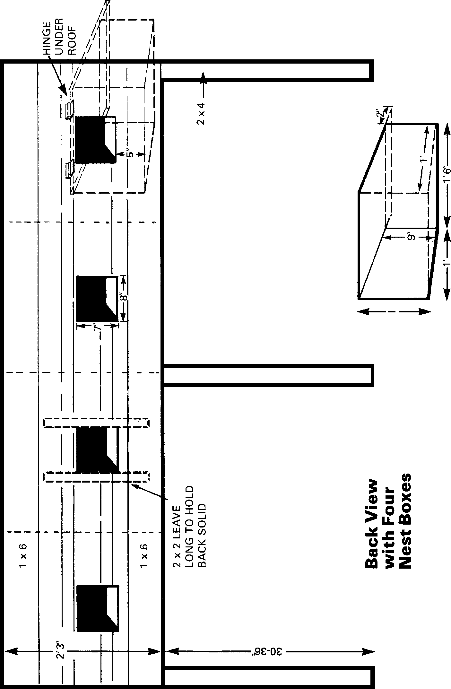

Nest Boxes
- Rabbit raisers use many types of nest (kindling) boxes for baby rabbits. Among them are apple boxes and nail kegs that have been modified. However, the present trend is away from modified nest boxes to those that can be bought or to kinds that are built at home by the breeder. A good design takes into consideration size and shape, warmth, ventilation and sanitation.
- The size of the nest box may vary, depending upon the breed you are raising. As a rule-of-thumb, provide a nest box about 10 inches high by 10 inches wide by 14 inches long for small breeds like the Dutch. For larger breeds like the New Zealand provide an area about 14 inches high by 12 inches wide by 18 inches long. Remember, it is best to provide a ramp as part of the box since it permits young rabbits to return more easily to the nest, reducing mortality (death losses) during freezing weather.
- You can make nest boxes from wood. Or you can buy the throwaway kind. You can also buy all-metal nest boxes with wooden floors.

- A nest box 18 inches long and 12 inches wide and at least 12 inches high is a size that is generally recommended. One end should be full height and the other should have an opening at least 10 inches wide and 6 to 8 inches from the floor. Through this opening the doe enters and leaves the box. You can tack a board across the back of the box to form a top and something to hold on to when you take the box out of the hutch. If you want a lid over the entire box in very cold weather, be sure to leave some open space in the back for ventilation and add three inches to the height of the box.
- Place the box so that the opening is not facing the front of the hutch. It is best to put it beside the back wall. In cold weather, place a piece of good insulation board under the nest box. This protects the litter against chilling when the rabbits burrow down to the floor of the box.

All About Feeding and Watering Equipment.
Once you have your hutches, start thinking about what you need to feed and water your rabbits.

Feeders
You may want to build your own feeders. However, remember that wooden feed hoppers are not recommended because rabbits chew on them. All metal feeders are better, either made from a can or purchased. The kind that you buy - gravity flow feed hoppers with small openings in the bottom - are best.
- Any feeder - homemade or purchased should have a screened bottom or have many s inch holes in the bottom to allow fines (very small food particles) to sift out. Accumulations of feed dust in the feeder may cause respiratory irritations leading to unhealthy rabbits with sinus ailments.

- Once you are experienced with rabbits, you may want to use self-feeders, mounted to the side of the cage about 2 inches above the floor. These reduce the time needed for rabbits to feed and also reduce feed wastage, especially with young rabbits. Young rabbits tend to hop into the feeder when they eat and foul it with their droppings.

Water Containers
Automatic-type watering systems are best. In the winter you must protect them from freezing by using inside water line heat tape. Aluminum pans or crocks are probably best for year round use if you have a very small rabbit herd.

How to Care For Rabbits
Once you have hutches and rabbits, the next step is the care of the animals. This is one of the more important phases of successful rabbit breeding. When the showman talks about condition, it usually reflects just one thing - Care.

Handling
Handle rabbits of different ages in different ways. Hold small rabbits by the loin. Hold older rabbits by grasping a fold of the skin over the shoulder, placing your other hand under the rump. When you carry a rabbit, it is best to support him in your arm. See

Figure 6

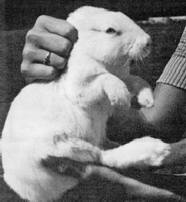

Figure 6.
NOTE: Do not lift the rabbit by the ears only.

Feeding
You must feed your rabbits properly to get top returns from them. Rabbits need a wellbalanced ration that meets their nutritional needs and tastes good. They are herbivorous which means they like to eat plant material. Rabbits do not like feeds that contain animal products.
A good rabbit ration must supply the proper amounts of protein, energy, minerals and vitamins. Almost all feeds contain each of these nutrients. Some feeds, however, are high in one nutrient and low in another. For example, corn is high in energy and low in protein, while soybean oil meal is high in protein and low in energy. The ideal ration is the one that supplies the proper balance and amount of each nutrent at a minimum cost.
Remember these things when you are feeding your rabbits:

- You can feed good, clean, cured, leafy hay to rabbits daily.

- Do not feed young rabbits cabbage or lettuce. It causes diarrhea and/or scours.

- Use about four ounces of a feed with at least 16 percent protein each day to keep rabbits in good shape.

- A doe with a litter needs all the feed she will eat.

- You can lower feed costs by feeding some good, clean hay and oats.

- Use some suitable sized container to measure your feed.

- You should get a booklet on feeding rabbits from one or more feed companies. They have good suggestions on what to feed rabbits at different weights and ages. These books tell about different rations and their proper uses.
A regular feeding schedule is important. Try to feed at about the same hour each day. Some breeders feed night and morning; others feed just the does with litters in the morning and then feed all rabbits, including the does with litters, at night.

Salt and Water
Commercially prepared feed pellets contain salt. However, if you prepare your own ration, you need

Mating

All About Reproduction

to provide salt in a free choice form. You can do this by supplying each hutch with a salt spool that your rabbit can lick any time he wants. If you use salt spools, be sure to keep them away from the cage wiring because the salt can cause rusting.
Have fresh, clean water in front of your rabbits at all times. Clean all water bowls every day. Rabbits that eat dry rations need a lot of water. During the winter, give rabbits water twice a day. During warm weather, a doe and her litter will drink about one gallon of water each day. Water your rabbits several times a day during the summer. Crocks and secured coffee cans make good water containers.
You can breed most rabbits when they reach 6 or 7 months. You must separate and individually house rabbits at least 18 days before breeding. Since the doe objects to having another rabbit in her hutch, take her to the buck's hutch. Usually mating occurs immediately, after which the buck falls over on his side. Return the doe to her hutch immediately. Five to eight hours later, breed the doe a second time to insure maximum litter size.
One of the best symptoms that the doe is bred is her continual moving of the bedding on her hutch floor, especially clawing it from the back corners of the hutch.

Breeding Chart
Breed In | Pre-JR.  Meat Pen | Juniors | 6-8 | Seniors
Jan. | April | June-July | Aug.-Sept. | Oct.
Feb. | May | July-Aug. | Sept.-Oct. | Nov.
Mar. | June | Aug.-Sept. | Oct.-Nov. | Dec.
April | July | Sept.-Oct. | Nov.-Dec. | Jan.
May | Aug. | Oct.-Nov. | Dec.-Jan. | Feb.
June | Sept. | Nov.-Dec. | Jan.-Feb. | March
July | Oct. | Dec.-Jan. | Feb.-Mar. | April
Aug. | Nov. | Jan.-Feb. | Mar.-Apr. | May
Sept. | Dec. | Feb.-Mar. | April-May | June
Oct. | Jan. | Mar.-Apr. | May-June | July
Nov. | Feb. | Apr.-May | June-July | Aug.
Dec. | Mar. | May-June | June-July | Sept.

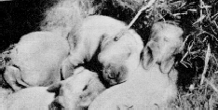
Check the nest daily and remove any dead. Only the person caring for the rabbits should check the nest. Otherwise, the odor of a strange hand in her nest may upset the doe and she may not pay proper attention to the babies. If this happens, some of the babies may die.
The day the doe kindles, cut her feed down to almost nothing. Gradually return to the regular amount of feed by the third day. Then, at the end of the first
The normal length of gestation (pregnancy) for a doe week, begin increasing her feed slightly until you is 31 days. Occasionally, a doe does not become double her regular ration. If she begins getting too bred, even though it seemed that a normal mating thin, give her slightly more, but be careful. Always
occurred. Therefore, 18 days after mating, return the keep clean, fresh water in front of a doe with a litter. doe to the buck for "testing." If she is pregnant, she During the winter months it is a good idea to use will run from the buck and actively resist him. lukewarm water - just lukewarm, not warmer.
Rabbits drink more water when it is lukewarm than

Kindling
The birth process in rabbits is called "kindling." The care of the doe at this time is important. The young are usually born 30 to 34 days after the mating of the buck and the doe.
About three days before kindling time, the doe may begin to carry straw in her mouth. This is a good sign. Give her a nest box immediately. Never leave the nest box out of the hutch later than the third day before the doe is to kindle.
In fact, plan to put the nest box in the hutch on the 27th day after breeding. If the doe does not give birth, remove the box on the 34th day and rebreed her. If the doe does not become bred the second time, think about disposing of her.
When you put the nest box in the hutch, be sure it has a small amount of straw pressed in the bottom. Place a large handful of good, clean straw in the hutch. The doe will carry this material into the nest box and prepare her nest. It is best to let her handle
they do when it is ice cold. This helps produce more milk for nursing the litter.
When you check the litter, remove the nest box from the hutch so that the doe cannot see you looking at the babies. Be sure not to handle other rabbits immediately before handling these babies. If there are more than five or six babies, you need to do some culling. If there are some good show specimens, it is wise to cut the litter to four or five babies. Culling gives the remaining rabbits an extra start. And you have unusually nice development by the time you show them.
Do not be too disappointed if you have a litter with no outstanding specimen. The very best parents sometimes produce just a plain "meat litter." However, keep this in mind when you make your next mating.
After checking the litter, return the nest box to the hutch

Weaning

the birth as much as possible. After the babies are Leave the doe in the hutch where she kindled until born, the doe will cover the nest with fur. the babies are coming out of the nest box regularly. If
she refuses to go into the nest box after you have During kindling, the doe is usually thirstier than moved it out to check the litter, don't worry. The usual. She should have a good supply of water. If a babies will come to the doe for nursing. It is better to doe does not have enough water at this time, she may leave them unmolested until they are old enough to even kill her babies or desert them soon after birth. wean. If there is an outstanding baby in the litter,
leave it in the original hutch as long as possible, even after you have weaned the rest.

Do not wean the litter until the babies are at least eight weeks old. Some people prefer to breed the doe on the fifty-sixth day after kindling and then leave her with the litter another week. If you do this, you can be sure that the doe has stopped her milk supply, thus preventing caked nipples.
If you separate the doe from the litter without putting the babies in individual hutches immediately, be sure it is the doe you move. Babies go longer without fighting if they stay in their original hutch than if you move them to new quarters. You can seldom leave bucks together more than two months if the mother is not with them. Occasionally two or three does will get along in a large hutch until they are almost six months old, but don't count on it.

Re-breeding the Doe
Success in the rabbit business requires that the doe not only produce large litters of rapid gaining rabbits but that she produce four to five litters a year. Most rabbit raisers re-breed the doe 56 days (eight weeks) after kindling.

Tattooing
It is absolutely essential that you tattoo any rabbits you are raising. Tattooing is the acceptable method for keeping accurate breeding information. Keep your herd book up-to-date and record all identification marks of the offspring against the actual sire and dam. Be accurate and truthful with all pedigree records.
Place the permanent identification tattoo mark in the left ear of the young rabbit. At the same time, make out pedigrees for all you plan to keep. Do this while the bunnies are still with their mothers.
The rabbit's right ear is reserved for use by an official
A.R.B.A. registrar who places a permanent tattoo number in the right ear if the individual rabbit merits registry. Merit is determined in accordance with the
A.R.B.A. Standard of Perfection for rabbits, published by the American Rabbit Breeders Association, Inc.
When tattooing a rabbit, you can hold it on a training table. However, the rabbit will struggle to get away. It is best to keep the rabbit quiet by using a box especially designed to hold rabbits. In this kind of box, the compartment for the rabbit is adjustable and holds rabbits of various sizes. See Figure 7.

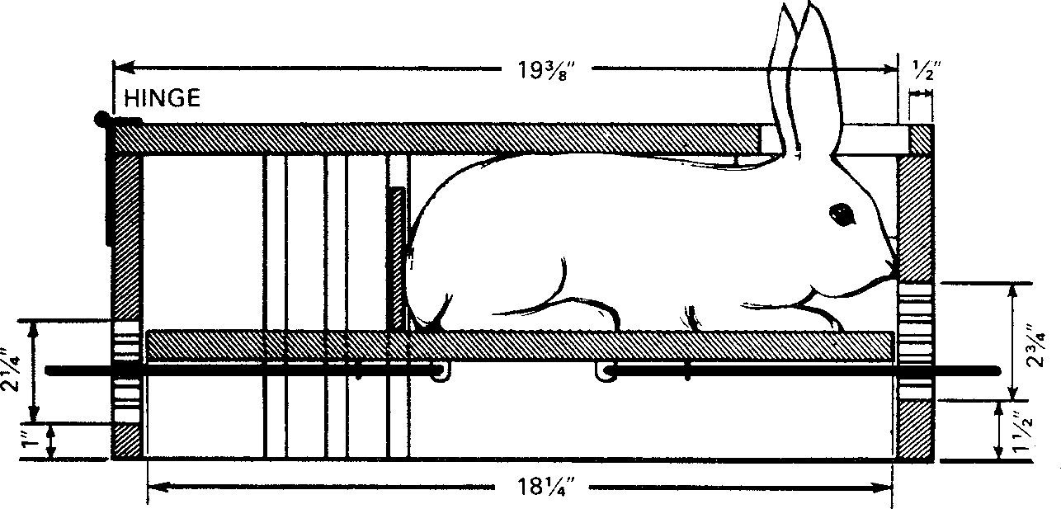

Figure 7
Vertical section of box for restraining a rabbit for tattoing. The spring-type holders tacked to the lower side of a movable floor compress the rabbit toward the top of the box. A movable cross partition holds the rabbit toward the front. Blocks of wood on eac side hold the rabbit’s head in the center of the hole at the top.

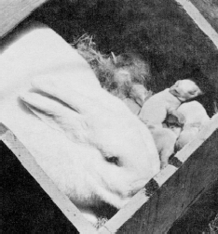

Raising the Young
The objective of successful rabbit production is to raise a litter that averages about 4 pounds per rabbit (3 to 3½ pounds for smaller breeds such as the Dutch) at the weaning age of 8 weeks. Newborn rabbits grow on their mother's milk alone for about the first three weeks. Then, in order for the rabbits to grow rapidly, they must have access to feed and water at all times when they leave the nest box and start to feed with their mothers. This happens at about three weeks, until the time you market them. Because rabbits inherit growth and carcass muscling characteristics, it is important to select good parent stock if you are to get maximum profit from the sale of your rabbits.
If you plan to sell any of these young rabbits, be sure to check each animal carefully and represent him truthfully to your prospective buyer. Do not sell rabbits until they are at least two months old. Then the transfer from your rabbitry to that of the new owner is likely to be more successful. Always indicate the kind of feed you use and your feeding program so that if it is not the same as the new owner's he can make the change gradually.

How to Have Healthy Rabbits
Rabbits are healthy normally. A good experience with rabbits depends upon their continued good health. Disease is often the reason a rabbit enterprise fails. Infectious disease results from either of two causes or sometimes a combination of both.
- A large invasion of disease organisms greater than the animal can fight off. These include mites, bacteria and viruses.

- A decrease in the ability of the animal to fight off invading disease organisms.

To prevent the buildup of large numbers of disease organisms, practice proper sanitation. Clean hutches, feeding dishes and nest boxes thoroughly after you wean each litter. Use hot, soapy water and a scrub brush. Periodically brush a household bleach or disinfectant on the inside of the wooden hutches.
Guard against the introduction of disease into a herd, especially when you buy new animals. It is a good idea to have an extra hutch where you can isolate new animals from the remainder of the herd until you are certain that they are free from disease.
Disease can also come from using old hutches or nest boxes discarded by breeders who are no longer raising rabbits. It is better not to use equipment from such sources.
Young rabbits are more susceptible than mature rabbits to disease caused by environmental stress. Rabbits can tolerate low temperatures and excessive cold, but wet and drafty conditions can weaken their resistance to disease organisms.

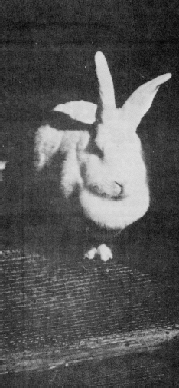
Place hutches where cold rains will not blow in, chilling the rabbits. Face them south for the best protection. Baby rabbits may develop infected eyes if they are exposed to rain. Often an eye ointment that contains an antibiotic used in human eye treatment works satisfactorily.
It seldom pays to treat disease in rabbits. It is better to sacrifice a sick animal and prevent infection of the entire herd than to attempt lengthy or costly treatment. However, when signs of continued illness develop, you may want to check with your local veterinarian.

Careful Sanitation
One of the best ways to protect against disease and parasites is to follow a careful sanitation program. It takes less money to prevent an outbreak of disease than to try to get rid of disease once it is in the rabbitry.
These simple rules of sanitation help keep the herd free from disease and infection:

- Never loan bucks to other rabbit breeders.

- Isolate new rabbits or those returning from shows.

- Quickly get rid of rabbits that die. If you suspect disease, disinfect all equipment thoroughly. Burn the droppings and bedding of sick animals.

- Clean cages regularly and keep droppings and moisture from collecting.

- Disinfect feed and water bowls regularly.

- When loose hair on cages and other equipment becomes a problem, burn the hair off with a gas torch. Move the flame quickly so that the wire will not get red hot. This rapid burning of hair does not kill the disease organisms, so you also need to sanitize the equipment. Remove any rabbits before burning.

- Always make sure that the nest box is as clean as possible. After scrubbing it with soap and water, disinfect it and set it in the sun to dry.

RABBIT DISEASES

Cause and Control

Disease | Cause | Symptoms | Prevention | Treatment*
Abscesses | Bacterial infection | Enlargements under skin near jaw. | Minimize fighting. Eliminate sharp | Clip the fur around the
 |  | Can occur on other parts of body | objects that can injure the rabbit. | abscesses, then lance and
 |  | where there are wounds or scratches. |  | remove the pus. Disinfect
 |  |  |  | with peroxide and use an
 |  |  |  | approved antibiotic
 |  |  |  | ointment or powder to
 |  |  |  | promote healing.
Caked | Milk production is in | One or more of the mammary glands | Reduce ration by one-half the day the | Relieve some congestion by
Mammary | excess of utilization. | may become swollen, hot and firm. | doe kindles and gradually increase full | partial milking. Massage
Gland | Too few young or the | Often mistaken for mastitis. | feed in 7 days. | gland with an anti-
 | young are not nursing. |  |  | inflammatory ointment
Coccidiosis | Five different species | Affects primarily young rabbits. In | Keep pens clean and prevent fecal | Sulfaquinoxaline in feed or
 | of protozoa (one celled | severe cases, symptoms are diarrhea, | contamination of feed and water. Use | drinking water continuously
 | animals) that can | loss of flesh, pot belly, loss of | wire floor pens. | for 2 weeks.
 | injure the bile ducts, | appetite, rough fur coat. Liver may be
 | intestines or cecum. | white spotted and enlarged and there
 |  | may be small hemorrhages in the
 |  | intestines.
Conjuctivitis | Inflammation of eye | Excessive tear formation and fluid | Minimize sources (dust, dirt) of | Use a commercial
“Weepy Eye” | lid. Can result from | runs down cheek. Rabbit rubs eyes | irritation. Remove chronically affected | eyewashing product to
 | irritation by dust, | with it front feet which further | rabbits. | remove dust, dirt or other
 | sprays, fumes or by | aggravates the condition. Rabbits with |  | foreign object. If
 | bacterial infection. | snuffles frequently have “weepy eye”. |  | inflammation persists, an
 |  |  |  | opthalmic ointment
 |  |  |  | containing anitbiotics may
 |  |  |  | be helpful.
Ear Canker | Ear mite | Scabs or a crust start forming at base | Do not let unaffected rabbits in | Use a cotton swab to apply
 |  | of inner ear. Mites cause considerable | contact with rabbits that have ear | mineral , vegetable or olive
 |  | irritation and rabbit will shake its head | canker. | oil over all visible crust.
 |  | and try to scratch ears with hind feet. |  | Usually one or two
 |  |  |  | treatments is sufficient.
Enteritis: | Likely caused by | A watery diarrhea may be only | Develop a program to control | Keep rabbits confortable
Diarrhea | coccidiosis or other | symptom. | coccidiosis. Do not feed “greens” to | and encourage feed
 | intestinal |  | rabbits. | consumption. A medicated
 | inflammation. In |  |  | or vitamin fortified feed
 | young rabbit excessive |  |  | may be helpful.
 | “greens” will cause
 | diarrhea.
Muciod | Thought to result from | Characterized by sub-normal body | Prevent or reduce stress factors and | No successful trestment
 | an irritant, a toxin or | temperature, loss of appetite, | have strict sanitation of hutches, | known, but mortality may
 | other stress factors | depression, rough fur coat, tooth | feeding and watering equipment. | be slighlty reduced by
 | such as dietary | grinding, dehydration, bloated |  | feeding a medicated or
 | changes, antibiotics | abdomoen and diarrhea containing |  | vitamin fortified feed.
 | and travel stresses. | mucus material. |  | Eliminate all afftected
 | Not thought to be |  |  | rabbits, and purchase
 | contagious. |  |  | breeding stock that are free
 |  |  |  | of the disease.
Eye Infection | Several types of | The eyes of baby rabbits may stick | Prevent cold drafts and other stress | Apply an antibacterial
 | bacteria | shut and pus around the eyes may be | conditions. | opthalmic eye ointment.
 |  | noticed.

Fur Block “Hair Rabbits ingests a large Rabbit will sporadically eat small Fur block is noted more often in An oral dose of ½ oz.
Ball” amount of its own hair amounts of feed. A firm mass can be Angora rabbits. Mineral oil may be
or that from another palpated in the stomach. effective. If the fur block is
rabbit in a short period too large, surgical removal
of time. is necessary.
Fungus Fungus A dry scaly skin (dandruff) on the Prevent contact with affected rabbits. Apply tolnaftate to affected Infection shoulders and back. area. Other medications are
available.
Heat Excessively high Increased respiration rate (panting), Provide shade, adequate air Rabbits suffering from heat Exhaustion temperatures (above prostration, and excessive saliva movement, plenty of cool water on a exhaustion can be
85°F) and high discharge. Pregnant does and young in hot day. Wet burlap in cage will aid in immersed in lukewarm
humidity (above the next box are most susceptible. cooling. water to reduce body
70%), obesity, poor temperature to the normal
ventilation, 101-104°F. Apply a cool
insufficient water and compress to the ears.
crowding.
Hutch Burn Usually associated Usually a brownish crust covers the Do not allow fecal material to Clean affected skin with a with wet and dirty infected areas and a bleeding exudate accumulate in the hutch. germicidal soap and keep hutches. Urine and may be seen. the area clean.
fecal material cause the skin to become irritated and infected.
Ketosis Obesity, large litter, Usually occurs just before or just after Prevent young does from getting too Obesity can be prevented by lack of excercise. kindling. Does go off feed and will not fat and make sure the does are eating limiting feed to 4 to 6 oz.
eat. at kindling time. Daily for does.
Mastitis “Blue A bacterial infection The mammary gland will become red Reduce any chance of injury to Penicillin is effective Breast” in the mammary gland in color, dwollen, tender and dark blue mammary gland as the does enters the against staphytococcus or
caused by an injury streaks may appear. nest box. Do not transfer the young to streptococcus or organisms. from nest box, cage or another lactating doe.
a bite from nursing young.
Malocclusion An inheritaed Lower teeth protrude and upper teeth Do not use rabbits with “buck teeth” Teeth on young rabbits can “Buck Teeth” condition curve into mouth. for breeding purposes. be trimmed until they reach
characterized by slaughter weight.
excessive growth of the front teeth.
Pasteurellosis A chronic upper Typical early sign are a nasal Quarantine all new rabbits for a 3 Tetracycline in feed may be “Snuffles” respiratory ailment discharge, watery eyes, head shaking, week period. Cull rabbits that show effective in an
cause by bacterail sneezing or rattling noise in breathing continuous chronic symptoms of the uncomplicated case. For infection. and a loss of weight. Continual disease. Reduce stress factors and accurate treatment, the
infection may cause rabbits to become have good management and sanitation organism needs to be sterile. practices. cultured and identified.
Pneumonia A bacteria or virus Elevated temperature, labored Control of “Snuffles” reduces chances Treatment may vary infection usually breathing, nasal discharge and loss of of pneumonia. Eliminate drafts and depending upon the associted with other appetite are symptoms. wet conditions. causative agent. A broad respiratory diseases or spectrum antibiotic may be
stress factors such as helpful.
damp, drafty and unsanitary hutches.
Ringworm A fungus finection Loss of hair in circular patches. A Do not allow infected rabbit in contact Clip the fur around affected that can appear on any yellowish crust forms and sloughs off with other rabbits. Wear gloves when area and treat with
part of the body but in about 3 weeks. If infection goes handling the infected rabbit. tolnaftate. Other
most often will occur untreated, considerable scratching will medications are available. on the head. This occur.
fungus infection can be transmitted to humans.

Salmonellosis “Scours” | Several members of the Salmonella group of bacteria can affect rabbits. | General symptoms are diarrhea, loss of weight, conjunctivities, and rapid breathing. | Good husbandry practices and a quaratine of new rabbits. | Tetracycline in the feed may be effective.
Skin Mange | An infestation of | There will be some loss of hair, scaly | Infected rabbits should be separated | Dust with an insecticide
 | mites that burrow | skin and intense itching and | and treated. The premises should be | approved for the purpose.
 | through the skin and | scratching. | disinfected. | Treatment should be
 | cause considerable |  |  | repeated in 7 days.
 | irritation. Mange
 | mites that affect dogs
 | and cats infect rabbits.
Sore Hocks | A bruised or infected | Scabs usally appear in the bottom of | Do no let wet litter and manure | Wash the hock with a
 | area on the | the rear feet. Pad and toes of the front | accumulate. Eliminate sharp objects | germicidal soap and apply
 | undersurface of the | feet may become infected. Nervous | on the floor. | an antiseptic sich as tincture
 | hock joint. Related | and heavy rabbits are more susceptible |  | of iodine.
 | stress factors are a | to the sore hock condition.
 | dirty hutch, rough
 | surfaces on the floor,
 | or a floor constructed
 | with the wrong size
 | wiregrid.
Spirochetosis | Infection by a | Blisters or scabs occur on the sex | Always check the breeders before | Injection of penicillin is the
“Vent Disease” | spirochete and can be | glands. | mating. Isolate all new rabbits. | best treatment. Do not breed
 | transmitted by mating. |  |  | until all lesions disappear.
Tyzzers | A bacterial infection | The acute form results with diarrhea, | The best preventative measures are | Treatment wih antibiotics is
Disease | usually associated | dehydration and death within 48 | clean stock and good husbandry | not very effective.
 | with stress conditions | hours. | practices.
 | and poor sanitation.
Warbles | The growth of the | Warbles can be observed as | Screen the area to keep the botfly | Remove the larvae without
 | botfly larvae under the | enlargments under the skin with a | away from the rabbit. | crushing it. Clean the
 | skin. | small hole in the center. The condition |  | wound with a germicial
 |  | is painful and the rabbit may lick the |  | soap or apply an antibiotic
 |  | area. |  | powder or ointment to
 |  |  |  | prevent infection.

*Ask your local veterinarian for dosage levels when using antibiotics and for names of antibiotic powders and ointments.

**When antibiotics are a part of the treament program, a withdrawal period of 10 days must be allowed before the animal is slaughtered for food.
**This information on diseases and treatment was reviewed by Dr. David J. Black, University of Tennessee, College of Veterinary Medicine; and Dr. T. J. Lane, University of Florida College of Veterinary Medicine.

How to Keep Records
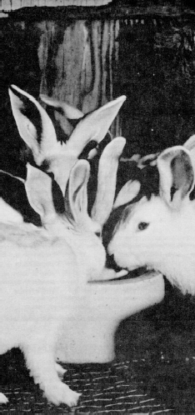
Records are an important part of raising rabbits. Records represent the "backbone" of your rabbitry. They keep things in order, tell how your rabbits are doing and can help make your business profitable. Keep your records up-todate and accurate.
Good records include the following:

- Beginning inventory.

- Total operating expenses.

- Total marketing receipts.

- Closing inventory and a profit or loss financial summary statement at the close of the project or at year's end.

- Doe and buck performance records, including growth records of litters at:
  - Four weeks of age - individually weigh all rabbits. The average is a good indication of the lactating ability of the doe.
  - Eight weeks of age - individually weigh all rabbits. Make first selections for herd replacements at this time. For commercial
meat-type rabbits, all animals should be ready for fryer marketing.
- Herd book.
  - Complete pedigree of each rabbit.
  - Performance record on service of bucks.

- Show record.
  - Record the shows entered by date and place.
  - Record information on classes entered, number in competition and awards received.

You can get record forms, free of charge, from many commercial rabbit feed companies. Write to the
A.R.B.A. for additional information on keeping a herd book and show record.
The Florida 4-H Rabbit Record, publication 4HRAR01, goes with this manual. Fill it out regularly and turn it in to your 4-H club leader at fair time. You can get a copy of the 4-H Rabbit Record at your County Extension Office.

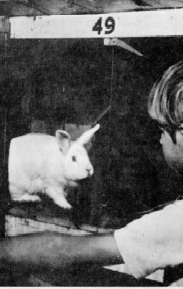
Kinds of Production
You may want to think about raising pedigreed rabbits as you get experience or as you want to get a start in this business. To get pedigree forms, contact your local rabbit feed dealer, your 4-H Rabbit project leader or the A.R.B.A. Good pedigrees help to sell stock.

Rabbits, rabbits, rabbits
Page 24
November 1990

Suggested Procedures for Rabbit Shows at Fairs
If you want to put competition into your 4-H rabbit raising program, both county and state fairs can provide you with a good opportunity to experience competition and learn more about showing your rabbits.
Here are suggested procedures for showing.
- When the show superintendent decides which breed to judge first, the judge will judge each variety (color) within each breed separately.
Example: If he starts with the New Zealands, he judges the whites first, then the reds and then the blacks.
- Within each color, he judges the separate classes. Example: He starts with senior bucks, then senior does; 6-8 bucks, then 6-8 does (if the 6-8 months applies to the breed); junior bucks, then junior does; and finally pre-junior bucks and pre-junior does (if applicable).
- The judge then determines best of variety from rabbits within the separate classes. This is done by placing all of the first place winners in each class, in the same variety, on the judging table.
Example: In New Zealand Whites, the judge saves the first place winner in the class of senior bucks, senior does, 6-8 bucks, 6-8 does, junior bucks and junior does (pre-junior rabbits are not eligible for placement). If each class has been filled, he has six rabbits from which to choose a best of variety and the best opposite sex in that variety.
- The judge follows the procedure outlined above for each of the other varieties within a breed.
Example: To continue judging the New Zealands, he would next judge the reds followed by the blacks, selecting the best of variety and best opposite sex of each variety.
- Then he judges all first place rabbits for each variety for the Champion or Best of Breed and Reserve Champion or Best Opposite Sex of the breed.
Example: In the New Zealands, the Best of Breed or Champion could be a white buck and Best Opposite Sex or Reserve Champion may be a red doe.
- All rabbits to be shown are required to have a tattoo number in their left ear. The numbers are what the judge calls off when he places the rabbits.
- When the judge places the rabbits, he orders the last place animal off the table first. The first place winner stays on the table until last.
Example: There are five New Zealand White senior bucks in the show and their ear numbers are - A-1, B-2, C-3, D-4 and E-5. After the judge decides how to place them, he says A-1 is fifth, then gives comments on the rabbits. In this way the owner learns exactly what is wrong with the rabbit, information which will help in culling future litters. This also gives the owner a better guide to go by when adding to his original stock. When the judge says B-2 is fourth. D-4 is third and E-5 is first, he gives comments on each rabbit as he places it.
Rabbits are removed from the judging table after the judge completes his comments on that rabbit.
It is a good idea to show your 4-H rabbits in other shows sanctioned under A.R.B.A. rules to gain experience and knowledge. Rabbits shown at county and state fairs should be judged only by licensed

A.R.B.A. judges, registrars or knowledgeable rabbit breeders.

Preparing Rabbits for Show
Talk to older 4-H'ers, junior leaders and your 4-H rabbit leader about how to prepare your rabbits for showing at county and state fairs.

Cleanliness is very important in the appearance of a rabbit. If you keep clean hutches and give good daily care, you will have clean rabbits when it is show time. To remove loose hair, use a soft brush or your moistened hands. Remove any hutch stains on the feet with dry cornstarch.
In some county and state rabbit shows, rabbits are expected to have a pedigree. In other shows this is not a requirement. The A.R.B.A. registration number must be in the rabbit's right ear. The owner's private registration number is in the left ear.
Regardless of the kind of show, you must be sure you have the correct sex for the class into which you put your rabbit. Check with your leader or other experienced rabbit raisers on how to determine the correct sex.

Smaple 4-H Rabbit Score Card Glossary of Show Room Classes

COOP. NO EAR NO. ENTRY NO. FUR CLASS
BREED and VARIETY
CLASS and SEX NO. IN CLASS AWARD

 | VERY  GOOD | GOOD | FAIR | POOR
HEAD
EARS
BONE
TYPE:
BALANCE
SHOULDERS
BACK
LOIN
HIPS
FLESH CONDITION
COLOR:
SURFACE
RING DEFINITION
UNDERCOLOR
BELLY COLOR
TICKING
CONTRAST
FUR:
TEXTURE
DENSITY
LENGTH
CONDITION
SHEEN
MARKINGS:
BLAZE
SADDLE
UNDERCUT
STOPS
BUTTERFLY
EYE CIRCLES
CHEEK SPOTS
EARS
SPINE
PATTERN
BALANCE

LOSES TO
ON REMARKS:

Small Breeds
Junior Bucks and Does - under six moths of age

Senior Bucks and Does - over six months of age.

Intermediate and Giant Breeds
Junior Bucks and Does - under six months of age (weight limit on some breeds)

6-8 Months - intermediate six to eight months of age (weight limit on some breeds)

Senior Bucks and Does - eight months of age and over

Pre-Junior Bucksand Does - three months old or under (weight limit by breed)

For Additional Information
For more information about raising rabbits, write to:

American Rabbit Breeders Association, Inc. 1925 South Main Street
P.O. Box 426
Bloomington, Illinois 61701

Rabbit Show Standards General Disqualifications - All Breeds
A.R.B.A. Standard of Perfection

General Faults - All Breeds
Specimen in moult or otherwise out of condition (but not diseased).

Hutch stains. Broken toe nails.
Stray white hairs in colored fur. Double dewlaps.
Poor tail carriage - one that is not permanently set on either side.

Poor ear carriage. Poor eye color.
Flabby or over-fat, thin and extremely poor in flesh.

General Eliminations - All Breeds
(Eliminations are presumed to be temporary in nature and curable; nevertheless, they are cause for elimination ftom competition in a show - or from registration until the ailment is cured or corrected.)
Any of the following are cause for elimination: Colds, ear canker, slobbers, pot belly, does heavy with young, sore hocks (showing infection - not merely bare), vent disease, abscesses, sore eyes, running eyes, if severe or conspicuous.
Mange, or a scurvy condition with large flakes resembling dandruff or scale at the roots of the fur; fungus growth or mites causing scabby condition.
Overweight or underweight to eliminate from regular class but animal may compete in fur classes if entered. A rabbit eliminated from its class for being the wrong sex for the class may compete in fur classes, if entered.
Illegible permanent ear marking.
(Disqualification - One or more permanent defects, deformities or blemishes which renders an animal unfit to win an award in competition or from taking part in an exhibition.)
Any of the following ailments: Snuffles, tumor, rupture, blindness in one or both eyes, lop ears (except in lop-eared varieties), ears torn or ears with any portion missing.
Off-colored eyes, wall eyes, moon eyes, unmatched eyes, spots or specks in the iris.
Wolf or "buck" teeth, malocclusion, broken or missing teeth.
Crooked feet or legs, bowed legs, severe cow hocks, deformed bones.
Foreign colored spots in solid or self varieties or marked varieties when specifically noted in breed standard, dying, plucking, or trimming. Any faking designed to alter the natural condition or appearance.
Wry tail (permanently set to either side), screw tail, bob tail (shortened so as to be conspicuously out of proportion), broken tail permanently out of line.
Dew laps in the following breeds: Himalayan, Netherland Dwarf, Polish, Tans, Silvers.
Bucks not showing both testicles in normal condition.
White toe nail or toe nails to disqualify in all solid colored breeds, including Himalayan and Californians. A toe nail or toe nails merely showing the pinky cast reflected by its blood vessel, is to be considered as a white toe nail(s). A light colored toe nail is one that does not carry the full coloring called for by its bred standard. To be considered a light toe nail, it must carry at least some of the color pigment called for by its breed standard and must match the color of the nails on that and the corresponding foot.
Colored toenails disqualify in any rabbit whose foot color is white like New Zealand White, Dutch, Checkered Giant, White Polish, White Rex.
Absence of toe nail or nails, including dew claw nail, on all breeds.

Suggest Exhibits

These are suggested requirements for the county
4-H Rabbit Project. They are general enough so that they may be adapted for all ages of 4-Hers in each county. Be sure to check with your County Extension Office for the exact rules for your county's 4-H rabbit program.

Suggested First Year in Rabbits - Fancy or Commercial
- Help construct hutches for your rabbits.
- Obtain feeding and watering bowls
- Study and learn the parts of a rabbit.
- Study breeding and management practices.
- Study the "Standard of Perfection" for your breed.
- Learn the way to handle and carry rabbits properly.
- Purchase a minimum of one buck and two does, making sure they are purebred rabbits. It is recommended that the rabbits be at least four months old, but not over one year of age.*
- Feed a good recommended rabbit pellet.
- Feed and water rabbits daily.
- Wash water bowl daily.
- Learn how to keep housing and equipment clean and sanitary. Learn how to prevent diseases and parasites of rabbits.
- Complete your 4-H Rabbit Record and give it to the proper person according to your county's rules.
- Exhibit original living rabbits.

*lt is suggested that the 4-H'er buy three rabbits so that if one dies the project can still be completed. Also having rabbits of both sexes provides a start on the next year.

Suggested Second Year in Rabbits - Fancy or Commercial
- Improve on everything done for the First Year.
- Learn how to tattoo a rabbit.
- Learn how to pedigree a rabbit.
- Improve your equipment.
- Raise young rabbits with your rabbits from the First Year. Breed so that the litters will be born in early spring - April or May.
- Keep two does and one buck for the third year project.
- Begin this year's record with the closing inventory of the year before.
- Exhibit original rabbits and a junior buck and/or junior doe from your litter (Also 6/8 buck and doe if applicable.)

Suggested Third Year in Rabbits
- Use the two does and one buck saved from the Second Year.
- Improve upon everything done for the Second Year.
- Plan a breeding program so you can raise your own rabbits and/or purchase additional rabbits to add to or improve your breed. Also, consider the alternatives of adding a second breed of rabbits of your choice to improve and expand your 4-H rabbit program.
- Learn to dress rabbits and find a market for the offspring that you do not plan to keep.
- Show your rabbits in at least one A.R.B.A. Youth Division Show to find out how your rabbits measure up to the rabbits of other breeders.
- Begin this year's record with the closing inventory of the year before.
- Exhibit one or more rabbits that you have fed and cared for from the time of birth. County rules on the total number and specific exhibit take precedence.

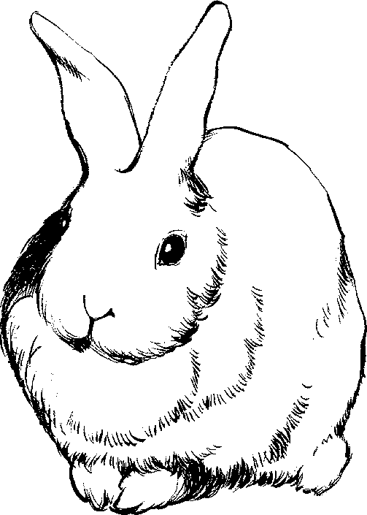
Suggested Fourth Year in Rabbits
- Improve upon everything done for the Third Year.
- Help at least one new, beginning 4-H rabbit member get started. Help the new member get two 4-month-old does and a buck from pedigreed stock.
- Begin this year's record with the closing inventory of the year before.
- Exhibit a commercial meat pen.
- Exhibit two does and one buck in their show room classes.
- Exhibit one of the does or the buck, either a colored or a white rabbit of any age that is in top fur condition.

Suggested Fifth Year and Above in Rabbits
- Improve upon everything done for the Fourth Year.
- Serve as a 4-H junior leader for the 4-H rabbit program in your county or in your 4-H club as the project leader.
- Begin this year's record with the closing inventory of the year before.
- Exhibit rabbits in all show room classes for your breed(s). (Four classes for small breeds, six classes for medium and giant breeds.)
- Exhibit a commercial meat pen.
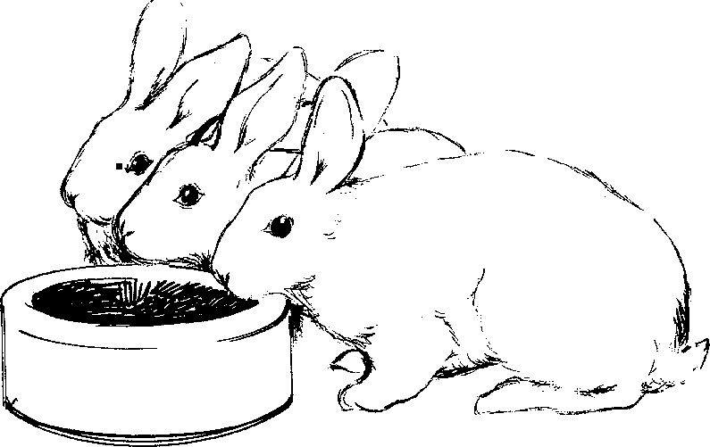
- Exhibit at the State Fair, as well as at your county fair.
- Exhibit in more than one A.R.B.A. show in either the Youth or Open Class Division.

Meat Pen - Commercial Rabbits
Exhibit three rabbits of the same breed and color or variety. They should be of equal size, litter mates, not over 5 pounds in weight and not over 69 days of age. They can be opposite or like sex. Rabbits of marked breeds must be marked with no disqualifications. If not, the entire pen can be disqualified.

Glossary of Rabbit Terms
Adult - See Senior.
Abcess - See Boils.
Agouti - A hair shaft having three or more bands of color with a definite break in color bands on the entire body. Usually dark slate at the base, with two or more alternating light and dark bands or rings interspersed with black guard hairs. Head, ears and feet usually carrying ticking. Belly color usually much lighter and not carrying ticking.
Example: steel or gray Flemish, Chinchilla and Belgian Hares.
Back - The entire top portion of the rabbit, extending from neck to tail.
Bare Spots - A section of the rabbit entirely without fur.
Bell Ears - Ears that have large tips with a distinct fall or lop.
Belly - The lower part of the body containing the intestines. The abdomen. For purposes of defining color area, it is the underbody of the rabbit from the forelegs to the crotch area.
Belt - The line where the colored portion of the body meets the white portion just behind the shoulders. Example: Dutch.
Blaze - White on the head and nose running up between the eyes on rabbits with multi-colored fur.
Boils - A hard swelling or isolated collection of puss or purulent matter occurring in the rabbit's skin, accompanied by localized fever and heat.
Bowed Legs - Applied to both fore and hind legs.
Bent like a bow. Curved outwardly in the middle.
Breed - A race or special class of domestic rabbits that reproduce distinctive characteristics of fur markings, fur texture, shape, size and growth. A breed may be subdivided into varieties. Example: the Black, Blue and Tortoise varieties of the Dutch breed.
Breeder - A person who breeds or raises a special variety or varieties of rabbits in conformity with accepted standards of perfection or for the purpose of improving their commercial value.
Breeding Certificate - A written certificate by the owner of a stud buck, showing its pedigree and the date of breeding to a particular doe. Given to prove the ancestry of the young.
Broken Coat - Guard hair broken or missing in spots exposing the undercoat. Areas where the coat is affected by molt exposing the undercoat.
Broken Ear - A distinct break in the cartilage which prevents erect ear carriage.
Broken Tail - A tail that is or has been broken and is out of line. A disqualification.
Buck - An unaltered male rabbit.
Buck Teeth - See Wolf Teeth.
Buff - A rich golden orange color with a creamy cast.
Bull Dog - A short, broad, bold head of pronounced masculine appearance.
Butterfly - A dark colored area on the nose, such as found on the Checkered Giant and English Spot breeds.
Carcass Weight - The weight of the rabbit after it has been killed and dressed.
Carriage - The way a rabbit bears itself. The style or station of a rabbit.
Cheek - The sides of the face beneath the eyes
Chest -The front portion of the body between the forelegs and neck.
Choppy (or Chopped Off) - Having the back and loins cut off abruptly and falling vertically to the tail. Not having a gracefully arched back and loins.
Cobby - Stout and stocky. Short legged and short coupled.
Collar - A white band completely circling the body at the chest and forelegs.
Condition - The physical state of a rabbit in reference to health, cleanliness, texture and molt of fur, and grooming.
Cow Hocks - Hocks that turn or bend inward causing the foot portion to turn outward.
Creamy - Light yellow. The color of cream.

Culling - Selecting only the best rabbit from the litter Fly Back -The property of fur that causes it to return

for future breeding and show stock. Cutting out the least desirable specimens from a litter.
Dam - A mother rabbit.
Density - The property or quality of a thick coat.
Dewlap - A pendulous fold or folds of loose skin hanging from the throat.
Disqualify - One or more permanent defects, deformities or blemishes that make a rabbit unfit to win an award in competition or to take part in an exhibition. (Disqualified rabbits are not eligible for registration by A.R.B.A.)
Doe - A female rabbit that has not been altered.
Ear Lacing - A black or dark colored line of fur outlining the sides and tips of the ear.
Elimination - One or more defects presumed to be temporary and curable. Cause for elimination in a show or from registration until cured or corrected. (Elimination for overweight or underweight - rabbit can compete in fur class.)
quickly to its normal position when stroked toward the head of the rabbit.
Flying Coat - A loose, fluffy coat of fur, caused by undue length and thinness of under wool and weak guard hairs.
Foot - That part of the leg on which the rabbit stands. On the foreleg - that portion below the ankle or pastern. On the rear leg - that portion below the hock joint.
Forehead - The front part of the head between the eyes and the base of the ears.
Foreign Color - Any color of fur, eyes or nails that is different from the prescribed standard of perfection for the breed and variety.
Frosty - Having the appearance of being powdered or sprinkled with meal. Mealy.
Genotype - The genetic inherited characteristics and potential of the rabbit stock.
Gestation - Carrying young in the uterus. Pregnancy.

Eye Circle - Even marking of color around both Glossy - The reflected luster or sheen from. naturally eyes. Example: Checkered Giant. healthy fur in rabbits. Improved by grooming.
Eye Color - The color of the iris. The circle of color Guard Hair - The longer coarser hair of the coat, surrounding the pupil. offering protection to the undercoat and

Faking - Any change in the external appearance of a
providing wearing quality and sheen to the coat.

rabbit on exhibition, done with intent to deceive. Hairline - A narrow white line running between the

Faults - Imperfections or lacking ideal type for breed and variety, not serious enough to disqualify the
ears, connecting the blaze and collar on the Dutch.

rabbit. Examples are cheek spots too large, bars Hindquarters -The after portion or posterior section instead of spots, lack of taper in spine marking or of the body, made up of loins, hips, hind legs and herring bone. rump.
Fine Coat - Coat is too fine in texture and lacking Hip - The thigh joint and large muscular first joint of body. Guard hairs are too weak and thin in the hind leg.

structure, similar to hairs making up the undercoat.
Flabby - The condition of a rabbit when the flesh or fur hangs loosely. Not trim and shapely.
Hock - The middle joint or section of the hind leg between the foot and hip.
Hog Fat - The condition of a rabbit obviously
over-fattened and, as a result, out of proportion

Flank - The sides of the rabbit between the ribs and to the true type of the breed.

hips and above the belly.
Hump Back - Having a hump or protuberance on the

Flat Coat - Coat lying flat or close to the body, back, marring a gracefully arched outline.

lacking spring or body. Fine coat coupled with lack of density.
Inbreeding - A system involving very close mating of rabbit stock, such as brother and sister.

Inherited - The degree for which a trait or Marked - Having the basic color broken up by characteristic is passed on from parent to orderly placement on a white (usually)
offspring. background.
Inner Ear - The concave portion of the ear. Massive - Bulky and heavy. Ponderous. Large and

Intermediate - A rabbit at least six months old and no more than eight months.
compact.
Mealy - See Frosty.

Junior - A rabbit under six months of age. Meaty - The quality of being able to carry a large

Kindle - To give birth to young rabbits.
Knee -The second joint of the leg, connecting the thigh and leg. In animals, more properly called the "hock." The second joint of the foreleg is the elbow.
Knock Kneed - See Cow Hocks.
Lapin - French word for rabbit. Also, in the fur trade, it is dyed rabbit fur.
Lazy Tail - A tail that is slow to assume its normal position when it is moved.
Line Breeding -A system of mating stock so that the offspring are highly related or close descendants of the chosen ancestor.
Litter - Young rabbits of a doe born at the same time.
Live Weight - Weight of a rabbit before it is dressed for market.
Loin - That part of the back on either side of the spine and between the lower rib and the hip joint.
Loose Coat - Fur lacking density in the undercoat, coupled usually with fine guard hairs and a resulting lack of texture. Does not indicate a slipping coat.
Lopped Ear - Pendulous ear. Not carried erect.
Falling to the side or front.
Luster - Brightness and brilliance of fur.
Malocclusion - An inherited defect where the upper and lower jaws do not let the teeth meet, resulting in long uneven teeth extending out of the mouth.
Mandolin - Having the appearance of the body of a mandolin laid face down. Back and saddle arching toward loins to make noticeably large, broad hindquarters.
proportion of meat for the size and type of rabbit. A noticeable meatiness at the forequarters, back, saddle, loins and haunches.
Molt (Moult) - The process of shedding or changing the fur twice each year. The baby or nest fur is molted at two months. The first natural coat of fur is fully developed at four to six months.
Muzzle - The projecting portion of the head surrounding the mouth, nose and lower jaw.
Neck - That part of the rabbit connecting the head and body.
Nest Box - Special box inside the hutch or cage hole where the young are kindled and live for the first 18 to 21 days.
Nostrils -The two openings of the nose leading to the head.
Off Colored - Applied to several hairs or patches of fur foreign to the standard color of the rabbit.
Open Coat - See Loose Coat.
Outcrossing - A system of mating unrelated stock of the same breed.
Pair - A male and female rabbit.
Palpation - A hand method used to determine if a doe is pregnant and will bear young.
Patches - A small section of fur foreign to the color standard of the rabbit.
Paunch - The prominent portion of the abdomen of the rabbit.
Pedigree - A written chart of the male and female ancestors of a rabbit, showing the date of birth, ownership of dam and parents, grandparents and greatgrandparents of the specimen.
Pelage - The fur coat or covering.

Pepper and Salt - A flat, unattractive appearance of scoring. Occurs more often in the agouti breeds
black and white ticking. Example: Chinchillas. than in selfs.

Caused by lack of contrast and waviness and in ticking and weakness of color in the tips of guard hairs.
Phenotype - The appearance of the individual rabbit.
Poor Coat - Fur not in good condition through molting, rust, poor grooming or ill health of the rabbit.
Rabbit - A domesticated rodent of the genus
Orctolagus cuniculus.
Racy - Slim, trim, slender in body and legs, harelike, alert and active.
Ribs - The curved portions of the sides immediately back of the shoulders above the belly.
Rump - The hind portion of the back and bones.
Rust - A reddish-brown coloration of fur, usually appearing on the sides, flanks or feet of rabbits, having the appearance of iron rust and being foreign to the standard color. Rust usually appears in American Blues, Black, Havanas and Lilacs. May be caused by fading through
over-exposure to the sunlight, dirty hutches or dead hair about to molt.
Saddle - The rounded, intermediate portion of the back between the shoulder and loin.
Sandy - The color of sand, as in sand-gray Flemish Giants. Gray with reddish brown cast interspersed with dark guard hairs.
Screw Tail - A tail that is twisted. A corkscrew tail has more than one turn and is a disqualification.
Self or Self-Colored - Rabbits of the same colored fur over the entire head, legs, body and tail. Not having ticking, agouti hair pattern or shadings.
Senior -A rabbit six months of age and over in those breeds having two show room classes, Junior and Senior. A rabbit eight months of age and older in those breeds having three show room classes, Junior, Intermediate, Senior.
Shadow Bars -Weakness of self-color in the fur of both fore and hind feet, appearing in the form of white or lighter colored bars running across the feet and acting as a severe cut or penalty in
Shoulder - The uppermost joint of the foreleg, connecting it with the body.
Silvered - Having an abundance of silverwhite or silver-tipped guard hairs interspersed through the fur that produces a lustrous silvery appearance.
Sire - A father rabbit.
Slipping Coat - A coat that is shedding or molting a profusion of hairs.
Slobbers - Excessive salivation creating wet or extremely moist and unsightly fur around the mouth and lower jaw and forelegs.
Snaky - Slender, narrow body, thin and typical of the Himalayan.
Snipey - Narrow and elongated head, with an appearance of undue leanness.
Solid Color - Of the same color uniformity over the entire animal, not mixed with any other color. Having no markings or shadings. Includes ticked or agouti colored rabbits. Also includes brindled rabbits but not rabbits of basic "tan" pattern.
Sport - Rabbit not true to the characteristics of its breed.
Spraddled Legs - Forefeet bowed outward when viewed from the front. Knock kneed. Hind feet not set parallel with the body. Turned outward from the hock joint.
Station - Ideal manner of standing of carriage in conformity with standard position of pose.
Stocky - Compact, stout and cobby.
Stops - In the Dutch, white part of the hind foot extending upward from toes and ending abruptly about one third of the way to the hocks.
Strain - A race or stock of rabbits in any standard breed of the same family blood, having the quality of reproducing marked racial characteristics.
Stringy - The quality of having a ropy or sinewy finish, noticeably in the larger breeds of rabbits if not properly fattened for market.

Sway Back - Having a distinct fall or scoop in that Wool - Descriptive of the fur of Angora rabbits. The

portion of the back between the shoulders and hindquarters, as distinguished from a gradually arching back.
Sweep - An unbroken flow of designated markings.
There should be no gaps or congested areas.
Symmetry - The quality of possessing a harmonious proportion of head, ears, legs and body structure conforming to the standard type of the breed represented.
Tail Carriage - The way in which a rabbit carries its tail. Poor tail carriage is denoted by the tail being carried to one side or the other.
Tattoo - A punched code in the ear that is a permanent method of identification.
Texture - The character of fur as determined by feel or touch, such as "fine" or "coarse" texture.
Trio - One buck and two does.
Tucked Up - The trim appearance of a Belgian Hare, with long rounded body and breast and belly gathered in closely to form an arch when the rabbit is sitting.
Type - Used to denote body conformation of a rabbit, or shape of a particular part of a rabbit, as in "head type." The general description of the physical makeup of the rabbit.
Typical -Serving as an ideal representative of any given breed or variety as applied to type, color or fur quality.
Under Color - The base of the fur hair. Shaft next to the skin. Not the belly fur of the rabbit.
Variety - A subdivision of any recognized standard breed, distinct in color of fur from other subdivisions. With rabbits type shows the breed and color the variety.
Wall Eyes (Moon Eyes) - Having a milky film over the cornea or appearance similar to a moonstone. Colored eyes having an extremely light iris giving the eye a glazed appearance.
Wolf Teeth - Protruding or elongated teeth in the upper or lower jaw caused by improper alignment of the upper and lower front teeth preventing normal wearing action.
guard hairs and under-fur being from 2½ to 5 inches long and resembling fine wool in texture.
Wry Tail -Abnormally bent, curled or twisted.
Permanently held to one side. A disqualification for a rabbit.

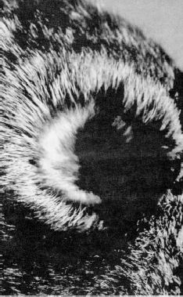




- This document is 4HRAM10 (which supercedes 4H-9), one of a series of the 4-H Youth Development Program, Florida Cooperative Extension Service, Institute of Food and Agricultural Sciences, University of Florida. Printed November 1990; reviewed January 2012. Please visit the FAIRS Website at http://hammock.ifas.ufl.edu.
- Norman . Young, Extension Specialist - Youth, Purue University and the Indiana State 4-H Rabbit Committee, Cooperative Extension Service, Institute of Food and Agricultural Sciences, University of Florida, Gainesville, 32611.
COOPERATIVE EXTENSION SERVICE, UNIVERSITY OF FLORIDA, INSTITUTE OF FOOD AND AGRICULTURAL SCIENCES, Christine
Taylor Waddill, Director, in cooperation with the United States Department of Agriculture, publishes this information to further the purpose of the May 8 and June 30, 1914 Acts of Congress; and is authorized to provide research, educational information and other services only to individuals and institutions that function without regard to race, color, age, sex, handicap or national origin. The information in this publication is available in alternate formats. Single copies of extension publications (excluding 4-H and youth publications) are available free to Florida residents from county extension offices. Information on copies for out-of-state purchase is available from Publications Distribution Center, University of Florida, PO Box 110011, Gainesville, FL 32611-0011. Information about alternate formats is available from Educational Media and Services, University of Florida, PO Box 110810, Gainesville, FL 32611-0810. This information was published November 1990 as 4HRAM10, Florida Cooperative Extension Service.

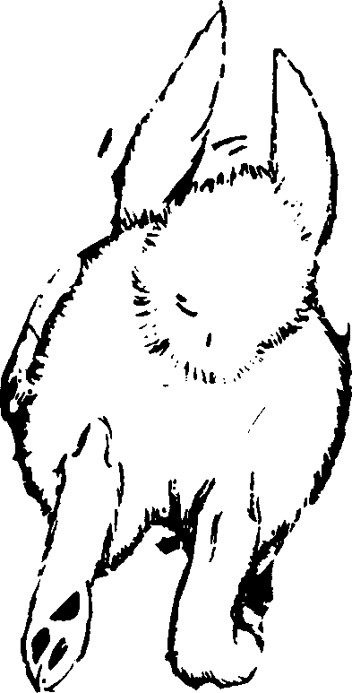
rab rabbit rabbi rabb rabbi rabbits, r
rabbits, rabbi
rabbits, rabbits, r
rab

