4-H Family Newsletter – May 2026
Nebraska Extension – Platte County
2715 13th Street, Columbus NE 68601-4916
Phone: 402-563-4901
Website: http://platte.unl.edu
Like Us on Facebook: Nebraska Extension – Platte County

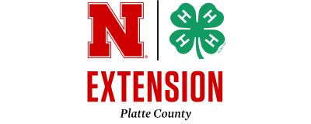
Month Events/Deadlines
May 1
Diamond Clover Goal
Submission, Jr. Camp
Registration & Jr. Camp
Counselor Application
Deadline
May 3
County Fair Trap Contest
4:30 pm @ Izaak Walton
May 4
Growing Clover Club Mtg.
6 pm
May 4
Jr. Leader Club Mtg. 7 pm
May 6
County Fair Information
Mtg 5:15 pm
May 11
County Fair Online Entry &
Interview Sign Up Opens
May 11
YQCA Training 7:30 pm
May 15
County Fair Animal
Nomination ID/DNA
Deadline
May 22
YQCA Training 3 pm
May 25
Memorial Day – Office Closed
May 29
Horse ID, Level Testing &
YQCA Certification Deadline

COUNTY FAIR INFORMATION MEETING
A leader and parent meeting (open to everyone) will be held on Wednesday, May 6th at 5:15 p.m. at the Extension Office, Columbus to discuss new and exciting changes for the 2026 fair.
It is important for someone from each club attend and new and/or independent families are especially encouraged to attend this meeting to get fair updates, sign up for pop stand shift, club booth information, learn how to complete on-line fair entry forms and ask questions.
The meeting will last one hour.

CLOVER ACADEMY – SUMMER WORKSHOPS
You can find workshop descriptions and registration forms in this newsletter!
To register for the summer workshops is a two-step process, one - register online in Sign Up Genius and two – submit payment immediately to the Platte County Extension Office by mailing or dropping off payment. Youth are not completely registered unless both steps are completed before the May 15 deadline.

AREA PLANT SCIENCE AND INSECT CONTESTS
4- H Plant Science and Insect Contest Day is Thursday, June 25 at Ag Park Clubroom in Columbus. Mark your calendars!
Contests held are Horticulture Judging and ID, Tree ID, Grass and Weed ID and Insect ID. You can participate in one, two, three or all four based on your interests. The contests mainly consist of identifying plant samples.
If you’ve never participated, feel free to come, watch, and learn more about it. For information on contests, contact Taylor Cammack at tcammack7@unl.edu. Registration flyer included in this newsletter.

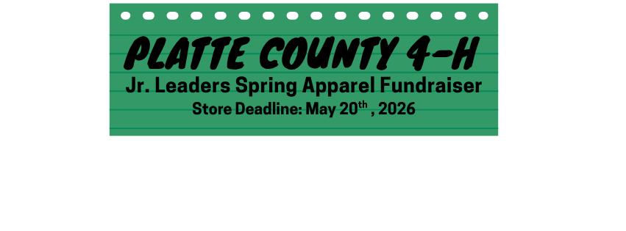Don’t miss out—this is your only opportunity to order 4-H apparel before the County Fair! Check out the attached flyer for details and
use the online ordering link to get your gear in time.
Order now so you’re ready to represent at the fair!

Staff
Blake Wert Taylor Cammack
Hailey Held Beth Jones
Sandra Swanson

Office Hours:
Monday – Friday
8:00 a.m. – 5:00 p.m.

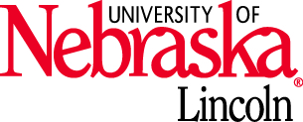
Nebraska Extension is a Division of the Institute of Agriculture and Natural Resources at the University of Nebraska-Lincoln cooperating with the Counties and United States Department of Agriculture. The 4-H Youth Development program abides with the nondiscrimination policies of the University of Nebraska-Lincoln and the United States Department of Agriculture.
CONGRATULATIONS RON KASPAR
Congratulations to Ron Kaspar for being named the Emerging 4-H Volunteer award winner for Zone 7!
Ron has served as a 4-H trap coach for the last two years and has played a vital role in ensuring the team is successful. Ron brought decades of trap shooting expertise to the team. His knowledge, willingness to advise on equipment and shooting technique is a difference maker for many team members. Ron goes the extra mile to ensure the range is ready for practice, clays are stocked and the end of practice Annie Oakley games are a highlight for all.
Ron will be celebrated during a recognition ceremony at the 2026 Nebraska State Fair.
ONLINE HORTICULTURE JUDGING CONTEST
Do you know what it takes to pick the best fruit and vegetables out at the grocery store? Or do you know what judges are looking for when they judge your plants at the county fair? Have you ever wondered, what plant is that!?! We are excited to offer the opportunity to learn these and other important horticulture skills through the Online Horticulture Contest. The contest will be available June 9-23, 2026 at: http://go.unl.edu/online4hhortcontest
Horticulture judging contest consists of three parts. The first is identification of plant material. Participants identify the plants by common name from a plant list. Specimens may be alive or preserved plant parts like stems, twigs, leaves, flowers, seeds, fruits, roots, bulbs, tubers, or plant products.
The second is a knowledge portion, usually in the form of a true/false or multiple choice quiz. Questions will test the contestant's knowledge of cultural practices for horticultural crops, plant science, pesticides, horticultural careers and other topics related to the production, processing and consumption of horticultural crops.
The last portion is judging or placings. This is where four different plants, plates of vegetables, or containers flowers are ranked from best to worst based on a set of criteria. Classes are judged on the basis of condition, quality, uniformity, true-to-type, and size.
More information about the Nebraska State contest along with a list of study materials can be found in the Horticulture ID Contest Fairbook. Here you can find the written study materials for the knowledge portion, follow links to plant pictures for help with identification, and read how judging of plant material is done.
More details at: https://4h.unl.edu/online-horticulture-judging-contest
More details at: https://4h.unl.edu/online-horticulture-judging-contest

Office Closed – Monday, May 25
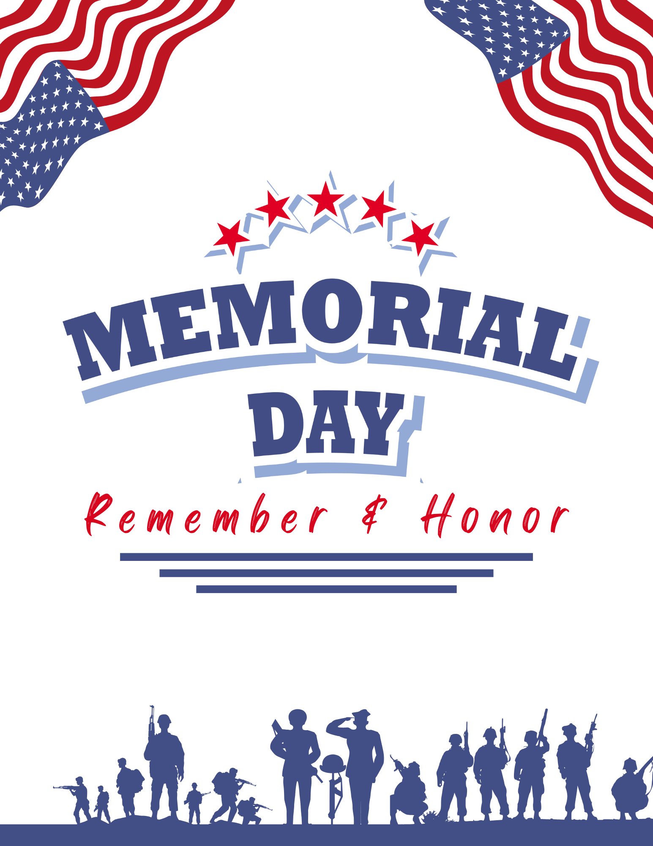
COMMUNICATION EVENT HELD
Congratulations on a job well done to all the 4-H’ers and Clover Kids who participated in the Communication Event which included Speech, PSA, Presentation, and Impromptu Speech division on April 12 at CCC. There were 4-H’ers representing Butler, Colfax, and Platte County at the event.
Junior Speech:
Cameron Kosch – Blue
Karsta Kersting - Blue
Intermediate Speech:
Sydney Kosch – Blue & Reserve Champion
Intermediate Impromptu Speech:
Sydney Kosch - Blue
Senior Impromptu Speech:
Delaney Cheloha – Blue
PSA Intermeidate:
*Karis Kersting – Purple & Reserve Champion

*Congratulations to this 4-H’er who qualified to attend the Premier Communication Event held in Lincoln on June 16 & 17, 2026.
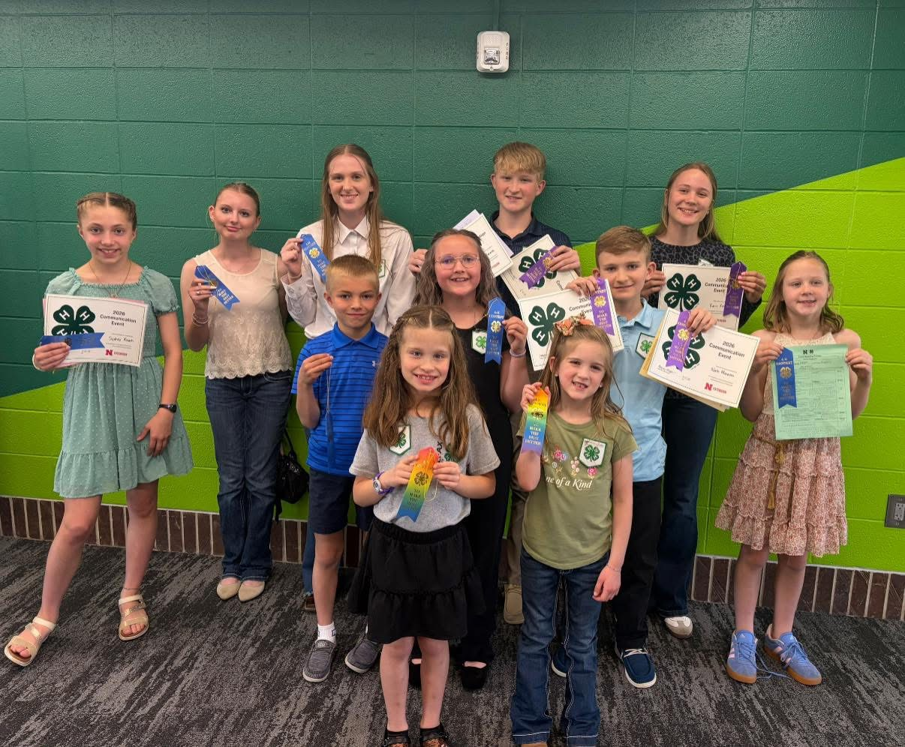

Minutes for the Platte County 4-H Council
Monday, April 20, 2026 - 7:30 p.m. at Nebraska Extension – Platte County

7:30 p.m. – 4-H Council Meeting

Call meeting to order – Cory Osten, President
Roll Call – Julie Kreikemeier, Secretary
- Members in attendance were Kenna Dicke, Marissa Hellbusch, Brigen Kinnison, Adelle Kinnison, Briggs Klug, Crystal Klug, Alivia Kreikemeier, Julie Kreikemeier, Cory Osten, Angie Reardon, Callista Reichmuth, Shelley Reichmuth, Sandi Seckel, Stephanie Schmidt, Kristy Spawn, Rachel Spawn, and Pat Wiese. Staff in attendance was Blake Wert.
Approval of minutes of last meeting – Julie Kreikemeier – Sandi Seckel motioned to approve minutes as presented. Stephanie Schmidt seconded the motion; motion carried.
Correspondence – Julie Kreikemeier – no report

Treasurer’s Report – Brigen Kinnison – Brigen reported the current balance of $41,456.29 and that sponsorships have been coming in and they were listed on the back of the budget sheet.
4-H Revolving Account Report – Office – Blake Wert reported that the current balance is $2213.62

Committee Reports:
- Executive Committee – Cory Osten- No report
- Extension Board Liaison Report – Stephanie Schmidt – Stephanie reported that at the Extension Board meeting the budget was discussed and that they are looking into replacing the Platte County Educator position that is currently open.
- Beef Efficiency – Travis Dicke – No report
- Livestock Sale – Logan Went – Blake Wert reported on behalf of Logan that Sandra Swanson received a new computer. The new computer does not have the livestock program needed and will need to be purchased. This purchase will come out of the livestock sale budget.
- Recognition – Crystal Klug – No report
- Scholarship & Awards – Shelley Reichmuth – It was reported that there were 11 youth that applied for the junior camp scholarship. 11 scholarships will be awarded with 5 going to youth that have never attended or received a scholarship with the value of $110 each and 6 going to the youth that have received for the second year or more with the value of $85 each. This used the amount budgeted for camp scholarships.
- Pop & Food Stand – Stephanie Schmidt – Blake Wert reported that there will be an email going out for needs soon.
- Jr. Leaders – Marissa Hellbusch & Rachel Spawn – The last meeting was held on April 13. Communications Event was discussed. Jr. Leaders also discussed signup for fair week. They practiced the lesson for May Clover Kid meeting – water and tissue paper to make tie dye – since they will be co-teaching that lesson.
- Other - Staff Reports – Blake Wert reported on the following:
  - Life on the Farm which was held in March with 280 youth participated. This event is now for 3rd graders instead of 2nd graders. Because of the age level change, Blake made the event way more hands-on. Flying drones, making yogurt for dairy, punch ear tag through cardboard, etc.
  - School enrichment – 625 kids in embryology and plant life cycles. Also getting reach through Butterfly life cycle & Nebraska History escape room which is led by teachers.
  - Applications for the Platte County Educator Opening will come available at the end of April and be open until end of May to beginning of June. The decision was made to make the hire after fair. Hailey Held will return middle of June from maternity leave. Gretta Kinnison joining on May 12 as summer intern. Hosting interviews for another summer intern position. 6 applications for intern position.

Education: None

Unfinished Business:
- 4-H Enrollment
  - There are currently 347 youth enrolled compared to 366 last year. Currently 38 volunteers enrolled.
- Council must enroll in 4HOnline (no background check required but must complete Volunteer Orientation Training)
- Market Cattle Weigh-In
  - Cattle Weigh-in was held in February with 144 head weighed which included cattle for the Pen of 3 contest and led cattle interested in rate of gain. This number is more than the previous year. The weigh-in ran smoothly and thankful for all the volunteers that helped.
- Family Recruitment Night
  - Recruitment night was held in February at Pizza Ranch. The funds raised at this event was $361.64 and $2.85 in tips.
- FLL Robotics Challenge Championship
  - There were three FLL Challenge teams and four JFLL Explore Teams from Platte County who competed at the FLL Challenge in March. The Challenge team Code Huskers received the Core Values first place award and Robo Rangers were a robot design finalist. Code Huskers ranked 16th and Robo Rangers ranked 39th in the robot games. Platte County also received “Excellence in Advocacy Award” for our outstanding support of 4-H State Robotics at the local level throughout the years.
- YQCA, PASE Contest, Showmanship Clinic & Heartland Triple Crown Livestock Judging Series
  - YQCA – Currently 100 youth have completed the instructor led with 2 more trainings left. Deadline is May 29th. Reminder emails will be going out to make sure youth are trained.
  - PASE – There are currently 25 Platte County youth signed up. Blake is working on finalizing the livestock judging and skill-a-thon practices as he is waiting on materials from the state. Practices will be in the evenings. Blake is planning to coach livestock judging. Blake will be leading skill-a-thon and then having the interns co-teaching skill-a-thon. Quiz Bowl and Meats Judging – need coaches for these two events with shortage of the Extension office staff.
  - Showmanship Clinic- This event will be held on June 13th, 2026. Participants can attend all sessions or one session for one fee.
  - Heartland Triple Crown Livestock Judging Series will take place June 17-19, 2026. Columbus event is on June 17th, Bladen event is on June 18th, and Nelson event is on June 19th. All contest awards for individual county and series will be done on June 19th.
- Ag Park & County Fair Update
  - Ironing out details of where the Extension office staff will be located during the fair. Will have final answer by the June Council meeting.
  - Manure dumpsters – Ag society is not doing dumpsters. Cement bunkers will be created. Members of Ag Society will come push it up throughout the fair. During the fair, council members will need to please remind 4-H families of this change and to make sure manure is getting dumped in the bunkers and not outside of the barns.
  - County Fair information night will be held on May 6th at 5:15 PM at the Extension Office.

New Business:
- Trap Club Parent Attended March Certification Training / Requesting Reimbursement
- Dale Priester took training to be a volunteer for trap club. $140 needs to be reimbursed for the cost of the training.
- Crystal Klug motioned to reimburse $140 to Dale Priester for the trap club volunteer training. Sandi Seckel seconded. Motion carried.
- Communication Event
- Communication event took place on April 12, 2026. KateLynn Ness, Colfax 4-H Educator took the lead on this event. Five youth from Platte County participated. Karis Kersting received purple and Reserve champion in PSA Intermediate and qualified for Premier Communications Event in Lincoln on June 16th and 17. 4-H Council will pay registration fee if she attends.
- Clover Academy and Clover College
- Cut back on workshops due to short staff. Gretta Kinnison will be taking lead on the workshops. 7 workshops and 2 already full. 8 youth currently signed up for Showmanship clinic. Junior leaders taking the lead for Clover kid college workshop
- Jr. Camp
- 63 youth registered for camp. Need 30+ more to break even on the event. 19 from Platte County with 11 receiving scholarships. Need camp counselors aged 16 to 18.
- Fair Sponsor Thank-You’s
- During the 2025 Platte County Fair, all banners and medals had attached thank you notes for 4-Hers to send out. 307 thank you notes were handed out with 261 thank you notes returned from 4-Hers to the Extension Office after fair to be mailed. Approximately $179 was spent last fair on postage. $80.64 was cost for purchasing thank you notes. Stephanie Schmidt made motion to do thank you notes as same as last year, Kristi Spawn seconded. Motion carried.
- Amazon Pressure Washer
- Amazon Company reached out to Blake that they have a 4000 PSI pressure washer ($4500 value). We don’t have a purpose for it. Reached out to the state for options – one option is that Amazon donates it, 4-H Council keeps it until fair, and then auction off at the livestock sale. The funds it brings off the auction would go to general budget of 4-H Council. Blake Wert will work with the state to see how it can be advertised and will update at the June Council meeting.
- Fair Foundation – Future Fundraising
  - Extension Staff is looking at getting a poster of the rough draft of new fairgrounds for public to see in the office. Hoping to get the Extension office to be moved out to the fairgrounds at Ag Park. The current indoor arena will stay and house the horses. Most all other buildings will come down, and an all new species show building to be built. All floors will be concrete with hopes of having other events hosted in the space. It is a costly project and currently working on fundraising plans. Fair Foundation members will give an update at the Businessman Breakfast on Thursday morning of fair. Reach out to a Fair Foundation member if you would like to have them come talk to your group. Call Columbus Bank if you would like to borrow a poster. Fair will stay at Ag Park and it will be done in stages to keep fair running as usual. Goal is to also be able to bring in Junior National Livestock Shows.

Other Business: None

June 15th is the next meeting at 7:30 p.m.
Shelley Reichmuth made motion to adjourn at 8:33 p.m., Stephanie Schmidt seconded.
Minutes respectfully submitted by Julie Kreikemeier
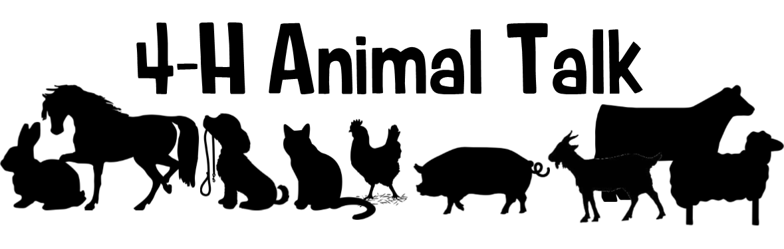

YQCA: The final instructor led YQCA training sessions will be held at the Extension Office on Monday, May 11th at 7:30 pm and Friday, May 22nd @ 3 pm. The deadline for quality assurance is May 29! Registering for quality assurance will be done online through the YQCA website (yqcaprogram.org). The cost for in-person training sessions is $3, while online sessions are $12. Payment is made online at the time of registration. Youth must register before attending an in-person session. These face-to-face sessions will last approximately one hour. NOTE: After you complete the YQCA Training, please either email the certificate to Blake at bwert3@unl.edu or bring a copy into the Extension Office.

Platte County Showmanship Clinic: Plan to attend this hands-on multi-species clinic on June 13th at Ag Park to learn how to show or to gain tips to help improve the showing of your animal for the county fair and beyond! This clinic is open to any 4-H youth in Platte County and surrounding counties! 4-H'ers are encouraged to bring their own animals, but it is not required! The cost for this clinic is $5/youth. Prepayment is required. Payment can be dropped off at the Extension Office or mailed to us! Preregistration and payment are due June 12th. To register, please fill out this form at: https://go.unl.edu/96yo. The contest flyer is attached to this newsletter and if you have any questions, reach out to Blake!

Heartland Triple Crown Livestock Judging Series: We are getting closer to the inaugural Heartland Triple Crown Livestock Judging Series being held June 17-19! Get ready for an unforgettable three-days worth of livestock judging experience! This event will bring together youth from across the state of Nebraska and surrounding states. Participants will take part in 10 placing classes, enjoy a clinic, and compete for awards in each age division and species. With events hosted in Columbus June 17, Bladen June 18, and Nelson June 19, each day offers something unique—plus fun evening activities, including an after-party and a final banquet and awards ceremony. Whether you're a seasoned judge or new to the arena, this is the perfect opportunity to sharpen your skills, meet fellow competitors, and close out the Great Plains Livestock Judging Circuit in style.
🔗 Registration details available at: https://go.unl.edu/lj26

Nebraska State Fair Livestock Nominations: Show Stock Manager is open for livestock nominations for the 2026 Nebraska State Fair! Website Link: www.showstockmgr.com. All livestock in contention to exhibit at the Nebraska State Fair will be required to complete an online nomination, with payment through Show Stock Manager and submit a DNA collector envelope with a hair sample. This includes all 4-H and FFA breeding livestock, market livestock, and feeder calves. State fair EID tags and DNA envelopes are available at the Extension Office. The deadline for ALL online nominations is Monday, June 15, 2026. DNA Envelopes need to be turned into the Extension Office June 15th by 5:00pm.
If you have any questions on how to submit your online nominations, you can review the 2026 Step-by-Step Nomination Instructions.pdf document.

Important Nebraska State Fair Livestock Update: Exhibitors that want to show an animal at the NSF and Aksarben Stock Show (AKSS) will be required to submit two separate envelopes and online nominations. AKKS exhibitors will be ordering and purchasing their DNA envelopes through the AKKS website – https://www.aksarbenstockshow.com/. The DNA process and the online nomination process will be separate for each livestock show! * Direct all AKSS questions to the AKSS website! *

Stall Reservation Form Reminder: Exhibitors showing Beef, Dairy, Goat, Horse, Poultry, Rabbit, Sheep, and Swine will need to complete a Platte County Fair Stall Reservation Form. All 4-H & FFA animals penned at the fair must be recorded on this sheet so the number of pens/stalls required can be determined. Please read the instructions thoroughly at the top prior to filling out the form. There are no guarantees that you will receive all tack space! The stall order form will be due on Monday, June 15th at 5:00 pm with payment. Get your entries in early!

Nebraska 4-H Livestock Achievement Program: This program provides an additional opportunity for enrolled 4-H livestock project youth to strengthen their knowledge and leadership skills across all aspects of livestock projects, including selection, production, leadership, and exhibition. The program recognizes Members of Excellence in the following livestock project areas: beef, sheep, meat goat, swine, dairy cattle, dairy goat, rabbit, and poultry. Youth who complete the program and earn Member of Excellence recognition will be recognized during the Grand Drive during the 4-H weekend at the Nebraska State Fair. Applications are due June 15 and Plan and Project Records are due August 1. For more information and to apply, visit https://go.unl.edu/lap

Pen of 3 Show: The Pen of 3 Show this year is Tuesday, June 23rd at 9 am at the Sale Barn. NOTE: Please contact Blake with how many pens you are bringing by June 15th, so we can line up enough trucks. We will be weighing in cattle on Monday, June 22nd from 7- 8:30 pm. Each exhibitor will need to pick up a form at weigh-in and fill it out to be given to the judge during the show. The form will ask for your pen of three tag numbers, beginning weights, ending weights, rate-of-gain, origin of calves (home-raised or purchased), and any other information the exhibitor wants to share with the judge.

4-H and Clover Kid Obstacle Course: The obstacle course show is Friday, July 10 beginning at 2:00 pm in the green barn with sheep obstacle course. The goat obstacle course will follow sheep before the show transitions over to the indoor arena for the bucket calf obstacle course. To view the obstacle course layouts for Sheep, Goat, and Bucket Calf, visit Animal Record Books, Handbook, and Obstacle Courses | Nebraska Extension in Platte County | Nebraska Extension | Nebraska. The links will be close to the middle of the page when scrolling.

Livestock Progress Shows, Animal Shows & Clinics: Check out our website for a listing of Nebraska 4-H/Extension livestock progress shows, animal shows and clinics. This includes horse, rabbit, poultry, small pet, beef, swine, sheep, and goat. Use this link to see all these great opportunities: https://extension.unl.edu/statewide/platte/4-h/4-hextension-livestock-progress-animal-shows-clinics-judging-contests/ We will continue to update this page as more shows and clinics become available!

Dates to Remember:
May 11 YQCA Training at Platte County Extension Office @ 7:30 pm
May 15 County Fair Animal Nomination ID/DNA Deadline
May 22 YQCA Training at Platte County Extension Office @ 3:00 pm
May 27-29 PASE at UNL East Campus
May 29 Horse ID, Horse Level Testing & YQCA Certification Deadline
June 13 Platte County Showmanship Clinic
June 15 County Fair Online Entry Deadline
June 15 Stall Reservation Form Deadline
June 15 State fair online nominations due on https://showstockmgr.com/
June 17 Heartland Triple Crown Livestock Judging Series - Platte County Contest
June 20 Platte County Fair/Wrangler 4-H Club Open Horse Show at Ag Park
June 23 Pen of 3 Show at Columbus Sales Pavilion

