Nebraska Extension – Platte County 2715 13th Street, Columbus NE 68601-4916
Phone: 402-563-4901
Website: http://platte.unl.edu
Like Us on Facebook: Nebraska Extension – Platte County

4-H Family Newsletter – March 2026
RURAL RECOGNITION BANQUET MARCH 17
Month Events/Deadlines
March 2
Growing Clovers 4-H Club Mtg. 6 pm @ Extension Office
March 2
Jr. Leaders 4-H Club 7 pm @ Extension Office
March 13
YQCA Training 10 am @ Extension Office
March 17
Rural Recognition Banquet 5:30 pm @ Ag Park
March 20-21
FLL Robotics Challenge Championship @ UNL
March 27
County Fair Broiler Order Deadline to Extension Office
April 1
Communication Event Registration Deadline
April 8
Camp Scholarship Deadline April 12
Communication Event 4 pm @ CCC
April 13
Growing Clovers 4-H Club Mtg. 6 pm @ Ext. Office
Staff
Sheila Hoppe Taylor Cammack Blake Wert Beth Jones
Hailey Held Sandra Swanson
Office Hours:
Monday – Friday 8:00 a.m. – 5:00 p.m.
Congratulations to Platte County 4-H award recipients who will be recognized at the Rural Recognition Banquet on Tuesday, March 17. Because of these leaders and volunteers and their continuous support, the Platte County 4-H program is stronger than ever!
Meritorious Service Award: Bank of the Valley Friends of 4-H Award: Don & Alice Sieh
Club Leaders’ Years of Service: 10 years: Kristy Spawn 30 years: Holly Schultz
4-H Scholarship Winners and Diamond Clover Award recipients to be recognized:
4-H $250.00 College Scholarship Recipients: Jordyn Loseke Diamond Clover Award Recipients:
Level 1 Amethyst: Maria Chvala, Cameron Kosch, Bennett Reichmuth, Will Reichmuth
Level 2 Aquamarine: Kendall Goedeken, Kesler Kersting, Knox Paulsen, Kolyns Wilke
Level 3 Ruby: Brooke Faltys, Claire Hellbusch, Hunter Niedbalski, Jada Rosendahl, Charlie Wilke, Cooper Wilke
Level 4 Sapphire: Lucy Faltys, Natalie Faltys, Marissa Hellbusch, Sydney Kosch, Brooke Kreikemeier, Gavin Rosendahl
Level 5 Sapphire: Delaney Cheloha, Alivia Kreikemeier, Cooper Niedbalski, Alaina Rosendahl
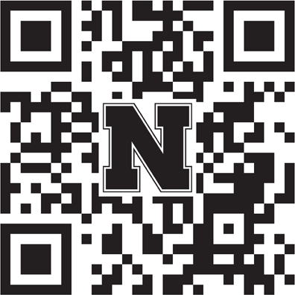
Level 6 Diamond: Adelle Kinnison, Callista Reichmuth, Justine Reichmuth
The public is invited to attend the Rural Recognition Banquet on Tuesday,
March 17 at the Ag Park, Club Room, Columbus. Scan the code to purchase tickets at the Columbus Chamber of Commerce website.

PLATTE COUNTY FAIR BOOK
Enclosed is the 2026 Platte County Fair Book. ALL information about exhibiting 4-H & FFA at the Platte County Fair will be in the book.
Changes within classes have been made throughout the fair book, so please take the time to read so you are well-informed.
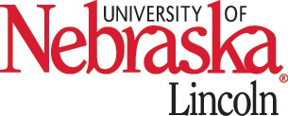
This book will be needed for the County Fair Online entry deadline of Monday, June 15th.

Nebraska Extension is a Division of the Institute of Agriculture and Natural Resources at the University of Nebraska-Lincoln cooperating with the Counties and United States Department of Agriculture.The 4-H Youth Development program abide with the nondiscrimination policies of the University of Nebraska-Lincoln and the United States Department of Agriculture.

ENROLL IN 4-H BEFORE YOU MISS OUT
4-H Members, Volunteers/Leaders, and Council Members must re-enroll every year! Cost is $5.00 per 4-H’er. No cost to leaders, volunteers, or Council members.
If not currently enrolled in 4-H, you will miss out on participating in contests, summer workshops, camps, and the County Fair.
The enrollment website is https://v2.4honline.com or you can go to our county website at http://platte.unl.edu for enrolling or re-enrolling instructions to the 4-H Online enrollment website.
Any questions, please contact Sandra at the Extension Office at 402-563-4901 or send an email to sswanson5@unl.edu.
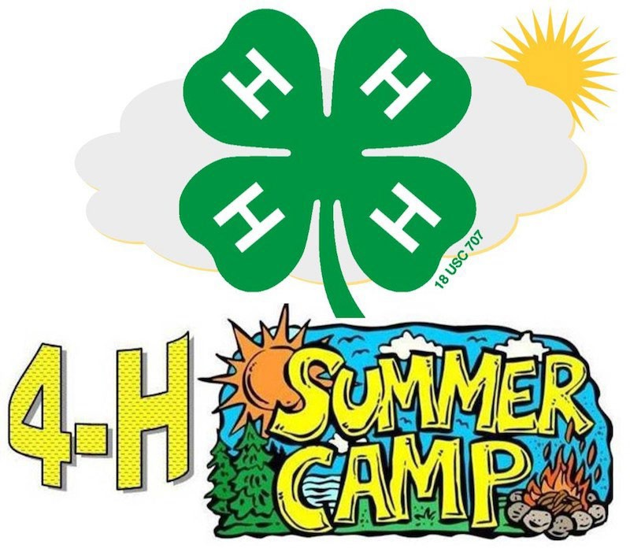
JR. 4-H CAMP ONLINE REGISTRATION
Jr. 4-H Camp is scheduled for June 3-5, 2026 at Whispering Cedars near Genoa. 4-H’ers from Platte, Antelope, Boone, Merrick, Nance, Polk, and Hamilton counties are welcome to attend. Jr. Camp is for 4-H’ers age 8 – 11 and the cost is $110.00 per camper.
See camp flyer included in this newsletter for all registration requirements. Jr. 4-H Camp registration deadline is May 1, 2026.
All Jr. Camp information and links can be found on the Platte County website at https://extension.unl.edu/statewide/platte/

JR 4-H CAMP COUNSELORS
Are you ready to have the experience of a lifetime? Are you ready to make memories that will last forever? Are you ready to show off your skills? If you said yes to those questions, then you are ready to be a camp counselor at the 2026 4-H Jr. Camp.
The opportunity to be a role model for youth doesn’t come around often so take the chance while it’s here. You don’t want to miss out on that!
Counselors must be 16 to 18 years of age before January 1 of the current year. No fee for Counselor to attend camp. Must complete an online Counselor Registration form by May 1, 2026 deadline. Registration form can be found online at https://extension.unl.edu/statewide/platte/
COMMUNICATION EVENT REGISTRATION DEADLINE – APRIL 1
Log into your 4HOnline account at https://v2.4honline.com/#/user/sign-in to register for any of these contests:
Speech
Public Service Announcement Impromptu Speech Presentation

NEW FOR 2026! COMPLIMENTARY 4-H CURRICULUM FOR NEBRASKA 4-H YOUTH AND VOLUNTEERS
Nebraska 4-H is pleased to announce that all enrolled Nebraska 4-H youth and volunteers receive complimentary online access to 4-H curriculum developed at the University of Nebraska-Lincoln!
More than 30 digital publications are now available at no cost to enrolled Nebraska 4-H members and volunteers. These learning resources cover a variety of topics, including clothing, babysitting, shopping, entomology, poultry, and many more.
Access to the digital curriculum is provided through the 4HOnline Member Enrollment system. Once enrollment has been completed and approved, youth members and volunteers will receive an email with a link to begin exploring the available resources.
The free version of Nebraska-developed publications is view-only. Printed or downloadable copies of most materials may be purchased in the UNL Marketplace.
More digital, print, and online 4-H curriculum is also available from National 4-H to guide your 4-H learning Journey and may be accessed on the Nebraska 4-H Project & Learning Resources web page!
Nebraska 4-H looks forward supporting your learning journey this year as you discover new sparks, explore your interests, and build skills that prepare you to be Beyond Ready for whatever comes next!
If you have questions about Complimentary 4-H Curriculum, please email nebraska4h@unl.edu.

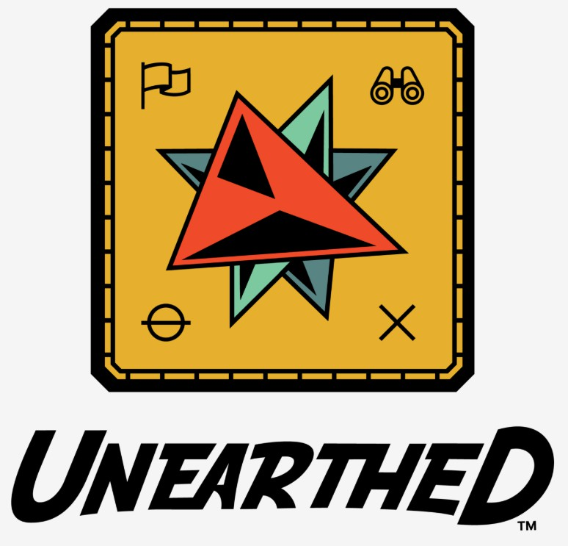
Join us in cheering on the Platte County 4-H Challenge & Explore teams competing at the First Lego League Challenge Championship on March 20 & 21 at UNL Cook Pavilion and Coliseum.
Ready….Set….Lego!!!

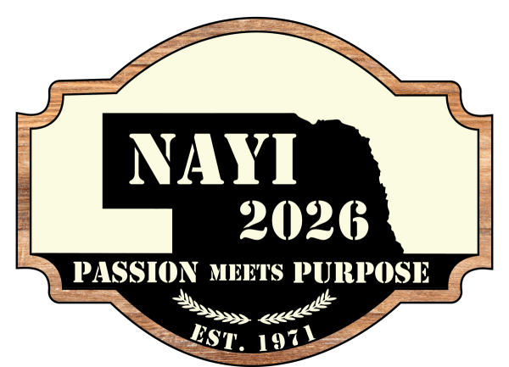
NDA OPENS APPLICATION PROCESS FOR 2026 NEBRASKA AG YOUTH INSTITUTE
The Nebraska Department of Agriculture (NDA) is currently accepting applications from high school juniors and seniors for the Nebraska Agricultural Youth Institute (NAYI). NAYI is one of Nebraska’s largest agriculture youth outreach events. This five-day program brings students together, offering networking opportunities with ag leaders and a chance to learn more about the industry, discover careers and make new friends. NDA helps sponsor and coordinate NAYI every year. This year’s theme is “Passion Meets Purpose.”
NAYI will be held at the University of Nebraska-Lincoln’s East Campus July 6–10, 2026. Current high school juniors and seniors interested in attending must apply online at www.nda.nebraska.gov/nayi. All applications must be submitted by April 15, 2026.
“NAYI is a long-standing tradition in Nebraska agriculture and a one-of-a-kind opportunity for high school students to connect with peers from around the state,” said NDA Director Sherry Vinton. “It is one of the best ways for students to learn more about Nebraska’s diverse agricultural industry and the hard-working people who help make our ag industry great.”
NAYI features motivational speakers, discussions on agricultural issues, career development, networking opportunities, leadership activities, a farm management game, a formal banquet and awards presentation, and a dance. In its 55th year, NAYI is the longest running agricultural youth program of its kind in the nation.
More than 225 students attended NAYI last year.
NDA selects students to attend NAYI based on their leadership skills, interests and involvement in agriculture. Students attend NAYI free of charge due to generous donations from agricultural businesses, commodity groups and industry organizations. Space is limited. Those interested in helping sponsoring NAYI can visit https://nda.nebraska.gov/NAYIsponsors for more information.
NAYI is coordinated by the Nebraska Agricultural Youth Council, which is comprised of 21 college-aged students selected by NDA for their passion and interest in the ag industry. The Council’s purpose is to provide young Nebraskans with a better understanding of agriculture, including agricultural opportunities available to today’s youth.
PLATTE RIVER ART SHOW SEEKING YOUTH ARTISTS
4-H youth artists are invited to exhibit their work at the Platte River Art Show! Meet amazing artists and view their work! The artwork created ranges from photography to mix media, paintings, jewelry, glass, woodwork, handcrafted artwork, and sculptures.
The show will be held April 24-26, 2026, at Mahoney State Park near Ashland, NE, and will run on Friday from 6-9pm, Saturday, from 10am – 7pm, and Sunday from 10am – 4pm.
Tables, chairs, and electricity will be provided at no cost to youth artists.
For more information about the opportunity, contact Nebraska 4-H alum Nia Karmann at nyestreetstudio@gmail.com or at 308-391-0406.
More details at: https://www.facebook.com/people/Platte-River-Art-Show/100083554623192/


SPECIAL OFFER FROM THE LIED CENTER FOR NEBRASKA 4-H
The Lied Center for Performing Arts invites Nebraska 4-H to attend the performance of Music Man, to be held March 5-8, 2026, with a
special offer of 20% off tickets.
Tickets can be purchased at https://tickets.liedcenter.org/events/3641?promo=4H 20; use promo code 4H20.
More information about the Music Man performance can be seen at https://www.liedcenter.org/event/meredith-willsons-music-man.

BULLSEYE ARCHERY CLUB PRACTICE DATES


Thursday, March 12
Thursday, March 26
Thursday, April 9
Thursday, April 23
Time: 7 – 8:30 PM

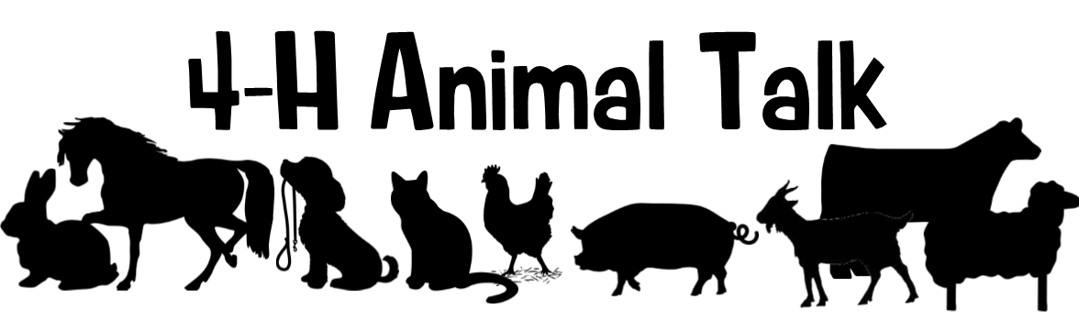
YQCA: If 4-H youth are planning on exhibiting beef cattle, dairy cattle, swine, sheep, goats, poultry, or rabbits, they must complete a Youth for the Quality Care of Animals (YQCA) training again this year! Blake Wert will be offering Instructor-Led Trainings at the Platte County Extension Office. The deadline for youth to complete YQCA is Friday, May 29.
Registering for quality assurance will be done online through the YQCA website (yqcaprogram.org) using the Family 4-H Online login for active youth. If you are involved in both 4-H and FFA, please register through the 4-H login. The cost for instructor led training sessions are $3, while online trainings are $12. Payment is made online at the time of registration. Youth must register before attending an in-person session. These instructor led trainings will last approximately one hour, and the following dates have been set.
Friday, March 13 10:00 – 11:00 a.m.
Monday, April 20 6:00 – 7:00 p.m.
Monday, May 11 7:30 – 8:30 p.m.
Friday, May 22 3:00 – 4:00 p.m.

Ordering Broilers: All broilers shown at the Platte County Fair must be ordered through the Platte County Extension Office. Pickup will take place 6 weeks prior to fair. Broilers cost $2.80/bird or if you order 100 birds or more, cost is $2.75/bird. The broiler order deadline is March 27 and payment must accompany order.
Nebraska State Fair Livestock Nominations: Show Stock Manager is open for livestock nominations for the 2026 Nebraska State Fair! Website Link: www.showstockmgr.com. All livestock in contention to exhibit at the Nebraska State Fair will be required to complete an online nomination, with payment through Show Stock Manager and submit a DNA collector envelope with a hair sample. This includes all 4-H and FFA breeding livestock, market livestock, and feeder calves. State fair EID tags and DNA envelopes are available at the Extension Office. The deadline for ALL online nominations is Monday, June 15, 2026.
If you have any questions on how to submit your online nominations, you can review the 2026 Step-by-Step Nomination Instructions.pdf document.
Important Nebraska State Fair Livestock Update: Exhibitors that want to show an animal at the NSF and Aksarben Stock Show (AKSS) will be required to submit two separate envelopes and online nominations. AKKS exhibitors will be ordering and purchasing their DNA envelopes through the AKKS website – https://www.aksarbenstockshow.com/. The DNA process and the online nomination process will be separate for each livestock show! * Direct all AKSS questions to the AKSS website! *
Nebraska 4-H Livestock Achievement Program: This program provides an additional opportunity for enrolled 4-H livestock project youth to strengthen their knowledge and leadership skills across all aspects of livestock projects, including selection, production, leadership, and exhibition. The program recognizes Members of Excellence in the following livestock project areas: beef, sheep, meat goat, swine, dairy cattle, dairy goat, rabbit, and poultry. Youth who complete the program and earn Member of Excellence recognition will be recognized during the Grand Drive during the 4-H weekend at the Nebraska State Fair. Applications are due June 15 and Plan and Project Records are due August 1. For more information and to apply, visit https://go.unl.edu/lap

ATTENTION LIVESTOCK JUDGING ENTHUSIASTS
We are excited to announce that Platte County is a part of the Heartland Triple Crown Livestock Judging Series. Get ready for an unforgettable three-day livestock judging experience! The Heartland Triple Crown Livestock Judging Series is coming June 17–19, 2026, bringing together youth from across the region for competition, learning, and celebration as the Great Plains Judging Circuit wraps up its season. This three-day event is open to all states.
Participants will take part in 10 placing classes, enjoy a clinic, and compete for awards in each age division and species. With events hosted in Columbus, Bladen, and Nelson, Nebraska, each day offers something unique—plus fun evening activities, including a BBQ after-party and a ﬁnal banquet and awards ceremony.

Whether you're a seasoned judge or new to the arena, this is the perfect opportunity to sharpen your skills, meet
fellow competitors, and close out the circuit in style.

� June 17–19, 2026
�•� Columbus • Bladen • Nelson, Nebraska
� Registration details available at: https://go.unl.edu/lj26
Join us for three exciting days of livestock evaluation, learning, and community. We can’t wait to see you there! More details to come for each day.

PASE: The Nebraska 4-H Premier Animal Science Event (PASE) features a variety of state level animal science contests. Youth have the opportunity to participate in livestock contests that do not require owning or exhibiting a live animal, including livestock, meat, poultry, companion animal, and animal welfare judging, as well as livestock skill-a-thon and livestock quiz bowl. Youth can participate in more than one contest or event as their schedule allows.
If you are interested in competing at PASE, please ﬁll out this Google Form – https://go.unl.edu/t9cb or scan the QR code below. Livestock Judging and Skill-a-thon practices will begin end of April with most practices being in the evenings. Please sign up by April 3rd to give 4-H Staff time to prepare the materials. Those interested would practice at the Extension Office and would compete on May 27-29 in Lincoln. For more information about the contests, go to Premier Animal Science Event Contests | Nebraska 4-H | Nebraska. Any questions, feel free to reach out to Blake!


Dates to Remember:
March 7 UNL Poultry Extension Chick Days in Lincoln
March 13 YQCA Training at Platte County Extension Office @ 10:00am March 27 Broiler order deadline for County Fair
April 20 YQCA Training at Platte County Extension Office @ 6:00pm

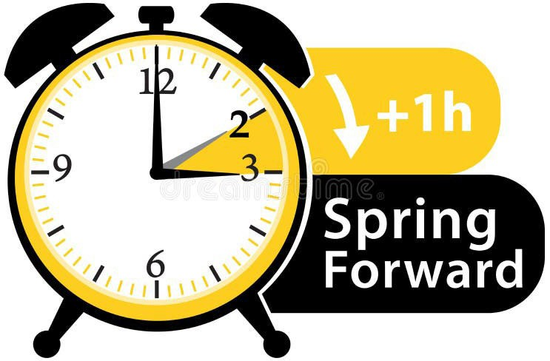

Day Light Savings Time Begins
Sunday, March 8

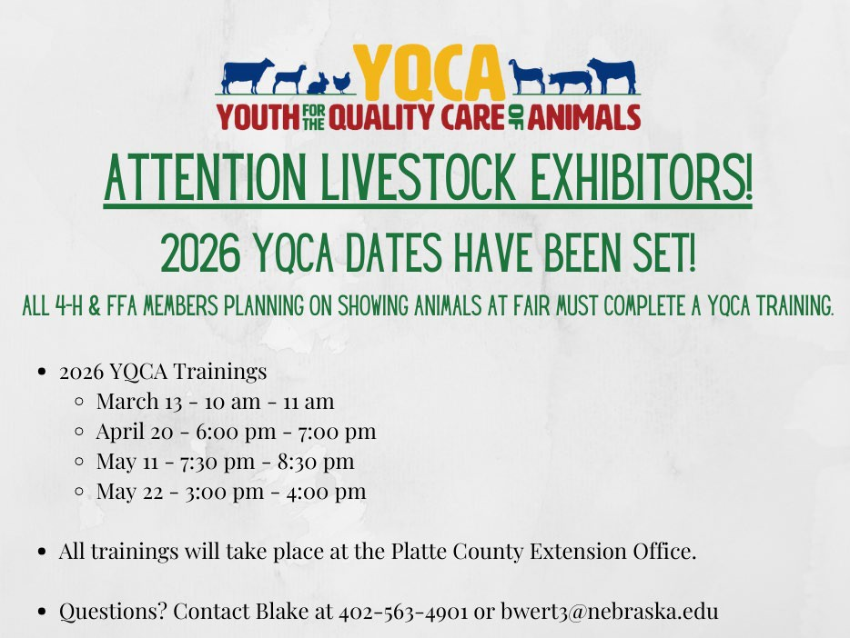
Computer Science Summer Camp July 19-August 1, 2026

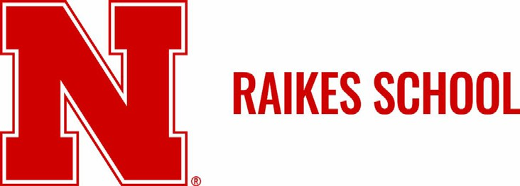
The Jeffrey S. Raikes School of Computer Science and Management at the University of Nebraska–Lincoln is now accepting applications for a summer learning opportunity for high school students. The Raikes School is hosting its tenth year of “Innovate: The Raikes School Way,” led by Raikes School Faculty Members Dr. Steve Cooper and Dr. Seth Polsley. The summer camp was highlighted by Forbes in 2019 and continues to provide high-quality computer science education to interested students!
During the two-week, overnight camp students will:
- Develop core programming skills and learn innovation concepts through a project-oriented curriculum
- Receive instruction from Raikes School faculty members and experience what classes can be like in the Raikes School
- Visit campus research labs and local employer partners
- Interact with Raikes School students and staff, all of whom play a key role in the competitive selection process to our program each year
Key Details:
- Innovate: The Raikes School Way is a great opportunity for high school students, with priority given to students in the high school graduating class of 2027.
- The camp serves students with little to no experience in computing, as well as those looking to enhance their existing computer science skills.
- Students in the graduating class of 2028 will be accepted on a space-available basis.
- The camp will be held at the Kauffman Academic Residential Center, home of the Raikes School, in the heart of Nebraska's City Campus from July 19-August 1, 2026.
- The fee to participate is $3,000. Students attending a Nebraska high school will receive a $1,000 discount, lowering the cost to $2,000 for Nebraska high school students. The cost covers all housing, meals, instruction, and activities associated with the camp.
- Full and partial scholarships are available - students can apply for scholarships through the Summer Camp application.
Priority Application Deadline: April 1, 2026 - Students who submit their application by this priority date will be notified of admission & scholarship decisions by April 13, 2026.
Final Application Deadline: May 1, 2026 - Applications will be accepted on a rolling basis after May 1 as space is available.
Interested students can find more details and complete the application at https://raikes.unl.edu/summer-
camp/.
If you have any questions about the camp, please email me at tluensmann2@unl.edu.




2026 Clover Academy
All summer 4-H programs are open to all youth regardless of 4-H membership. To enroll in a class, use the Sign-Up Genius link first (for each individual youth), then complete the attached registration form and return it to the Extension Office with registration payment. Classes will be filled on a first-come basis with paid registration fees and may be canceled in case of low registration. No refunds after the registration deadline or if participants do not attend workshops. Any questions, please contact the Nebraska Extension-Platte County Office at (402) 563-4901.

Workshop Title | Workshop Description
Crayons Gone Wild: Crayon Melting | Tuesday, June 9th  9:30 am - 11:30 am @ Platte County Extension Office (2715 13th St)  Ages: 8+ / Max: 15 youth  Cost: $15.00 County Fair Class: Home Design and Restoration (Middle Unit) C 257 13 Get ready to turn ordinary crayons into extraordinary works of art! In this hands-on 4-H workshop, youth will explore creativity and basic science by melting crayons to create colorful, one-of-a-kind  masterpieces. Participants will learn how heat changes solids into liquids, experiment with color blending, and discover different techniques for designing vibrant melted crayon art.
Piece by Piece: Mosaic Coasters | Tuesday, June 9th  1:30 pm – 3:30 pm @ Platte County Extension Office (2715 13th St.)  Ages: 8+ / Max: 15 youth  Cost: $15.00 County Fair Class: Home Design & Restoration (Middle Unit) C 257 16 Discover how small pieces can come together to create something beautiful! In this hands-on 4-H workshop, youth will design and create their own unique mosaic coasters using colorful tiles, glass,  or other decorative materials. Participants will learn basic mosaic techniques, including pattern planning, arranging pieces, and grouting to complete their finished project.
Bright Blooms: Floral Suncatchers & Jean Pocket Floral Frames | Wednesday, June 10th  9:00 am – 11:30 am @ Platte County Extension Office (2715 13th St.)  Ages: 8+ / Max: 15 youth  Cost $10.00 Sun Catcher County Fair Class: Home Design and Restoration C 257 12  Jean Pocket Floral Frame County Fair Class: Home Design and Restoration C 257 14 Let your creativity bloom in this hands-on 4-H workshop! Participants will design and create beautiful floral suncatchers that sparkle in the sunlight, as well as unique jean pocket floral frames that turn recycled denim into charming works of art. Youth will explore color, texture, and composition while  learning simple crafting techniques to preserve and display their floral designs.
From Crust to Filling:  Pie Making Everything but the Baking | Wednesday, June 10  1:30 pm – 3:30 pm @ Platte County Extension Office (2715 13th St.)  Ages: 12+ / Max: 10 youth  Cost: $25.00 County Fair Class: Food and Nutrition (Cooking 401) E 412 1  Taught by Gretta Kinnison 4-H Intern  In this hands-on workshop, youth will learn the fundamentals of pie preparation, including how to make and roll out a flaky crust, prepare delicious fillings, and assemble a beautiful pie. Participants will gain practical kitchen skills, food safety knowledge, and confidence in measuring, mixing, and assembling ingredients. While we won’t bake the pies during the session, youth will leave ready  to bake their creations at home!

Clover Kid College | Thursday, June 11  9:30 am – 11:30 am @ Platte County Extension Office (2715 13th St)  Ages: 5 – 8 / Max: 20 youth Cost: $10.00  A flyer will be handed out day of for County Fair Classes  Your clover kid will spend the morning creating three different projects that will be eligible for fair. This workshop is taught by our Jr. Leaders with Extension staff.
Desert Bloom Builders: Cactus Garden | Thursday, June 11  1:00 pm – 3:00 pm @ Platte County Extension Office (2715 13th St)  Ages: 8+ / Max: 20 youth  Cost: $17.00 County Fair Class: House Plants G 770 65  Taught by Horticulture Educator Taylor Cammack and Platte County Master Gardeners  Start your very own desert oasis in this hands-on 4-H workshop! Youth will explore fascinating desert environments and learn about some of the world’s most drought-tolerant plants, including cactus and succulents. Participants will discover how desert-adapted plants survive in dry climates, learn about their unique environmental adaptations, and practice creative design techniques. Each youth will design and build their own miniature desert garden, carefully arranging and labeling their plants. At the end of the workshop, participants will take home their personalized desert garden along with a helpful care guide for youth and parents to ensure their desert creation thrives.  Materials needed: 12” or less diameter container for planting. Drainage holes are not required. Decorative embellishments: stones, wood, shells, marbles, etc., not required for workshop.
Showmanship Clinic | Saturday, June 13  Ag Park Arena and Green Barn 822 15th St, Columbus, NE 68601  Open to 4-H members ages 8-18 in Platte and surrounding counties. Cost $5.00  Plan to attend one or more sessions of this hands-on, multi-species clinic to learn how to show or gain tips to help improve the showing of your animal at the county fair and beyond!  For questions, please contact: Platte County Extension Office:  402-563-4901 Blake Wert: bwert3@unl.edu

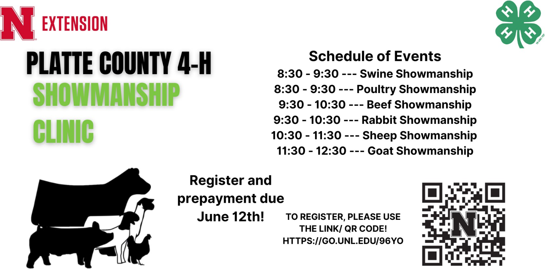

4-H Clover Academy Registration Form (one form per family) – Deadline May 15
� Registration Process:
- Scan the QR Code to access the Platte County 4-H Sign Up Genius registration form for Clover Academy.
- Register each youth individually using the form.
- Scan the Showmanship Clinic QR Code to access the Showmanship Clinic registration form.

- Submit payment immediately after registration by mailing or dropping it off at the Platte County Extension Office, 2715 13th Street. Columbus, NE 68601

Scan Code to Register:

🗓🗓 Registration Timeline:
  - April 1 – May 15: Registration is OPEN.
  - April 1: Registration opens exclusively for enrolled 4-H youth.
  - May 1: Registration opens to non-4-H youth, as space allows.
  - June 12: Registration closes for showmanship clinic.

� Payment Info: (Cash or Check only, no cards)
  - Make checks payable to: Nebraska Extension – Platte County
  - Payment is required to secure your spot—don’t delay!

Please remit this section with the payment for Clover Academy Workshops

Participant Name Age Participant Name Age Participant Name Age Participant Name Age Participant Name Age Participant Name Age
Parent Name Phone Email
Mark workshops you will be attending:
Workshop | Price | # Youth | Total $
Crayon Melting | $15.00
Mosaic | $15.00
Suncatcher/ Jean Floral | $10.00
Pie Making | $25.00
Clover Kid College | $10.00
Cactus Garden | $17.00
Showmanship Clinic | $ 5.00

Workshop Total Due: $

Parent/Guardian Signature
By signing this, you permit to use your child’s name/photography in publications, advertisements, 4-H webpage, Facebook,
or news articles about 4-H activities.

Return this form and registration fee by Thursday, May 15th to: Nebraska Extension – Platte County, 2715 13th Street, Columbus NE 68601-4916

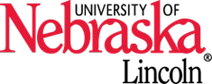
Nebraska Extension is a Division of the Institute of Agriculture and Natural Resources at the University of Nebraska–Lincoln cooperating with the Counties and the United Sates Department of Agriculture.
Nebraska Extension educational programs abide with the nondiscrimination policies of the University of Nebraska–Lincoln and the United States Department of Agriculture. 2026


-  om1nun1•
►
•

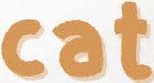
IOh

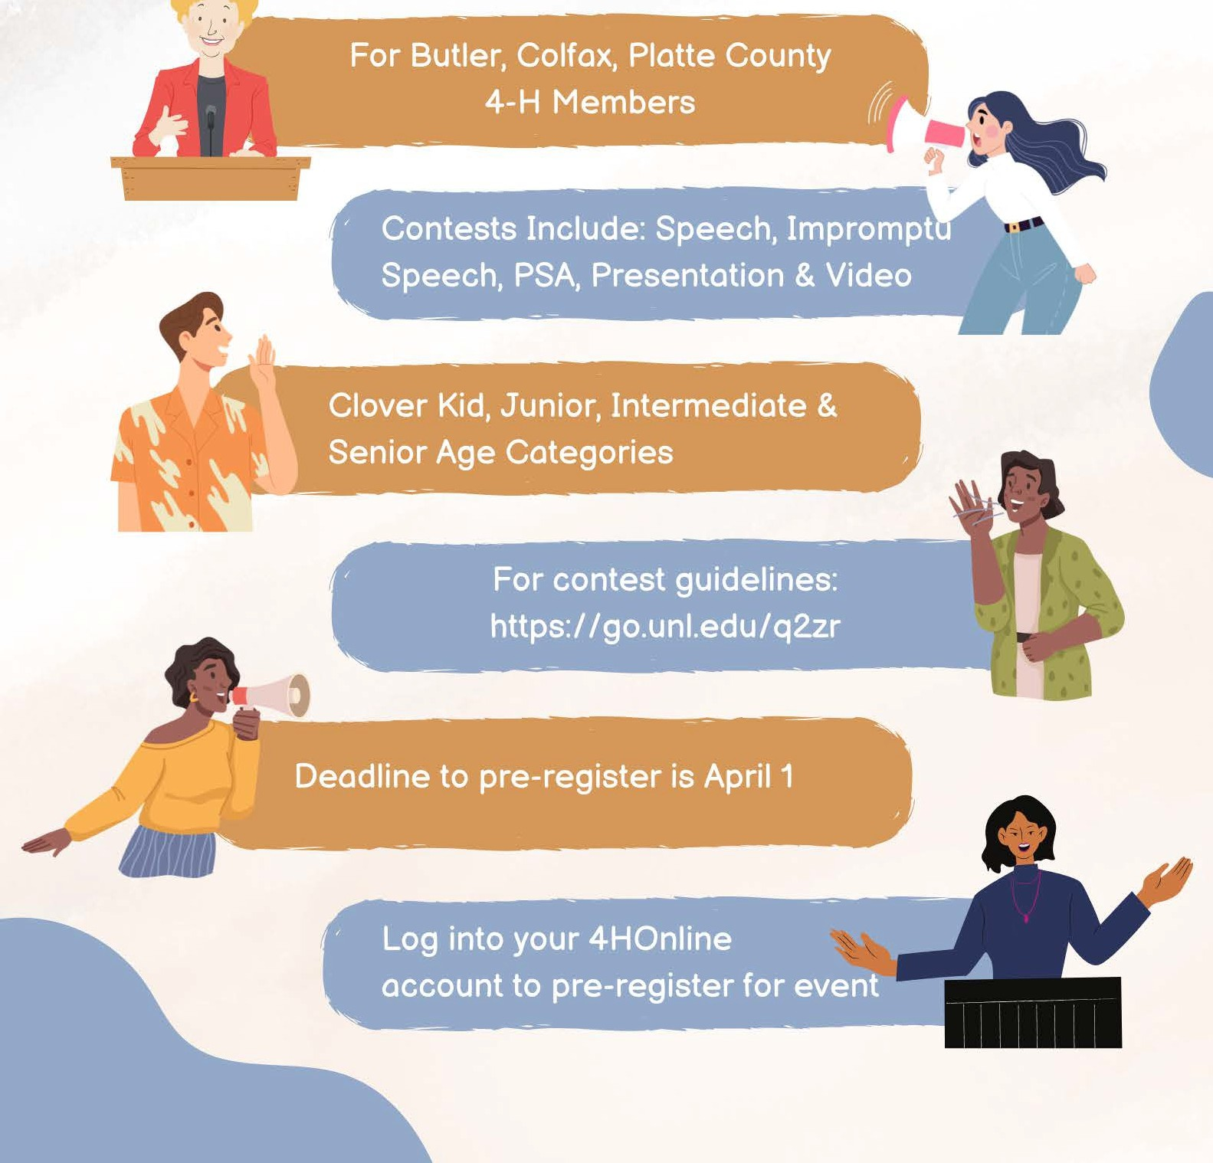
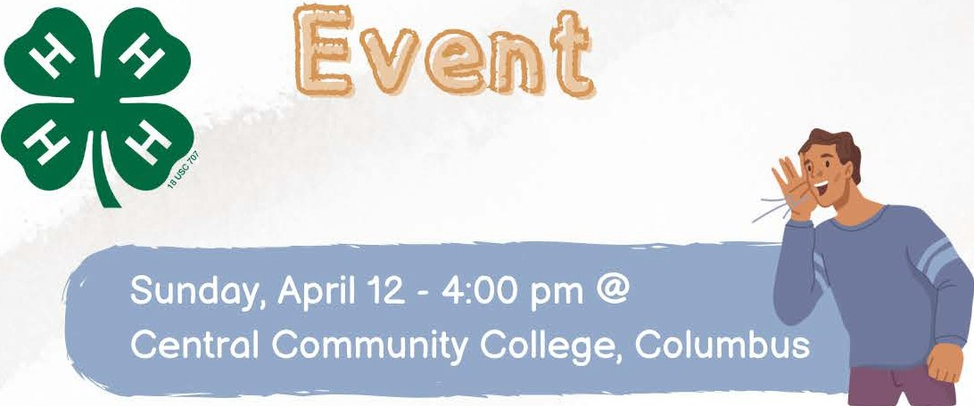

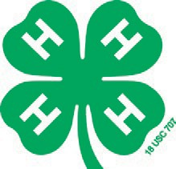
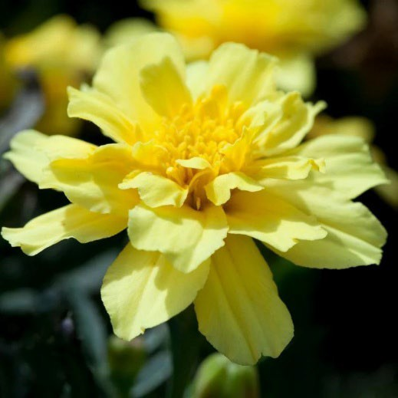
2026 Special Garden Project – Alumia Vanilla Cream Marigold
Tagetes patula ‘Alumia Vanilla Cream’
- Grow a marigold that produces creamy, yellow
ﬂowers on compact plants with a long bloom time
- Learn about growing & using Marigolds
- Enter an exhibit/s at County Fair

This project is open to all youth of 4-H and it provide them the opportunity to learn about growing, harvesting, and exhibiting this unique �lower. The Special Garden Project lets 4-H members try their hands at growing unusual vegetables, �lowers, and herbs. The project allows experienced 4-H gardeners to grow something fun, new, or different while letting those new to gardening get their feet wet in this project area.
$3.00 per Family –Clip and return form below with payment by April 15th to receive seeds! Also must enroll in Horticulture project in 4HOnline.
4-H’ers enrolled in the Special Garden Project will:
  - Receive a packet of Alumia Vanilla Cream Marigold seed (one packet per family) in late April/early May.
  - Receive a newsletter about:
    - Planting and growing marigolds
    - Marigold problems and insects, and harvesting and exhibiting at fair
  - Be able to enter the marigold or related exhibits at the County Fair (Classes G-775-001 to G775-002)
  - At the project or season-end, complete an evaluation
2026 Special Garden Project Fee
I have enrolled in this project online and I’m enclosing my $3.00 fee with this form to cover the cost of seed and mailing of seed/newsletter.
Make checks payable to: University of Nebraska-Lincoln
Mail form and payment to “Special Garden Project” Nebraska Extension – Platte County, 2715 13th Street,
Columbus, NE 68601 by April 15, 2026 deadline.

Name/s:

Address: Email:

Nebraska Extension is a Division of the Institute of Agriculture and Natural Resources at the University of Nebraska–Lincoln cooperating with the Counties and the United Sates Department of Agriculture.
Nebraska Extension educational programs abide with the nondiscrimination policies of the University of Nebraska–Lincoln and the United States Department of Agriculture.

© 2026

Stars Stripes and Campfire Nights




JR. -H A P
••••••••••••••••••••••••••
J-5,


JUNE 2026


EXTENSION
•••

VHISPERING CEDARS N I GENOA NE
••••••••••••••••••••••••
Camp begins at 1 p.m.on June 3rd and Ends at 11:30 a.m. on June 5th, 2026.


2026 FeeSchedule
Now until May1st@ 4pm Early Bird $110

May 2nd -7th@ 4pm - $135
May 9th - Registration Closed

2026 Refund Schedule Until May1st@ 4pm - 100% May 7th @ 4pm - 50%
May 8th and on no refund
Junior 4-H Camp counties involved are: Polk, Platte, Merrick, Antelope, Hamilton, Boone and Nance.


"Junior" Camp is open to ALL youth, 4-H ages 8-11. 12-year-old campers will be placed on a waiting list if registered and paid. If space allows after the deadline, they will be notified if they can attend.

Final instructions will be sent after all registrations are collected.

QQm.Qlete the on-line form using the link below and turn in the QaY.ment as soon as Qossible.
If fee(§) are not received bY. the deadline, camQer(§)registration will be canceled.


All participants must complete the 4-H Participant Permission and Health Form in their 4hOnline
a,<.
2.0 enrollment. Complete Online Form and Return below form with PAYMENT TO
-N�A�A�TE:ON..:..PL��O':TY�F� - - - - - -

NAfvtE

https:// ga.unl.edu/2Gjrcamp
'
l!.. -l�Il!]
HAVE YOU COMPLETED:

The Google Form?

YES NO

lt..

•·-

4-H Participant Permission and Health Form?

YES NO

$110/$135 Fee Cash Check#
MAKE CHECK PAYABLE TO PLATTE COUNTY 4-H COUNCIL�

- - - - - -.-::.iiiiiiiiiiiii.--=iiiiiiiiio-:.iiiiiiiiiiiiiiiio"-=--,.........--;;-- - - - - - - - -
Extension is a Division of the lnstituteof Agriculture and Natural Resourcesat the University of Nebraska-Lincoln cooperating with the Counties and the United States Department of Agriculture. The 4-H Youth Development programabides with thenondiscrimination on policies of the University of Nebraska-Lincolnand the United StatesDepartment of Agriculture.


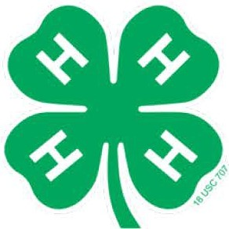
N.EXTENSION

4-H Council Scholarship Application
** Due Wednesday, April 8, 2026 **

Name Age _ Address City Zip _
4-H Club Name Years in 4-H Scholarship(s) Applying For: (please list the camp or event you are requesting money for)
Cost:

PLEASE COMPLETE THE FOLLOWING IN YOUR OWN HANDWRITING.
"Why I want to go to " (50-150 words)

Nebraska Extension is a Division of the Institute of Agriculture and Natural Resources at the University of Nebraska-Lincoln cooperating with the Counties and the United Sates Department of Agriculture.
Nebraska Extension educational programs abide with the nondiscrimination policies of the University of Nebraska-Lincoln and the United States Department of Agriculture.
©2026
N �IVERSITYl<:!,....
eutasM®
Lincoln

N.EXTENSION
List three things you hope to gain from participating.

1.

2.

3.

How do you plan to share your experiences with others?

Have you received a 4-H Council Scholarship in the past?

Yes, I have received a scholarship in the past for (list the camp/event)
and for this amount $

No

Return completed application by the due date to:

Nebraska Extension - Platte County Attn: 4-H Scholarship Committee
2715 13th Street, Columbus, NE 68601-4916

Nebraska Extension is a Division of the Institute of Agriculture and Natural Resources at the University of Nebraska-Lincoln cooperating with the Counties and the United Sates Department of Agriculture.
Nebraska Extension educational programs abide with the nondiscrimination policies of the University of Nebraska-Lincoln and the United States Department of Agriculture.
©2026
N �IVERSITYl<:!,....
eutasM®
Lincoln

