Support Platte County 4-H Youth!
15

JOIN US FOR THE LIVESTOCK SALE SUNDAY, JULY 12, 2026 – 1:00 PM
AG PARK, COLUMBUS - INDOOR ARENA BLDG
Nebraska businesses and communities are the best at supporting 4-H youth. Be a part of your local success story and support youth in the 4-H Livestock Sale during the Platte County Fair.

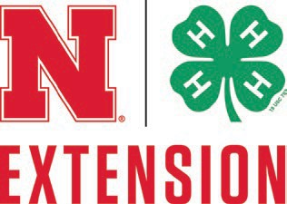
We hope you’ll consider supporting a youth in the livestock sale or donating any amount to our youth livestock support fund.

For more information about the livestock sale or donating, contact Nebraska Extension – Platte County at 402-563-4901.

