4-H Family Newsletter – June/July 2026
Nebraska Extension – Platte County
2715 13th Street, Columbus NE 68601-4916
Phone: 402-563-4901
Website: http://platte.unl.edu
Like Us on Facebook: Nebraska Extension – Platte County

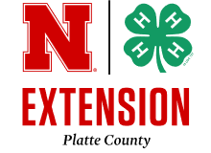

Month Events/Deadlines
June 1
State Horse Show Online Entry
Deadline
June 1
Growing Clovers Club Mtg.
6 pm @ Extension Office
June 1
Jr. Leaders Club Mtg. 7 pm
@ Extension Office
June 3-5
Jr. Camp @ Whispering Cedars
June 13
Platte County Showmanship
Clinic @ Ag Park
June 15
Platte County Fair Online Entry
and Stall Reservation Deadline
June 15
4-H Council Mtg 7:30 pm @
Extension Office
June 17
Heartland Triple Crown
Livestock Judging Series @
Columbus, Ag Park
June 19
Holiday - Office Closed
June 20
Platte County Fair/Wrangler
4-H Club Open Horse Show @
Ag Park
June 22
Pen of 3 Weigh-In 7-8:30 pm
@ Columbus Sale Barn

4-H & FFA ONLINE FAIR ENTRY DEADLINE
MONDAY, JUNE 15

Website for 2026 Platte County Fair online entries is:
https://plattene.fairwire.com/. Instruction sheet enclosed in newsletter.

For all late entries between June 16-18 deadline, late entry fees will be accessed as follows NO EXCEPTIONS:
Large Animal Fee (beef, dairy, sheep, goat, swine) = $50.00 per animal
Small Animal Fee (poultry, rabbit, dog, companion animal) = $25.00
Static Entry Fee = $20.00 per exhibitor
Must contact Extension Office for late entry worksheet.
No entries will be accepted after 5:00 p.m. on Wednesday, June 18th.

Also due on Monday, June 15th –
Stall Reservation form accompanied by payment.

Hay Bale Decorating Contest and Club Booth reservations are due
Friday, June 12th.

THANK YOU NOTE PLANS FOR 2026 PLATTE COUNTY FAIR
Again this year, Platte County 4-H Council is going to provide thank yous for our 4-H’ers to sign at County Fair because we want to make sure every sponsor feels appreciated for their support of our 4-H youth!
Grand and Reserve Winners: Any youth who earns a Grand or Reserve Champion award will also receive a thank you note labeled with the name of the sponsor who funded that award. These thank yous must be filled out and returned to the 4-H Fair Office before premium money is distributed.
Thank You Cards: Inside the 4-H Fair Office, we’ll have a Thank You table with pre-labeled thank you cards for every 4-H Fair sponsor. We ask all 4-H members stop by during the fair and take a moment to sign a few cards. Our goal is to have each sponsor card filled with many signatures, showing our collective gratitude.
We strongly encourage families who already send personal thank you to continue doing so—this new system is simply an added way to make sure every sponsor receives acknowledgment for their support. Together, let’s show our appreciation and help ensure continued support for our 4-H programs!


Nebraska Extension is a Division of the Institute of Agriculture and Natural Resources at the University of Nebraska-Lincoln cooperating with the Counties and United States Department of Agriculture. The 4-H Youth Development program abides with the nondiscrimination policies of the University of Nebraska-Lincoln and the United States Department of Agriculture.
Staff
Blake Wert Taylor Cammack
Hailey Held Beth Jones
Sandra Swanson

Office Hours:
Monday – Friday
8:00 a.m. – 5:00 p.m.

PLANT & INSECT CONTESTS
4-H Plant and Insect Contest Day is June 25 at the Club Room, Ag Park in Columbus. Mark your calendars!
Contests held are Horticulture Judging and ID, Tree ID, Grass and Weed ID and Insect ID. You can participate in one, two or all four. Your choice based on your interests.
For information on contests, contact Taylor at tcammack7@unl.edu. Registration flyer enclosed in this newsletter.

YOUTH ROBOTICS CAMP
Youth of all skill levels are invited to attend the Explore Robotics Camp (ages 5–10) or the Challenge Robotics Camp (ages 8–14) on July 1–2. No prior robotics experience or 4-H membership is required, making this a great opportunity to bring a friend along.
Participants in the Explore Camp will build a robot from scratch while learning basic coding skills. Challenge Camp participants will also build a robot from scratch while working with advanced sensors and more complex coding activities.
See the enclosed flyer for registration details and payment required to reserve your spot.

THAT’S A WRAP POOL PARTY
What better way to celebrate after a hot county fair than a cool pool party.
Join us for a 4-H Wrap Up Pool Party at the Pawnee Plunge on Friday, July 31st, 4-7 pm. Cost $5.00 per person swimming. Cost $3.00 for non-swimmers.
Family members are welcome to join us!
Treats will be available in the party room and gift bags will be given out to all 4-H members attending.
4-H families will be able to purchase an admission ticket at the Extension Office now or during the County Fair at the 4-H Fair Office.
See the enclosed flyer for more information.
FAIR SUPERINTENDENT MEETING
The fair superintendent meeting will be held on Wednesday, June 24 at 8:00 p.m. at the Club Room Ag Park, Columbus. We highly encourage all superintendents to attend the meeting to discuss, make final plans, and assign jobs at the fair.
STATIC ENTRY CARDS
Entry cards will be available for pick up on Tuesday, June 23 at 1:00 p.m. at the Extension Office by club leaders and members of Platte County Independent Club. Cards will move to the 4-H Fair Office at Ag Park (NOT the Extension Office) on Monday, June 29 starting at 8:00 a.m.
Entry cards must be attached to all static exhibits prior to entering exhibits on Monday and Wednesday of County Fair.
4-H O FFICE MOVING TO FAIR OFFICE
The 4-H division of the Extension Office will be moving to the fairgrounds to begin fair preparations on Thursday, June 18.
Starting the morning of Friday, June 19, all 4-H questions can be addressed to the 4-H Fair Office at 402-562-7625.

DON’T FORGET
All 4-H’ers are required to wear the 4-H clover emblem when presenting in front of a judge, whether exhibiting static projects or livestock. Please plan accordingly.
Options with the 4-H Clover Emblem:
- Chevron (4-H Patch) – Can be pinned to clothing. Cost: $2.00
- Armbands – Horse exhibitors are required to wear an armband with proper attire. Cost: $3.00
- 4-H T-Shirt – May be a county t-shirt, club t-shirt, or the free exhibitor t-shirt.
We are hoping to have exhibitor fair t-shirts available for pickup on Monday, July 6. Please stop by the 4-H Fair Office to check availability.
All items are available at the Extension Office or the 4-H Fair Office when open. Please note the office has a limited supply of gray county t-shirts available.
Be sure to check the Platte County Fair Premium Book for additional dress code rules and regulations.

RESOURCES FOR EXHIBITING AT FAIR
There are lots of resources available to families to help them prepare and exhibit at the fair. They are available at https://platte.unl.edu, scroll down and click on “Stars, Stripes, County Fair Nights - Platte County Fair 8-12, 2026”.
Make sure you check out the following for the Platte County Fair:
- How 4-H Clover Kids Participate
- How to Exhibit 4-H Static Exhibits
- How to Exhibit 4-H Livestock Exhibits
- Platte County 4-H Fashion Show Manual
- Modeling/Fashion Show Narration Forms
- Platte County 4-H Favorite Foods Revue Manual (table setting)
- Preparing Cut Flowers
- Selecting and Preparing Vegetables, Herbs and Fruits
- Home Design & Restoration Supporting Information
- Visual Arts Supporting Information
- Clothing Design Data Card
- Crochet & Knitting Data Cards
- Food Preservation Labeling Cards
- Photography Photo Data Tag Template
- Archery Shoot Guidelines

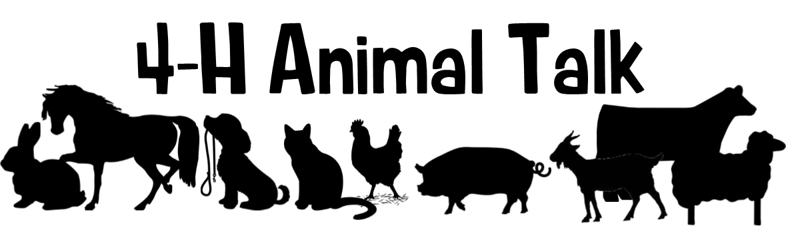

Platte County Showmanship Clinic: Plan to attend this hands-on multi-species clinic on June 13th at Ag Park to learn how to show or to gain tips to help improve the showing of your animal for the county fair and beyond! This clinic is open to any 4-H youth in Platte County and surrounding counties! 4-H'ers are encouraged to bring their own animals, but it is not required! The cost for this clinic is $5/youth. Prepayment is required. Payment can be dropped off at the Extension Office or mailed to us! Preregistration and payment are due June 12th. To register, please fill out this form at: https://go.unl.edu/96yo. The contest flyer is attached to this newsletter and if you have any questions, reach out to Blake!

Heartland Triple Crown Livestock Judging Series: We are getting closer to the inaugural Heartland Triple Crown Livestock Judging Series being held June 17-19! Get ready for an unforgettable three-days worth of livestock judging experience! This event will bring together youth from across the state of Nebraska and surrounding states. Participants will take part in 10 placing classes, enjoy a clinic, and compete for awards in each age division and species. With events hosted in Columbus, June 17; Bladen, June 18; and Nelson, June 19; each day offers something unique—plus fun evening activities, including an after-party and a final banquet and awards ceremony. Whether you're a seasoned judge or new to the arena, this is the perfect opportunity to sharpen your skills, meet fellow competitors, and close out the Great Plains Livestock Judging Circuit in style.
🔗 Registration details available at: https://go.unl.edu/lj26

Nebraska State Fair Livestock Nominations: Show Stock Manager is open for livestock nominations for the 2026 Nebraska State Fair! Website Link: www.showstockmgr.com. All livestock in contention to exhibit at the Nebraska State Fair will be required to complete an online nomination, with payment through Show Stock Manager and submit a DNA collector envelope with a hair sample. This includes all 4-H and FFA breeding livestock, market livestock, and feeder calves. State fair EID tags and DNA envelopes are available at the Extension Office. The deadline for ALL online nominations is Monday, June 15, 2026. DNA Envelopes need to be turned into the Extension Office June 15th by 5:00pm.
If you have any questions on how to submit your online nominations, you can review the 2026 Step-by-Step Nomination Instructions.pdf document.

Important Nebraska State Fair Livestock Update: Exhibitors who want to show an animal at the NSF and Aksarben Stock Show (AKSS) will be required to submit two separate envelopes and online nominations. AKKS exhibitors will be ordering and purchasing their DNA envelopes through the AKKS website – https://www.aksarbenstockshow.com/. The DNA process and the online nomination process will be separate for each livestock show! * Direct all AKSS questions to the AKSS website! *

Pen of 3 Show: The Pen of 3 Show this year is Tuesday, June 23rd at 9 am at the Sale Barn. NOTE: Please contact Blake with how many pens you are bringing by June 15th, so we can line up enough trucks. We will be weighing in cattle on Monday, June 22nd from 7- 8:30 pm. Each exhibitor will need to pick up a form at weigh-in and fill it out to be given to the judge during the show. The form will ask for your pen of three tag numbers, beginning weights, ending weights, rate-of-gain, origin of calves (home-raised or purchased), and any other information the exhibitor wants to share with the judge.

Reminder - To find out about area 4-H livestock events, clinics, and shows, visit the link to our website! https://extension.unl.edu/statewide/platte/4-h/4-hextension-livestock-progress-animal-shows-clinics-judging-contests/

County Fair Reminders:
Animal Exhibitor Handbook- Reference the handbook for new information about 2026 changes, the livestock sale, and more! If you have any questions, contact the Extension Office at 402-563-4901.
Stall Reservation Form – Exhibitors showing Beef, Dairy, Goat, Horse, Poultry, Rabbit, Sheep, and Swine will need to complete a Platte County Fair Stall Reservation Form. All 4-H & FFA animals penned at the fair must be recorded on this sheet so the number of pens/stalls required can be determined. Please read the instructions at the top thoroughly prior to filling out the form. There are no guarantees that you will receive all tack space! The stall form will be due on Monday, June 15 at 5 pm with payment.
Fair Entry Deadline- Fair entry deadline is Monday, June 15th 11:59 PM and is completed online. https://plattene.fairwire.com/. After this deadline, ShoWorks will not be accessible. Late entries will be accepted until June 18th at 5:00 with late fees included. Large animals (beef, dairy, sheep, goat, swine) have late fees of $50/animal. Small Animal (poultry, rabbit, dog, companion animal) fee is $25/animal. Contact Sandra at the Extension Office regarding late entries. After June 18th at 5:00 pm, late entries will NOT be accepted! Get your entries in early! How-to instructions are included in this newsletter.
Showmanship and Record Books- A reminder, exhibitors for all animal areas except small animals, rabbits, and poultry will be required to have record books complete and turned in at the County Fair during check/weigh-in or the exhibitor will be dropped a ribbon placing in showmanship. All livestock exhibitors are expected to participate in at least one or more showmanship contests.
Livestock Sale- The Platte County Fair Livestock Sale is on Sunday, July 12th at 1:00 pm! The sale is terminal. Make sure to withdraw any animal you don’t want harvested! This needs to be done by completing the paperwork at the 4-H Fair office by 1:00 pm on Saturday, July 11. After 1:00 pm, it will cost $100 to withdraw your animal. See the Animal Exhibitor Handbook for more information!
DNA Process for Fair – 4-H Staff will pull DNA samples during the respective market shows for the Grand and Reserve Overall in Sheep, Goat, Beef, and Swine. Reminder: 4-H staff will also be able to pull an additional three random samples per species to be sent for testing.
Bucket Calf Project – Components include: Interview, Record Book, and Show Evaluation. Interview signups are through Sign Up Genius: https://www.signupgenius.com/go/10C0A45ADAA22A0F4C70-62784967-bucket#/ Record books are due at check-in. Show Evaluation will be the last class of beef show.
Round Robin- Only Senior Division Showmanship winners may qualify for the Round Robin Competition. Previous Round Robin winners will not be eligible for Round Robin for the same species in the future. The previous winners will be recognized at the current Round Robin event. If the Grand Champion Showman is ineligible, the Reserve Champion will be selected to participate. Reminder: The Beef Showmanship portion will take place in the Beef ring inside the Indoor Arena for space purposes.
4-H and Clover Kid Obstacle Course: The obstacle course show is Friday, July 10 beginning at 2:00 pm in the green barn with sheep obstacle course. The goat obstacle course will follow sheep before the show transitions over to the indoor arena for the bucket calf obstacle course. To view the obstacle course layouts for Sheep, Goat, and Bucket Calf, visit Animal Record Books, Handbook, and Obstacle Courses | Nebraska Extension in Platte County | Nebraska Extension | Nebraska. The links will be close to the middle of the page when scrolling.
Woodchips: We will continue to provide woodchips for the indoor arena (beef and dairy exhibitors). Sheep, goat, and swine exhibitors will need to bring their own bedding! We will not be providing woodchips for the green barn.
Livestock Manure: Livestock Manure will need to be put INSIDE of the manure bunkers on the south side of the indoor arena/green barn. Staff will be pushing manure in a pile throughout the day. Please ensure the manure is dumped inside the bunkers and not outside of the building. Let’s help make the fairgrounds look clean during the fair and help make cleanup easier for everyone afterward.
Herdsmanship: Poultry and rabbit have been added to Herdsmanship. 4-H Staff will hang stall cards for poultry and rabbit to keep clubs together.
Sick or Injured Animals/Vet Calls – In the event of sick/injured livestock, please call your personal veterinarian. If necessary, have the veterinarian contact 4-H Staff.
Dates to Remember:
June 13th: Platte County Showmanship Clinic- See attached flyer for more information
June 15th: State Fair Market Beef, Goat, Sheep, Swine, and Feeder Calf ID DNA Envelope Deadline. EID Tags and DNA envelopes are available at the Extension Office. EID tags cost $3.34 each for beef and $2.93 each for swine.
June 15th: State Fair online nominations due on https://showstockmgr.com/
June 15th: Stall Reservation Forms DUE!
June 15: County Fair Entry Online Deadline https://plattene.fairwire.com/
June 20th: Platte County Fair/Wrangler 4-H Club Open Horse Show at Ag Park
June 23rd: Pen of 3 Show at Columbus Sales Pavilion
July 11th – 15th : Fonner Park State 4-H Horse Show in Grand Island, Nebraska

Office Closed:
Friday, July 3
Friday, June 19

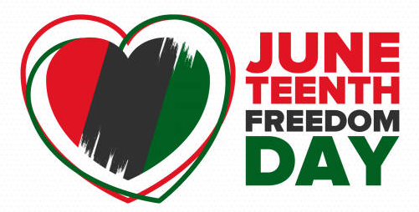
On-line Entry for the Platte County Fair
Entry
Deadline
Monday, July 15

We recommend printing these instructions for use during registration.

If you have questions about rules or the registration process related to departments, divisions, classes, required ID numbers, affidavits, or paperwork, please consult the current year Platte County Fairbook and/or Platte County 4-H Animal Exhibitor Handbook.

If you have lost your password, please click the “Forgot your password?” link on the registration screen. The system will send a message containing your password to the e-mail address you previously provided. If you have any other technical difficulties with the online registration, please call the Platte County Extension Office at 402-563-4901 or email platte-county@unl.edu.

Step 1. Register
To begin registration, go to https://plattene.fairwire.com

Click on Sign In at top right. Choose a login type:

To register one exhibitor, choose Exhibitor. Go To Step 2.

To register multiple exhibitors, choose Quick Group.

Quick Group users only: Quick Groups are useful for families with multiple exhibitors.

To create a Quick Group, enter a username and password for your group. Write them down so that you can log in again later to add exhibitors or entries or to view your registration history. You may choose a Default Club. The default club will automatically appear for each exhibitor and entry on later screens. Please note that as you add exhibitors and entries, you may need to change from the default club if registering both FFA and 4-H exhibits. NOTE: If exhibitor showing both 4-H & FFA, do not create a new registration for both, just change club for each entry.

Now proceed with the instructions below for each exhibitor in your Quick Group. In the future, you may enter the site again with either your Quick Group name and password or the login information for any individual exhibitor in your group.

Step 2. Entries
- Choose a Department for your first entry. Choose a Department name for each entry.
- Then choose a Division for the entry. It may be helpful to consult the fairbook when choosing Divisions.
- Then choose a Class and complete other required boxes.
- You must select a Club for each entry.
- Click the Add Entry to Cart button.
- You may now add another entry:
- Add different entry is for adding another entry in a different Department.
- Add similar entry is an easy way to add another exhibit in the same Department.
Repeat the steps above for each entry. Note that you may add many types of entries without logging off. Remember that if you are using the Quick Groups option, you may need to change from a default club as you add entries.
Once all entries have been completed, click Continue.

Step 3. Review
Review your entries and additional items for accuracy. Before checking out, you may add more entries and save this cart and log in to add more entries later. Note that your cart and login information are not saved until you click Save This Cart. Your exhibits are not registered until you click Check-out.

Quick Group Users: You may now click the button Add Entries for a different Exhibitor. This will take you back to Step 1 in order to create a new exhibitor within your Quick Group. Once you are done entering all group members, you can click Check-out to check out for all of your exhibitors at once. Remember that if you are using the Quick Groups option, you may need to change from the default club as you add entries.

Step 4. Confirm
Type “Yes” in the red dashed box to indicate that you agree with 4-H, FFA and Nebraska State Fair rules and regulations. See the links below for this information. Click Submit.

Review your summary of entries and additional items. You may print and request an e-mail of the receipt. If everything is correct, click Finish.

You may review your previous transactions and view your profile by clicking on your name in the top right hand corner of the page.

Congratulations! You are registered for the Platte County Fair.
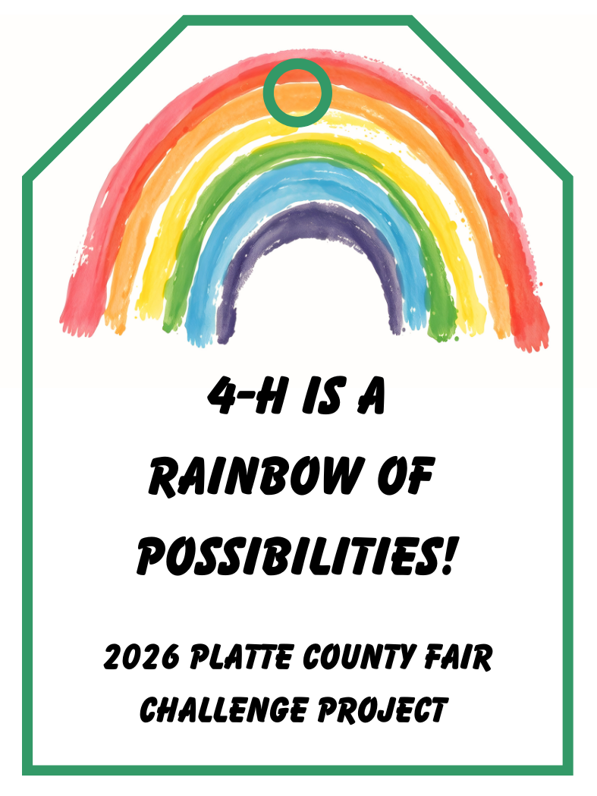

Platte County Fair Challenge Project:
4-H is a Rainbow of Possibilities

Does your 4-H project align with the 2026 Platte County Fair Challenge Project?
If so, be sure to print and attach one of the official Challenge Project tags to your entry, along with your standard fair entry tags.
Please note: Your project must still correspond with a class listed in the fair book. The Challenge Project is an additional opportunity to showcase your creativity within the existing categories.
All Challenge Projects will be featured in a special exhibit booth at the county fair -don’t miss your chance to be part of it!

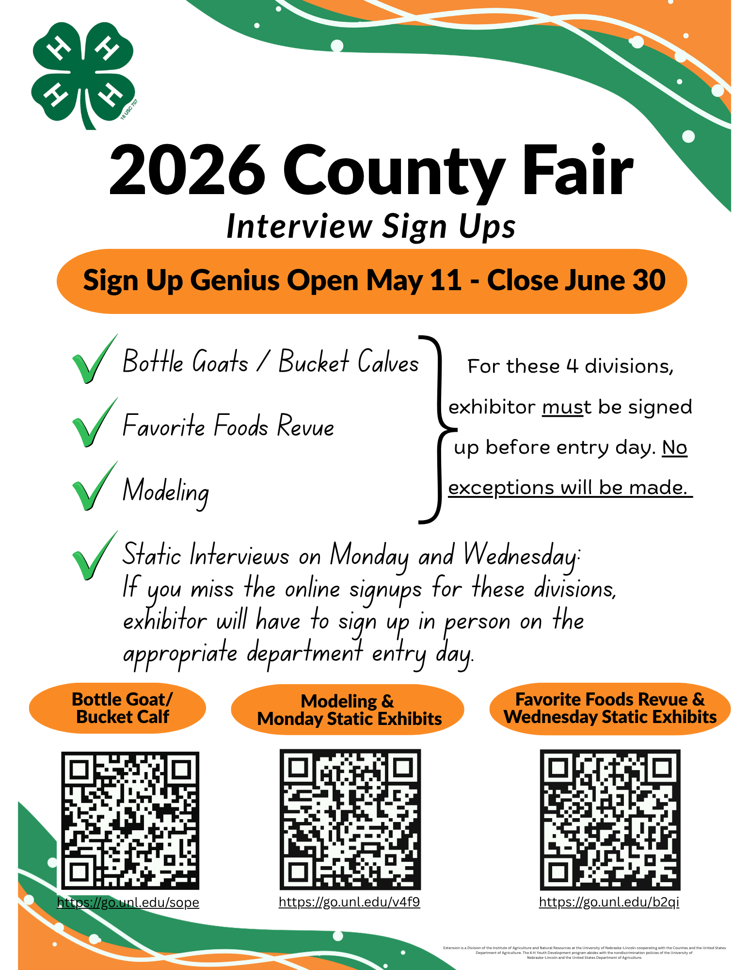

INTERVIEW SIGN UP DIRECTIONS
- Click the link to go to the Platte County Fair SignUpGenius.
If you already have an account, it may automatically sign you in. If not, you do not “have to create an account”, but you can.
From this first page you can ...
  - Click the tabs across the top of the page to find the project area you would like to sign up for interview(s).
  - Click “More sign up groups” box to switch between Monday, Wednesday, and Livestock interview sign ups. Once you find the project area of choice, scroll down to find the time you would like to select for interviews. Click "Sign Up" to sign up for an interview slot for your exhibitor
You will only be able to sign up for one time slot in one project area at a time.
- Once one sign-up (time slot) is selected, click "Save and Continue" to move on to sign-up completion for that projects time slot.
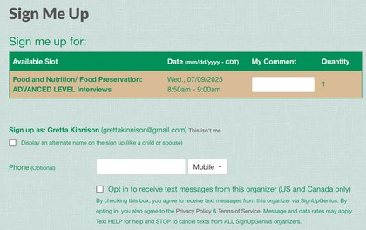
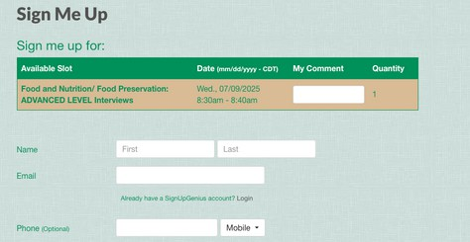
- Review selected sign-up under "Sign me up for:”. (Is this the correct project area and chosen time slot?) Next, if you see this... or this...

Do # 4 Move on to #5
- Continue to “Sign up as: “. Fill this in with your youth exhibitor’s name that will be interviewing. If you are not logged in you may bypass steps 5.
- If you are logged in, continue to "Sign up as: Parent Name" or "Sign up as: Account holder's name". Select the box "Display an alternate name on the sign-up (like a child or spouse)" Fill this in with your youth exhibitors name that will be interviewing.
- Continue to "Sign Up Now" This will complete your sign-up process. You must complete this process for every sign-up area you wish to interview in.
7. If signing up for interviews with more than one exhibitor, fully complete these directions. Then, select "Back to Sign Ups" to complete more interview sign-ups for other exhibitors. Thank you!

COMMON QUESTIONS
- What happens if I don’t have my exhibitor name on the sign-up sheet?
  - If the sign-up is filled with the parent’s name, the sign-up process has been completed incorrectly. You must go back in and fix this.
- How do I sign up multiple exhibitors?
  - If signing up for interviews with more than one exhibitor, fully complete the above directions and steps for one exhibitor for each interview time needed. Then, select "Back to Sign Ups" to complete more interview sign-ups for a different exhibitor following the same steps.
- How do I edit my sign-up?
  - Go to the sign-up sheet with the sign-up you would like to edit. Then click the pencil icon.
- How do I delete a sign-up?
  - Go to the sign-up sheet with the sign-up you would like to delete. Then click the X icon.
- How do I see all my sign-ups?
  - Move to the top right corner, click on your initials, and select “sign-ups.” Then select “invited to”. This should allow you to see a list of your sign-ups.
- What happens if I miss the sign-up period?
  - If the sign-up period is missed you will be able to sign up on entry day. But it will be only open slots that were not filled on SignUpGenius.
- What happens if I realize I signed up for an interview with a project I am unable to complete?
  - If you have an interview time slot but are unable to complete the project, go back into the sign-up sheet and remove your sign-up before June 30th. This allows other exhibitors to fill those time slots.

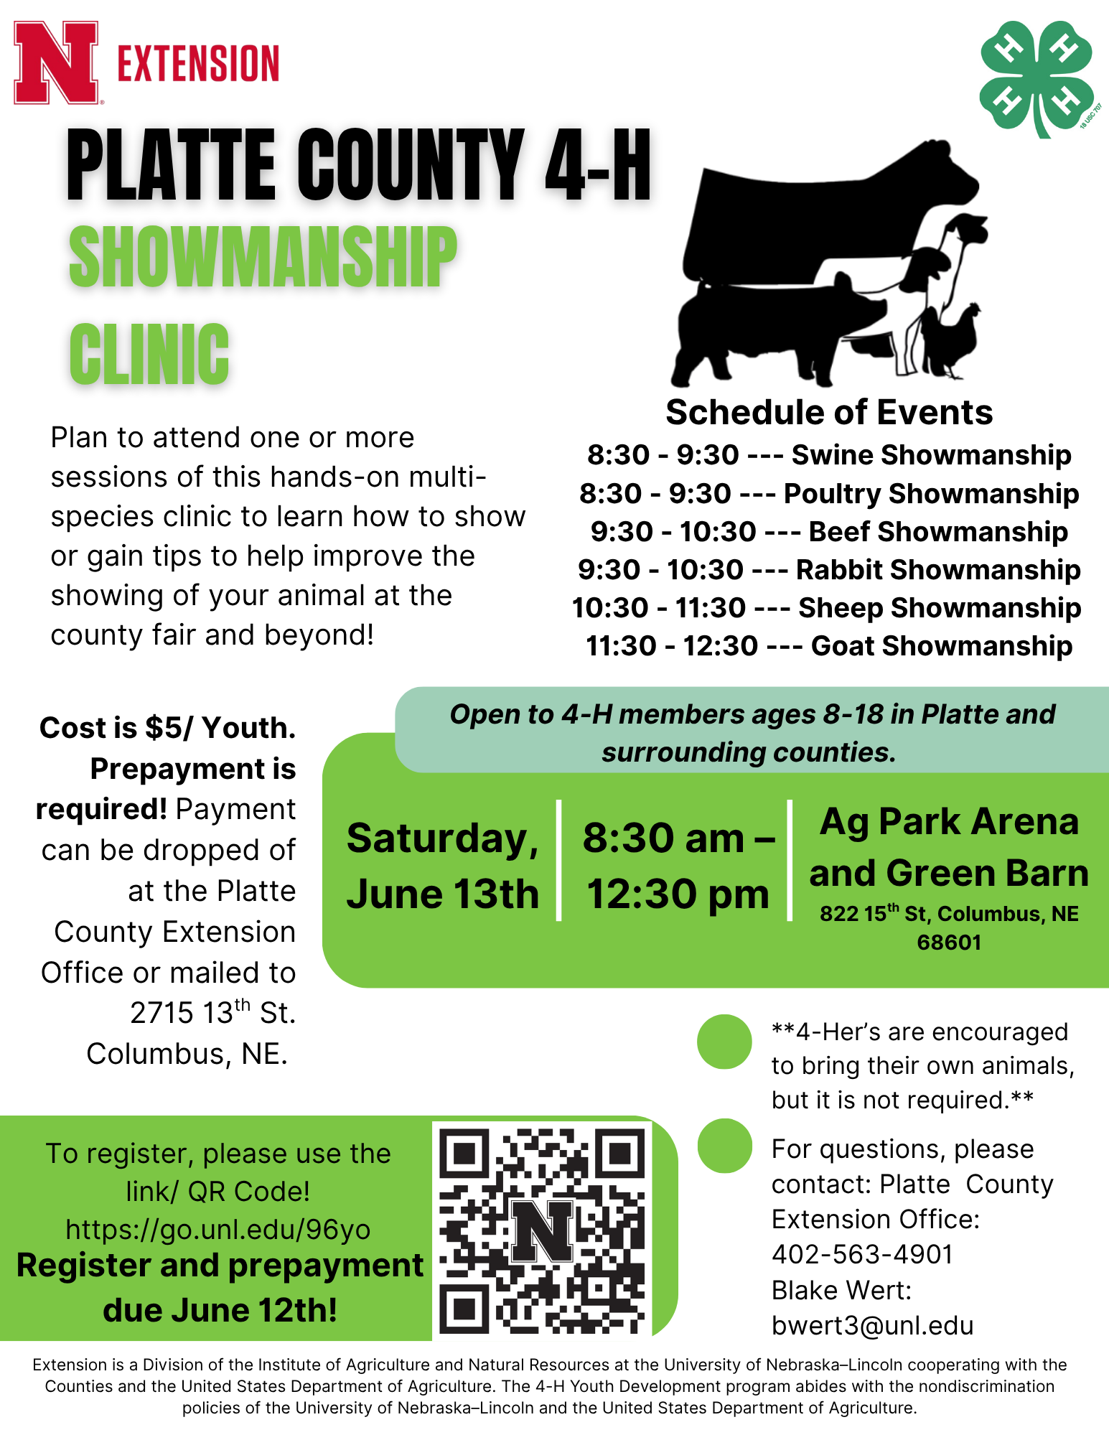
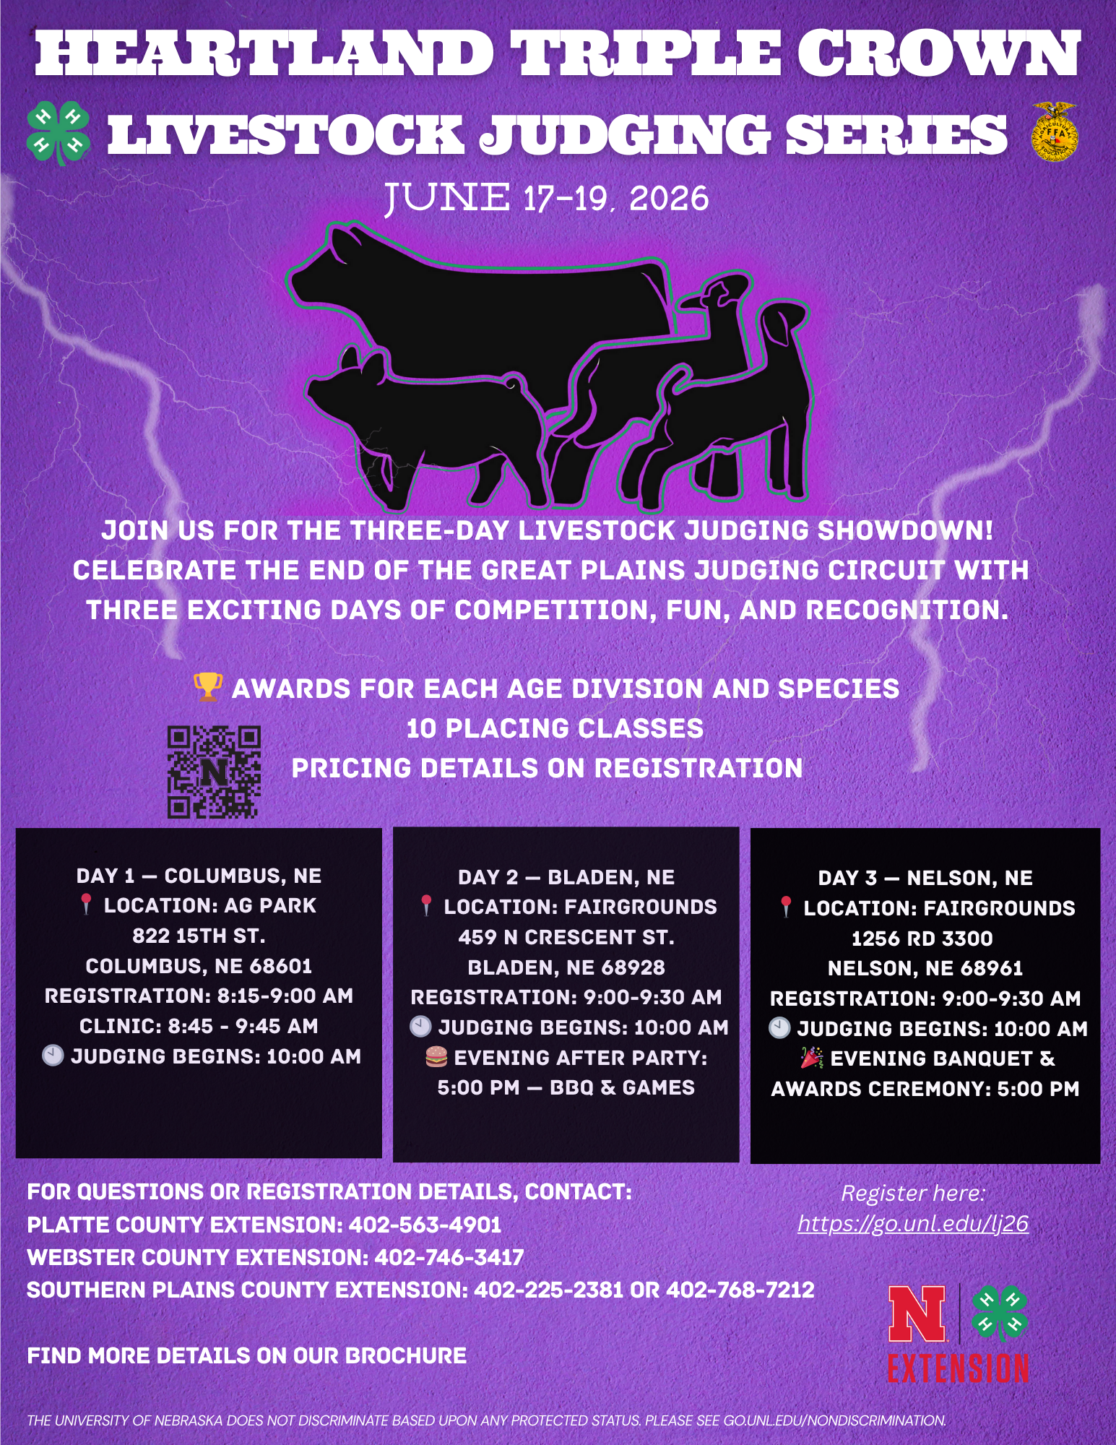
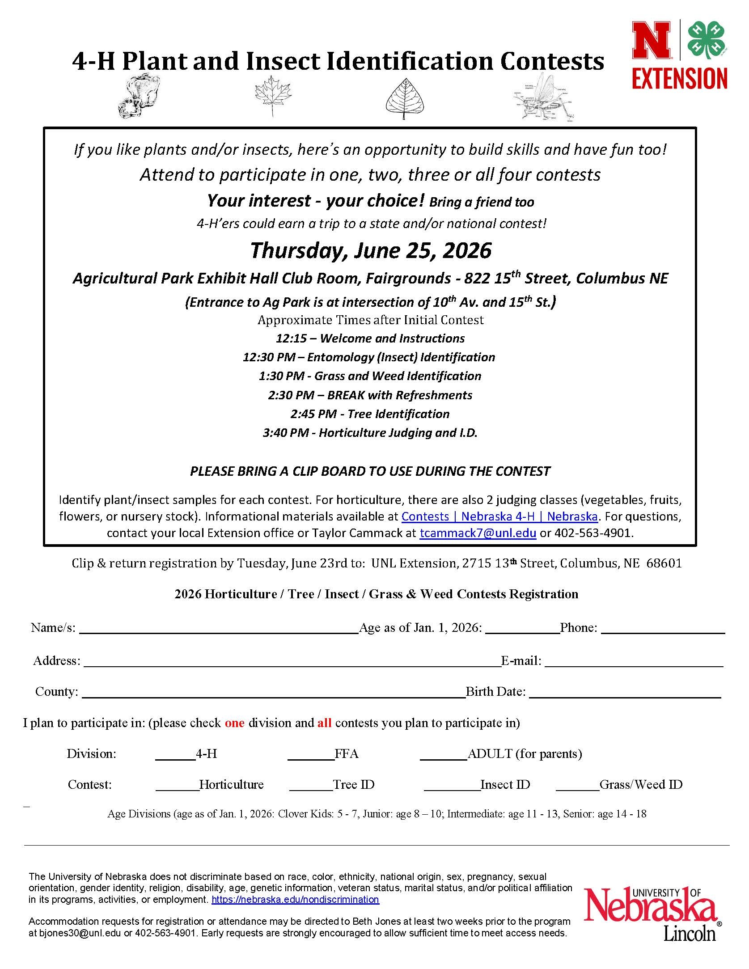
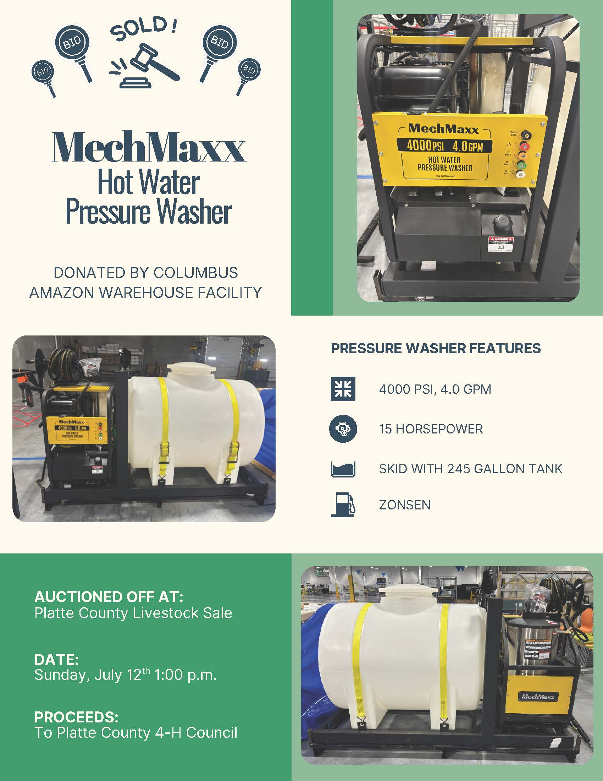
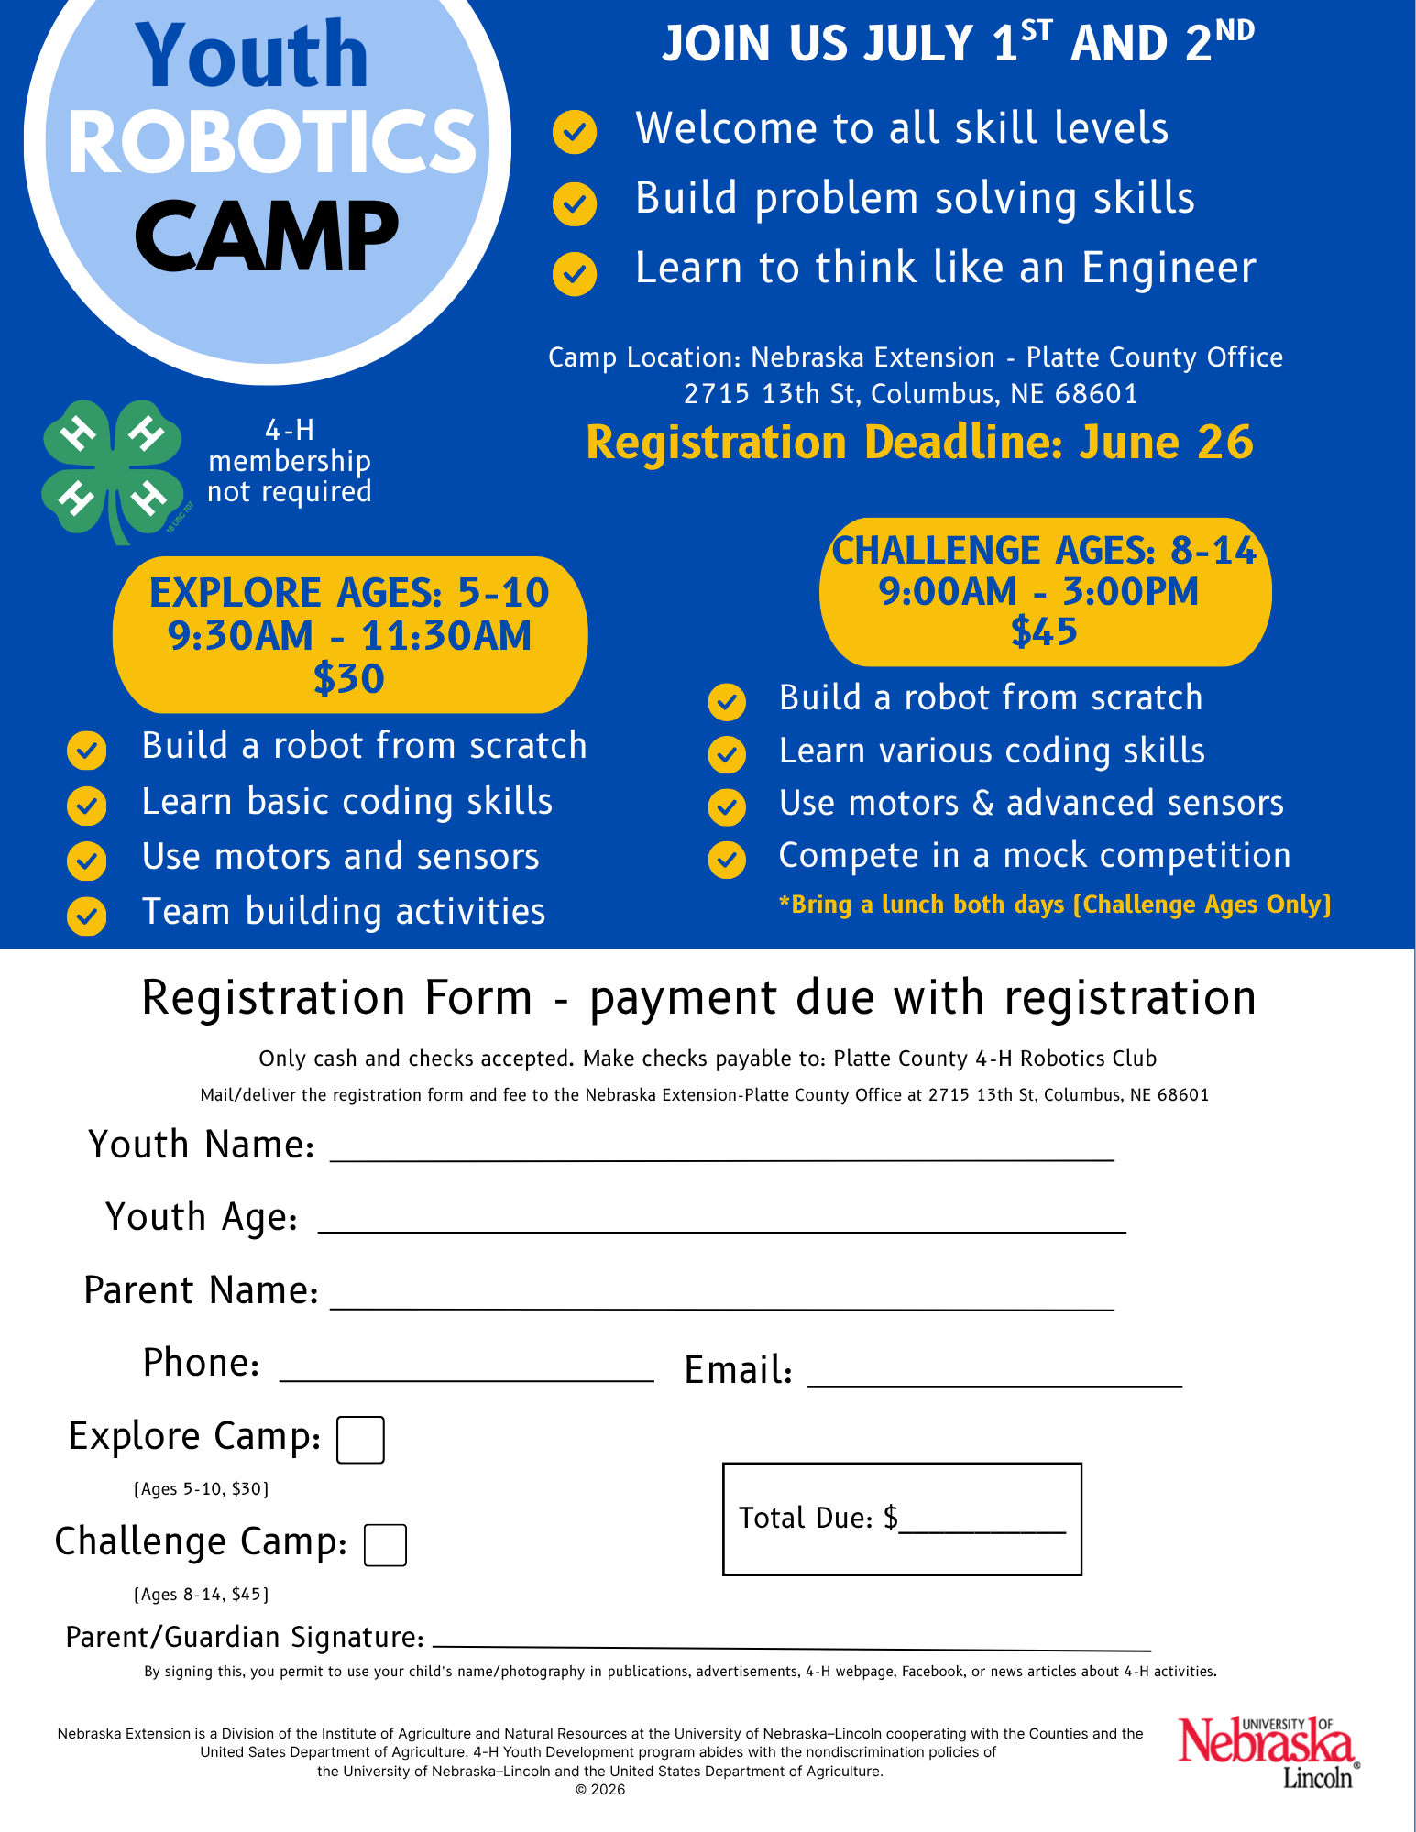
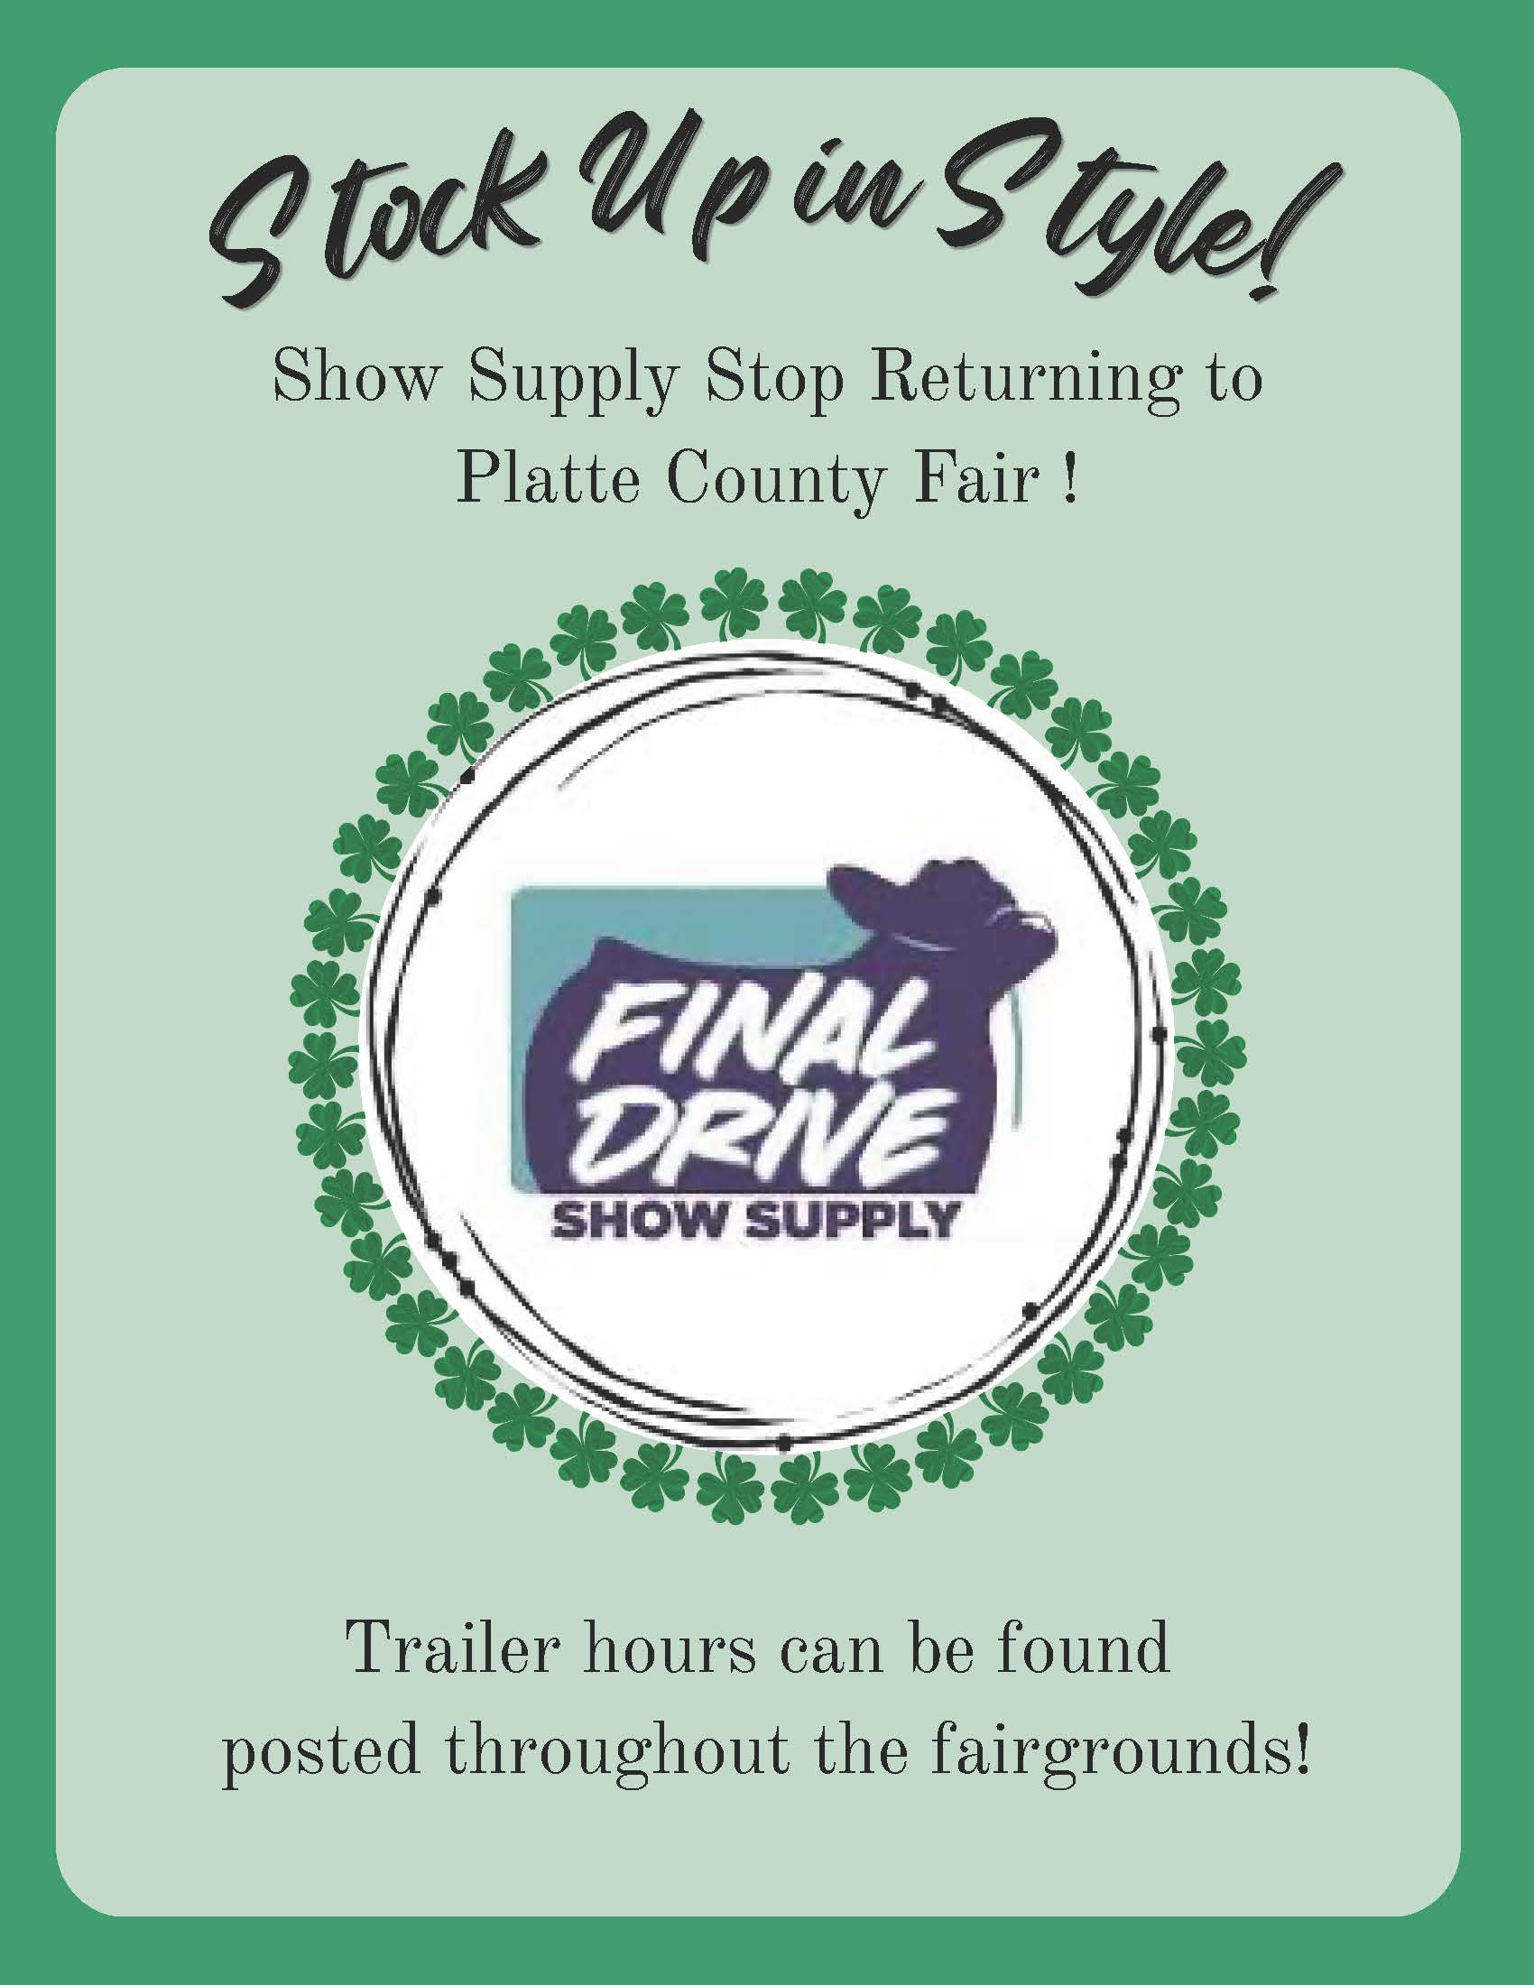
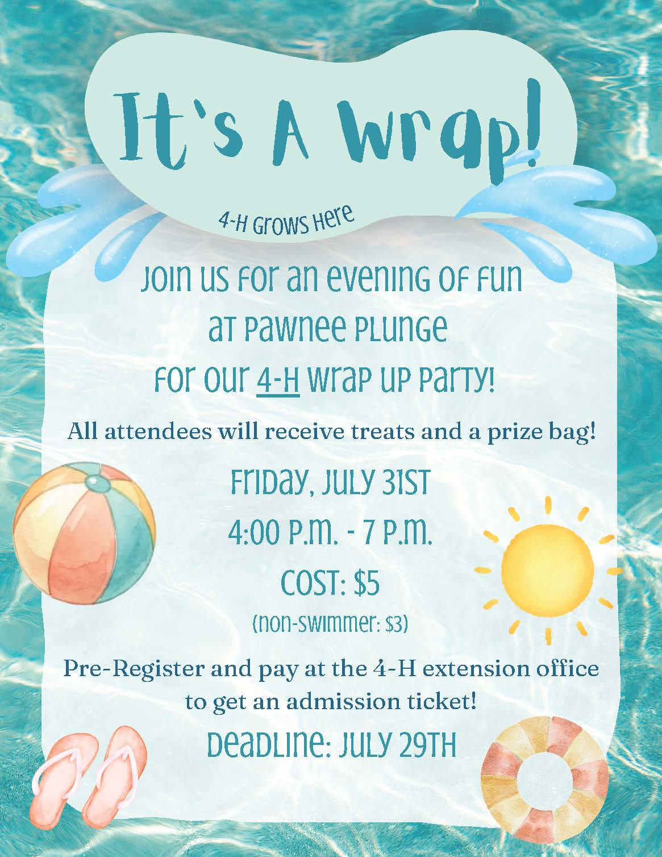

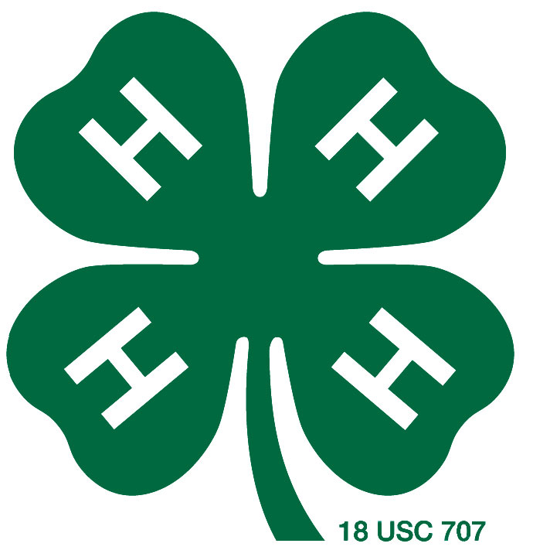
Clover Kid Show ‘n Tell
Wednesday, July 8th 6:00 pm

4-H Clover Kids exhibiting in the fair are invited to a Show ‘n Tell experience on Wednesday, July 8th at 6:00 pm.
Participants should sign up during exhibit entry day on Monday, July 6th.

Clover Kids should check in upstairs near the Club Room stage at 5:45 pm with the exhibit they will share. Youth will be placed in small groups and
brought on stage to tell more about their exhibit.

Ribbons and prizes will be awarded for participating!
Parents and grandparents are welcomed to watch!

Nonprofit Organization
U.S. Postage
PAID
COLUMBUS, NE 68601
PERMIT NO. 36

Nebraska Extension – Platte County
2715 13th Street
Columbus NE 68601-4916



