Nebraska Extension – Platte County 2715 13th Street, Columbus NE 68601-4916
Phone: 402-563-4901
Website: http://platte.unl.edu
Like Us on Facebook: Nebraska Extension – Platte County

4-H Family Newsletter – January 2026
4-H LEADER TRAINING
Month Events/Deadlines
January 1
New Years Day – Office Closed
January 5
Growing Clovers Club Mtg. 6 pm @ Extension Office
January 5
Jr. Leaders Club Mtg. 7 pm @ Extension Office
January 19
MLK Jr. Day – Office Closed January 23
Leader Training Registration Deadline
January 24
State Indoor 4-H Archery Championship @ Grand Island
January 26
Leader Training 5:15 pm @ Extension Office
January 26
4-H Council Mtg. 7:30 pm @ Extension Office
January 31
County Fair Market Cattle Weigh-In 10 am – Noon @ Columbus Sale Barn
January 31
Blue Region FLL Robotics Miniplay @ CCC
Staff
Sheila Hoppe Beth Jones
Blake Wert Sandra Swanson Hailey Held
Office Hours:
Monday – Friday 8:00 a.m. – 5:00 p.m.
Mark your calendars for Monday, January 26 for the 2026 4-H Leader Training. This training must be attended by at least one representative from each club.
A meal will be served 5:15 – 5:30 p.m. and the training will begin at 5:30 p.m. at the Extension Office. RSVP to Sandra by Friday, January 23rd. Can call 402-563-4901 or send an email to sswanson5@unl.edu by deadline.

4-H ONLINE ENROLLMENT IS OPEN
On-line enrollment is now open to enroll or re-enroll your 4-H’er(s) for 2026. 4-H leaders along with Council members are required to enroll or re-enroll for the new year. New leaders are to complete screening and orientation.
The enrollment website is https://v2.4honline.com or you can go to our county website at http://platte.unl.edu for enrolling or re-enrolling instructions to the 4-H Online enrollment website. Google Chrome and Firefox are the recommended web browsers to use when enrolling online. Also, enrolling will not work on cell phones.
Enrollment fee for 2026 is $5.00 per 4-H’er and no charge for leaders or Council members. Payment is required at end of enrollment process.
Remember this is project enrollment NOT fair exhibit entries. A project is centered around a topic of interest to members. A project should include a series of learning experiences related to that topic.
When you enroll in 4HOnline, you sign up for projects.


IMPORTANT – PLEASE READ:
If you are re-enrolling in 4-H, please DO NOT create a new enrollment. Use your email address and password from last year to log in and start your re-enrollment
for this year.

Nebraska Extension is a Division of the Institute of Agriculture and Natural Resources at the University of Nebraska-Lincoln cooperating with the Counties and United States Department of Agriculture.
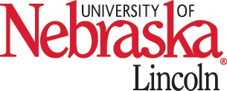
Nebraska Extension educational programs abide with the nondiscrimination policies of the University of Nebraska-Lincoln and the United States Department of Agriculture.


2026 SPECIAL GARDEN PROJECT

JOIN THE FUN WITH 4-H CLOVER KIDS IN 2026!

The Special Gardening Project lets 4-H members try their hand at growing unusual vegetables, flowers, fruit, and herbs. The project allows experienced 4-H gardeners to grow something fun, new, and different while letting those new to gardening get their hands dirty in this project area.
The 2026 Special Garden Project will focus on the Alumia Vanilla Cream Marigold. This marigold produces creamy, yellow flowers on compact plants. This variety not only has a unique color, but it also has a very long bloom time.
This project is open to all youth of 4-H ages 5-18 and it will give them the opportunity to learn about growing, harvesting, and exhibiting this unique flower.
Youth are encouraged to enroll in a Horticulture project through 4-H Online. Look for registration form in a future Platte County 4-H newsletter to receive seeds in the Spring.

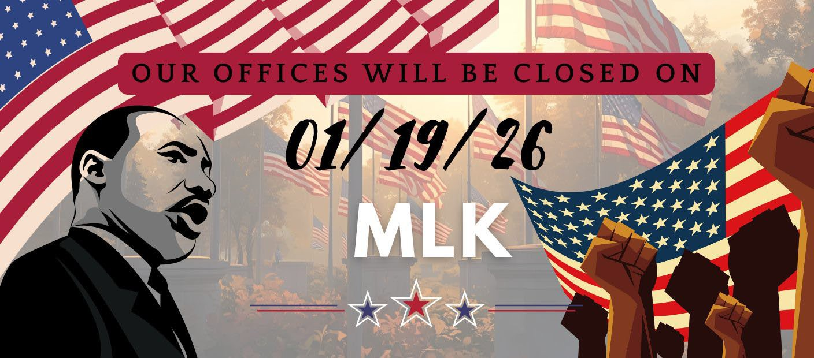
Is your child turning 6, 7, or 8 years old during the 2026 calendar year? If so, we invite them to be part of 4-H Clover Kids.
Clover Kids is a fun, hands-on introduction to 4-H designed especially for younger youth.
Participants explore new interests through activities such as crafts, simple science experiments, games, and group projects. Along the way, children build confidence, practice working with others, and make new friends in a welcoming and supportive environment.
The first Clover Kids meeting for 2026 will be held on Monday, January 5 at 6:00 p.m. at the Platte County Extension Office. This meeting is a great opportunity for families to learn more about the program, meet leaders, and kick off the year with engaging activities.
For more information or questions, please contact the Platte County Extension Office. We look forward to welcoming new Clover Kids and another great year ahead.

EXPLORE 4-H ROBOTICS AT THE BLUE REGION MINI PLAY EVENT
Families are invited to attend the Blue Region Mini Play event on Saturday, January 31, 2026, in the East Education Building on Central Community College Campus. This event is a great opportunity to see what 4-H Robotics is all about and watch youth put their skills to the test.
Platte County will have five Explore teams and four Challenge teams participating. Mini Play is similar to a county fair for robotics, giving teams a chance to practice and prepare for the State Robotics Competition in March. Teams will showcase their robots, explain their designs, and complete a variety of challenges.
Whether you’re new to robotics or already interested in STEM, this is a fun way to learn more about the program, meet current team members, and see robotics in action. Stop by, cheer on our teams, and discover how 4-H Robotics helps youth build skills through hands-on learning.

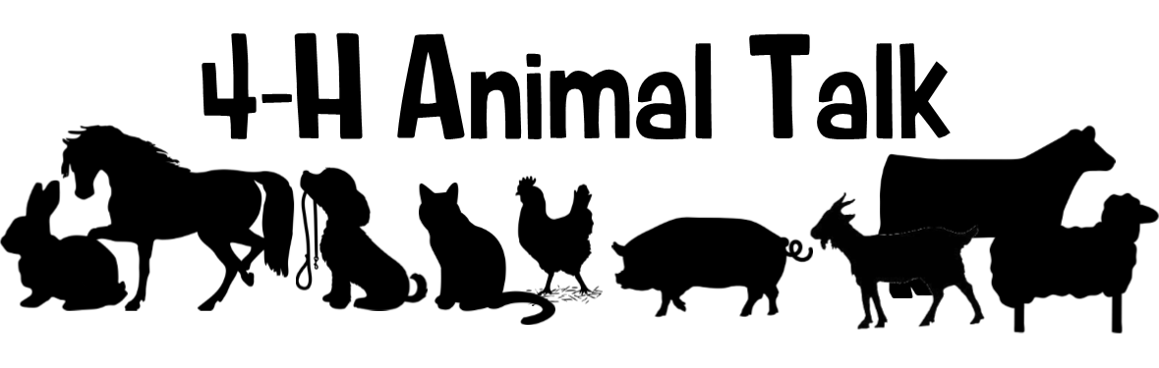

Beef: The County Fair Market Beef Weigh-In will take place Saturday, January 31, from 10 am to Noon at the Columbus Sales Pavilion. This is the only scheduled weigh-in time, so be sure to plan accordingly!
- What cattle are required to be at the County Fair Market Beef Weigh-In on January 31?
  - All Pen of 3 Cattle
    - Pen of 3 cattle are required to use EID tags again this year rather than county tags. EID Beef tags cost $3.34/each and county fair tags cost $1.50/each. Both can be purchased at the Extension office starting in January.
  - Led cattle participating in the Market Beef Rate-of-Gain Contest
- To alleviate some wait times for families weighing in cattle on January 31, the following schedule will be followed.
  - Families with 1-10 head of cattle will weigh from 10:00 am - 10:45 am.
  - Families with 11 or more head of cattle will weigh in from 10:45 am – Noon
    - Note: Families with 11 or more head are kindly asked to wait until families with fewer cattle are done before backing up to the chute. This will help ensure a smooth and efficient weigh-in process.
YQCA Scholarship Opportunity: The Youth for the Quality Care of Animals (YQCA) is proud to announce a scholarship fund for 2026! This opportunity is available to youth who are certified in YQCA and are currently high school seniors or up to age 21, with plans to pursue a degree or trade in agriculture.
Scholarship applications will open on January 1 and close on February 15th. For more details and to apply, visit YQCA - Youth for the Quality Care of Animals starting in January 2026. For questions, feel free to reach out to YQCA at help@yqcaprogram.org.
ATTENTION LIVESTOCK JUDGING ENTHUSIASTS
We are excited to announce that Platte County is a part of the Heartland Triple Crown Livestock Judging Series. Get ready for an unforgettable three-day livestock judging experience! The Heartland Triple Crown Livestock Judging Series is coming June 17–19, 2026, bringing together youth from across the region for competition, learning, and celebration as the Great Plains Judging Circuit wraps up its season. This three-day event is open to all states.
Participants will take part in 10 placing classes, enjoy a clinic, and compete for awards in each age division and species. With events hosted in Columbus, Bladen, and Nelson, Nebraska, each day offers something unique—plus fun evening activities, including a BBQ after-party and a final banquet and awards ceremony.
Whether you're a seasoned judge or new to the arena, this is the perfect opportunity to sharpen your skills, meet fellow competitors, and close out the circuit in style.
� June 17–19, 2026
�•� Columbus • Bladen • Nelson, Nebraska
� Registration details available at: https://go.unl.edu/lj26
Join us for three exciting days of livestock evaluation, learning, and community. We can’t wait to see you there! More details to come for each day.

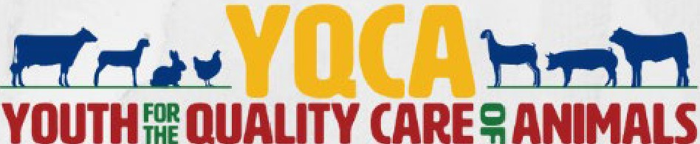

Important
PASE
Announcement
PASE 2026 will now be a three-day event held on UNLEast Campus earlier in the year!
Mark your calendars.
More information will come out in February 2026 newsletter.
Premier Animal Science Event (PASE)
May 27 - 29, 2026
ATTENTION LIVESTOCK EXHIBITORSI
2026 YOCA DATES HAVE BEEN SET!
ALL!r-H & FFA MEJI\BERS PLANNING ON SHOWING ANIMALS ATFAIR Ji\UST COJI\PLETE A YOCA TRAINING.

- 2026 YQ A Trainings
0
March 13 - 10 am - 11 am
o April 20 - 6:oo pm - 7:00 pm
0

0
May n - 7:30 pm - 8:30 pm May 22 - 3:00 pm - 4:00 pm
- All tTainings will take place at the Platte County Extension Office.

- Questions? Contact Blake at 402-563-4901or bwert3@nebraska.edu

HEARTLAND TRIPLE CROWN
LIVESTOCK JUDGING SERIES
JUNE 17-19, 2026

Join us for the Three-Day Livestock Judging Showdown!
Celebrate the end of the Great Plains judging circuit with three exciting days of competition, fun, and recognition.
🏆 Awards for each age division and species 10 placing classes
Pricing details on registration

Day 2 — Bladen, NE

Day 3 — Nelson, NE
📍 Location: Fairgrounds 1256 RD 3300
Nelson, NE 68961
registration: 9:00-9:30 am
🕙 Judging begins: 10:00 AM
🎉 Evening Banquet & Awards Ceremony: 5:00 PM

Day 1 — Columbus, NE
📍 Location: Ag park 822 15th St.
Columbus, NE 68601
registration: 8:15-9:00 am
cLINIC: 8:45 - 9:45 AM
🕙 Judging begins: 10:00 AM
📍 Location: Fairgrounds 459 N Crescent St.
Bladen, NE 68928
registration: 9:00-9:30 am
🕙 Judging begins: 10:00 AM
🍔 Evening After Party: 5:00 PM — BBQ & Games

FOR QUESTIONS OR REGISTRATION DETAILS, CONTACT: PLATTE COUNTY EXTENSION: 402-563-4901
WEBSTER COUNTY EXTENSION: 402-746-3417
Register here: https://go.unl.edu/lj26


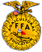






SOUTHERN PLAINS COUNTY EXTENSION: 402-225-2381 OR 402-768-7212 FIND MORE DETAILS ON OUR BROCHURE
THE UNIVERSITY OF NEBRASKA DOES NOT DISCRIMINATE BASED UPON ANY PROTECTED STATUS. PLEASE SEE GO.UNL.EDU/NONDISCRIMINATION.

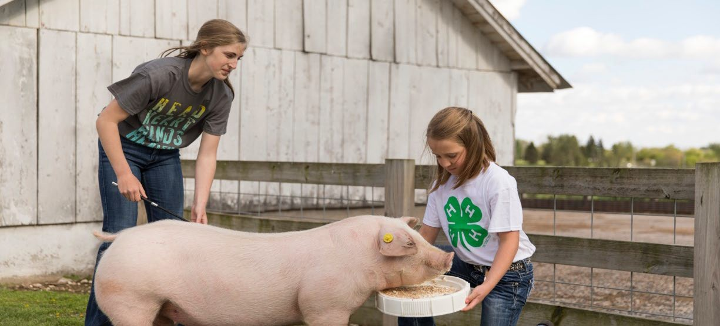
Farrowed and Owned Swine Cohort
A Farrowed and Owned Breeding and Market Swine division for youth interested in learning more about the swine industry is available for youth statewide in 2026! The Nebraska 4-H Farrowed and Owned Swine Cohort is designed to enhance the traditional 4-H swine project and cultivate the next generation of leaders in the swine industry by providing opportunities focusing on swine production as a goal of the 4-H member's project, along with accurate and complete record-keeping, industry knowledge, and engagement by the 4-H member. In order to participate, youth must be 4-H age 8-18 as of January 1, 2026, complete YQCA, farrowed their project animal(s) and participate in monthly virtual educational meetings.
Youth participating in the Farrowed and Owned Cohort will:
- Network with 4-H members across the state who are also participating in the cohort experience.
- Participate in learning opportunities hosted by Extension Swine Specialist Benny Mote about biosecurity, meat science, economics of raising swine and more.
- The cohort will meet virtually the first Sunday of the month at 7:00 p.m. CT, the months of February, March, April, May and June.
- Gain knowledge related to their project and the swine industry as a whole.
- Maintain records related to swine management and basic care.
- Exhibit their Farrowed and Owned project animals at a 2026 Nebraska county fair or the Nebraska State Fair. All cohort members will participate in an interview at the 2026 Nebraska State Fair. Exhibiting your animal at the Nebraska State Fair is not a requirement for the record book and interview portion of the cohort. Join the first session in February for more details!
- NEW for 2026: virtual tour of the UNL swine teaching facility will be a featured topic!

Register here by January 30, 2026!
**Optional special virtual education session on farrowing will be held on January 4, 2026, at 7:00 p.m. CT Register by January 2nd to participate!**
After the registration deadline, youth will receive more detailed information via email. For questions, contact Nebraska Extension Swine Specialist Benny Mote at bmote8@unl.edu or 402-310-9878.

Extension is a Division of the Institute of Agriculture and Natural Resources at the University of Nebraska–Lincoln cooperating with the Counties and the United States Department of Agriculture. University of Nebraska–Lincoln Extension educational programs abide with the nondiscrimination policies of the University of Nebraska–Lincoln and the United State Department of Agriculture. ©2016


2026 FAIR CHALLENGE
4-H IS A RAINBOW
OF POSSIBILITIES

YOU CAN CHOOSE ANY PROJECT IN ANY AREA THAT COULD RELATE TO THE TOPIC
OF 4-H IS RAINBOW OF POSSIBILITES. THIS COULD BE A CAKE IN THE SHAPE OF A RAINBOW,
A COLOR WHEEL USING ANY TYPE OF MATERIALS, OR ANY PROJECT THAT MIGHT INCORPORATE A RAINBOW IN SOME WAY.
YOUR IMAGINATION IS THE LIMIT!

JOIN US!!

We are looking for 4-H youth who are ages 13-18 that are wanting to expand their leadership skills and contribute to the community!!
JR. LEADERS CLUB MEETING
January 5th, 2026 7:00pm - 8:30pm

At the Extension Office
Jr. Leaders is growing and changing!
Come Join the Fun!!

WHAT WILL WE BE DOING THIS YEAR?
Leadership Building Fundraising

Local Tours

BENEFITS
Community Involvement


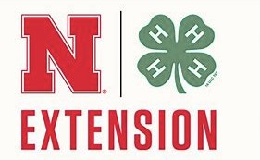
Looks great on resumes! Building relationships Great way to get letters of recommendation

CONTACT
Hailey- hheld3@nebraska.edu 402-563-4901 Sheila- shoppe3@nebraska.edu



• • • •

• • • • • • •

• • •

GROWING CLOVERS

A 4-H CLUB FOR THE CLOVER KIDS
Open to youth who turn 6, 7,or 8 in 2026

What is Clover Kids?
- Similar to other 4-H clubs, but tailored to younger learners only.
- Each meeting will feature the

Meeting Structure
2026 Meeting Dates
January 5, February 2, March 2. April 6,
May 4 and June 8.
- Meetings will be from 6:00 - 7:00 pm
- Meetings will be held at the Platte County Extension Office at
2715 13th St, Columbus.

pledges and an age appropriate . All youth must be accompanied by an
learning activity. adult.

For more information:
Nebraska Extension Platte County 2715 13th St. Columbus, NE 68601
Phone: 402-563-4901
Email: shoppe3@nebraska.edu or hheld3@nebraska.edu



Beyond Ready

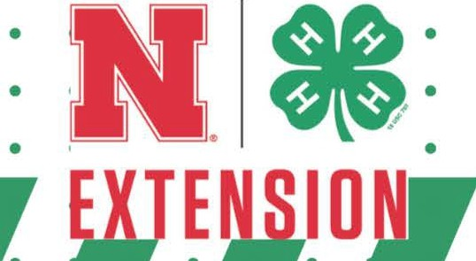

The University of Nebraska does not discriminate based upon any protected status.
Please see go.unl.edu/nondiscrimination

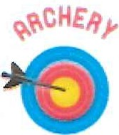

Practice Dates for Bulleyes Archery Club
7PM-8:30PM
Thursday January 81 2026 Thursday, January 22, 2026 Thursday, February 12, 2026
Thursday1 February 26, 2026
Thursday, March 12, 2026
Thursday, March 26, 2026
Thursday, April 9, 2026
Thursday, ApriI 23, 2026

Loaner bows available

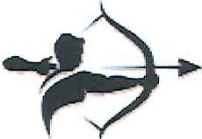

Bulleyes Archery Club Leader: Mistie Ziems (402) 910-6265 Practice location: Platte Valley Archers 126126th A...e, Columbus:, r-JE 68601

