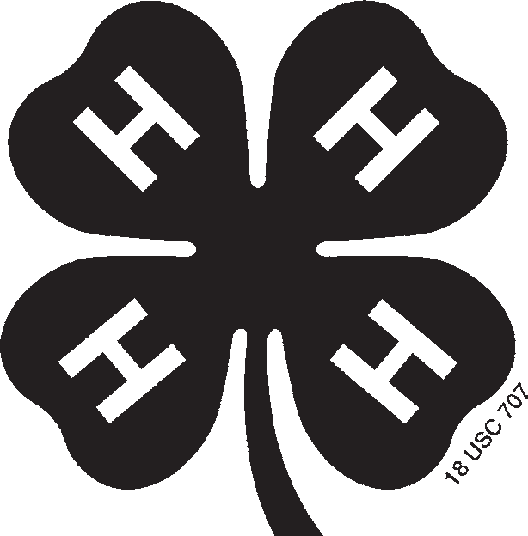

4HF109
Last Name First Name(s) and Age(s) Mailing Address
Street or P.O. Box, Town, State, Zip

County Phone Year

Club Member’s Birthday (Month, Day, Year)

NEBRASKA 4-H DAIRY GOAT IDENTIFICATION AFFIDAVIT
See reverse side for important instructions and lease affidavit.
REGISTERED GRADE BREED BRED BY EXHIBITOR: YES NO
Name of Animal Registry No.
Tattoo or Ear Tag No. Right Left Date Born
Month Day Year
Vaccination Tag No.
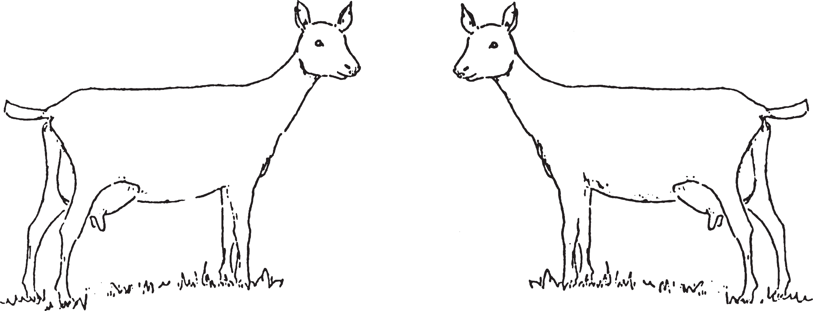
[Need at least one of these forms of ID (tattoo, tag or vaccination tag) for animals without distinct markings.] Sketch markings and include colors or attach photographs showing both sides of face.

I (we) certify that this is a 4-H project animal this year and that to the best of my (our) knowledge the above information is correct.
Date

Signature of 4-H Member(s) (At least one of those listed above must sign.)
This (these) youth has (have) submitted this livestock identifica-tion affidavit in accordance with all rules of the state and county 4-H Program and also has (have) successfully completed a Food Animal Quality Assurance program/test for this period.
Date

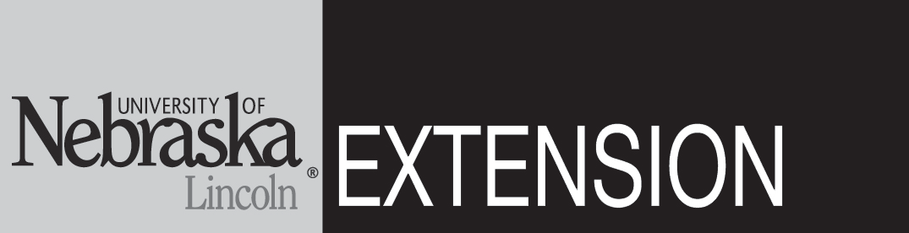

Extension Staff Signature
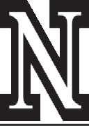



Parent Signature

®
PRINT
CLEAR
Fill out this form. Click on the PRINT button to print three copies. Sign and fill in the bottom portion of all three forms. Send a copy to the State 4-H Office and the local Extension office and keep one copy for your files. Click on the CLEAR button to clear all fields to be filled out again.

4-H Animal Exhibitor and Animal Project Regulations

Age of 4-H Exhibitor
A 4-H animal owner/exhibitor 8 to 18 years old on Jan. 1 of the current calendar show year is eligible to exhibit in 4-H-sponsored events. Exhibitors who are 10 as of Jan. 1 may exhibit at the
State Fair and at the Ak-Sar-Ben Livestock Exposition. 4-H members may be certified for state and interstate shows if they meet age requirements for that event and have properly enrolled animals.

4-H/FFA Exhibits
Any animal shown as an FFA exhibit is ineligible to show as a 4-H exhibit by any exhibitor. An animal may be nominated for show participation in 4-H or FFA, but not both.

Animal Ownership
All beef, swine and sheep project animals must be owned:
- solely by the 4-H exhibitor, or
- the exhibitor in partnership with other member(s) of his or her immediate family. Only the name of the showman can be on the show entry. Immediate family is defined as
members of a household, including parents, brothers and sisters, and youth in the care of the head of the household.

Registration Papers
For State Fair and Ak-Sar-Ben, registration papers must show one of the following:
- the member’s name as owner, or
- the name of the exhibitor and/or a co-owner who is a member of the exhibitor’s immediate family (see immediate family definition above), or
- the family farm or ranch name or parent’s name.

Identification of Animals
All animals must be individually identified, listed on the appropriate 4-H form and on file in the local extension office.

Species Number of Animals Identification Method (State Fair) State Identification Deadline* Form

Dairy |  | Sketch, picture, tattoo or tag | June 15 of the current year | 4HF108
Dairy Goat |  | Sketch, picture, tattoo or tag | June 15 of the current year | 4HF109
Meat (Market) Goats | 20 per member | Official 4-H eartags, DNA Sample | June 15 of the current year | 4HF111
*Individual counties and other shows or contests may use different information deadlines and/or rules, but for Nebraska State 4-H, these deadlines and information minimums must be met.

NOTE — DNA samples required for market beef, lambs, swine and meat goats at both State Fair and Ak-Sar-Ben.

NOTE: FILL IN THIS PORTION, PRINT 3 COPIES, SIGN AND ATTACH TO THE AFFIDAVIT.

Owner’s Affidavit

As owner of the animal described on the attached 4-H Dairy Goat Identification Certificate, I certify that has my permission to use this animal in 4-H projects.
Name

I understand the 4-H member must manage (including feeding, grooming, fitting, etc.) and have access to the animal at least 75 percent of the time during the project year.

Date Owner

Approved by Date
Extension Staff Signature

Extension is a Division of the Institute of Agriculture and Natural Resources at the University of Nebraska–Lincoln cooperating with the Counties and the United States Department of Agriculture. The 4-H Youth Development program abides with the nondiscrimination policies of the University of Nebraska–Lincoln and the United States Department of Agriculture.
1/09

