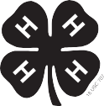
4-H HORSE IDENTIFICATION CERTIFICATE

Year County

Member’s Name Address Age Jan. 1, 20

Name of other Member if a Joint Project Address

Phone E-mail Club Name Approved County Extension Educator Date


Name of Horse Reg. # Breed Age Sex Colors Height

This horse is owned by me: _
by my family: _
or borrowed:

Sketch markings and indicate colors or attach photographs showing both sides and face.
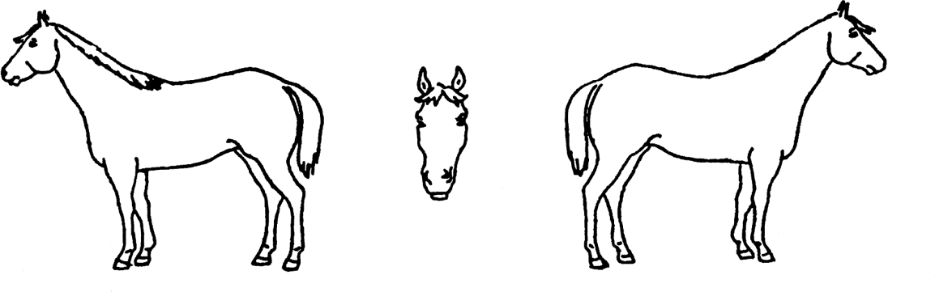
Name of Horse Reg. # Breed Age Sex Colors Height

This horse is owned by me:_ _ by my family: _ or borrowed:
____

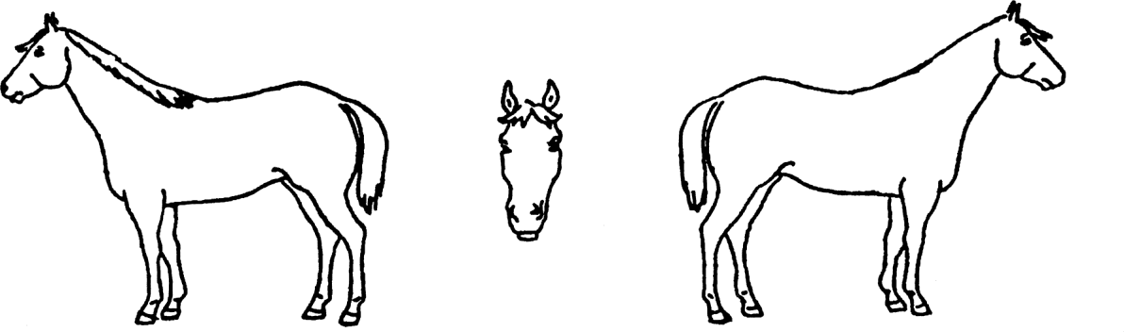
Sketch markings and indicate colors or attach photographs showing both sides and face.
If horse is owned by someone other than you or your immediate family, the owner must complete the following affidavit on next page.

OWNER’S AFFIDAVIT
As owner of the horse(s) described above, I certify that
Name(s)
has my permission to use this animal in the 4-H project.
I understand that the 4-H member(s) must manage (including feeding, grooming, exercising, training, stall management, etc.) and have access to this horse at least 75% of the time during the course of the project year.

Date Owner of horse
Revised 2017

IDENTIFICATION OF 4-H ANIMALS FOR NEBRASKA DISTRICT, STATE AND INTERSTATE SHOWS

Only 4-H members 10 years of age or older on January 1 of the current year will be certified for state or interstate shows.

Horse
Animals must be identified by color markings or photograph. Project animals not owned by the exhibitor or his family must have an affidavit from the owner certifying that the exhibitor will manage and have access to the horse at least 75% of the time during the course of the project year. The term manage includes all of the following: feeding, grooming, exercising, training, stall management and use of the horse.

NOTE: USE BALLPOINT PEN. PRINT LEGIBLY. BE CERTAIN OF INFORMATION BEFORE FILLING OUT FORM. CORRECTIONS ARE DIFFICULT TO MAKE.

Extension is a Division of the Institute of Agriculture and Natural Resources at the University of Nebraska–Lincoln cooperating with the Counties and the United States Department of Agriculture.
The 4-H Youth Development program abides with the nondiscrimination policies of the University of Nebraska–Lincoln and the United States Department of Agriculture.

