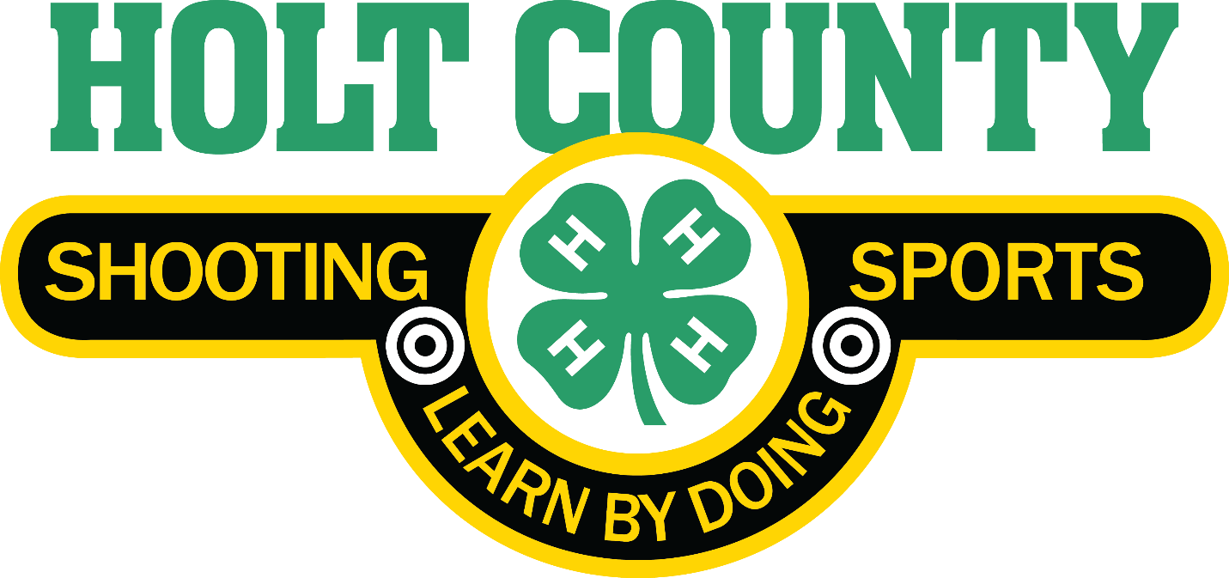Program Guide and Information

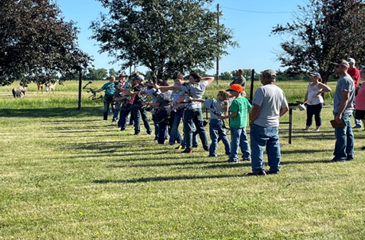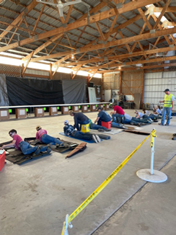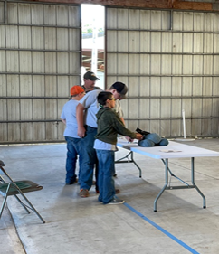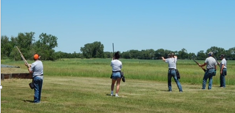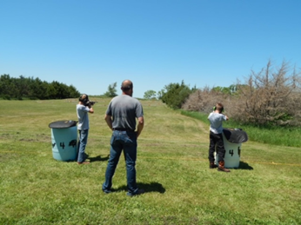

Table of Contents
NEBRASKA 4-H SHOOTING SPORTS PROGRAM 2
What is 4-H? 2
4-H, Why’s it important? 3
PROGRAM OVERVIEW 4
GOALS 4
MEMBERSHIP 4
DUES 4
PRACTICE REQUIREMENTS 4
MEETINGS 5
CLUB LEADERSHIP 5
YOUTH OFFICERS 5
ADVISORY COMMITTEE 6
COMMUNICATION 6
RECORD BOOK 7
CODE OF CONDUCT 7
DRESS CODE 7
DISCIPLINE POLICY 9
EQUIPMENT GUIDELINES 9
COMPETITIONS 10
Holt County Invitational Shoot 10
Holt County Fair 10
State and National Competitions 11
Trap Team 11
2026 Holt County 4-H Shooting Sports Coaches & Coordinators 12

Updated: December 2025
**For individual discipline information, refer to the Holt County Shooting Sport Discipline Guide**

Promoting Positive Youth Development through the Safe and Responsible Use of Firearms and Archery Equipment using Comprehensive Education, Life-Long Recreation, and Healthy Competition.
Welcome to the Holt County Shooting Sports Club we are looking forward to an exciting year of growth and development. You will learn important life skills through safe and educational experiences. You will explore firearms safety and the importance of conserving Nebraska's natural resources. Trained and certified 4-H leaders throughout Holt County lead this program. Holt County Shooting Sports is an affiliate of Nebraska 4-H.

NEBRASKA 4-H SHOOTING SPORTS PROGRAM

The Shooting Sports program offer opportunities for youth to learn safe gun handling skills and sound fundamentals of shooting under the guidance of caring and knowledgeable adult volunteers. Youth who are at least 8 years of age by January 1
(4-H Age) may explore subject areas such as:
- Archery - 8 years old & up
- BB Gun - 8 years old & up
- Air Rifle, Air Pistol - 9 years old & up
- Smallbore Rifle (.22 caliber) - 9 years old and up
- Smallbore Pistol (.22 caliber) -10 years old & up
- Shotgun - 9 years old & up
- Trap Team - Grades 6-12 (must have hunter safety)
- Muzzle Loading - 10 years old & up

First Year Shooters:
- 8 years or older without Hunter Safety - Archery and BB Gun Only
- First year with Hunter Safety - Eligible for all disciplines

The focus of the Nebraska 4-H Shooting Sports programs are the total development of the 4-H member. The shooting sports and related natural resource activities are utilized as a vehicle for human growth and development. It uses the skills and disciplines of shooting to assist young people and their leaders in obtaining knowledge and developing skills. Development of skills within the discipline of shooting and life skills is emphasized in the program curriculum and explicitly stated for volunteers. 4-H Shooting Sports promotes positive youth-adult interaction and peer leadership.

What is 4-H?

4-H is America’s largest youth development organization – empowering over six million young people nationwide each year with the knowledge and skills to lead for a lifetime. 4-H believes in the power of youth. 4-H recognizes the valuable strengths and real influence that every child possesses to improve the world around us.

4-H provides:
- “Hands-on” learning experiences
- Safe, supportive environments
- Guidance from caring adult mentors
- Encouragement towards leadership roles
- Accessibility for all youth

The 4-H team comes from every corner of America through an amazing network of over 3,500 4-H professionals and more than 500,000 dedicated 4-H volunteers who operate under the direct supervision of those 4-H professionals.

4-H, Why’s it important?

The 4-H Study of Positive Youth Development is a longitudinal study that began in 2002 and was repeated annually for eight years, surveying more than 7,000 adolescents from diverse backgrounds across 42 U.S. states. Based on this study 4-H members are:
- Nearly 4X more likely to make contributions to their communities,
- About 2X more likely to be civically active
- Nearly 2X more likely to participate in science programs during out-of-school time,
- Nearly 2x more likely to make healthier choices.

The 4-H pledge, adopted in 1927, is a tangible reminder for all 4-H participants and their families as to the real purpose of this dynamic program. Each 4-H meeting, activity, and/or event starts with the 4-H Pledge. From time to time, youth may be asked what one of the specific lines means to them and what they are committing themselves to do. This brings the 4-H Pledge to life.

I pledge …
My HEAD to clearer thinking,
My HEART to greater loyalty,
My HANDS to larger service, and
My HEALTH to better living
For my club, my community, my country and my world.

PROGRAM OVERVIEW

GOALS

Holt County 4-H Shooting Sports Objectives are to enable youth to:
- Find and explore passions and interests
- Engage in an effective 4-H program setting
- Develop positive relationships with adults, youth, and peers
- Explore a vast array of 4-H educational, recreational, and competitive activities
- Thrive in multiple settings
- Strengthen knowledge and life skills
- Enhance developmental and long-term outcomes
- Practice safe and responsible use of firearms and archery equipment, enhancing existing shooting, conservation, and hunter education programs
- Explore the three National 4-H Mission Mandates (Science, Technology, Engineering and Mathematics (STEM), Healthy Living, Civic Engagement)
- Model safety, sportsmanship, and ethical behavior

MEMBERSHIP

- Holt County Shooting Sports Youth who are at least 8 years of age by January 1st (4-H Age)

DUES

- Dues must be paid by April 1
- $15.00 per year, per member for one discipline, and an additional $5.00 for each additional discipline. Except for Muzzleloader which will be an additional $10.
  - Example - BB Gun ($15) + Archery ($5) + Trap ($5) = $25
  - Example - Archery ($15) + Trap ($5) + .22 Rifle ($5) = $25
  - Example - SB Pistol ($15) + Trap ($5) + Muzzleloader ($10) = $30
- Membership dues go towards equipment upkeep and supplies.

PRACTICE REQUIREMENTS

- Each shooter must complete 3 practices in each discipline to compete in that discipline at fair.
  - Archery discipline requires 3 practices with at least one indoor and one outdoor practice
- Attendance at practice will be tracked from sign-in sheets.
- Shooters can count practices and competitions outside of Holt County. The shooter must return proof of attendance to one of the club coordinators for
- recording. Examples of proof could be a picture of the completed sign-in sheet or a signed note from the 4-H certified discipline Coach of that discipline from the event.

MEETINGS

- Youth meetings will be held on the 3rd Monday, of every other month at 7:00 pm, or aligned with practices as available. Meeting months will be January, March, May, July, September, and November. Meetings will be alternated between O’Neill, Atkinson, and Chambers. Refer to the meeting schedule for location and times. Members are highly encouraged to attend club meetings to provide input and to keep up to date on events. Meetings are separate from practices. Nebraska 4-H requires 4-H Clubs to have 6 official meetings per year. A quorum for the Holt County Shooting Sports 4-H club consists of 10% of members present at each meeting to vote and make decisions. Please be present at meetings so we can continue to have an active shooting sports club.
- Parents are also encouraged and invited to attend the youth meetings to keep up to date on events.
- The orientation “Kick-Off” meeting is the first meeting, normally held in December.
- Youth planning meeting and officer elections are held in November.
- Each meeting will start with the Pledge of Allegiance and the 4-H Pledge, parliamentary procedure will be followed.

CLUB LEADERSHIP

Club Leaders are a valued and essential part of the 4-H program. The Holt County 4-H Shooting Sports program includes both youth and adults in leadership roles. The Nebraska 4-H Youth Development Policy emphasizes that the 4-H Clubs belong to the membership and the youth members should make the decisions. It clearly states the importance of “Youth involvement
in leadership and decision making”.

Our club strongly believes and supports this vision and encourages youth involvement at all levels. We believe adult leaders should serve as advisors and that the club's youth members should be involved in making the club's decisions.

YOUTH OFFICERS

The officers of the Club shall include president, vice-president, secretary, treasurer, and reporter/historian. Their duties shall be as follows:
- The president will preside at all meetings, uphold the constitution, and adhere to parliamentary procedure. The president shall appoint committee chairs and members.
- The vice-president shall preside over the club in the absence of the president. The vice-president shall assist the president and serve as a link to all committees.
- The secretary shall write minutes of each meeting and report at the next meeting. The secretary will also keep attendance records and write club correspondence.
- The treasurer shall be responsible for all club funds and property, along with the adult finance chairman. The treasurer will keep an accurate record of the receipt and expenditures of all funds and give a report of the club’s finances at each meeting.
- The reporter/historian shall write news reports of all meetings and activities and send them to the county 4-H office, local newspapers, radio stations, etc. They shall collect newspaper and county newsletter clippings, photos, etc., for a club scrapbook/bulletin board/history.

ADVISORY COMMITTEE

The Advisory Committee consists of the following:
Adult Positions:
- Club Coordinators
- Adult Treasurer
- Certified Discipline Leaders
Youth Positions:
- Club Officers
- Apprentice Leaders
The Advisory Committee is responsible for planning the annual calendar, scheduling practices, and addressing policy issues.

COMMUNICATION

- Communication related to practices and meetings will be email and Facebook posts.
  - Information about meetings and practices will be in the Holt County 4-H Newsletter as well.
  - Email reminders will also be sent from the Holt County 4-H Office and from Holt County 4-H Shooting Sports. You will be able to sign up for specific practice line times via Sign-up Genius, these links will be sent out approximately 2-3 weeks before each practice.
  - Communications related to trap team will be on the Sports on app.
- Meetings and practices will also be listed on the Holt Boyd 4-H Calendar.
- Information regarding cancellations will be communicated via email and KBRX radio.
- Please use your judgement if the weather is questionable. Notify the discipline leader via phone or email if you do not feel safe traveling to practice due to the weather.

RECORD BOOK

- Each member is encouraged to keep a 4-H Shooting Sports Record Book during the year. Completed Record Books are due in the Extension office October 1.
- These record books will be treated as other record books within Holt County with ribbon placements and recognition at the Achievement Ceremony.
- Shooting Sports Record Book

CODE OF CONDUCT

Each enrolled member is required to a Signed Code of Conduct located in 4Honline, under the profile information section. Violations of the code of conduct can affect “member in good standing” or “volunteer in good standing” status. It is the responsibility of all program participants to reinforce the code of conduct.
4-H members, leaders, parents, and other adults participating in 4-H programs will:
- Follow safety rules.
- Be curious to learn.
- Be respectful to self and others.
- Work to positively resolve problems or differences.
- Accept guidance from Extension volunteers and staff.
- Follow program rules, curfews, dress codes, policies, and rules of the facility being used.
- Use appropriate language, exhibit good sportsmanship, and be a positive role model.
- Comply with local, state, and federal laws.
- Abstain from the use of alcohol, illicit drugs, and tobacco during any 4-H program, activity, or educational experience.
- Fully participate in scheduled activities and orientations.
- Respect others' property and privacy rights.
- Abstain from child abuse (physical, sexual, emotional and neglect), harassment, hazing and bullying.
- Refrain from all sexual activity/contact during any 4-H program, activity or educational experience.
- Accept personal responsibility for behavior including any financial damage.

DRESS CODE
- Please refer to the Fair book for specific dress code requirements for shooting at the Holt County Fair.
- At practice and competitions, participants will be required to wear shoes that completely cover their feet. Examples of footwear that are not acceptable include, but are not limited to, sandals, clogs, flip flops, and bare feet.
- When shooting BB Gun, Air Rifle or Air Pistol, cowboy boots or high-top shoes are not allowed. Please ask discipline leader for further clarification.
- Any clothing/hats with pictures, caricatures, designs, messages, writings, or other embellishments with direct or indirect references to alcohol, tobacco, sex, sexual connotations, drugs, gambling, or profanities are prohibited.
SAFETY RULES
- While on the firing line, firearms may be handled/touched only with the permission of the range leader.
- All firearms must be unloaded and have the action open with a CBI in place when not shooting. Shotgun will have the action open when not shooting.
- Firearms are to remain unloaded until a member is on the firing line and has received instructions from the range leader to load/fire.
- All firearms will be carried with the muzzle pointed in a safe direction. The position and direction of firearm muzzles and arrows should be such that accidental injury to others cannot occur.
- Listen and obey all range commands immediately.
- Dry firing of firearms is permitted only on the firing line with the range leader’s permission.
- Eye and hearing protection is each participant’s responsibility and must be worn.
- When not shooting a firearm, it will be placed in a gun rack, stored in a case, or locked in a vehicle.
- While standing at the firing position, arrows may be handled/touched only with the permission of the range leader. Arrows may be nocked only when the shooter is on the archery shooting line and has received instructions from the range leader to nock an arrow/shoot. Arrows will remain in a quiver when they are not being shot from a bow.
- When members are carrying/transporting firearms (not actually shooting the firearm) the firearm is to remain unloaded, and the action is to remain open.
- Always keep your finger out of the trigger guard area until your firearm is ready to be shot.
- If you or another shooter needs assistance, ask a junior leader, range leader or adult volunteer for assistance
- No eating or drinking while on the practice line
- Wash your hands with cold soap and water after handling ammunition.
- Any use of a cell phone while on the firing line is prohibited.
  - It is allowed for the certified range leader to keep a cell phone on his/her person for emergency purposes.
- No horseplay or disruptive behavior will be tolerated.

The 4-H Shooting Sports program has a great safety record, but as with any shooting sports activity there are inherent dangers that require stringent safety practices to be followed. There will be no tolerance of any unsafe practices, actions or behaviors by youth members or adults during 4-H activities.

All members, including youth, adult leaders and volunteers have the responsibility to always keep the range safe.

*** Refer to discipline specific Range Safety Rules and Range Etiquette for further details

DISCIPLINE POLICY

4-H Shooting Sports is a Privilege not a right. Youth may be removed from the shooting line for unsafe activities or safety violations and may not return to the shooting line until cleared. Certified Range Leaders have the right to remove any member that violates safety protocol from the practice line, range, or building.

Depending on the severity of the offense, the 4-H club Leaders(s) may also decide to meet with the member and his/her parent/guardian to discuss the situation and importance that the member comply with expectations and policies. Violation of any Code of Conduct or Safety Rules may result in an immediate dismissal from the club meeting, practice, competition, and / or permanent dismissal from the Holt County Shooting Sports program.

EQUIPMENT GUIDELINES

The club has a limited number of firearms, bows and safety equipment available. All shooters are welcome to use club equipment as it is available. Reach out to your individual discipline leader for details and availability.
If you wish to bring your own firearm or bow to shoot, the following rules apply:
- Firearms need to be brought in a case. Keep your firearms cased until presented at the range.
- If you bring your own bow, you must bring your own arrows and have them quivered.
- ALL personal firearms and bows will be safety-checked each time prior to allowing use on the range.
Any Certified Range Leader has the right to examine any item of a shooter’s equipment including bows, arrows, air rifles, shotguns, ammunition, and other equipment to ensure proper accordance with required specifications.

COMPETITIONS

- Each competition may have its own rules that youth will be responsible to know and obey.
- There are competitions in other counties during the year in most of the disciplines. The best resource for locating these competitions is the Nebraska
4-H Shooting Sports calendar.
- Parents are encouraged to drive and coach their own children, however, reach out to your discipline leader as rides are sometimes available.
- Competition can teach many valuable lessons, however, competitive shooting at the local, district, state or even national level is NOT the primary goal of Holt County Shooting Sports programs. Participation in competitive events is optional and not required of members. 4-H Shooting Sports competition serves as an evaluation of how well 4-H youth have developed their skills. It is important to keep in mind the purpose and focus of our 4-H Shooting Sports program - POSITIVE YOUTH DEVELOPMENT.

Holt County Invitational Shoot

- The Club will host the Holt County Invitational Shoot each year, usually on the second Saturday in June. This provides members an opportunity to compete in events that have been practiced throughout the year, as well as provide opportunities for members across the State to qualify for 4-H National Competition.
- The Holt County Shoot offers the following events:
  - Archery
  - BB Gun
  - Air Pistol
  - Air Rifle
  - Small Bore Pistol
  - .22 Rifle
  - Shotgun - Trap
  - Muzzle Loader
- Watch the 4-H Newsletter for more information.

Holt County Fair

There are both shooting and static projects that youth can compete in at fair, refer to the annual fair book for specifics on static projects.
- All members who wish to participate in the Holt County Fair MUST:
  - Be a member of the Holt County 4-H Shooting Sports Club
  - Register pre-fair entries to shoot at the Holt County Fair by July 21
  - ***Youth must be enrolled in specific shooting sports disciplines to participate. Exhibitors may only enter in the department/class that corresponds with the 4-H projects they are enrolled in. Refer to the Fair book for the most recent guidelines. Sign up for disciplines(s) within 4H online.
    - Each shooter is required to attend 3 practices per discipline to be allowed to shoot at the fair.
  - Exhibitor information can be found on the Holt County Fair Website.
No early shoots will be held. Participants wishing to take part in the Holt County Fair Shoot must do so on the date scheduled for each discipline, no exceptions.

State and National Competitions
- State competitions for individual disciplines are held throughout the year. Refer to the Nebraska 4-H Shooting Sports Calendar.
- Youth can qualify to shoot at State competitions. Visit with your discipline leaders for more details.
- Youth can qualify for National competition, speak with your Discipline Coach for details.

Trap Team (Previously called North Central Trap Team).
- High School, Junior High, and 6th Grade students are invited to participate.
- Practices will start as soon as soon as weather permits in January or February.
- Youth will travel to Heartland Shooting Park in Grand Island during March & April for Saturday conference shoots. Stay tuned for exact dates, will announce as soon as dates are released.
- Youth will travel to the Cornhusker High School Shoot in Doniphan (April 27-29th) for a national trap shoot.
- Youth will be encouraged to participate in summer and fall leagues.
- Hunter Safety is required.
- It will be the responsibility of each family to get youth to each event.
- More information will be available in January or as it becomes available.
- Please expect some changes & clarification as we grow into this new roll.

First | Last | Town | Cell # | Email Address | Discipline
Kyle | Asher | Atkinson | 402-340-5604 | gpsekna@gmail.com | *Head BB Gun/Air Rifle Leader, Rifle
Ryder | Asher | Atkinson | 402-340-5604 | gpsekna@gmail.com | Jr Leader Rifle
Erin | Asher | Atkinson | 402-340-5604 | easher5216@gmail.com | Rifle
Zac | Callison | O’Neill | 402-669-8109 | zacharycallison83@gmail.com | Archery
Spencer | Endorf | O'Neill | 402-860-3124 | spencerendorf1@gmail.com | *Head Archery Leader
Jason | Koehlmoos | O'Neill | 402-616-7622 | jckoehlmoos@gmail.com | Rifle, Pistol, Muzzleloader
Jennifer | Koehlmoos | O'Neill | 402-340-3111 | jkoehlmoos@gmail.com | *Head Air Pistol, Coordinator
Chris | Koehlmoos | O’Neill | 402-340-6053 | cwmoose09@gmail.com | Jr Leader Muzzleloader, Rifle, & Pistol
Matt | Koehlmoos | O’Neill | 402-340-7315 | mrkmoose05@gmail.com | Muzzleloader, Rifle
Dan | Krugman | O’Neill | 402-340-0793 | dkrugman63@hotmail.com | Shotgun
Cory | Mitchell | Stuart | 402-340-2867 | voiceoftherace@gmail.com | * Head Pistol Leader
Scott | Moore | O'Neill | 402-336-7219 | ssmoore284@gmail.com | BB Gun/Rifle
Joe | Sanders | O’Neill | 402-340-4283 | joe_s70@hotmail.com | Shotgun
Amber | Shane | O'Neill | 402-340-5915 | amber.dawn.shane@gmail.com | * Head Shotgun Leader, Rifle
Case | Shane | O’Neill | 402-340-5915 | amber.dawn.shane@gmail.com | Jr Leader Shotgun & Rifle
Ian | Shane | O’Neill | 402-340-5915 | amber.dawn.shane@gmail.com | Jr Leader Shotgun & Rifle
Oliver | Shane | O’Neill | 402-335-8162 | amber.dawn.shane@gmail.com | Jr Leader Shotgun & Rifle
Talya | Shutt | Atkinson | 402-340-2349 | talyashutt2023@gmail.com | Club Coordinator
Brad | Slaymaker | Atkinson | 402-340-3979 | bslay55@gmail.com | Archery
Brad | Smith | Atkinson | 402-340-6437 | brad.smith5980@gmail.com | *Head Muzzleloader Leader
Amy | Timmerman | Chambers | 402-430-5187 | atimmerman2@unl.edu | *Head .22 Rifle Leader

2026 Holt County 4-H Shooting Sports Coaches & Coordinators
12

