2026 HOLT BOYD
COUNTY FAIR
4-H REGULATIONS
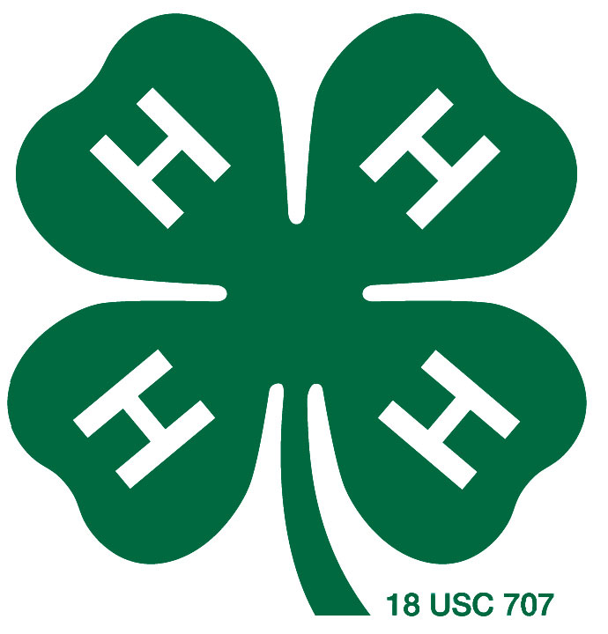

Prepared by the University of Nebraska-Extension
in Holt and Boyd County

Extension is a Division of the Institute of Agriculture and Natural Resources at the University of Nebraska–Lincoln cooperating with the Counties and the United States Department of Agriculture.

The 4-H Youth Development program abides with the nondiscrimination policies of the University of Nebraska–Lincoln and the United States Department of Agriculture.

©2026
4-H is the University of Nebraska-Lincoln Extension educational program for youth. 4-H is a community of young people across America who are learning leadership, citizenship, and life skills. 4-H youth "Learn by Doing”. The primary goals of 4-H are to help youth develop competency in their projects, confidence in themselves and others, connections to their communities, life skills, and good character. One of our goals is personal growth of the individual - not grand champion projects, but grand champion kids! We celebrate the success of youth in 4-H. The County Fair is the showcase for
4-H members to share what they have learned and accomplished throughout the year.

GREAT FANS. GREAT SPORTS.
When competition is a part of an event, it should be clearly understood that competition is secondary in importance to the education and development of youth. Ribbons and trophies are a small part of competition. We ask you to remember the importance of good sportsmanship and what youth projects are meant to teach. When new skills are learned or old ones perfected, we have excelled beyond the ribbon we receive. Parents and other adults are powerful influences on children’s behavior; we ask for your cooperation. Character development is the cornerstone for sportsmanship. We expect participants and spectators to practice the six pillars of character: trustworthiness, respect, responsibility, fairness, caring, and citizenship.

“Be bold, be brave, and be true to principles, true to ethics, true to real world agriculture and most importantly, be true to yourself.” –
Hubert Wilkerson

WHAT DO THE 4-H RIBBON COLORS MEAN?
Purple ribbons designate an exhibit of superior quality that has met and exceeded all of the standards.

Blue ribbons denote an above average exhibit that has met almost all of the standards in a way that surpasses the norm.

Red ribbons indicate average quality and indicate that the exhibit has met the majority of standards in such a way that the benchmark was reached but not exceeded.

White ribbons indicate that the exhibit has not met the majority of the standards

4-H YOUTH DEVELOPMENT MISSION STATEMENT
4-H empowers youth to reach their full potential working and learning in partnership with caring adults.

