Nebraska Extension – Platte County 2715 13th Street, Columbus NE 68601-4916
Phone: 402-563-4901
Website: http://platte.unl.edu
Like Us on Facebook: Nebraska Extension – Platte County

4-H Family Newsletter – February 2026

4-H RECRUITMENT & FAMILY NIGHT
Month Events/Deadlines
February 2
Growing Clover Club Mtg 6 pm @ Extension Office
February 2
Jr. Leaders Club Mtg
7 pm @ Extension Office February 10
Recruitment & Family Night 5-7:30 pm @ Pizza Ranch
February 16
President’s Day – Office Closed
March 2
Growing Clover Club Mtg 6 pm @ Extension Office
March 2
Jr. Leaders Club Mtg
7 pm @ Extension Office March 13
YQCA Training 10:00 am @ Extension Office
March 17
Rural Recognition Banquet March 20-21
FLL Robotics Challenge Championship @ UNL
March 27
County Fair Broiler Order Deadline
Staff
Sheila Hoppe Taylor Cammack Blake Wert Beth Jones
Hailey Held Sandra Swanson
Office Hours:
Monday – Friday 8:00 a.m. – 5:00 p.m.
Know a Platte County family interested in joining 4-H?
Have them stop by Pizza Ranch on Tuesday, February 10, from 5:00–8:00 PM to visit with Platte County 4-H staff and learn more about getting involved!
Bring your family and enjoy dinner too—10% of all sales during the evening will be donated to Platte County 4-H, making it an easy (and tasty!) way to support our local program.
Be sure to keep the enclosed Recruitment & Family Night flyer handy so you don’t forget!

CLOVER ACADEMY SUMMER WORKSHOPS ARE COMING SOON!!
We are so excited to be brainstorming new ideas for this summer’s Clover Academy Workshops.
Stay tuned for the March newsletter, we will announce the workshop ideas, along with details on registration dates and processes.
In the meantime, we would love to hear from you about what you would like to see or have interest in. Please email Hailey at hheld3@nebraska.edu with your ideas and requests.

COMMUNICATION EVENT
The Communication Event will include Speech, Impromptu Speech, PSA, Presentation, and Video Communication contests. This event is scheduled for Sunday, April 12th, 4:00 pm at the West Education Center at Central Community College, Columbus.
The local Communication Event will include the Impromptu Speech category. In this category, youth will write and present a speech on a 4-H related topic that is selected at the competition. Participants will be given 15 minutes to develop and prepare their presentation, then deliver the speech to judges and an audience.
The Video Communication Contest is where 4-H youth may use a phone, laptop, or tablet to create a 60-90 second multi-media piece around a theme. County contest winners will have the opportunity to showcase their video at the State 4-H “Premier Communication Event” in June.
This is a great way for 4-H’ers to start or expand on their public speaking or presentation skills.
For more information and how to register online utilizing 4HOnline for any of these contests, see enclosed flyer with this newsletter.

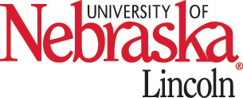
Nebraska Extension is a Division of the Institute of Agriculture and Natural Resources at the University of Nebraska-Lincoln cooperating with the Counties and United States Department of Agriculture.

Nebraska Extension educational programs abide with the nondiscrimination policies of the University of Nebraska-Lincoln and the United States Department of Agriculture.

SPECIAL AGRONOMY PROJECT
The Nebraska Extension Special Agronomy Project gives 4-H members an opportunity to experience a crop that is grown, was grown or has the potential to be grown in Nebraska. Youth participate by receiving seed and resources to grow the crop, research traits of the crop and determine the viability of that crop in the part of the state they live in.
The project allows 4-H members interested
in agronomy to grow something fun, new, and different. This year, we will be exploring a crop that can be marketed different ways depending on the variety.
In the sixth year of the special agronomy project, youth will explore popcorn. There are two varieties of popcorn; Nebraska Red and Robust 997.
Be eligible to enter an exhibit at the County and/or State Fair in the agronomy project area.
Enroll for the 2026 Special Agronomy Project through 4-H Online by enrolling in the Agronomy project and returning the enclosed registration form along with payment to the Platte County Extension Office.

TIME TO ENROLL IN 4-H
4-H Members, Volunteers/Leaders and Council Members must re-enroll every year! Cost is $5.00 per 4-H’er. No cost to leaders, volunteers, or Council members.
The enrollment website is https://v2.4honline.com or you can go to our county website at http://platte.unl.edu for enrolling or re-enrolling instructions to the 4-H Online enrollment website. Google Chrome and Firefox are the recommended web browsers to use when enrolling online.
If you have enrolled in 4-H in the past, no need to set up a new account.
Any questions, please contact Sandra at the Extension Office at 402-563-4901 or send an email to sswanson5@unl.edu.


2026 SPECIAL GARDEN PROJECT

The local Extension Office will order and distribute the seeds to members. Deadline to contact Extension Office is March 1 to participate in the Special Agronomy Project.

ATTN HIGH SCHOOL JUNIORS & SENIORS: UNL RED LETTER DAYS
Experience for yourself what life is like as a student at UNL. During your Red Letter Day, you'll tour campus with a current student, eat lunch in a dining center, learn about student engagement opportunities and resources for success and delve into your career path during academic sessions. You'll also tour one of our suite-style residence halls and learn more about housing.
Because Red Letter Days fill up quickly, we encourage you to reserve your spot early. Walk-in registration is open only on a space-available basis the day of the event.
Red Letter Days: February 13, March 6, April 10, and May 1. To see a sample schedule and to register go to: https://admissions.unl.edu/events/on-campus/red-letter-days/
If you have any questions about this event, please contact the Nebraska Office of Admissions at 402-472-2023.

Office Closed – Monday, February 16

The Special Gardening Project lets 4-H members try their hand at growing unusual vegetables, flowers, fruit, and herbs. The project allows experienced 4-H gardeners to grow something fun, new, and different while letting those new to gardening get their hands dirty in this project area.
The 2026 Special Garden Project will focus on the Alumia Vanilla Cream Marigold. This marigold produces creamy, yellow flowers on compact plants. This variety not only has a unique color, but it also has a very long bloom time.
This project is open to all youth of 4-H ages 5-18 and it will give them the opportunity to learn about growing, harvesting, and exhibiting this unique flower.
Youth are encouraged to enroll in a Horticulture project through 4-H Online. Look for registration form on March 4-H newsletter to receive seeds in the Spring.

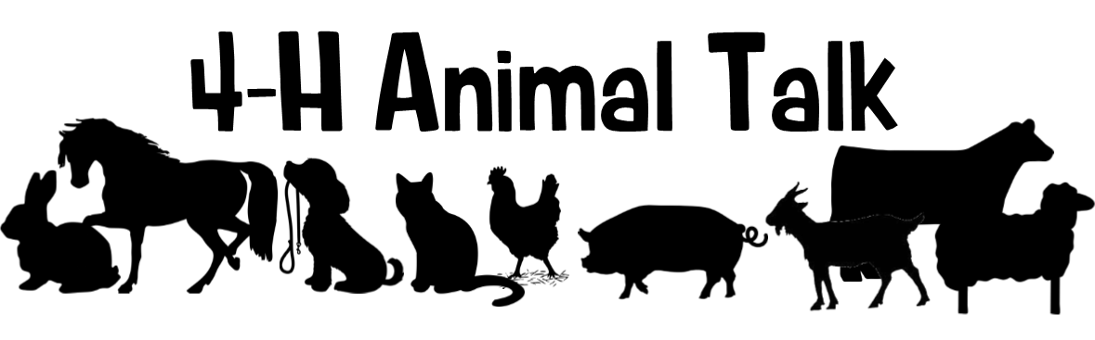
YQCA: If 4-H youth are planning on exhibiting beef cattle, dairy cattle, swine, sheep, goats, poultry, or rabbits, they must complete a Youth for the Quality Care of Animals (YQCA) training again this year! Blake Wert will be offering Instructor-Led trainings at the Platte County Extension Office. The deadline for youth to complete YQCA is Friday, May 29.
Registering for quality assurance will be done online through the YQCA website (yqcaprogram.org) using the Family 4-H Online login for active youth. If you are involved in both 4-H and FFA, please register through the 4-H login. The cost for instructor-led training sessions are $3, while online trainings are $12. Payment is made online at the time of registration. Youth must register before attending an in-person session. These instructor led trainings will last approximately one hour, and the following dates have been set.
Friday, March 13 - 10:00 – 11:00 a.m.
Monday, April 20 - 6:00 – 7:00 p.m.
Monday, May 11 - 7:30 – 8:30 p.m.
Friday, May 22 - 3:00 – 4:00 p.m.
YQCA Scholarship Opportunity: The Youth for the Quality Care of Animals (YQCA) is proud to announce a scholarship fund for 2026! This opportunity is available to youth who are certified in YQCA and are currently high school seniors or up to age 21, with plans to pursue a degree or trade in agriculture. Scholarship applications will close on February 15th. For more details and to apply, visit YQCA - Youth for the Quality Care of Animals. For questions, feel free to reach out to YQCA at help@yqcaprogram.org.

Nebraska State Fair Livestock Nominations: Nominations are done in Show Stock manager (www.showstockmgr.com) with opening day of the site on February 1! State fair EID tags and DNA envelopes are available at the Extension Office. The deadline for ALL online nominations is Monday, June 15.
Important Nebraska State Fair Livestock Update: Exhibitors that want to show an animal at the NSF and Aksarben Stock Show (AKSS) will be required to submit two separate envelopes and online nominations. AKKS exhibitors will be ordering and purchasing their DNA envelopes through the AKKS website – https://www.aksarbenstockshow.com/. The DNA process and the online nomination process will be separate for each livestock show! * Direct all AKSS questions to the AKSS website! *

Nebraska 4-H Livestock Achievement Program: This program provides an additional opportunity for enrolled 4-H livestock project youth to strengthen their knowledge and leadership skills across all aspects of livestock projects, including selection, production, leadership, and exhibition. The program recognizes Members of Excellence in the following livestock project areas: beef, sheep, meat goat, swine, dairy cattle, dairy goat, rabbit, and poultry. Youth who complete the program and earn Member of Excellence recognition will be recognized during the Grand Drive during the 4-H weekend at the Nebraska State Fair. Applications are due June 15 and Plan and Project Records are due August 1. For more information and to apply, visit https://go.unl.edu/lap
ATTENTION LIVESTOCK JUDGING ENTHUSIASTS
We are excited to announce that Platte County is a part of the Heartland Triple Crown Livestock Judging Series. Get ready for an unforgettable three-day livestock judging experience! The Heartland Triple Crown Livestock Judging Series is coming June 17–19, 2026, bringing together youth from across the region for

competition, learning, and celebration as the Great Plains Judging Circuit wraps up its season. This three-day event is open to all states.
Participants will take part in 10 placing classes, enjoy a clinic, and compete for awards in each age division and species. With events hosted in Columbus, Bladen, and Nelson, Nebraska, each day offers something unique—plus fun evening activities, including a BBQ after-party and a final banquet and awards ceremony.
Whether you're a seasoned judge or new to the arena, this is the perfect opportunity to sharpen your skills, meet fellow competitors, and close out the circuit in style.

� June 17–19, 2026
�•� Columbus • Bladen • Nelson, Nebraska
� Registration details available at: https://go.unl.edu/lj26
Join us for three exciting days of livestock evaluation, learning, and community. We can’t wait to see you there! More details to come for each day.

PASE: The Nebraska 4-H Premier Animal Science Event (PASE) features a variety of state level animal science contests. Youth have the opportunity to participate in livestock contests that do not require owning or exhibiting a live animal, including livestock, meat, poultry, companion animal, and animal welfare judging, as well as livestock skill-a-thon and livestock quiz bowl. Youth can participate in more than one contest or event as their schedule allows.
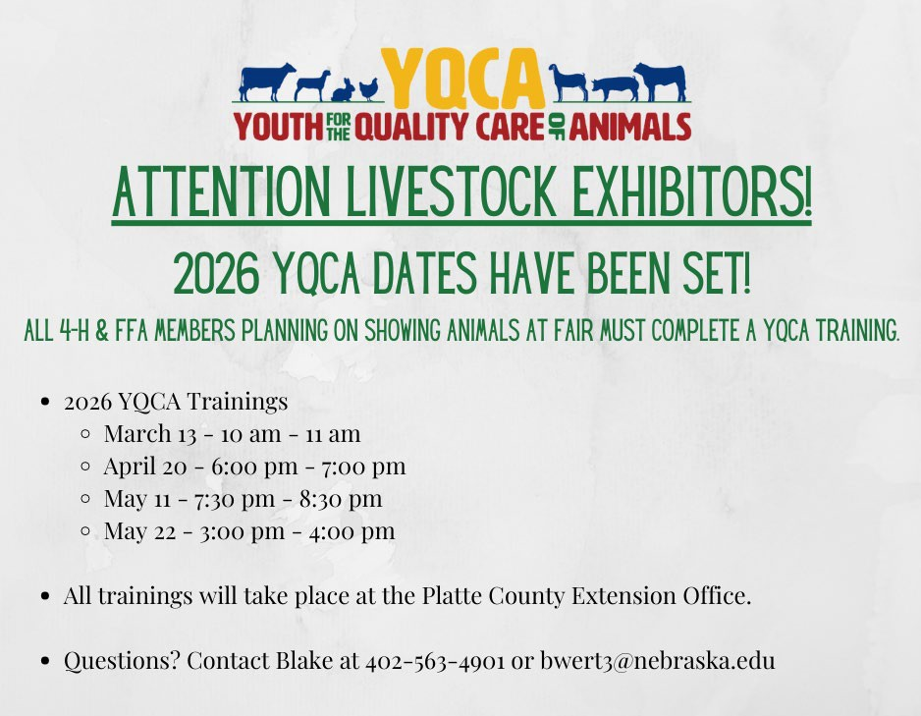

TeIf you are interested in competing at PASE, please fill out this Google Form – https://go.unl.edu/t9cb or scan the QR found at right. Livestock Judging and Skill-a-thon practices will begin end of April with most practices being in the evenings. Please sign up by April 3rd to give 4-H Staff time to prepare the materials. Those interested would practice at the Extension Office and would compete on May 27-29 in Lincoln. For more information about the contests, go to Premier Animal Science Event Contests | Nebraska 4-H | Nebraska. Any questions, feel free to reach out to Blake!

Minutes for the Platte County 4-H Council
Monday, January 26, 2026 - 7:30 p.m. at Nebraska Extension – Platte County

Call meeting to order – Cory Osten, President Roll Call – Julie Kreikemeier, Secretary
- Members in attendance were Kenna Dicke, Marissa Hellbusch, Brigen Kinnison, Adelle Kinnison, Crystal Klug, Alivia Kreikemeier, Julie Kreikemeier, Cory Osten, Shelley Reichmuth, Gina Renner, Sandi Seckel, Stephanie Schmidt, Kristy Spawn, Rachel Spawn, Kim Went, and Logan Went. Staff in attendance were Hailey Held, Sheila Hoppe, and Blake Wert.
Approval of minutes of last meeting – Julie Kreikemeier – Stephanie Schmidt motioned to approve minutes as presented. Crystal Klug seconded the motion; motion carried.
Correspondence – Julie Kreikemeier – no report
Treasurer’s Report – Brigen Kinnison – Kim Went reported as Brigen is transitioning into the treasurer’s position - $33, 617.14 current balance
4-H Revolving Account Report – Office - $2759.26 current balance

Committee Reports:
- Executive Committee – Cory Osten – Executive board updated budget, which will be voted on later in the meeting. The budget items had little to no change besides adding expense for robotics.
- Extension Board Liaison Report – Stephanie – There was a meeting on January 13th for new members to transition in. Next meeting will be February 10th. Stephanie is unable to attend February meeting and ask if representative could be there to get information. Brad Christensen remaining president for the Extension Board.
- Beef Efficiency – Travis Dicke – Market Cattle and Pen of 3 weigh-in will be held January 31st from 10:00 a.m. to 12:00 p.m. at Columbus Sale Barn.
- Livestock Sale – Logan Went – Committee met in December. The only major decision made was to change the livestock sale order only for grand and reserve. New official wording will be in the 2026 Animal Exhibitor Handbook.
  - Recognition – Crystal Klug – ask for the committee to stay after January 26th meeting.
  - Scholarship & Awards – Shelley Reichmuth - Only one scholarship was submitted. The committee members reviewed and scored the scholarship on January 26th.
  - Pop & Food Stand – Stephanie Schmidt – no report
  - Jr. Leaders – Marissa Hellbusch & Rachel Spawn - First meeting was held on January 5th. One point of discussion was possibly having Jr. Leaders at the promotion night.
  - Other - Staff Reports - Sheila Hoppe reported that they are continuing to work on final details for the 2026 Platte County Fair Book and that Ozobots are wrapping up for 4th graders. Blake Wert reported that they are heavy working on fair prep, planning summer events, and Life on the Farm (March 3rd). Hailey Held reported that the Clover Workshops scaling back a bit due to her being on maternity leave this spring. There will be more options sent for at-home project ideas.
Education: Sheila Hoppe welcomed 4-H council members. She also reminded the youth that they are active members and to make sure to share as much as the adults.

Unfinished Business:
    - County Fair Suggestion Box:
      - Showmanship at end of shows - Blake did research – has seen showmanship both ways, pros and cons both ways as well. Decision was made to leave showmanship at the beginning of each show.
      - More contestants in Round Robin Showmanship – Concerns on money for budgetary reason, could make the show longer, already having to go to the 3rd place
        - Decision was made to leave it at 4 contestants

New Business:
    - Journey Pritchard Memorial Money - Journey Pritchard’s family donated $1420 to 4-H in honor of Journey. Blake Wert is working with family to decide on how funds will be used to benefit beef and dairy exhibitors. Journey’s brother will show her dairy cow in Journey’s honor. Family is very appreciative. Blake read the very appreciative thank you notes from the family.
    - Council members 4HOnline Enrollment (instructional handout) – Hailey Held handed out instructional handout to help members to get signed up. Hailey reported currently there are 17 volunteers enrolled and 141 youth enrolled.
    - 4-H Club Leader Training – Reported there was a good turnout of leaders. Extension staff handed out new games, went over changes that came throughout the year, and went over deadlines and expectations.
    - State Horse Show & Fair Stalling – Blake Wert reported that the State Horse Show is July 11-15, which is during the fair. Therefore, exemption letters for not stalling horses must be submitted to the Extension office by June 15 at 5:00 PM. This information will be in the 2026 Platte County Fair Book as well and in the Animal Exhibitor Handbook.
    - County Fair & Fair Challenge Themes – Stars, Stripes, County Fair Nights will be the theme for the 2026 Platte County Fair. 4-H is a Rainbow of Possibilities is the theme for the Challenge Projects for the Platte County Fair.
    - Looking for new Fair Award Sponsors – Discussion was to make council members know that new sponsors are always welcome to cover any sponsors that don’t want to donate off the current list.
    - Family & Recruitment Night - February 10th at Pizza Ranch 5:00 p.m. to 8:00 p.m.
    - Jr. Camp Update – Dates for camp: June 3rd-5th. Recruiting 4-H members ages 8-12 to attend the camp. Also looking for camp counselors that are 16-18, need both male and female.
    - Market Cattle Weigh-In / Livestock Sale Committee Meeting - See above
    - YQCA, PASE Contest, Showmanship Clinic & Heartland Triple Crown Livestock Judging Series
      - YQCA is required if showing livestock at fair. Dates are in the newsletter. May 29 is deadline for certificates to be turned in at the Extension Office.
      - PASE Contest is May 27-29. Blake Wert was invited to be on the executive committee to help plan out agenda for the event. February newsletter will have more details for who want to participate with a Google Form to sign up. Skill-a-thon and PASE practices to begin at the end of April.
      - Platte County Showmanship Clinic will be held June 13th from 8:30 a.m. to 12:30 p.m. Planning to make it part of the summer workshops. More info in newsletters coming out.
      - Heartland Triple Crown Livestock Judging Series will be held June 17th – 19th. Fliers will be sent out in upcoming 4-H Newsletters. Day 1 will be held in Columbus, Day 2 in Bladen with evening events, and Day 3 in Nelson with evening banquet and award event.
    - Ag Park & County Fair Update - Ag Society meeting on January 26th. Therefore, no report.
    - Budget – discussion was had during the committee reports. Crystal Klug made a motion to approve the 2026 4-H Council budget. Shelley Reichmuth seconded the motion. Motion carried

Other Business:
  - Discussion was held on possible sponsorships for fair ribbons.

Stephanie Schmidt made a motion to adjourn the meeting at 8:30 p.m. Shelley Reichmuth seconded the motion. Motion carried.
Minutes respectfully submitted by Julie Kreikemeier


Pizza Ranch Fundraiser

Join us at the Columbus Pizza Ranch on Tuesday, February 10th
10% of sales

from 5-8pm will be donated to Platte County 4-H.


We invite you to join us in any manner you feel comfortable. All sales support Platte County 4-H

HEARTLAND TRIPLE CROWN
LIVESTOCK JUDGING SERIES
JUNE 17-19, 2026

Join us for the Three-Day Livestock Judging Showdown!
Celebrate the end of the Great Plains judging circuit with three exciting days of competition, fun, and recognition.
🏆 Awards for each age division and species 10 placing classes
Pricing details on registration

Day 2 — Bladen, NE

Day 3 — Nelson, NE
📍 Location: Fairgrounds 1256 RD 3300
Nelson, NE 68961
registration: 9:00-9:30 am
🕙 Judging begins: 10:00 AM
🎉 Evening Banquet & Awards Ceremony: 5:00 PM

Day 1 — Columbus, NE
📍 Location: Ag park 822 15th St.
Columbus, NE 68601
registration: 8:15-9:00 am
cLINIC: 8:45 - 9:45 AM
🕙 Judging begins: 10:00 AM
📍 Location: Fairgrounds 459 N Crescent St.
Bladen, NE 68928
registration: 9:00-9:30 am
🕙 Judging begins: 10:00 AM
🍔 Evening After Party: 5:00 PM — BBQ & Games

FOR QUESTIONS OR REGISTRATION DETAILS, CONTACT: PLATTE COUNTY EXTENSION: 402-563-4901
WEBSTER COUNTY EXTENSION: 402-746-3417
Register here: https://go.unl.edu/lj26


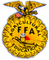






SOUTHERN PLAINS COUNTY EXTENSION: 402-225-2381 OR 402-768-7212 FIND MORE DETAILS ON OUR BROCHURE
THE UNIVERSITY OF NEBRASKA DOES NOT DISCRIMINATE BASED UPON ANY PROTECTED STATUS. PLEASE SEE GO.UNL.EDU/NONDISCRIMINATION.


A klD
A DOG?
lJAtlT


vow!
- LEAtttl HOW TO IJO,tk WITH 'IOU,t DOG
- TRAIii 'IOU,t DOG TO DO T,tlCkS

LEAtttl LEADE,tSHle SklLLS

- l'IAkE tlEIJ FRIEtlDS

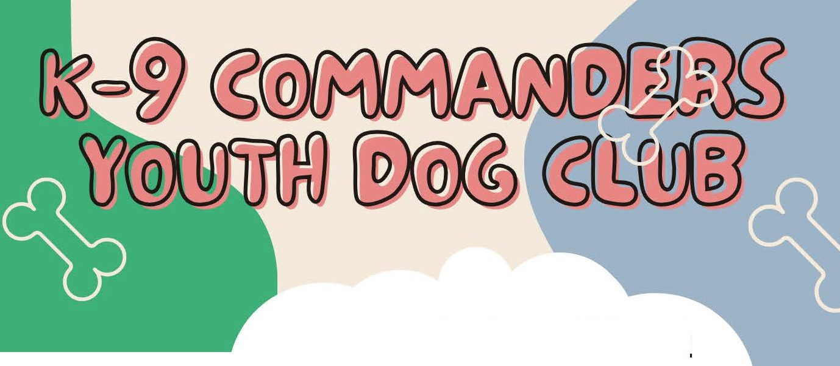




flRST CLUB l'IEETltl_G
TUESDAY, F£81(UAl('l 10
6=00 Pl'I@ AG PAl(k, COLUMBUS

Aft£ '10. AtlD HAVE THEIi WE

ANY QUESTiONS CONTACT:SUSAN LiTTLEF'iELD SUSAN@AMERiCANAGNETwoRk.COM
•EXT•ENSION
Platte County


2026 FAIR CHALLENGE
4-H IS A RAINBOW
OF POSSIBILITIES

YOU CAN CHOOSE ANY PROJECT IN ANY AREA THAT COULD RELATE TO THE TOPIC
OF 4-H IS RAINBOW OF POSSIBILITES. THIS COULD BE A CAKE IN THE SHAPE OF A RAINBOW,
A COLOR WHEEL USING ANY TYPE OF MATERIALS, OR ANY PROJECT THAT MIGHT INCORPORATE A RAINBOW IN SOME WAY.
YOUR IMAGINATION IS THE LIMIT!


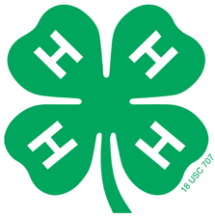
2026 Communication Event
Contests: Speech, Impromptu Speech, PSA, Presentation, Video
Event Date & Time: Sunday, April 12, 2026; 4:00 p.m.
Location: West Education Center, Room 205, Central Community College, Columbus
Registration: Online pre-registration required. Registration deadline is April 1, 2026.

Speech Contest

Age Categories, Time Limits, Topics:
- Clover Kid (ages 5 - 7 as of January 1st of current year)
3 minutes or less. Talk about anything! You may read a poem or a favorite story.
- Junior (ages 8 - 10 on January 1st of current year)
2 – 3 minutes. Must be an original speech relating to 4-H.
- Intermediate (ages 11 - 13 as of January 1st of current year)
3 – 5 minutes. Must be an original speech relating to 4-H.
- Senior (ages 14 - 18 as of January 1st of current year)
5 – 8 minutes. Must be an original speech relating to 4-H.

Contest Guidelines:
- All speeches must be original and include 4-H as the major component of the speech.
- Many speakers in the Public Speaking Contest have given speeches in other contests. This is fine; however, previous speeches may not be used verbatim for the 4-H contest. It is okay to use the same ideas from a speech previously delivered in competition, but it must be 4-H related. Enough changes should be made to make that speech new to the speaker and the audience. 4-H public speakers may not use an old speech written by a sibling, another 4-H member, or anyone else.
- Acknowledge the source of information used in the speech. For example, an article from a magazine may be used for reference but should not be quoted directly unless you tell the audience your source.
- Organization: Introduction, body, and conclusion.
- Use of visual aids and props is not allowed. Notes may be used for Clover Kid & Novice categories.
- Delivery: Eye contact, timing, gestures, and posture.
- Voice: Clear tones, correct volume, and good pronunciation.
- Dress appropriately. Do not wear costumes or special effect clothing. 4-H Chevron required.
- No team speeches are allowed.
- 4-H’ers who are 8 years old and older as of January 1 of the current year will be eligible for the Premier Communication Event (State Contest). Youth must be selected at the County Contest to compete in the Premier Communication Event.


Nebraska Extension is a Division of the Institute of Agriculture and Natural Resources at the University of Nebraska–Lincoln cooperating with the Counties and the United Sates Department of Agriculture.
Nebraska Extension educational programs abide with the nondiscrimination policies of the University of Nebraska–Lincoln and the United States Department of Agriculture.
© 2026

Impromptu Speech Contest

Age Categories, Time Limits, Topics:
- Junior (ages 8 - 10 as of January 1st of current year) 1 1/2 minutes.
- Intermediate (ages 11 - 13 as of January 1st of current year)
3 minutes.
3 Senior (ages 14 - 18 as of January 1st of current year)
5 minutes.

Contest Guidelines:
- Competition will give youth the opportunity to write and present a speech around a 4-H related topic that they select during the competition.
- Given 15 minutes to develop and prepare for their presentation. Participants will then deliver the speech to judges and audience members.
- Example topic: My Day in 4-H
- Only individuals may compete in this class; no team entries allowed.
- 4-H’ers who are 8 years old and older as of January 1 of the current year will be eligible for the Premier Communication Event (State Contest).

Contest Resources:
The following resources can be found online at: PCE Impromptu Speech Scoresheet.pdf

Public Service Announcement (PSA) Contest

Age Categories, Time Limits, Topics:
- Junior (ages 8 - 10 as of January 1st of current year)
- Intermediate (ages 11 - 13 as of January 1st of current year)
- Senior (ages 14 - 18 as of January 1st of current year)

Contest Guidelines:
- All PSA’s are 60 seconds in length.
- Youth will prepare a PSA around the theme: "Ready Today, Leading Tomorrow”
- All radio PSA’s must promote 4-H and be general enough to be used anywhere in Nebraska at any time of the year.
- All 4-H PSA’s must include the following tag line within the last ten seconds of the PSA: “Learn more about the Nebraska Extension 4-H Youth Development Program at 4h.unl.edu.” The tagline is included in the 60-second time limit.
- Sound effects and public domain music may be used. Copyrighted material may not be used.
- All PSA’s must be the original work of the presenter. Contestants may not use PSA’s written and provided by the state or national staff.
- No team PSA’s are allowed.
- Scoring is based on the content of the material and delivery.
- Appearance and gestures are not judged.

Nebraska Extension is a Division of the Institute of Agriculture and Natural Resources at the University of Nebraska–Lincoln cooperating with the Counties and the United Sates Department of Agriculture.
Nebraska Extension educational programs abide with the nondiscrimination policies of the University of Nebraska–Lincoln and the United States Department of Agriculture.
© 2026

- County Contest Only: Participants may read their PSA at the contest or submit it electronically in a .wav or .mp3 audio format on a flash/jump drive to be played at the contest.
- If selected to go onto the Premier Communication Event (State Contest), radio PSA’s will be submitted electronically as a .wav or .mp3 audio format. No CDs accepted.

Contest Resources:
The following resources can be found online at: https://extension.unl.edu/statewide/platte/platte-county-4-h-resources/
- Guide to Making Great Speeches/How to Prepare a 4-H Radio Public Service Announcement

Presentation Contest
Categories:

Show 'n Tell (County Only)
  - Description: A live presentation with a formal talk where youth will use visual aids (such as props, posters, computer-based visuals, handouts, video, etc.) to show and tell others how to do something.
  - Age: Clover Kids Only
  - Time Limit: up to 5 minutes individual, no team presentation available for this class

Illustrated Presentation (Premier Communication Event Eligible)
  - Description: An Illustrated Presentation involves one or two 4-H’ers giving a live presentation with a formal talk where the presenter(s) will use visual aids (such as props, posters, computer-based visuals, handouts, video, etc.) to show and tell others how to do something. All presentation topics should be related to what the 4-H youth is learning through 4-H educational experiences. Participants will be penalized if their presentation exceeds the time limit.
  - Individual or Team: An Illustrated Presentation may be given by one (1) individual or a team of two (2) individuals. If team members are not in the same age division, they must compete in the age division of the oldest team member.
    - Individual - Junior Division (ages 8 - 10 as of January 1st of current year); Length: 3-5 minutes
    - Individual - Intermediate Division (ages 11 - 13 as of January 1st of current year); Length: 6-8 minutes
    - Individual - Senior Division (ages 14 – 18 as of January 1st of current year); Length 6-8 minutes
    - Team - Junior Division: 5-7 minutes
    - Team - Intermediate and Senior Divisions: 8-10 minutes

Contest Guidelines:
- Presentations must include an introduction (the "why" portion of the topic), a body (the "show and tell" portion of the topic) and a conclusion/summary (the "what" portion of the topic).
- Each participant is required to wear the 4-H chevron, 4-H emblem, or 4-H shirt.
- All categories require the presence of the contestant(s).
- The judge views the entire presentation and engages in a question-and-answer session following the presentation.
- 4-H’ers who are 8 years old and older as of January 1 of the current year will be eligible for the Premier Communication Event (State Contest). Youth must be selected at the County
Contest to compete at Premier Communication Event.

Nebraska Extension is a Division of the Institute of Agriculture and Natural Resources at the University of Nebraska–Lincoln cooperating with the Counties and the United Sates Department of Agriculture.
Nebraska Extension educational programs abide with the nondiscrimination policies of the University of Nebraska–Lincoln and the United States Department of Agriculture.
© 2026

Contest Resources:
The following resources can be found under Contest Resources on-line at: https://extension.unl.edu/statewide/platte/platte-county-4-h-resources/
- The Versatile 4-H Presentation
- The Four Ps of Planning a Presentation
- Getting Ready to Give a 4-H Presentation
- Presentation Visuals
- Using PowerPoint in 4-H Presentation
- Evaluating a 4-H Presentation
- How to Prepare a Multimedia Presentation

Video Communication Contest

Video Communication (Premier Communication Event Eligible)
- Description: The video communication contest allows youth to create a multi-media video around a theme related to 4-H. Judges will be evaluating both the organization of information as well as the audio and video production.
- Age: 8 – 18 as of January 1st of current year
- Time Limit: 60-90 seconds individual only

Contest Guidelines:
- Youth may use a phone, laptop, or tablet to create a multi-media piece around the theme: “Ready Today, Leading Tomorrow”.
- Sound effects, public-domain music, and graphics can be used. Copyrighted materials may not be used.
- For county contest only, the 4-H’er must be present to play video. If selected to go onto Premier Communication Event (State Contest), the video will be electronically submitted as MP4 files.

Contest Resources:
The following resources can be found under County Resources online at: https://extension.unl.edu/statewide/platte/platte-county-4-h-resources/
- Video Communication Judging Criteria

2026 Communication Event On-Line Registration
Deadline April 1, 2026
Log into your 4HOnline family account at https://v2.4honline.com/ Click “View” button next to 4-H’er who is registering for contest.
Click on “Events” button stated down the lefthand side.
Click on blue “Register for a new event” button.
Select 2026 Communication Event (Butler, Colfax, Platte) – Click Next Select Category and Click on “Start Registration”

Nebraska Extension is a Division of the Institute of Agriculture and Natural Resources at the University of Nebraska–Lincoln cooperating with the Counties and the United Sates Department of Agriculture.
Nebraska Extension educational programs abide with the nondiscrimination policies of the University of Nebraska–Lincoln and the United States Department of Agriculture.
© 2026



2026 Special Agronomy Project – Popcorn!
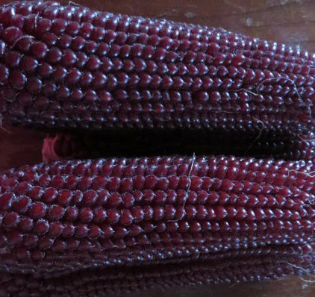
Nebraska Red heirloom popcorn
- Explore two varieties of popcorn! Nebraska Red is an heirloom variety discovered and developed by an eastern Nebraska Farmer. Robust 997 is a commercial variety.
- Enter an exhibit/s at County and/or State Fair
The Nebraska Extension Special Agronomy Project gives 4-H
members an opportunity to experience a crop that is grown, was grown or has the potential to be grown in Nebraska. Youth participate by receiving seed and resources to grow the crop, research traits of the crop and determine the viability of that crop in the part of the state they live. The project allows 4-H members interested in agronomy to grow something fun, new, and different.
$3.00 per Family –Clip and return form below with payment by March 1st to receive seeds! Must enroll in Agronomy Project in 4-H Online.
4-H members enrolled in the Special Agronomy Project will:
- For 2026, each youth will receive 2 ‘packets’ of seeds in April
- Grow their seeds in their garden – recommended not to plant sweet corn due to cross pollination potential, but dent corn won’t impact the popcorn and these two varieties when planted at the same day will pollinate at different times.
- Receive written resource materials
- Be eligible to enter an exhibit at both the County and/or State Fair in the agronomy project area:
  - G750011 - Special Agronomy Project - Educational Exhibit (SF259)
  - G750012 Special Agronomy Project - Video Presentation
  - G750013 Special Agronomy Project - Freshly Harvested Crop
2026 Special Agronomy Project Fee
I’m enclosing my $3.00 fee with this form to cover the cost of seed and mailing of seed/newsletter.
Make checks payable to: University of Nebraska-Lincoln
Mail form and payment to “Special Agronomy Project” Nebraska Extension – Platte County, 2715 13th Street, Columbus, NE 68601

Name/s: Address: Email:

Nebraska Extension is a Division of the Institute of Agriculture and Natural Resources at the University of Nebraska–Lincoln cooperating with the Counties and the United Sates Department of Agriculture.
Nebraska Extension educational programs abide with the nondiscrimination policies of the University of Nebraska–Lincoln and the United States Department of Agriculture. © 2026

