COMPLETING A PHOTOGRAPHY EXHIBIT DATA TAG
Double check to be sure you are use the correct data tag. There are different data tags for each photography level. Current Data Tags last updated for 2020 are available at https://unl.box.com/v/4h-photography

Name: Include both first and last name.
Age: Include your 4-H age, or the age you were on January 1st of the current year.
County: Include the county where you are exhibiting – this will be required if the exhibit is select for State Fair.
Year in Photography: List the total number of years you have been enrolled in any 4-H photography project.
Years in the Current Level: The total number of years you have been enrolled in the current 4-H photography level.

Camera:

- Indicate the brand make and model of the camera, such as Google Pixel 2, Nikon Coolpix B500, or Canon EOS Rebel T7.
- Indicate whether the camera is digital or film.
Tell us about this photo (special equipment, techniques, subject, location, goals, etc.). Use this space to tell the judges what you want them to know about the photo. For abstract photos, it might be a good idea to tell the judge what the subject is or how you took the photo. For especially unique images, tell the judge how you captured the image. For images where you used advanced equipment or tried a new technique, tell the judge about it here.
Describe any edits or changes made to the picture using digital software. Use this space to explain any digital manipulation done to the photo, including digital post-production filters, cropping, or any adjustments to exposure, contrast, etc. Explain what edits or changes were made, as well as what software was used. This include mobile/smartphone apps.

(The following questions are for Level 2 and 3 exhibitors only.)
Focal Length*: This is a number indicating the length of the lens which determines how much of a scene you are able to see through your viewfinder. This is typically measured in millimeters (mm).

Example: 29mm, 35mm, 50mm.
See Level 2 Activity 1 for more information.

Type/Source of light: Be as specific as possible. Identify whether the lighting was natural or artificial. If artificial, identify the light sources, such as camera’s flash, neon lights, car headlights, flashlight, etc. For natural light, identify the type, dawn, dusk, midday, reflected, diffused, direct, light shining through a window, etc.
Example: natural, midday direct sunlight
See Level 2 Activities 3 and 5 for more information.

(The following questions are for Level 3 exhibitors only.)
Shutter Speed*: This is the length of time a camera shutter is open to expose light into the camera sensor. Shutter speed is typically measured in fractions of a second when they are under a second. Slow shutter speeds allow more light into the camera sensor and are used in low-light situations, while faster shutter speeds help freeze motion. This might also be referred to as exposure time.
Example: 1/30, 1/125, or 1/500
See Level 3 Activity 1 for more information.
F Stop*: This is a number which indicates the size of the aperture, which allows light to travel into the camera. The aperture controls the depth of field. A larger aperture opening will result in a smaller depth of field. The aperture size is expressed in f numbers or f-stops.
Examples: f/1.4, f/4, f/22
See Level 3 Activity 1 for more information.
ISO*: This is a number that indicates a film’s sensitivity to light or more commonly its speed. It is typically measured in numbers, a lower number representing a darker image, while higher numbers mean a brighter image.
Examples: 100, 200, 400
See Level 3 Activity 1 for more information.
List advanced equipment and/or techniques used and/or what manual adjustment were made. Level 3 exhibitors should be exploring and experimenting with advanced techniques. This may include but does not necessarily require using a DSLR camera, manual adjustments, or other advanced equipment. Use this space to identify and, if needed, explain what advanced equipment or techniques were used to capture this image. If manual adjustments were made, identify which settings were adjusted (ISO, F Stop, Shutter Speed).

*Note: Regardless of whether or not you made manual adjustments or used special equipment, you must still identify this information. “Auto” is not an acceptable answer. Digital cameras automatically record this information for each photo captured. The information, referred to as Metadata, is attached to the image file and goes with it when the image is downloaded to a computer for example. There are many ways to access this data. See instructions below for more information.

Accessing Image Metadata on a PC Computer
Right-click the image file. Select “Properties” from the dropdown menu.
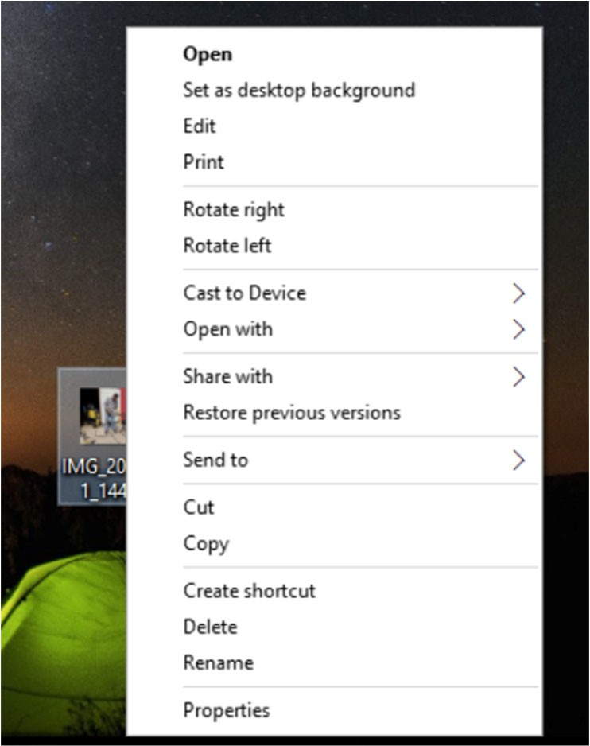

A pop-up window will appear.
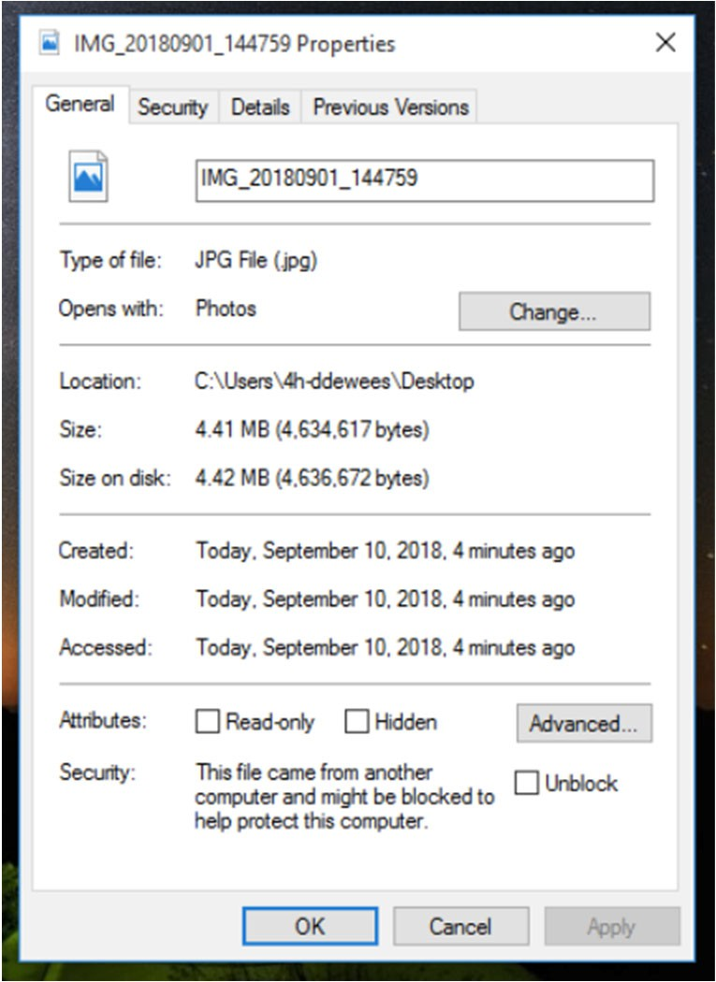

Select the “Details” tab.
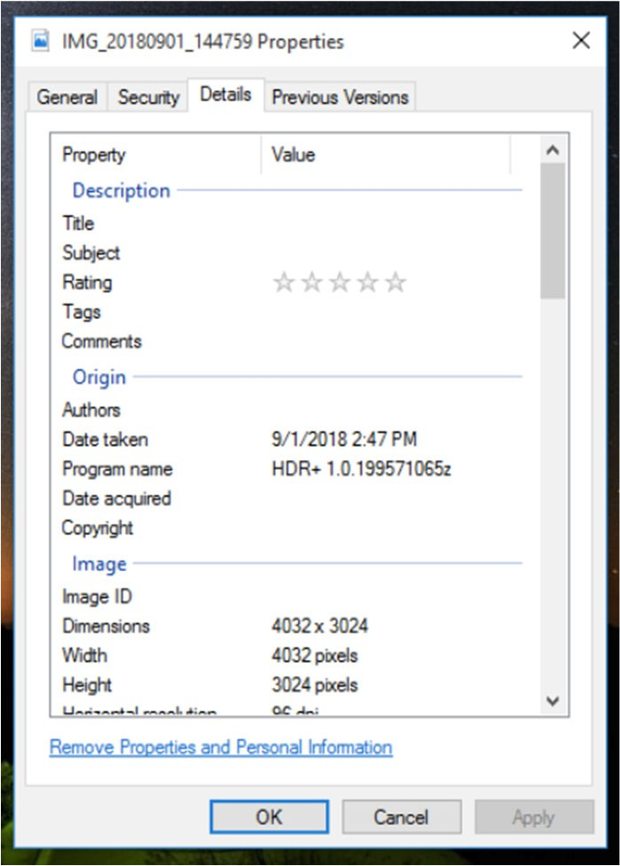

Scroll down to the section heading “Camera.”

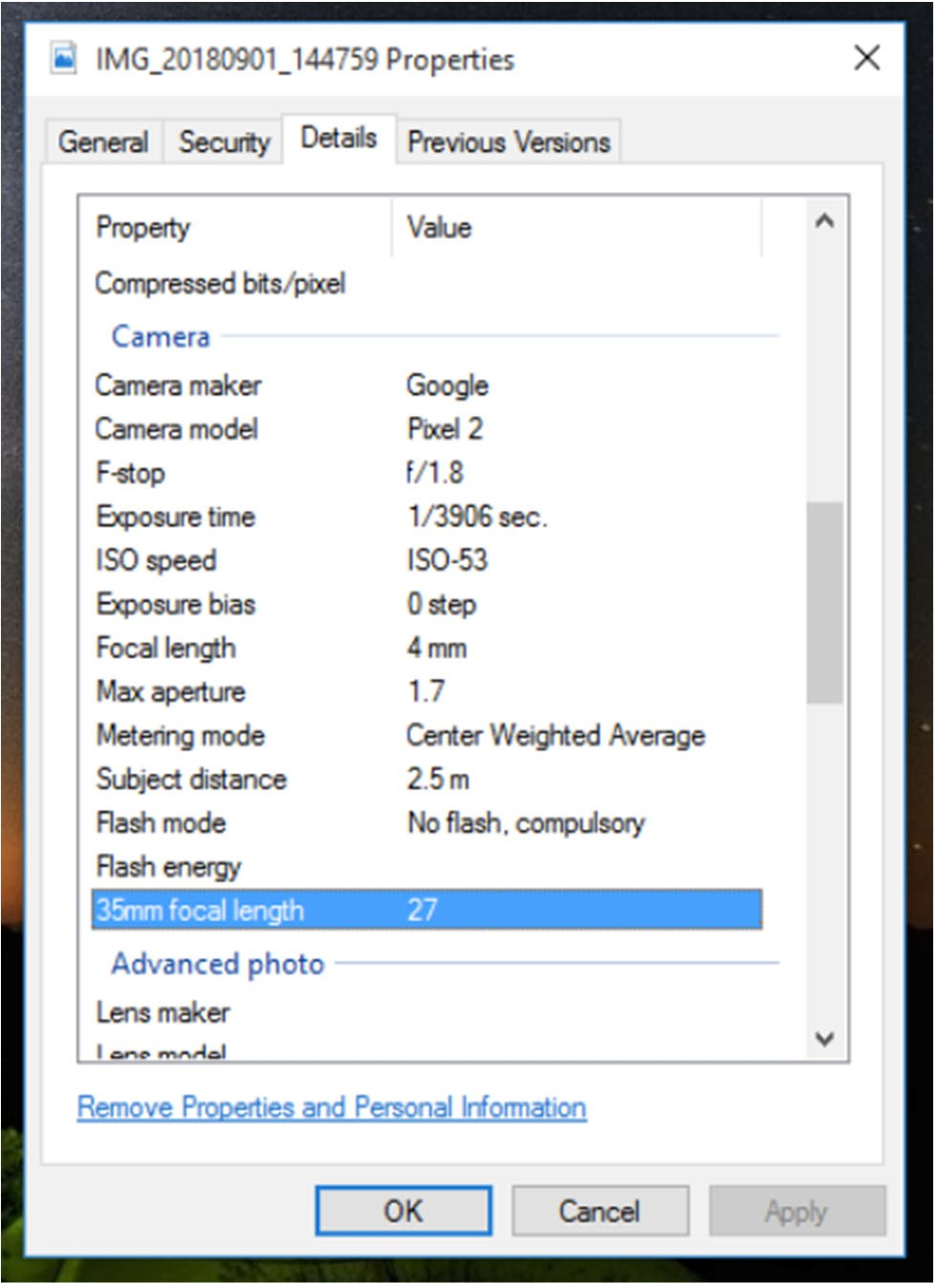
F Stop
Shutter Speed ISO
Focal Length

Accessing Image Metadata on a Mac Computer
Open the image file using the built-in Photos app.
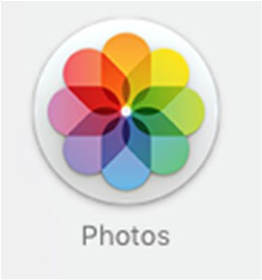
Right-click the image, and select “Get Info” from the dropdown menu.
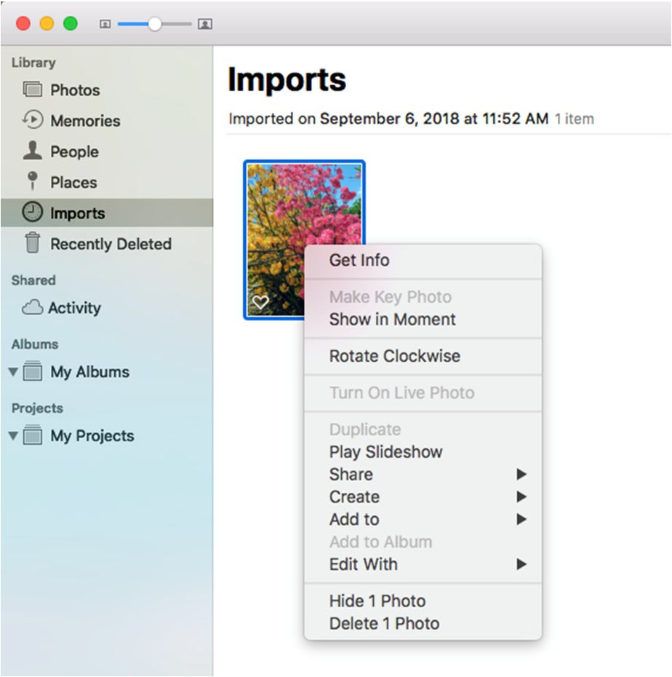
A pop-up will appear which provides the image’s metadata.

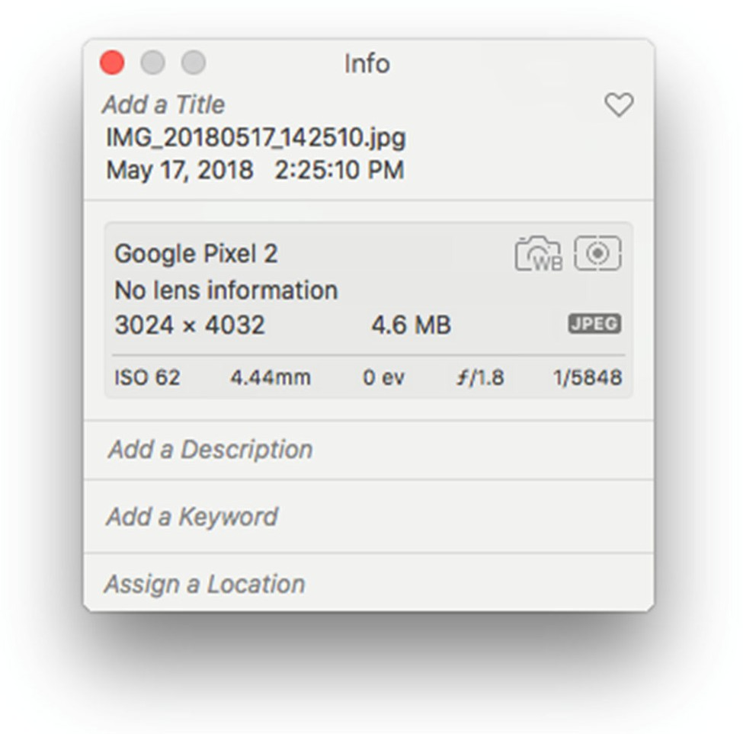
ISO

Focal Length F Stop Shutter Speed

