HOW TO PREPARE PHOTOGRAPHS
FOR 4-H FAIR EXHIBITS

GENERAL RULES
- 4-H members are allowed entries in only one level: Level 1, Level 2 or Level 3. Only 1 entry per class.
- An image may only be used on 1 exhibit with the exception of the Level 2 and Level 3 Portfolios which may include images entered in other classes.
- Cameras - Photos may be taken with any type of film or digital camera, including phones, tablets, and drones.
- Manual adjustments are encouraged for Unit 3.
- Photos must be shot during the current project year by the 4-H member with the exception of Level 2 and Level 3 Portfolios. Photos need to be appropriate for 4-H.
- Entry Tag must be securely attached to the upper right hand corner of displays or prints.
- Securely attach photos, mats, backing and data tags. Recommend double sided tape. Photos that are unattached will be disqualified. Do not use photo corners, borders, or place coverings over the exhibits. Do not include negatives.
- Instructions for Display: Mount three 4x6 photos on a single horizontal 11”x14” black or white poster or mat board. No foam board backing. Every photo on the picture display must be pencil numbered with lead pencil. Numbers should be readable but not detract from display. No titles, captions, or stick on numbers. Photos can be mounted vertically or horizontally. No frames.
- Instructions for Exhibit Prints: All exhibit prints are
8”x10” prints mounted in 11”x14” (outside size) cut matting with a sandwich mat-board backing (no foam board); rectangular or oval inside mat opening. Place photos horizontally or vertically as appropriate.
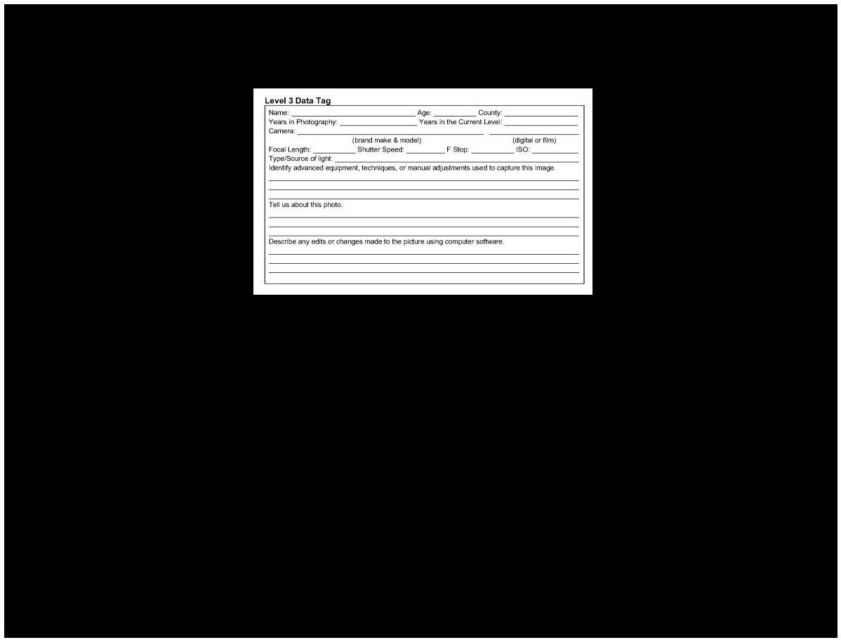
- Data Tags are required on the back of all photography exhibits. Level 1 Displays must have a level 1 data tag for each photo. Level 2 Prints - All Level 2 prints must have a Level 2 Data Tag. Level 2 Displays - Each photo in the display must have a separate Level 2 Data Tag. Data Tags should be numbered with the corresponding photo's number. Level 3 Prints - All Level 3 prints must have a Level 3 Data Tag. Portfolios -Each image in the portfolio must have a separate Level 3 Data Tag. See class description for more details.

DATA TAG SAMPLE PLACEMENTS
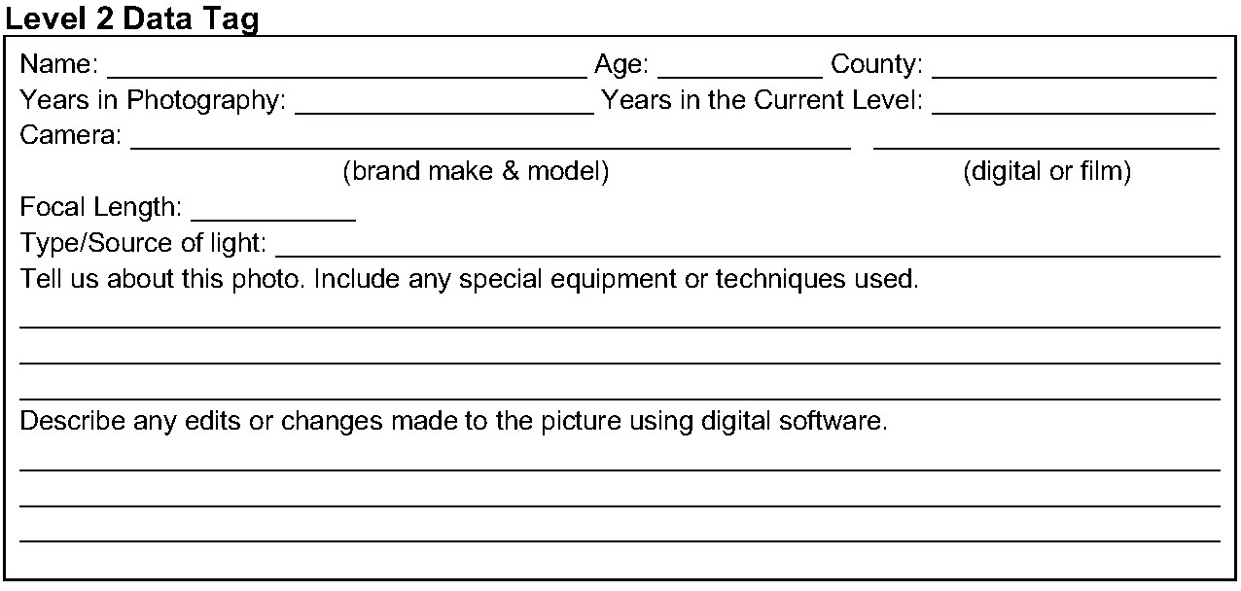
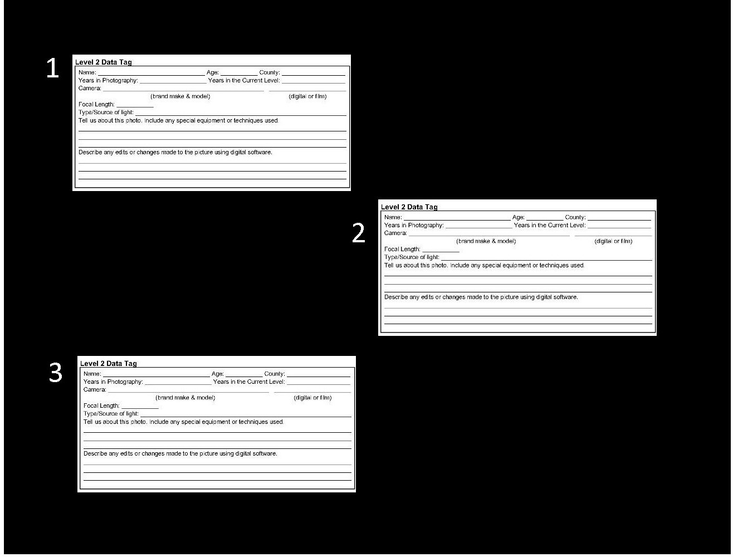

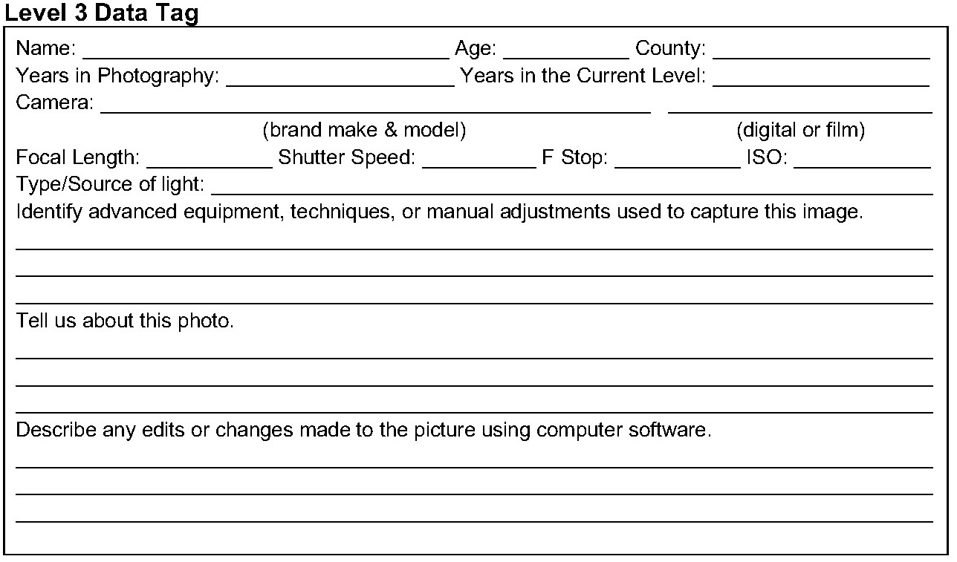

PHOTO DEVELOPING
Photos can be printed at retail or discount stores, professional photography stores or at online retail outlets. Results vary.
Sometimes quality is better at discount stores, sometimes prints are better at photography stores. Develop prints far enough ahead of time so you can have them redone if you are disappointed in the quality.

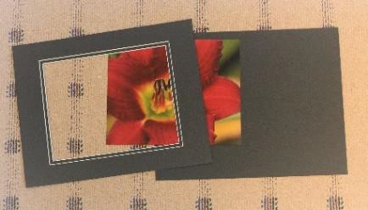
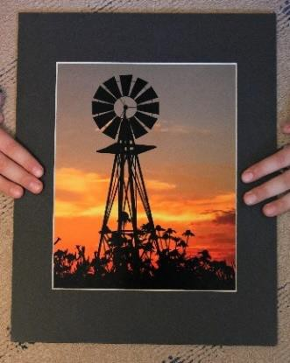
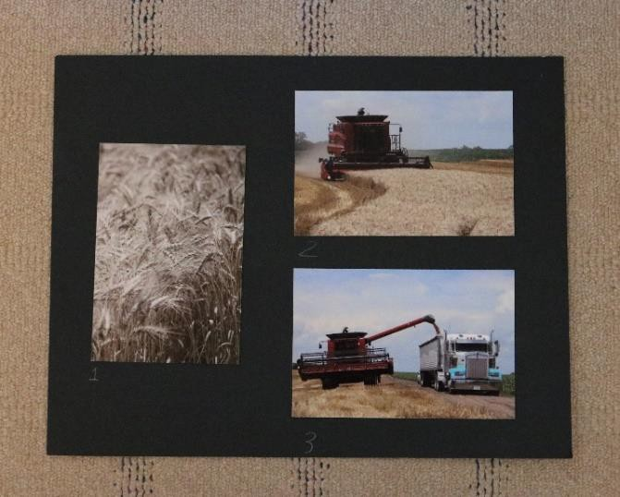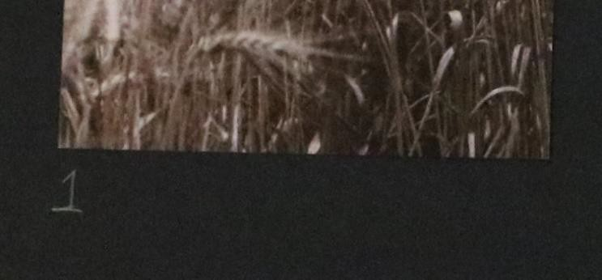
HOW TO PREPARE A SINGLE PRINT
- All exhibit prints are 8”x10” prints mounted in 11”x14” (outside size) cut matting (no frames) with a sandwich mat-board backing (NOT FOAM BOARD); rectangular or oval inside mat opening.
•
•
Place photos horizontally or vertically as appropriate.
Level 2 and Level 3 Data Tags are required. Securely
attach the Data Tag to the back of the photo project. Entry tag placed in upper right-hand corner.
- Choose a mat color which looks good with your photo. A color mat can overwhelm or detract from the subject in your photo, but some photos are enhanced by a color mat. Choose color carefully. Try to pick a color that is used in the photo. If you want a little color, try a double mat with a color inside border.
- Choose carefully when selecting a shape for your mat opening. Select a shape that truly enhances the photograph – rectangular and oval shapes are acceptable.
- Pre-cut 11”x14” mats (outside size) with rectangular or oval inside mat opening can be purchased at many discount, craft or art stores.
- For mat-board backing, some stores have pre-cut 11”x14” mat boards (without inside mat openings.) It can be cheaper to purchase 32”x40” mat-board or illustration board which can be cut down. Use an X-Acto knife to cut.
- Your photo is slightly larger than the mat opening. Place the mat slightly above the photo and move mat slightly from side to side and up/down until you decide which “cropping” (portion of the photo showing) looks best. Press down on the mat where the tape is underneath. This holds the photo to the mat. It is not recommended to put tape behind the 8"x10" photo.
HOW TO PREPARE PHOTO DISPLAYS
- Display on 11”x14” black or white poster or matting board.
- Display board MUST be HORIZONTAL. Photos may be horizontal OR vertical. It is best to have 1 photo vertical and 2 horizontal or 2 photos vertical and 1 horizontal. Positioning of the 3 photos is flexible – place how you think they look best.
•
•
•
Every photo must be PENCIL numbered 1, 2, and 3.
Data tags required on back of exhibit for each photo.
Entry tag is placed in the upper right-hand corner.
SUPPLIES
- Double-sided tape is recommended to securely attach photos and personal Data Tags with a good quality double sided tape.
- Black poster board can be purchased at many discount, craft or art stores. Size is usually 22”x28” (which you can cut into four 11”x14’ sheets.) Poster board can be cut with scissors or an X-Acto knife. Poster board is usually cheaper than mat-board, however, mat-board is more rigid and durable.
- Mat-board can be black or white on the front – it can be any color on the back.
Every photo must be numbered in pencil.

