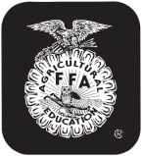

Last Name First Name(s) (and 4-H Age(s) if 4-H Project) 4-H Club or FFA Chapter Name County

Premise ID # (Mandatory) PQA # (Mandatory)

NEBRASKA 4-H and FFA MARKET SWINE OWNERSHIP AFFIDAVIT (Rev. 1/13)

4-H and FFA animals MUST be recorded on separate forms!

(Check one) □ 4-H □ FFA

Pig’s Right Ear Pig’s Left Ear Numbering of Universal Ear Notching System: Up to
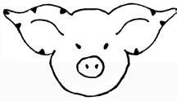
two notches can be made in each quarter of the ear, i.e.
9 27
9
3
3
1 1
4-H ONLY  Check Appropriate Box(es) For Show Eligibility |  | Please DRAW IN and write in universal numbers in the correct column.  You must have notches in both ears. Refer to universal notching system for pig numbers. Only those animals identified with ear notches will be eligible for  showing at State Fair.  Maximum 40 head per member |  |  |  |  |  | 4-H ONLY  Check Appropriate Box(es) For Show Eligibility
County only | State Fair  Ak-Sar-Ben DNA | Right Ear | Left Ear | Right Ear | Left Ear | Sex | Description [breed(s)] and Color if X-bred | County only | State Fair  Ak-Sar-Ben DNA | Right Ear | Left Ear | Right Ear | Left Ear | Sex | Description [breed(s)] and Color if X-bred

81 to have a 6-2; put 2 notches in the quarter of the right ear where the 3 is located and put 2 notches in the quarter of the left ear where the 1 is located. To correctly identify the right and left ear, face the same direction as the pig and your right and the pig’s right will be the same. If you stand looking at the face of the pig, its right ear is on your left.

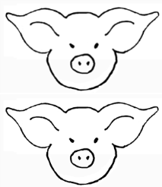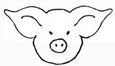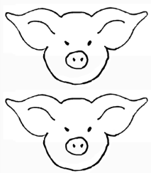

Signature of Club or Chapter Member(s) Signature of Parent and Address
(At least one of those listed at the top of this form must sign.)

Phone

This (these) youth has (have) submitted this livestock ownership affidavit in accordance with all rules of the state, county and Chapter 4-Hor FFA Program and also has (have) successfully completed a Food Animal Quality Assurance program/test for this period.
Date

Extension Staff or FFA Advisor

4-H & FFA Animal Exhibitor and Animal Project Regulations

Age of Exhibitor
4-H — A 4-H animal owner/exhibitor 8 to 18 years old on Jan. 1 of the current calendar show year is eligible to exhibit in 4-H-sponsored events. Exhibitors who are 10 as of Jan. 1 may exhibit at the State Fair and at the Ak-Sar-Ben Livestock Exposition. 4-H members may be certified for state and interstate shows if they meet age requirements for that event and have properly enrolled animals.
FFA — Only bona fide Nebraska FFA members that have paid dues shall be eligible for FFA Division entries. Members may retain their active membership until the 30th day
of November following the fourth National FFA Convention which occurs after the member graduates from or leaves high school. There will be no discrimination because of race, color, sex, religion, or national origin.

Animal Ownership
All beef, swine and sheep project animals must be owned:
- solely by the 4-H exhibitor, or FFA exhibitor
- the exhibitor in partnership with other member(s) of his or her immediate family. Only the name of the showman can be on the show entry. Immediate family is defined as
- members of a household, including parents, brothers and sisters, and youth in the care of the head of the household.

Registration Papers
For State Fair and Ak-Sar-Ben (4-H only), registration papers must show one of the following:
- the member’s name as owner, or
- the name of the exhibitor and/or a co-owner who is a member of the exhibitor’s immediate family (see immediate family definition above), or
- the family farm or ranch name or parent’s name.
Species | Number of Animals | State Identification Deadline*
Market Beef | 10 per member | April 15 of the current year
Market Lambs | 20 per member | June 15 of the current year
Beef Feeder Calves | 20 (total) per member | June 15 of the current year
Bucket Calves |  | June 15 of the current year
Registered Breeding Heifers |  | June 15 of the current year
Commercial Breeding Heifers |  | June 15 of the current year
Registered Breeding Ewes |  | June 15 of the current year
Commercial Breeding Ewes |  | June 15 of the current year
Swine | 40 per member | June 15 of the current year
Breeding Swine | 40 per member | June 15 of the current year
Dairy |  | June 15 of the current year
Dairy Goat |  | June 15 of the current year
Meat (Market) Goats | 20 per member | June 15 of the current year
*Individual counties and other shows or contests may use different information deadlines and/or rules, but for Nebraska State Fair 4-H and FFA division, these deadlines and information minimums must be met.
NOTE 4-H ONLY: DNA samples required for market beef, lambs, swine and meat goats at both State Fair and Ak-Sar-Ben.

Identification of Animals
All animals must be individually identified, listed on the appropriate form and on file in the local extension office or with the local FFA chapter and general FFA superintendent.
12/12

