Platte County Fair

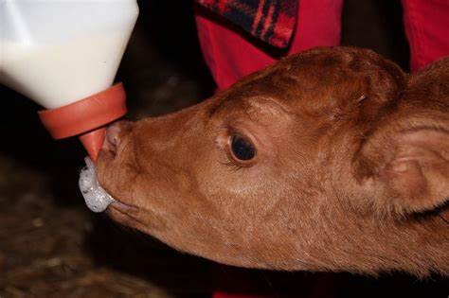

Bucket Calf Project Record Book
Junior/Intermediate

Exhibitor’s Name 4-H Age
4-H Club

4-H BUCKET CALF PROJECT REPORT

4-H’ers Name _________________________________________________ Age ________ Years in 4-H _________

Breed of Calf ______________________________________________ Sex of Calf: Male _______ Female _______

What is your calf’s ear tag number? ______________

When was your calf born? ________________________ How much did it weigh? ____________

What color is your calf? What breed is your calf? DAIRY or BEEF

Did you purchase your calf? ___________ If yes, what was the cost?

Did you borrow your calf? ____________ If yes, what is the value?

When did you get your calf (date)? _______

What did you feed your calf each day for the first 90 days?
What are you feeding your calf at the present time? _______
What equipment did you need to care for your calf? _______
What shots/medicines did you give your calf? _______

EXPENSES
Expenses are difficult, but essential to good management. If you need help, please ask your parents.

1. What was the value of your animal at the end of the project? $ _______________

2. What was the value at the beginning? $ _______________

3. Total income (subtract line 2 from line 1) $ _______________

4. Total feed costs $ ________________

5. Other expenses (vet, rent, equipment, etc.) $ ________________

6. Total expenses (add lines 4 and 5) $ _______________

7. Profit or loss on project (subtract line 6 from line 3) $ _______________

PROJECT GOALS
Goals are the tools that will help you decide how to get where you want to be and how to measure your success. To get ideas for your goals, look through your 4-H project materials and talk to your leader, parents and/or friends.

List 3 goals you have for this project:

- _______________________________________________________________________________________________
- _______________________________________________________________________________________________
- _______________________________________________________________________________________________

PROJECT STORY

Write a short story telling about your bucket calf. What shots or medicine were given to your calf? What did you enjoy the most? What did you learn? Did you feel good about your project?

__________________________________________________________________________________________________________________________________________________________________________________________________________________________________________________________________________________________________________________________________________________________________________________________________________________________________________________________________________________________________________________________________________________________________________________________________________________________________________________________________________________________________________________________________________
__________________________________________________________________________________________________________________________________________________________________________________________________________________________________________________________________________________________________________________________________________________________________________________________________________________________________________________________________________________________________________________________________________________________________________________________________________________________________________________________________________________________________________________________________________
______________________________________________________________________________________________________________________________________________________________________________________________________________________________________________________________________________________________________________________________________________________________________________________________________________________________________________________________________________________________________________________________
PROJECT PICTURES

Pictures of your bucket calf project (4 pictures minimum). Please include beginning pictures, pictures showing progress, and finished pictures if possible.

Caption: Caption:

Caption: Caption:
PROJECT PICTURES

Pictures of your bucket calf project (4 pictures minimum). Please include beginning pictures, pictures showing progress, and finished pictures if possible.

Caption: Caption:

Caption: Caption:
Signature Sheet

4-H Member: _____________________________________________________________________

Parent(s): _________________________________________________________________________

I verify that the information in this record book is accurate to the best of my knowledge and that I have followed the guidelines for this project as set by the Platte County Extension Office.

_________________________________________ _________________________________________
4-H Member Signature Parent/Guardian Signature

