Nebraska Extension – Platte County 2715 13th Street, Columbus NE 68601-4916
Phone: 402-563-4901
Website: http://platte.unl.edu
Like Us on Facebook: Nebraska Extension – Platte County

4-H Family Newsletter – April 2026

NEBRASKA STATE FIRST LEGO LEAGUE CHAMPIONSHIP
Month Events/Deadlines
April 1
Communication Event Registration Deadline
April 8
Camp Scholarship Deadline April 12
Communication Event 4 pm @ CCC, West Ed Bldg.
April 13
Growing Clovers Club Mtg 6 pm @ Extension Office
April 13
Jr. Leaders Club Mtg.
7:00 pm @ Extension Office April 20
YQCA Training 6 pm @ Extension Office
April 20
4-H Council Mtg. 7:30 pm @ Extension Office
April 24
Arbor Day – Office Closed May 1
Diamond Clover Goal Submission, Jr. Camp Registration & Jr. Camp Counselor Application Deadline
May 3
County Fair Trap Contest
Staff
Blake Wert Taylor Cammack
Hailey Held Beth Jones Sandra Swanson
Office Hours:
Monday – Friday 8:00 a.m. – 5:00 p.m.
Congratulations to all the Platte County 4-H Robotic teams who competed at the 17th annual FLL Robotics Challenge Championship at UNL on March 20-21, 2026. There were 99 Challenge teams, 9 Explore teams, and 695 youth registered for the Championship.
The Challenge team Code Huskers received the Core Values first place award and Robo Rangers were a robot design finalist. Code Huskers ranked 16 and Robo Rangers ranked 39 in the robot games.
Of the nine Explore teams, three were from Platte County; Knowledge Looters, Running Wolves, and Earth’s Secrets.
A big THANK YOU to the coaches. They have put in a tremendous amount of time teaching and learning about robots and the 4-H FLL robotic program.

TIME TO ENROLL IN 4-H BEFORE TOO LATE
Don’t want to miss out on the 2026 4-H year! To participate in great programs, summer workshops, livestock clinics, camps, and the Platte County Fair, you must be enrolled in 4-H. So, let’s get to it at https://v2.4honline.com.
The $5 enrollment fee is due at the time of enrollment, payable online. 4-H leaders (organizational and project leaders) are required to do their registrations online and choose Volunteer projects (not member projects). No fee for leaders to register.

COMMUNICATION EVENT


Join us for the Butler, Colfax, Platte County 4-H Communication Event on Sunday, April 12 at 4:00 pm at the West Education Center, Central Community College, Columbus.

Clover Kids and 4-H’ers will be competing in
Speech, Impromptu Speech, PSA, Presentation &
Video Contests.


Nebraska Extension is a Division of the Institute of Agriculture and Natural Resources at the University of Nebraska-Lincoln cooperating with the Counties and United States Department of Agriculture. The 4-H Youth Development program abides with the nondiscrimination policies of the University of Nebraska-Lincoln and the United States Department of Agriculture.

4-H PROJECT vs. FAIR EXHIBIT
A project is centered around a topic of interest to 4-H members. Members can choose one or more topics to learn about. There is a whole range of projects for 4-H’ers, everything from animals to gardening, to safety and more! A project should include a series of learning experiences related to that topic. When you enroll in 4HOnline, you sign up for projects.
An exhibit is the specific item or animal 4-H’ers bring to the fair. There is a separate online registration process for the Platte County Fair with a deadline in June. More information will be made available in a future newsletter.

MARK YOUR CALENDARS - COUNTY FAIR INFORMATION MEETING
A leader and parent meeting (open to everyone) will be held on Wednesday, May 6th at 5:15 p.m. at the Extension Office, Columbus to go over what’s new, schedule changes, location, forms, and other relevant information regarding the 2026 fair.
Everyone is HIGHLY RECOMMENDED to attend this meeting to get fair updates, sign up for pop stand shift, pick up necessary forms, and ask questions.
The meeting will last one hour. It is important for someone from each club attend and new and/or independent families are especially encouraged to attend.

DIAMOND CLOVER PROGRAM


The 4-H Diamond Clover Recognition Program is designed to complement our dynamic 4-H tradition in a non-competitive way and recognize the accomplishments of 4-H members from 8-19 years of age.

To learn more about the program or to obtain a level form online, go to https://4h.unl.edu/diamond-clover.
4-H’ers are required to turn in their goal/accomplishment plan sheet by Friday, May 1st. Final reports are due October 2, 2026, after the 4-H fiscal year. Only 4-H’ers who meet BOTH deadlines will be considered for their level award.

JR. 4-H CAMP ON-LINE REGISTRATION
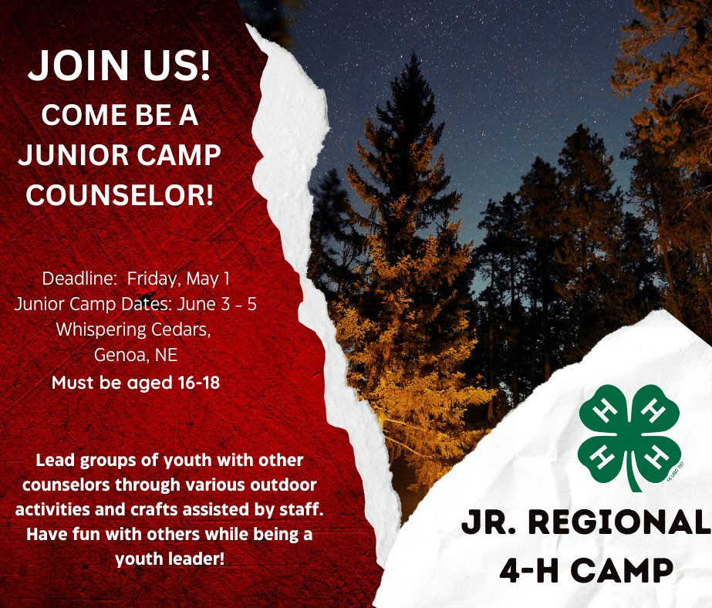
Jr. Camp is scheduled for June 3 – 5, 2026 at Whispering Cedars near Genoa. 4-H’ers from Platte, Antelope, Boone, Merrick, Nance, Polk, and Hamilton counties are welcome to attend. Jr. Camp is for 4-H’ers age 8 – 11 and the cost is $110.00 per camper.

If interested in being a camp counselor, email sswanson5@unl.edu for an application form and link to register online.
See camp flyer included in this newsletter for all registration requirements including registering online https://extension.unl.edu/statewide/platte/4-h/, completing 4-H Participant Permission and Health form in their 4HOnline account and payment information. Jr. Camp registration deadline is Friday, May 1st!

Arbor Day – Friday, April 24 Office Closed
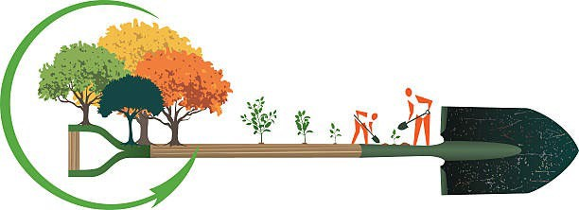

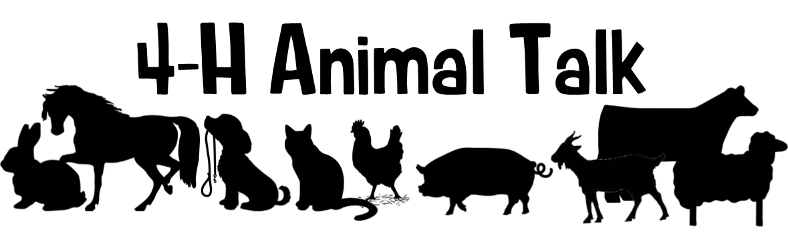

YQCA: There are still a few more opportunities for Instructor Led YQCA (Youth for the Quality Care of Animals) trainings this year! Blake Wert will be offering Instructor-Led Trainings at the Platte County Extension Office. The deadline for youth to complete YQCA is Friday, May 29.
Registering for quality assurance will be done online through the YQCA website (yqcaprogram.org) using the Family 4-H Online login for active youth. If you are involved in both 4-H and FFA, please register through the 4-H login. The cost for instructor-led training sessions are $3, while online trainings are $12. Payment is made online at the time of registration. Youth must register before attending an in-person session. The instructor-led trainings will last approximately one hour, and the following dates are remaining.
Monday, April 20, 6:00 – 7:00 p.m.
Monday, May 11, 7:30 – 8:30 p.m.
Friday, May 22, 3:00 – 4:00 p.m.

** After you complete the YQCA training, please either email the certificate to Blake at bwert3@unl.edu or bring a copy into the Extension Office.**
LAST CALL - PASE: The Nebraska 4-H Premier Animal Science Event (PASE) features a variety of state-level animal science contests. Youth have the opportunity to participate in livestock contests that do not require owning or exhibiting a live animal, including livestock, meat, poultry, companion animal, and animal welfare judging, as well as livestock skill-a-thon and livestock quiz bowl. Youth can participate in more than one contest or event as their schedule allows.
If you are interested in competing at PASE, please fill out this Google Form – https://go.unl.edu/t9cb or scan the QR found below. Livestock Judging and Skill-a-thon practices will begin end of April with most practices being in the evenings. Please sign up by April 10th to give 4-H Staff time to prepare the materials. Those interested would practice at the Extension Office and would compete on May 27-29 in Lincoln. For more information about the contests, go to Premier Animal Science Event Contests | Nebraska 4-H | Nebraska. Any questions, feel free to reach out to Blake!

Nebraska State Fair Livestock Nominations: Show Stock Manager is open for livestock nominations for the 2026 Nebraska State Fair! Website Link: www.showstockmgr.com. All livestock in contention to exhibit at the Nebraska State Fair will be required to complete an online nomination, with payment through Show Stock Manager and submit a DNA collector envelope with a hair sample. This includes all 4-H and FFA breeding livestock, market livestock, and feeder calves. State fair EID tags and DNA envelopes are available at the Extension Office. The deadline for ALL online nominations is Monday, June 15, 2026. If you have any questions on how to submit your online nominations, you can review the 2026 Step-by-Step Nomination Instructions.pdf document.

Important Nebraska State Fair Livestock Update: Exhibitors who want to show an animal at the NSF and Aksarben Stock Show (AKSS) will be required to submit two separate envelopes and online nominations. AKKS exhibitors will be ordering and purchasing their DNA envelopes through the AKKS website – https://www.aksarbenstockshow.com/. The DNA process and the online nomination process will be separate for each livestock show! * Direct all AKSS questions to the AKSS website! *
Nebraska 4-H Livestock Achievement Program: This program provides an additional opportunity for enrolled 4-H livestock project youth to strengthen their knowledge and leadership skills across all aspects of livestock projects, including selection, production, leadership, and exhibition. The program recognizes Members of Excellence in the following livestock project areas: beef, sheep, meat goat, swine, dairy cattle, dairy goat, rabbit, and poultry. Youth who complete the program and earn Member of Excellence recognition will be recognized during the Grand Drive during the 4-H weekend at the Nebraska State Fair. Applications are due June 15 and Plan and Project Records are due August 1.
For more information and to apply, visit https://go.unl.edu/lap
Livestock Progress Shows, Animal Shows & Clinics: Check out our website for a listing of Nebraska 4-H/Extension livestock progress shows, animal shows and clinics. This includes horse, rabbit, poultry, small pet, beef, swine, sheep, and goat. Use this link to see all these great opportunities: https://extension.unl.edu/statewide/platte/4-h/4-hextension-livestock-progress-animal-shows-clinics-judging-contests/ We will continue to update this page as more shows and clinics become available!

Dates to Remember:
April 20 YQCA Training at Platte County Extension Office @ 6:00 pm May 11 YQCA Training at Platte County Extension Office @ 7:30 pm May 15 County Fair Animal Nomination ID/DNA Deadline
May 22 YQCA Training at Platte County Extension Office @ 3:00 pm May 27-29 PASE at UNL East Campus
May 29 Horse ID, Horse Level Testing & YQCA Certification Deadline June 13 Platte County Showmanship Clinic
June 15 County Fair Online Entry Deadline
June 17 Heartland Triple Crown Livestock Judging Series - Platte County Contest

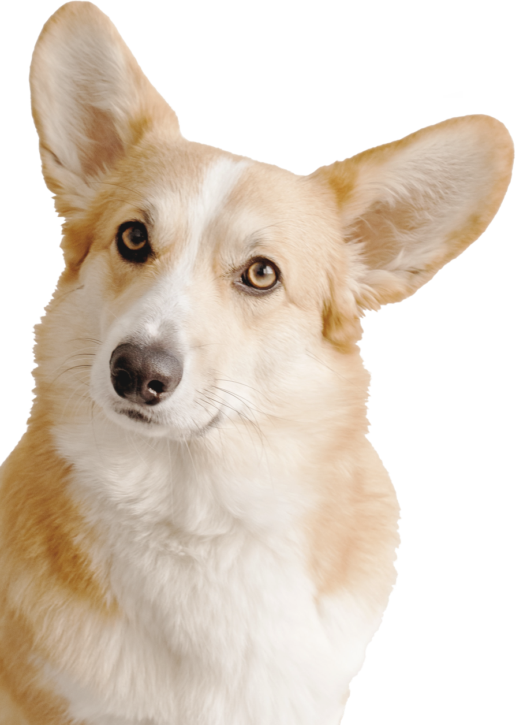

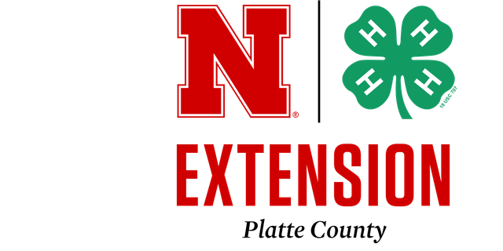
K-9 Commanders
Youth Dog Club

It's not too late to sign up for
the dog project!

K-9 Commanders dog Club Meets on Tuesday's from 6:00 - 7:00pm at AG Park.

ARE YOU A KID AND HAVE A DOG?
THEN WE WANT YOU!
- Learn how to work with your dog
- train your dog to do tricks
- learn leadership skills
- Make new friends

ANY QUESTIONS CONTACT: SUSAN LITTLEFIELD
SUSAN@AMERICANAGNETWORK.COM

HEARTLAND TRIPLE CROWN
LIVESTOCK JUDGING SERIES
JUNE 17-19, 2026

Join us for the Three-Day Livestock Judging Showdown!
Celebrate the end of the Great Plains judging circuit with three exciting days of competition, fun, and recognition.
🏆 Awards for each age division and species 10 placing classes
Pricing details on registration

Day 2 — Bladen, NE

Day 3 — Nelson, NE
📍 Location: Fairgrounds 1256 RD 3300
Nelson, NE 68961
registration: 9:00-9:30 am
🕙 Judging begins: 10:00 AM
🎉 Evening Banquet & Awards Ceremony: 5:00 PM

Day 1 — Columbus, NE
📍 Location: Ag park 822 15th St.
Columbus, NE 68601
registration: 8:15-9:00 am
clinic: 8:45 - 9:45 AM
🕙 Judging begins: 10:00 AM
📍 Location: Fairgrounds 459 N Crescent St.
Bladen, NE 68928
registration: 9:00-9:30 am
🕙 Judging begins: 10:00 AM
🍔 Evening After Party: 5:00 PM — BBQ & Games

FOR QUESTIONS OR REGISTRATION DETAILS, CONTACT: PLATTE COUNTY EXTENSION: 402-563-4901
WEBSTER COUNTY EXTENSION: 402-746-3417
Register here: https://go.unl.edu/lj26


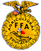






SOUTHERN PLAINS COUNTY EXTENSION: 402-225-2381 OR 402-768-7212 FIND MORE DETAILS ON OUR BROCHURE
THE UNIVERSITY OF NEBRASKA DOES NOT DISCRIMINATE BASED UPON ANY PROTECTED STATUS. PLEASE SEE GO.UNL.EDU/NONDISCRIMINATION.

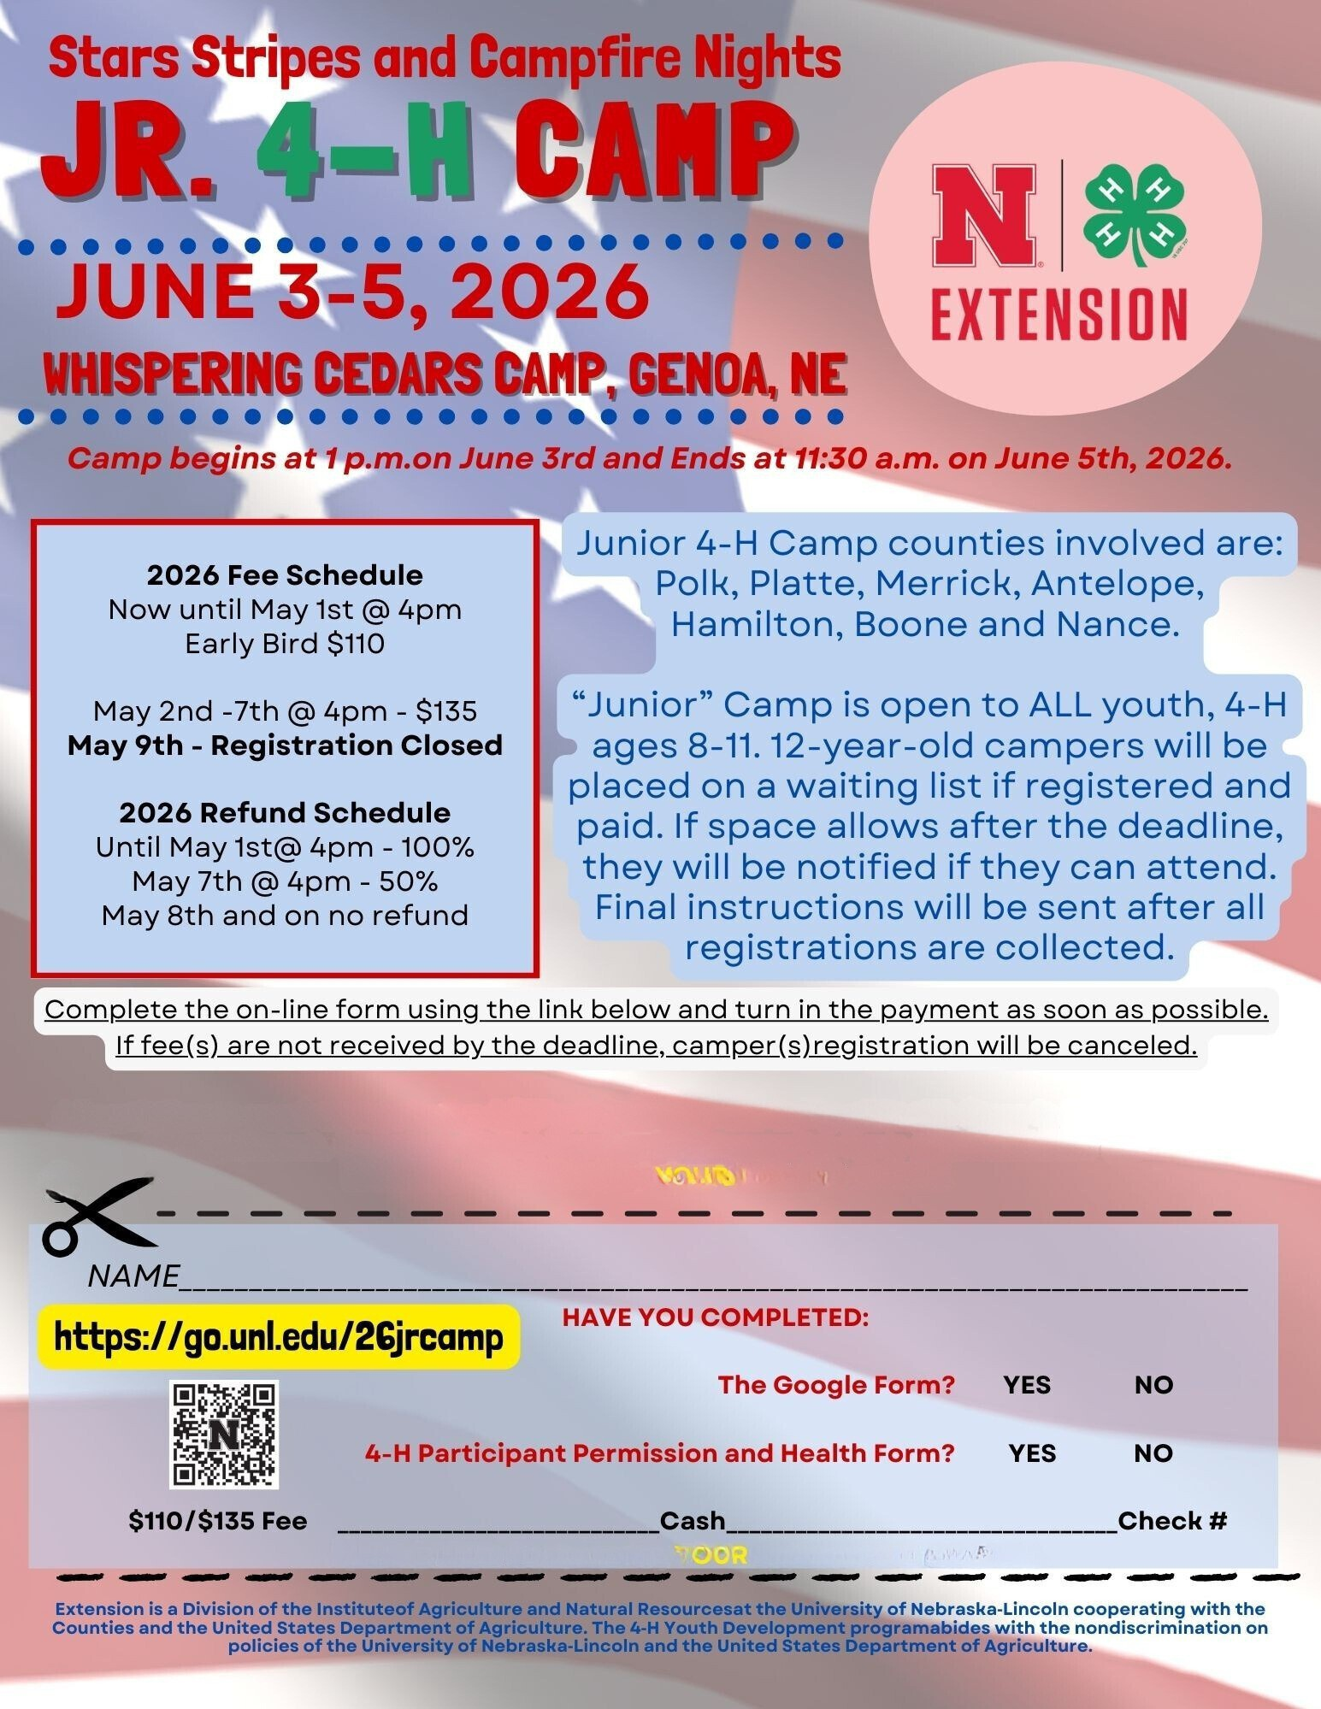

All participants must complete the 4-H Participant Permission and Health Form in their 4hOnline
2.0 enrollment. Complete Online Form and Return below form with PAYMENT TO NEBRASKA EXTENION - PLATTE COUNTY OFFICE

MAKE CHECK PAYABLE TO PLATTE COUNTY 4-H COUNCIL

EXTENSION
•••
Platte County

Work as part of a team of dedicated q_H

professionals and volunteers to:
- Provide q_H summer programming!
- Suppport youth engagement!
- Prep for & support county fair!

� Columbus, NE
$ $16/hr

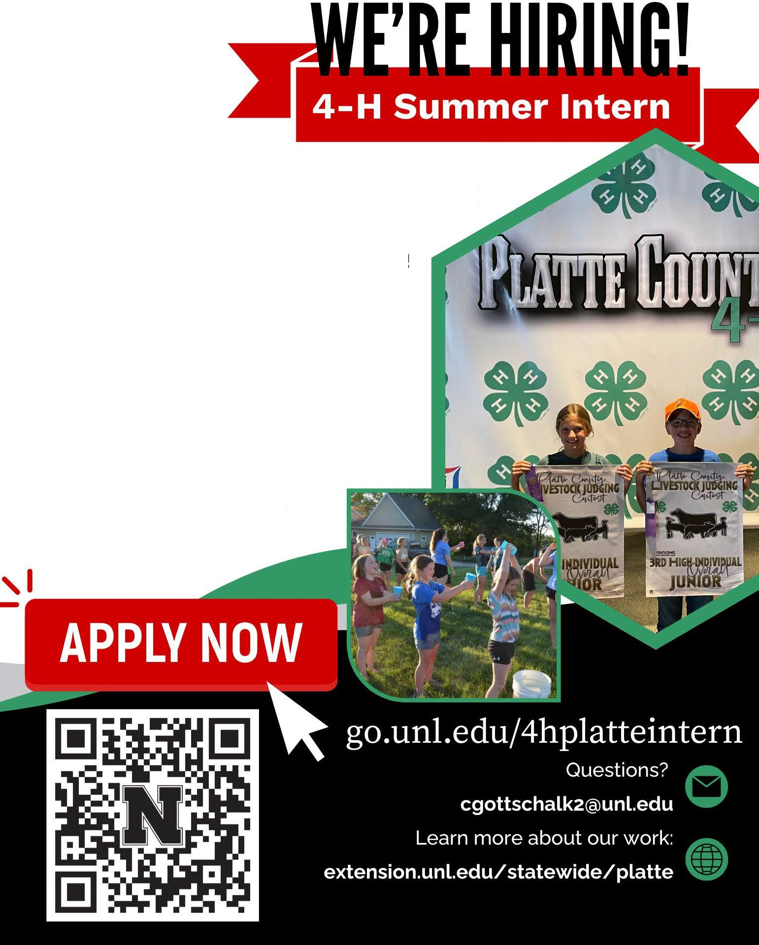

::••;•,•0

May - July
up to 40 hrs/week

EASY FINGER KNIT BLANKET

FINISHED SIZE APPROX. 56IN BY 60 IN.

FULL PATTERN FOR THIS FINGER KNOT BLANKET
Make a slip knot and Chain 30. Knit 14 rows with the teal
Knit 19 rows with red. Knit 23 rows with gray.
Finish off and weave ends.
Fair Class Entry: Fiber Arts C 225 3 ARM OR FINGER KNITTED ITEM

MATERIALS NEEDED:
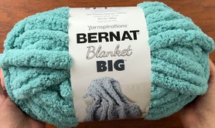

INSRUCTIONS:

STEP ONE: MAKE A SLIP KNOT
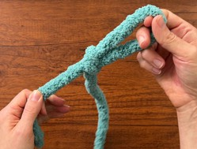

INSRUCTIONS CONT’D:

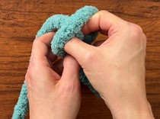
STEP TWO: MAKE THE FOUNDATION ROW
- skeins of Bernat Blanket Yarn (if doing one color)
- skeins of Bernat Blanket Yarn (if doing three colors) Scissors
Lighter (optional if melding yarn) (Adult Supervision Required)

First, find a nice flat surface that’s a decent width to work on.
A kitchen table would work pretty well. Or you could just work on the floor.
If you want to do the color block design shown the video link attached, start with the teal yarn.
Start by making a slip knot in the end of your yarn.
Loop the yarn around your hand, then pull the yarn through the loop formed.
Slide your fingers out of the loop, then pull on the loop and both ends of the yarn to tighten up the knot.
Adjust the loop so it’s about 2 inches long.
This part is just like crochet, except you’re using your fingers instead of a hook.
Stick your fingers through the loop, and grab the yarn.
Pull through a loop that’s the same size as the starting loop. That’s your first chain.
Keep doing that until you have a total of 30 chains.
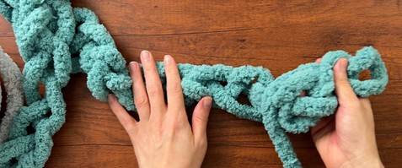
(If you want your blanket to be wider, keep chaining until it’s your desired width.)

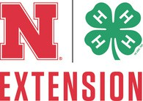
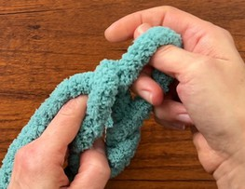
Video instructions can be found at this link
https://www.youtube.com/watch?v=kLJheU8eNCU 1

EASY FINGER KNIT BLANKET

FINISHED SIZE APPROX. 56IN BY 60 IN.

INSRUCTIONS CONT’D:

STEP THREE: KNITTING THE BLANKET
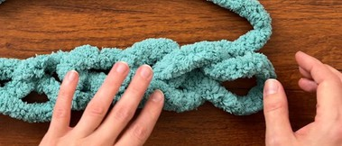

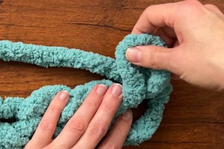

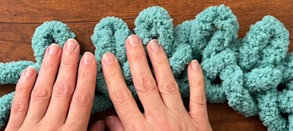
Now it’s time to start knitting!

First Row
Lay your working yarn above your chain and run the yarn all the way across the row to the left.
Starting with the last chain you made, pull a loop through the chain. Make it the same size as the chains you just made. (About 2 inches.) Continue that going to the left. At first it’ll be a little awkward, but it gets easier as you go.
Make sure you aren’t accidentally shrinking the previous loop when you make the next loop.
I like to hold the previous loop with my other hand to make sure that doesn’t happen.
Continue until you reach the last loop at the end of the row.

Second Row and Onward
Lay your yarn above the first row but this time it’ll be going across to the right.
Just like you did in the previous row, pull the yarn through the loops going across to make row 2.
Then when you reach the end of the row, go back in the other direction.
It’s that easy!
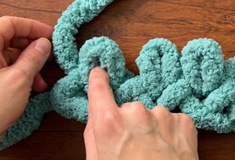
For the color block pattern, continue knitting until you have 14 rows.

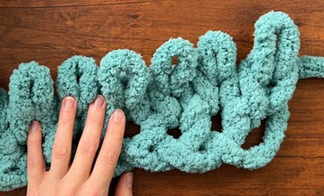

Video instructions can be found at this link
https://www.youtube.com/watch?v=kLJheU8eNCU 2

EASY FINGER KNIT BLANKET

FINISHED SIZE APPROX. 56IN BY 60 IN.

INSRUCTIONS CONT’D:

STEP THREE: KNITTING THE BLANKET
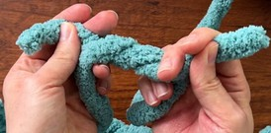

What to do when you run out of yarn
With this big, chunky yarn, you’re going to run out frequently. There are two ways you can join a new piece of yarn.
The simplest way is to tie a knot in the two yarn tails, cut off the excess yarn and continue on.
Or, you can use my new favorite method!
(This method involves fire, so be very, very careful if you go this route. The knot method is still totally fine, too.)
First, you use a lighter to light the center core of the yarn (I’ve only tried this with Bernat Blanket Big, so I can’t say if it will work with other yarns). Hold them there for a few seconds so it can cool, and it seamlessly melds the two yarn ends together.
Either way, just add on more yarn when you run out and continue on!

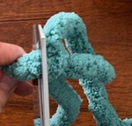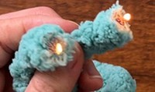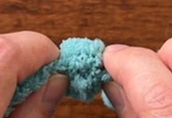

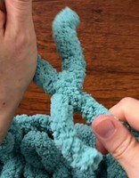
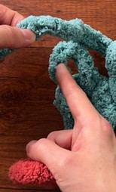
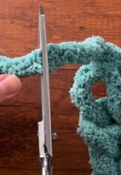
Changing Colors
OK, you’ve made it to the end of row 23 (or however many you chose to do) and now it’s time to change colors.
First, pinch the yarn right where it comes out of the last stitch you made. Carefully pull that last stitch out to undo it, and keep pinching that same spot. Be careful not to pull out the second loop.
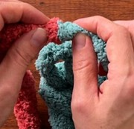
Where you’re pinching is where the join needs to happen.
Grab your next color of yarn (red if you’re following along with me).
If you’re tying them together, you’ll want your knot to be right where you’re pinching. Cut off the excess yarn tails.
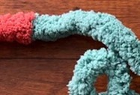
If you’re doing the lighter method, cut the yarn where you are pinching, then melt the two ends together.
Once your new color is joined, re-knit the last stitch that you undid.
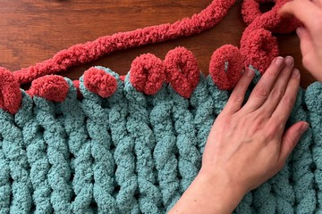
There should be just enough yarn to make the stitch without the new color peeking through.
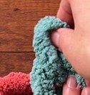
Now you will start the next row.

Video instructions can be found at this link
https://www.youtube.com/watch?v=kLJheU8eNCU 3

EASY FINGER KNIT BLANKET

FINISHED SIZE APPROX. 56IN BY 60 IN.

INSRUCTIONS CONT’D:

STEP THREE: KNITTING THE BLANKET
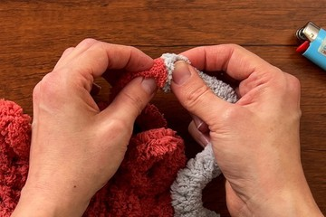
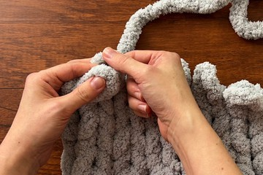
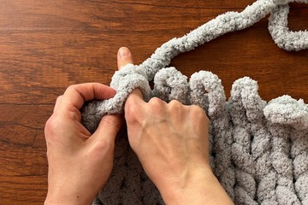
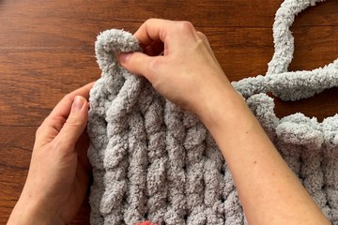
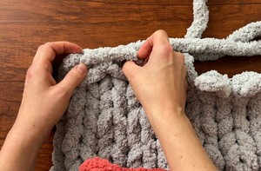
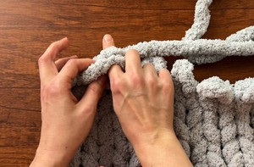

Keep on Knitting!
Knit 19 rows with the red yarn, adding on a new skein when ever you run out.
Then change colors again at the end of the 19th row, this time to the gray yarn.
Knit 23 rows with the gray yarn.
(If you want your blanket to be longer, just continue until it’s your desired length.)

Finishing Off
Once you knit your last row of gray, it’s time to finish off our blanket! (Don’t worry, it’s really easy.)
Starting on the last stitch you made, lay the left loop on top of the next loop to the right.
Reach your fingers through the two loops and grab your working yarn. Pull up a loop.
This new loop will be a bit longer than the previous loops, but not by much. You’re going to pull the new loop over and lay it on top of the next loop (so you want it to be long enough to do that), and repeat, grabbing the working yarn through those two loops and pulling through another loop.
Continue that until you get all the way across the row.
Note: my blanket ended on the left and if you’re following along with me yours should too. But if you ended on the right for some reason, do the same thing but in reverse, working in the opposite direction.
When you get to the end, cut the yarn leaving a yarn tail that’s at least 7 inches long or so.
Pull the tail through the last loop and pull to tighten it up.

Weaving in the ends
Last step is to weave in any ends you have.
You should have one at the beginning and end of your blanket. Weave them in really good, and your blanket is complete!
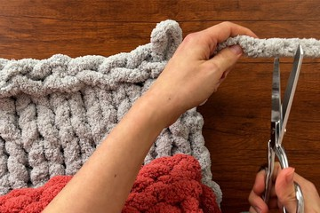
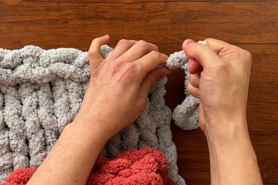
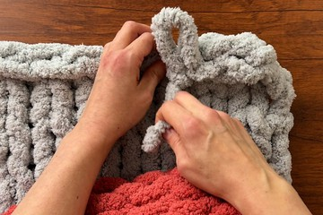
Video instructions can be found at this link
https://www.youtube.com/watch?v=kLJheU8eNCU 4




2026 Clover Academy
All summer 4-H programs are open to all youth regardless of 4-H membership. To enroll in a class, use the Sign-Up Genius link first (for each individual youth), then complete the attached registration form and return it to the Extension Office with registration payment. Classes will be filled on a first-come basis with paid registration fees and may be canceled in case of low registration. No refunds after the registration deadline or if participants do not attend workshops. Any questions, please contact the Nebraska Extension-Platte County Office at (402) 563-4901.

Workshop Title | Workshop Description
Crayons Gone Wild: Crayon Melting | Tuesday, June 9th  9:30 am - 11:30 am @ Platte County Extension Office (2715 13th St)  Ages: 8+ / Max: 15 youth  Cost: $15.00 County Fair Class: Home Design and Restoration (Middle Unit) C 257 13 Get ready to turn ordinary crayons into extraordinary works of art! In this hands-on 4-H workshop, youth will explore creativity and basic science by melting crayons to create colorful, one-of-a-kind  masterpieces. Participants will learn how heat changes solids into liquids, experiment with color blending, and discover different techniques for designing vibrant melted crayon art.
Piece by Piece: Mosaic Coasters | Tuesday, June 9th  1:30 pm – 3:30 pm @ Platte County Extension Office (2715 13th St.)  Ages: 8+ / Max: 15 youth  Cost: $15.00 County Fair Class: Home Design & Restoration (Middle Unit) C 257 16 Discover how small pieces can come together to create something beautiful! In this hands-on 4-H workshop, youth will design and create their own unique mosaic coasters using colorful tiles, glass,  or other decorative materials. Participants will learn basic mosaic techniques, including pattern planning, arranging pieces, and grouting to complete their finished project.
Bright Blooms: Floral Suncatchers & Jean Pocket Floral Frames | Wednesday, June 10th  9:00 am – 11:30 am @ Platte County Extension Office (2715 13th St.)  Ages: 8+ / Max: 15 youth  Cost $10.00 Sun Catcher County Fair Class: Home Design and Restoration C 257 12  Jean Pocket Floral Frame County Fair Class: Home Design and Restoration C 257 14 Let your creativity bloom in this hands-on 4-H workshop! Participants will design and create beautiful floral suncatchers that sparkle in the sunlight, as well as unique jean pocket floral frames that turn recycled denim into charming works of art. Youth will explore color, texture, and composition while  learning simple crafting techniques to preserve and display their floral designs.
From Crust to Filling:  Pie Making Everything but the Baking | Wednesday, June 10  1:30 pm – 3:30 pm @ Platte County Extension Office (2715 13th St.)  Ages: 12+ / Max: 10 youth  Cost: $25.00 County Fair Class: Food and Nutrition (Cooking 401) E 412 1  Taught by Gretta Kinnison 4-H Intern  In this hands-on workshop, youth will learn the fundamentals of pie preparation, including how to make and roll out a flaky crust, prepare delicious fillings, and assemble a beautiful pie. Participants will gain practical kitchen skills, food safety knowledge, and confidence in measuring, mixing, and assembling ingredients. While we won’t bake the pies during the session, youth will leave ready  to bake their creations at home!

Clover Kid College | Thursday, June 11  9:30 am – 11:30 am @ Platte County Extension Office (2715 13th St)  Ages: 5 – 8 / Max: 20 youth Cost: $10.00  A flyer will be handed out day of for County Fair Classes  Your clover kid will spend the morning creating three different projects that will be eligible for fair. This workshop is taught by our Jr. Leaders with Extension staff.
Desert Bloom Builders: Cactus Garden | Thursday, June 11  1:00 pm – 3:00 pm @ Platte County Extension Office (2715 13th St)  Ages: 8+ / Max: 20 youth  Cost: $17.00 County Fair Class: House Plants G 770 65  Taught by Horticulture Educator Taylor Cammack and Platte County Master Gardeners  Start your very own desert oasis in this hands-on 4-H workshop! Youth will explore fascinating desert environments and learn about some of the world’s most drought-tolerant plants, including cactus and succulents. Participants will discover how desert-adapted plants survive in dry climates, learn about their unique environmental adaptations, and practice creative design techniques. Each youth will design and build their own miniature desert garden, carefully arranging and labeling their plants. At the end of the workshop, participants will take home their personalized desert garden along with a helpful care guide for youth and parents to ensure their desert creation thrives.  Materials needed: 12” or less diameter container for planting. Drainage holes are not required. Decorative embellishments: stones, wood, shells, marbles, etc., not required for workshop.
Showmanship Clinic | Saturday, June 13  Ag Park Arena and Green Barn 822 15th St, Columbus, NE 68601  Open to 4-H members ages 8-18 in Platte and surrounding counties. Cost $5.00  Plan to attend one or more sessions of this hands-on, multi-species clinic to learn how to show or gain tips to help improve the showing of your animal at the county fair and beyond!  For questions, please contact: Platte County Extension Office:  402-563-4901 Blake Wert: bwert3@unl.edu

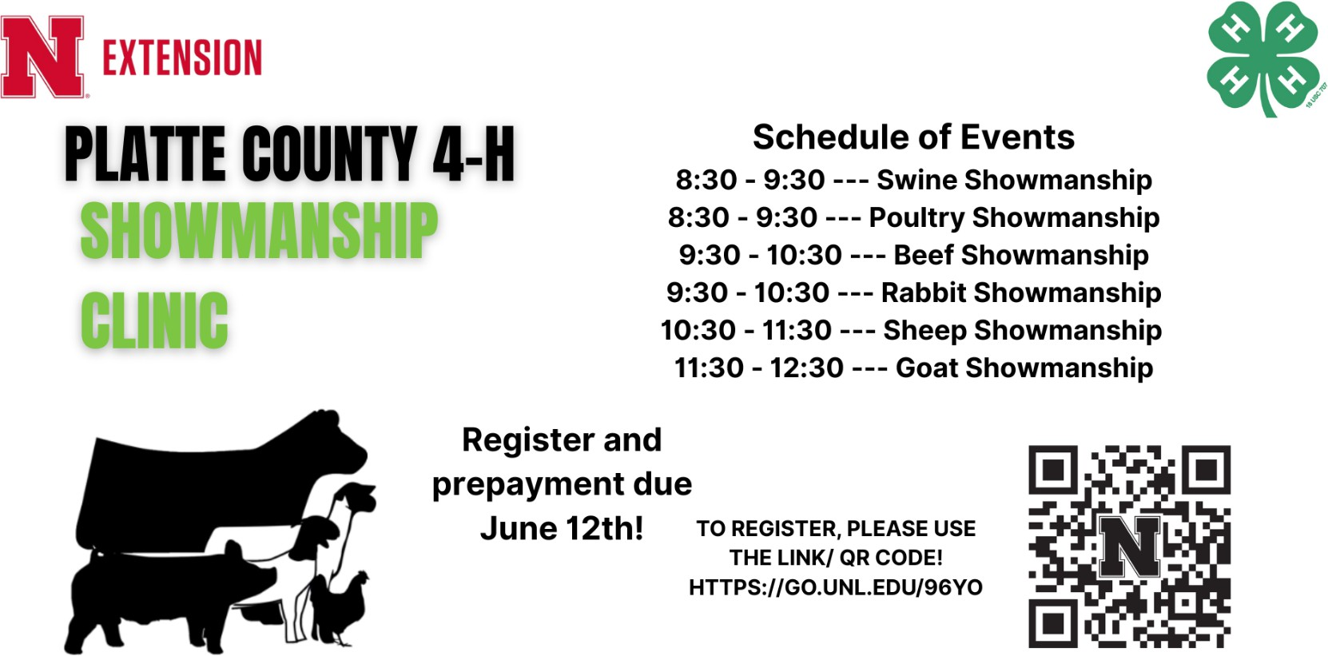

4-H Clover Academy Registration Form (one form per family) – Deadline May 15

� Registration Process:
  - Scan the QR Code to access the Platte County 4-H Sign Up Genius registration form for Clover Academy.
  - Register each youth individually using the form.
  - Scan the Showmanship Clinic QR Code to access the Showmanship Clinic registration form.

  - Submit payment immediately after registration by mailing or dropping it off at the Platte County Extension Office, 2715 13th Street. Columbus, NE 68601

Scan Code to Register:

🗓🗓 Registration Timeline:
    - April 1 – May 15: Registration is OPEN.
    - April 1: Registration opens exclusively for enrolled 4-H youth.
    - May 1: Registration opens to non-4-H youth, as space allows.
    - June 12: Registration closes for showmanship clinic.

� Payment Info: (Cash or Check only, no cards)
    - Make checks payable to: Nebraska Extension – Platte County
    - Payment is required to secure your spot—don’t delay!

Please remit this section with the payment for Clover Academy Workshops

Participant Name Age Participant Name Age Participant Name Age Participant Name Age Participant Name Age Participant Name Age
Parent Name Phone Email
Mark workshops you will be attending:
Workshop | Price | # Youth | Total $
Crayon Melting | $15.00
Mosaic | $15.00
Suncatcher/ Jean Floral | $10.00
Pie Making | $25.00
Clover Kid College | $10.00
Cactus Garden | $17.00
Showmanship Clinic | $ 5.00

Workshop Total Due: $

Parent/Guardian Signature
By signing this, you permit to use your child’s name/photography in publications, advertisements, 4-H webpage, Facebook,
or news articles about 4-H activities.

Return this form and registration fee by Thursday, May 15th to: Nebraska Extension – Platte County, 2715 13th Street, Columbus NE 68601-4916


Nebraska Extension is a Division of the Institute of Agriculture and Natural Resources at the University of Nebraska–Lincoln cooperating with the Counties and the United Sates Department of Agriculture.
Nebraska Extension educational programs abide with the nondiscrimination policies of the University of Nebraska–Lincoln and the United States Department of Agriculture. 2026

NEBRASKA 4-H LEADERSHIP ACADEMY
Nebraska Extension – Platte County
2715 13
th
Street
Columbus NE 68601-4916
Nonprofit Organization
U.S. Postage
PAID
COLUMBUS, NE 68601
PERMIT NO. 36
The 4-H Leadership Academy, founded by the late Joel Roth in partnership with National 4-H, is a dynamic leadership experience designed to develop high-potential youth into strong leaders, changemakers, and problem-solvers.
Building on the strength of the national program, the Nebraska 4-H Leadership Academy offers a state-level, one-year experience tailored to Nebraska while staying connected to the vision of the National 4-H Leadership Academy.
Nebraska Roth Scholars will engage in advanced leadership development, mentorship, and immersive learning experiences. Through this journey, scholars will grow as leaders who are prepared to create meaningful change in their communities and beyond. Selected youth will represent the best of Nebraska 4-H and help shape a better future for their communities, the state, and the world.
Scholars selected for the program will also receive a $500 stipend in recognition of their commitment and active participation.
Who we’re looking for:
      - Current high school sophomores
      - Active Nebraska 4-H members
      - Youth ready to grow, lead, and commit to the experience Program highlights:
      - Monthly virtual meetings
      - In-person statewide events
      - Late summer kickoff in alignment of 2026-27 academic year Application deadline: May 4, 2026
Apply here: https://forms.gle/gFV6PKpjbmr3M7gJ7

