2026
Platte County 4-H
Animal Exhibitor
Handbook

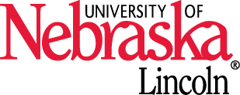
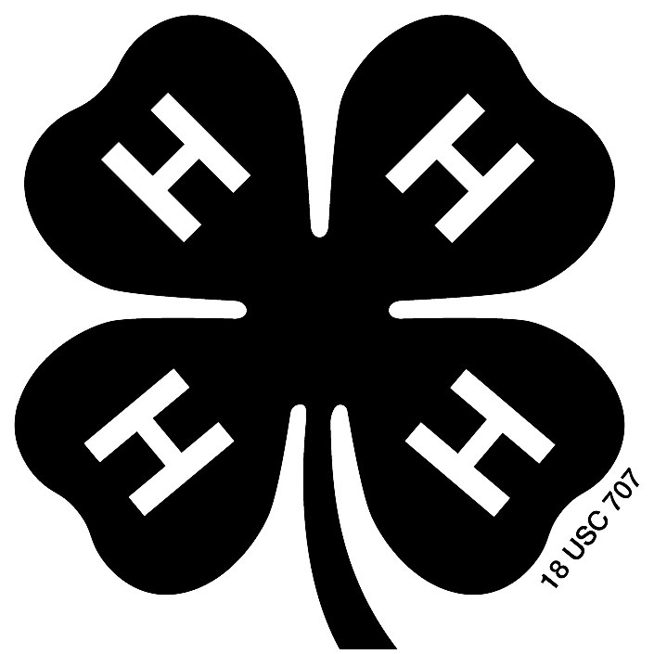
Nebraska Extension is a Division of the Institute of Agriculture and Natural Resources at the University of Nebraska-Lincoln cooperating with the Counties and United States Department of Agriculture. The 4-H Youth Development program abides with the nondiscrimination policies of the University of Nebraska-Lincoln and the United States Department of Agriculture.

© 2026
Materials covered in this handbook are
subject to change.
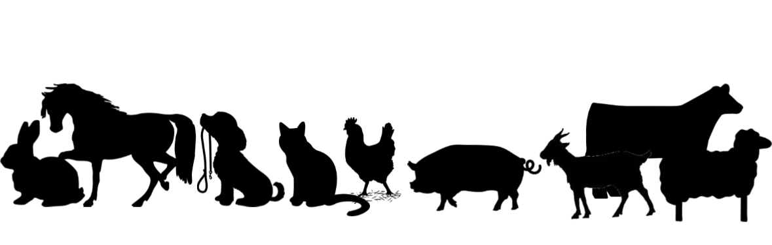
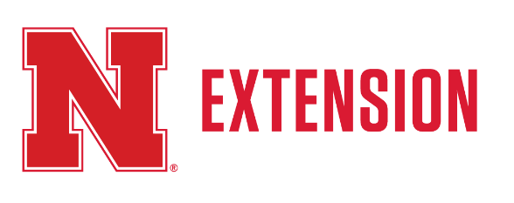

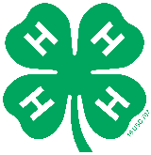
2026 CHECKLIST FOR LIVESTOCK FAMILIES

☐ Re-enroll in 4-H at https://v2.4honline.com
- Enrollment dues of $5 per 4-H member paid online

☐ County Fair: Turn in ID Sheets for ALL animals and DNA Envelopes (market beef, swine, sheep, and goat) to the Extension Office by May 15. (ID Sheets can be found on our website: https://extension.unl.edu/statewide/platte/4-h/platte-county-4-h-resources/ or at the Extension Office. For market beef, swine, sheep, and goat, a DNA sample must also be collected and returned to the Extension Office by May 15 using a Platte County DNA envelope.

☐ Complete Quality Assurance and turn in certificates by May 29. Access the YQCA course at yqcaprogram.org. *This includes ALL exhibitors (4-H Age 8-18) showing beef, bucket calves, sheep, goats, swine, dairy cattle, poultry, and rabbits* YQCA certificates can be sent to bwert3@nebraska.edu or dropped off at the Extension Office.

☐ State Fair: Enter nominations online at showstockmgr.com for any feeder calves, breeding beef, and market beef. State Fair DNA envelopes must be turned into the Extension Office by June 15 for all nominations. The deadline to nominate livestock online in Show Stock Manager is June 15th.

☐ Turn in Stall Reservation forms into the Extension Office by June 15th. All 4-H & FFA exhibitors showing Beef, Dairy, Goat, Horse, Poultry, Rabbit, Sheep and Swine must fill out this form to indicate how many stalls you are requesting for fair. This form can be found on platte.unl.edu or at the Extension Office.

☐ Submit Platte County Fair entries into Show Works by the June 15th deadline. Link found on platte.unl.edu along with all record books.

Please call the Extension Office at (402) 563-4901 if you have any questions

Platte County Animal Identification Guidelines – 2026

ID sheets for livestock entries found online at https://extension.unl.edu/statewide/platte/4-h/platte-county-4-h-resources/
* ID sheets/DNA Envelopes are due to the Extension Office by 5:00 p.m. on May 15. No late ID sheets/DNA Envelopes will be accepted.** State Fair livestock nominations are due online by exhibitor by deadline. DNA Envelopes are available for pickup at Extension Office. Nominations must be entered online at www/showstockmgr.com and completed envelopes returned to Extension Office by deadline. State Fair online entries are to be done by the exhibitor by deadline date stated. State Fair entry website is http://www.statefair.org
Project  Area | County Fair* |  |  |  | State Fair**
Project  Area | Max # of Animals shown per exhibitor | Method of ID | ID Sheet & DNA Deadline | Fair  Online Entry Deadline | Method of ID | Nomina-  tion Deadline | Fair  Online Entry Deadline
Market Beef | 2 | 4-H Ear Tag or EID Tag & DNA | May 15 | June 15 | EID Tag, DNA Envelope & Online Nomination | June 15 | August 10
Registered Breeding Beef | 2 | Tattoo | May 15 | June 15 | Tattoo, DNA Envelope & Online Nomination | June 15 | August 10
Commercial Breeding Beef | 2 | Tattoo or EID Tag | May 15 | June 15 | Tattoo or EID Tag, DNA Envelope & Online Nomination | June 15 | August 10
Feeder Calves | 2 | 4-H Ear Tag or  EID Tag | May 15 | June 15 | EID Tag, DNA Envelope & Online Nomination | June 15 | August 10
Bucket Calf | 1 | 4-H Ear Tag and Record book | May 15 | June 15 | No Class | ----- | -----
Dairy Cattle | 3 | Ear Tag/Tattoo and ID Sheet Drawing | May 15 | June 15 | ID Sheet Drawing | ----- | August 10
Dairy Goat | 4 | Scrapie Tag or 4-H Ear Tag and Drawing | May 15 | June 15 | No Class | ----- | -----
Breeding -  Meat Goat | 4 | Scrapie Tag or Tattoo | May 15 | June 15 | Scrapie Tag, DNA Envelope & Online Nomination | June 15 | August 10
Market -  Meat Goat | 4 | Scrapie Tag & DNA | May 15 | June 15 | Scrapie Tag, DNA Envelope & Online Nomination | June 15 | August 10
Bottle Goat | 1 | Scrapie Tag | May 15 | June 15 | No Class | ----- | -----
Horse | -------- | ID Sheet Drawing or Picture | May 15 | June 15 | ID Sheet Drawing &  Online Entry Form | June 1 | June 1
Breeding Swine | 4 | Ear Notch | May 15 | June 15 | EID Tag, DNA Envelope & Online Nomination | June 15 | August 10
Market Swine | 4 | 4-H Ear Tag & DNA | May 15 | June 15 | EID Tag, DNA Envelope & Online Nomination | June 15 | August 10
Broilers  (Fancy Breeds) | 1 pen  (10 fancy birds) | Order by March 28 & colored  leg band | ----- | June 15 | No Broiler Class/Fancy Breeds Only | ----- | August 10
Rabbit | 8 | Tattoo | May 15 | June 15 | Ear Tattoo | ----- | August 10
Breeding Sheep | 4 | Scrapie Tag | May 15 | June 15 | Scrapie Tag, DNA Envelope & Online Nomination | June 15 | August 10
Market Sheep | 4 | Scrapie Tag & DNA | May 15 | June 15 | Scrapie Tag, DNA Envelope & Online Nomination | June 15 | August 10
MEMBER RESPONSIBILITIES

To participate in a Platte County 4-H Livestock Project, 4-H members must complete the following.
- Enroll in 4-H online by the current enrollment deadline. The age requirement for membership in 4-H is 9 – 19 years old. To be in 4-H you should turn 9 during the current calendar year. Exhibitors who are 9 by January 1 may exhibit at the State Fair.
Enroll in the livestock project of their choice by the current year enrollment deadline. 4-H’ers enrolling in more than one county cannot take the same project in two counties (i.e. Beef is one project, and breeding and market animals cannot be shown in two different counties). Properly identify animals by method of identification and deadline listed in “Animal Identification Guidelines.” All identification tags used for livestock ID MUST be printed. Written tag numbers will not be accepted.
- To exhibit beef, dairy, goats, sheep, swine, poultry, and rabbit at the County Fair or State Fair exhibitors must be Quality Assurance certified by MAY 29. All members age 9 – 19 must attend a YQCA (Youth for the Quality Care of Animals) training in person or online. Registration for the training is online at https://yqcaprogram.org/.
- To participate in horse riding events, exhibitors must have completed the proper level testing by May 29 to meet current year deadline for the County Fair and State 4-H Horse Expo.
- Enter animal(s) for the County Fair or State Fair by the deadline listed in “Animal Identification Guidelines”.
- Follow the IAFE (International Association of Fairs and Expositions) National Code of Show
Ring Ethics. The entire code of ethics is included in this handbook.

The following guidelines must be met to exhibit livestock.
- 4-H/FFA Exhibits – 4-H and FFA youth will submit a list of the animals they have nominated to the county they plan to exhibit in by the county fair identification deadline per specie. Youth enrolled in both 4-H and FFA, will have the option of exhibiting their animal in the 4-H or FFA show at the Nebraska State Fair and be able to select which show by the State Fair online entry deadline of August 10.
- Animal Ownership – All beef, dairy, goats, sheep, pig, poultry, horse, and rabbit project
animals must be owned:
  - Solely by the 4-H exhibitor, or
  - The exhibitor in partnership with other member(s) of his or her immediate family. Only the name of the showman can be on the show entry. Immediate family is defined as members of the household, including parents, brothers and sisters, and youth in care of the head of the household.
  - When 4-H exhibitor(s) and parent(s) sign an ownership affidavit, indicating the exhibitor(s) will feed and care for the animals from the identification deadline until exhibition at the Platte County Fair, it is required that the exhibitor(s) will have primary responsibility for the animals during this time period. All exhibitors making animal entries in the Platte County Fair, must show, on request, proof of ownership showing animal(s) have been owned by the exhibitor by the required deadline and for the duration of the time. In cases where the exhibitor may not have primary responsibility for the duration of the project (i.e. separation of parents and more than one residence), it is recommended the exhibitor request exception from the local 4-H Council. The time the exhibitor will be able to care for the animals should be clearly defined in the request.
- Registration Papers – Must show one of the following:
  - The member’s name as owner.
  - The name of the exhibitor and/or a co-owner who is a member of the exhibitor’s immediate family (see immediate family definition above).
  - The family farm or ranch name or parent’s name.

The following is the County Extension Staff responsibilities.
a. The County Extension staff is responsible for establishing a system for livestock identification, and examination for horsemanship levels in the county and maintaining an accurate record in the County Extension Office.
b. The County Extension staff is also responsible for verifying the animals being entered in 4-H shows are properly identified and listed on either identification or nomination records in the County Extension Office. Nominations for State Fair are verified by County Extension Staff following nomination deadline. Verified animals are then eligible to be entered at State Fair by exhibitor.
IDENTIFICATION

Applicable Forms:
The following ownership affidavit forms are to be used for County Fair Only:
Breeding Beef Ownership Affidavit
Market Beef Ownership Affidavit
Feeder Calf Ownership Affidavit
Bucket Calf Ownership Affidavit and Record Book
Market Lamb Ownership Affidavit
Breeding Sheep Ownership Affidavit
Market Swine Ownership Affidavit
Breeding Swine Ownership Affidavit
4H F109: Dairy Goat Identification Affidavit
Market/Meat Goat Ownership Affidavit
Breeding/Meat (Doe)Goat Affidavit
Bottle Goat Ownership Affidavit
Dairy Cattle Identification Affidavit
Rabbit Ownership Affidavit
Horse Identification Certificate
All ownership affidavits can be printed from our website at http://platte.unl.edu under the Platte County 4-H Resource tab. REMINDER: These affidavit forms are due to Extension office May 15th!

Accuracy and Completeness:
All applicable information on each form should be completed. There is some information common in all forms, this includes:
- Names and ages of exhibitors
- Club Name
- County
- Signature of at least one listed exhibitor
- Signature and address of parent
- Phone number of parent
*These items must be completed for the listed animals to be eligible for County Fair. Separate sheets must be used for each species or show division (i.e. breeding heifers and breeding ewes should all be on separate sheets). Each form also has specie specific information – please complete as much as possible!
IAFE (International Association of Fairs and Expositions) NATIONAL CODE OF SHOW RING ETHICS

Exhibitors of animals at livestock shows shall at all times conduct themselves with honesty and good sportsmanship. Their conduct in this competitive environment shall always reflect the highest standards of honor and dignity to promote the advancement of agricultural education. This code applies to junior as well as open class exhibitors who compete in structured classes of competition. This code applies to all livestock offered in any event at a livestock show. In addition to the “IAFE National Code of Show Ring Ethics,” fairs and livestock shows may have rules and regulations which they impose on the local, county, state, provincial and national levels.
All youth leaders working with junior exhibitors are under an affirmative responsibility to do more than avoid improper conduct or questionable acts. Their moral values must be so certain and positive that those younger and more pliable will be influenced by their fine example. Owners, exhibitors, fitters, trainers and absolutely responsible persons who violate the code of ethics will forfeit premiums, awards and auction proceeds and shall be prohibited from future exhibition in accordance with the rules adopted by the respective fairs and livestock shows. Exhibitors who violate this code of ethics demean the integrity of all livestock exhibitors and should be prohibited from competition at all livestock shows in the United States and Canada.
The following is a list of guidelines for all exhibitors and all livestock in competitive events:

1. All exhibitors must present, upon request of fair and livestock show officials, proof of ownership, length of ownership and age of all animals entered. Misrepresentation of ownership, age, or any facts relating thereto is prohibited.

2. Owners, exhibitors, fitters, trainers, or absolutely responsible persons shall provide animal health certificates from licensed veterinarians upon request by fair or livestock show officials.

3. Junior exhibitors are expected to care for and groom their animals while at fairs or livestock shows.

4. Animals shall be presented to show events where they will enter the food chain free of drugs. The act of entering an animal in a livestock show is the giving of consent by the owner, exhibitor, fitter, trainer and/or absolutely responsible person for show management to obtain any specimens of urine, saliva, blood, or other substances from the animal to be used in testing. Animals not entered in an event, which culminates with the animal entering the food chain, shall not be administered drugs other than in accordance with applicable federal, state and provincial statues, regulations and rules. Livestock shall not be exhibited if the drugs administered in accordance with federal, state and provincial statutes, regulations and rules affect the animal’s performance or appearance at the event. If the laboratory report on the chemical analysis of saliva, urine, blood, or other sample taken from livestock indicates the presence of forbidden drugs or medication, this shall be prima facie evidence such substance has been administered to the animal either internally or externally. It is presumed that the sample of urine, saliva, blood, or other substance tested (by the approved laboratory to which it is sent) is the one taken from the animal in question. Its integrity is preserved and all procedures of said collection and preservation transfer to the laboratory and analysis of the sample are correct and accurate and the report received from the laboratory pertains to the sample taken from the animal in question and correctly reflects the condition of the animal at the time the sample was taken, with the burden on the owner, exhibitor, fitter, trainer, or absolutely responsible person to prove otherwise at any hearing in regard to the matter conducted by the fair or livestock show. At any time after an animal arrives on the fair or livestock show premises, all treatments involving the use of drugs and/or medications shall be administered by a licensed veterinarian.

5. Any surgical procedure or injection of any foreign substance or drug or the external application of any substance (irritant, counterirritant, or similar substance) which could affect the animal’s performance or alter its natural contour, conformation, or appearance, except external applications of substances to the hoofs or horns of animals which affect appearance only and except for surgical procedures performed by duly licensed veterinarian for the sole purpose of protecting the health of the animal, is prohibited.

6. The use of showing and/or handling practices or devices such as striking animals to cause swelling, using electrical contrivance, or other similar practices are not acceptable and are prohibited.

7. Direct criticism or interference with the judge, fair, or livestock show management, other exhibitors, breed representatives, or show officials before, during, or after the competitive event is prohibited. In the furtherance of their official duty, all judges, fair and livestock show management, or other show officials shall be treated with courtesy, cooperation, and respect and no person shall direct abusive or threatening conduct toward them.

8. No owner, exhibitor, fitter, trainer, or absolutely responsible person shall conspire with another person or persons to intentionally violate this code of ethics or knowingly contribute or cooperate with another person or persons either by affirmative action or inaction to violate this code of ethics. Violation of this rule shall subject such individual to disciplinary action.

9. The application of this code of ethics provides for absolute responsibility for an animal’s condition by an owner, exhibitor, fitter, trainer, or participant whether or not he or she was actually instrumental in or had actual knowledge of the treatment of the animal in contravention of this code of ethics.

10. The act of entering an animal is the giving of consent by the owner, exhibitor, fitter, trainer, or absolutely responsible person to have any disciplinary action taken by the fair or livestock show against such individuals published in any publication of the International Association of Fairs and Expositions, including Fairs and Expositions and any special notices to members.

11. The act of entering an animal in a fair or livestock show is the giving of verification by the owner, exhibitor, fitter, trainer, or absolutely responsible person that he or she has read the IAFE National Code of Show Ring Ethics and understands the consequences of and penalties provided for actions prohibited by the code. It is further a consent that any action which contravenes these rules and is also in violation of federal, state, or provincial statutes, regulations, or rules may be released to appropriate law enforcement authorities with jurisdiction over such infractions.

PLATTE COUNTY ANIMAL CHANGES FOR 2026

The 4-H Council made the following decisions on all the suggested changes.

Clover Kids ID Deadline is June 15. ID Sheets are to be turned into Extension office by this deadline. Also, on June 15th is the County Fair Online Entry Deadline. Families will need to complete both of these steps to be eligible for clover kid shows.

Woodchips. In 2026, we will continue to provide woodchips for the indoor arena (beef and dairy exhibitors). Sheep, Goat, and swine exhibitors will need to bring their own bedding! *We will not be providing woodchips for the Green Barn*

Livestock Manure. Livestock manure will need to be put INSIDE of the manure bunkers on the south side of the indoor arena/green barn. Staff will be pushing manure in a pile throughout the day. Please ensure the manure is dumped inside the bunkers and not outside of the building. Let’s help make the fairgrounds look clean during the fair and help make cleanup easier for everyone afterward.

Herdsmanship. Poultry and Rabbit have been added to Herdsmanship. 4-H Staff will stall out poultry and rabbits to keep the clubs together. See the Herdsmanship Guidelines sheet in this handbook for how herdsmanship will be judged!

Poultry. Broilers will check-in Thursday July 9th from 7:30-8:00pm. This change helps reduce the amount of time they’re at the fair and keeps them from getting as heat stressed by arriving in the evening. All other poultry will continue to check-in Wednesday July 8th from 12:00-1:30pm.

Bucket Calves. Record books are due at check-in time like all other specie record books.

Dog Show. Show time will be Tuesday, July 7th at 5:30 pm in the Indoor Arena.

Beef, Breeding Heifer, Feeder Calf, and Dairy Cattle Check-In Schedule for Thursday. All livestock will need to report to the check-in table to validate tag, registration papers, tattoo, etc.

3:00 p.m. – All Beef (including Bucket Calves) and Dairy Cattle in place – Ag Park Arena

3:00 p.m. – Bucket Calf Interviews by appointment only – Ag Park Arena

3:00-4:00 p.m. – Weigh-in of Market Beef – Ag Park Arena

4:00-4:30 p.m. – Check-in for Breeding Beef, Feeder Calves & Bucket Calves – Ag Park Arena

4:30-5:30 p.m. – Check-in Dairy Cattle – Ag Park Arena

Livestock Sale. New sale order has been put in place to eliminate confusion on sale limits. We will sell both champions first and then both reserves. For example, Grand Champion Steer, Grand Champion Heifer, Reserve Steer, and Reserve Heifer. The grand champion of each specie will have an open market (no ceiling). The reserve champion will not sell higher than the lowest grand champion in their species. “Purples” will not sell higher than the lowest in their species reserve champion.

Herdsmanship Guidelines

It is the responsibility of all 4-H Exhibitors (not the parents) to carry out these guidelines.

Superintendents will make inspections during the fair to determine those who, in their judgment, have done the best, taking into consideration the following points:

Herdsmanship will be judged once a day at any time of the day EXCEPT during the show of any given species.

Clubs with an average score less than 87 points will receive no premium.

Obstacle Course - Sheep and Goat Rubric

Exhibitor Name/ Back Tag Number: __________________________________
Age Division: _____________________________________
Obstacle | Possible Deductions | Possible Score | Score Earned | Comments
Open gate, lead animal through, then close and securely latch gate. | - Hitting animal with gate  - Not latching gate  - Not smooth when opening/closing gate  - Other: | 5
Tie animal to gate/fence using slip knot. (Judge will inspect and untie knot) | - Not knowing how to tie knot  - Tie knot on vertical bar so animal can’t slide  - Judge able to untie knot easily  - Exhibitor does not pause for judge inspection.  - Other: | 5
Lead animal between chairs/show boxes, which are two feet apart. | - Animal does not walk through chairs  - Animal or contestant hits chairs  - Other: | 5
Lead animal weaving through the cones. Cones are about two feet apart. | - Animal does not walk through cones  - Animal or contestant hits cones  - If the contestant does not properly weave through cones.  - Other: | 5
Lead animal over plywood, which is on 4 x 4 ‘s to make it sound like a bridge. | - Animal does not walk over plywood  - Animal gets on the plywood but gets stressed out.  - All four legs of the animal are not able to get on plywood.  - Other: | 10
Lead animal over blue plastic tarp. | - Animal does not walk on blue tarp  - Animal gets nervous when stepping on tarp  - Other: | 10
While holding the end of the halter, walk around the animal. | - Animal does not let exhibitor walk around animal.  - Animal gets nervous or spooked  - Contestant holding halter to close  - Other: | 5
Open the exit gate, lead the animal out, then close and latch the gate. | - Hitting the animal with gate  - Not latching gate  - Not smooth when opening/closing gate  - Other: | 5
 | Obstacle Course Completion Time | Final Score |  | Ribbon Placing
Obstacle Course Rules:
- Individual Participation: Each exhibitor is responsible for completing the obstacle course on their own, without any assistance from others.
- Timed Event: The Obstacle Course will be timed. However, the time taken to complete the course does not contribute to the final score. It is solely for the purpose of resolving possible tie breakers.
- Tie Breaker: In the event of a tie in final scoring, the fastest completion time in the obstacle course will determine the winner.
Final Score & Ribbon Placing
Purple 50-42 points
Blue 41-33 points
Red 32 and below

Obstacle Course - Bucket Calf Rubric

Exhibitor Name/ Back Tag Number: __________________________________
Age Division: _____________________________________
Obstacle | Possible Deductions | Possible Score | Score Earned | Comments
Open gate, lead animal through, then close and securely latch gate. | - Hitting animal with gate  - Not latching gate  - Not smooth when opening/closing gate  - Other: | 5
Lead animal over plywood, which is on 4 x 4‘s to make it sound like a bridge. | - Animal does not walk over plywood  - Animal gets on the plywood but gets stressed out.  - All four legs of the animal are not able to get on plywood.  - Other: | 10
Lead animal between chairs/show boxes, which are two feet apart. | - Animal does not walk through chairs  - Animal or contestant hits chairs  - Other: | 5
Lead animal over blue plastic tarp. | - Animal does not walk on blue tarp  - Animal gets nervous when stepping on tarp  - Other: | 5
Lead animal into trailer and back out of trailer. | - Animal does not go into the trailer  - Animal gets in the trailer but gets stressed out.  - All four legs of the animal are not able to get in the trailer.  - Animal does not get out of trailer.  - Other: | 10
Tie animal to side of trailer using slip knot. (Judge will inspect and untie knot) | - Not knowing how to tie knot  - Tie knot on vertical bar so animal can’t slide  - Judge able to untie knot easily  - Exhibitor does not pause for judge inspection.  - Other: | 5
While holding the end of the halter, walk around the animal. | - Animal does not let exhibitor walk around animal.  - Animal gets nervous or spooked  - Contestant holding halter to close  - Other: | 5
Open the exit gate, lead the animal out, then close and latch the gate. | - Hitting the animal with gate  - Not latching gate  - Not smooth when opening/closing gate  - Other: | 5
 | Obstacle Course Completion Time | Final Score |  | Ribbon Placing
Obstacle Course Rules:
- Individual Participation: Each exhibitor is responsible for completing the obstacle course on their own, without any assistance from others.
- Timed Event: The Obstacle Course will be timed. However, the time taken to complete the course does not contribute to the final score. It is solely for the purpose of resolving possible tie breakers.
- Tie Breaker: In the event of a tie in final scoring, the fastest completion time in the obstacle course will determine the winner.
Final Score & Ribbon Placing
Purple 50-42 points
Blue 41-33 points
Red 32 and below

PLATTE COUNTY LIVESTOCK SALE GUIDELINES

- All livestock selling in the sale must be the property of Platte County 4-H and FFA members.
- Each exhibitor is allowed a maximum of two (2) lots in the sale, however, only one (1) lot is allowed to participate in the purple ribbon auction.
- Each member (4-H or FFA) will be allowed to sell one (1) lot in the Purple Ribbon Auction, however, a member (4-H or FFA) may consign an additional one (1) lot for special premium. This means a member (4-H or FFA) may sell one (1) beef or one (1) lot of hogs (three or less) or one (1) lot of sheep (three or less) or (1) lot of market goats (three or less) or (1) lot of broilers.
- Sale order will be established by Sale Committee.
- Each exhibitor is allowed to sell one animal of their species before anyone sells a second, etc.
- Only purple ribbon animals will be allowed to sell in the auction.
- The grand champion of each specie, will be an open market (no ceiling). The reserve champion will not sell higher than lowest grand champion in their species. “Purples” will not sell higher than the lowest in their species reserve champion.
- A five-year average will be used to determine the ceiling on purple animals when no champions are in the sale.
- The purple, blue, red, and white ribbon livestock shown at the County Fair, not withdrawn from the sale, will be eligible for special premium (pool money).
- All Market animals will sell by the dollar (weight of animal not included). If purchaser wants to process these animals, the purchaser will also pay for the cost of the animal and the processing.
- If exhibitor does not want to sell your market animal, exhibitors must complete a withdrawal form at the 4-H Fair office. Any market animal not withdrawn from the sale (catalog) by 1:00 p.m. on Saturday (the day of the pig show) must pay a $100.00 service charge per animal to withdraw.
- The Platte County Fair 4-H/FFA Livestock Sale is a terminal sale only. All market animals going through the Livestock Sale, even keeps, will be harvested.
- Any youth not able to attend the livestock sale and take their animals through the ring MUST present the 4-H Staff in the 4-H Fair Office with a note explaining why they will be absent from the sale by 2:00 pm on Saturday of the fair.

Livestock Sale Arena set up will be on Saturday at 5:00 p.m. All Sale participants and parents are to help with setup, trash pickup, and make arena ready to host Sale.
Platte County 4-H and FFA Exhibitor Affidavit
(One form needed per specie per exhibitor & must be submitted at check-in/weigh-in.)
PLEASE PRINT
Last Name ____________________ First Name_____________________ Specie __________________

PLATTE COUNTY FAIR 4-H AND FFA EXHIBITOR
AFFIDAVIT AND STATEMENT OF DISCLOSURE

MARKET & DAIRY LIVESTOCK
Youth livestock producers understand they have an obligation to be a responsible food producer. All market animals will enter the food chain and become edible products for the consuming public. Dairy animals may be producing milk that will enter the food chain.

We, the undersigned, certify that:
DRAFT
- We have read, and in consideration for being permitted to exhibit at the Platte County Fair agree and consent to abide by the rules of competition including International Association of Fairs and Expositions (IAFE) Code of Show Ring Ethics as printed in the Platte County 4-H Animal Exhibitor Handbook. We agree to the condition that these entries (identified below) and/or the milk from these entries may be screened for residues.
- These animals were produced in accordance with applicable USDA and FDA regulations for drug residues and withdrawal periods, are free of drug residues not in compliance with applicable USDA and FDA regulations, and have not been supplied drugs in a form or at levels not approved by the FDA and USDA. This means the animals have not received any non-approved drug(s); and that our entries are not within any withdrawal time relative to the administration of any legal drug, vaccine or other substance UNLESS NOTED BELOW.
- To the best of our knowledge, while under our ownership, possession or direct control, none of the livestock are adulterated within the meaning of the Federal Food, Drug and Cosmetic Act, i.e. none of the cattle or other ruminants have been fed any feed containing ruminant derived meat and bone meal.
- We have completed the requirements for a Food Animal Quality Assurance program or test for this year.
- Any meat from this animal meets any and all voluntary and mandatory guidelines for human consumption.

If violations are detected, we shall not challenge the validity of testing or sampling procedures, and we shall be subjected to penalties determined by event management. Violations will result in the loss of any livestock sale premium, value of the animal, as well as suspension of the family exhibiting the specie in violation at the following Platte County Fair for one year.

ANIMAL ID OR EAR TAG NUMBER(S)
Beef Lamb Swine Dairy Meat Goat

Please complete the following information only if any antibiotic, medication, pesticide, or other substance has been administered to these animals requiring additional time to meet legal withdrawal limits before slaughter and/or sale of milk. It is the exhibitor’s responsibility to return any livestock home if withdrawal time is not met at the conclusion of the fair.
Animal ID Date Product Amount Route Reason
- ________ ______
- ________ ______ ____________________
- ________ ______ _____________________

We, the undersigned shall accept expenses of maintaining the animal during the withdrawal period until slaughter, plus transportation and slaughter fees, if any. We, the undersigned, have read and agree to abide by the guidelines above and shall accept the consequences if found in violation of this rule.
SIGN HERE:
_________________________ __________________________ __________________
Owner’s/Exhibitor’s Signature Parent’s or Guardian’s Signature Date

Support Platte County 4-H Youth!

JOIN US FOR THE LIVESTOCK SALE
SUNDAY, JULY 12, 2026 – 1:00 PM
AG PARK, COLUMBUS - INDOOR ARENA BLDG

Nebraska businesses and communities are the best at supporting 4-H youth. Be a part of your local success story and support youth in the 4-H Livestock Sale
during the Platte County Fair.

We hope you’ll consider supporting a youth in the livestock sale or donating any amount to our youth livestock support fund.
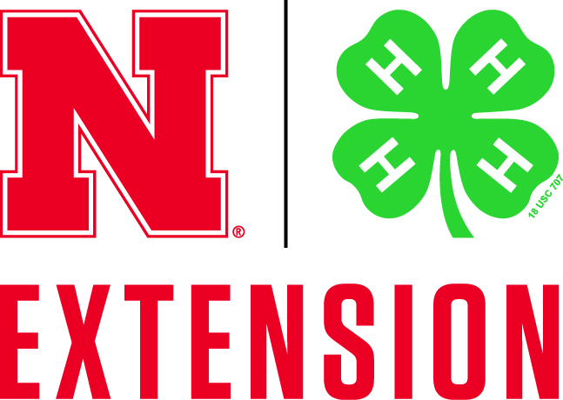
For more information about the livestock sale or donating, contact Nebraska Extension – Platte County at 402-563-4901.
