THE $20 CHALLENGE REPORT

Name: _____________________________________________________

1. Where did you purchase your outfit?
________ Consignment store ________ Goodwill Store
________ Garage sale ________ Salvation Army Store
________ Other: ______________________________________________________

2. Where do you plan to wear the outfit you selected?

3. If the fiber content label is still there and readable, what is the fiber content of the
garment(s) you selected?

4. If the care label is still attached, what kind of care is required for the garment(s) you
selected?

5. Please attach your receipt to the right edge of this page.

6. Tell the story of how and why you purchased this outfit.

7. Did you alter/enhance or embellish the garment(s)? ________ Yes ________ No
If yes, explain what you did, why you did it, and list any additional costs for
embellishment.


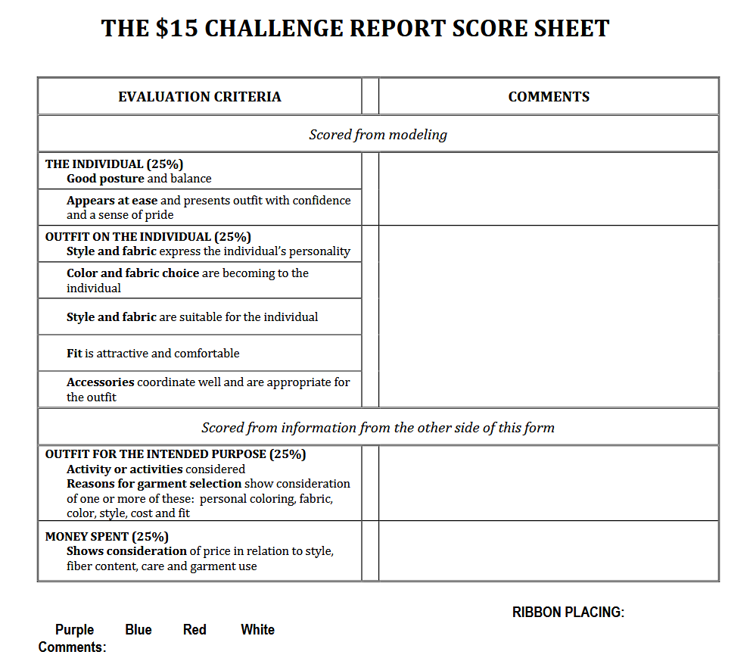
$20

