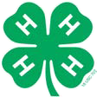

Platte County 4-H Favorite Foods Revue
The Favorite Foods Revue is open to all 4-H members ages 9–18. Participants MUST preregister for the contest on the County Fair entry website and sign up for a judging interview time slot using Sign Up Genius by the deadline. Class numbers for the online entry can be found in the fair book. Setup and interview times will be emailed to confirm participation. Check the current year fair book schedule to know when the Revue is held during the County Fair.
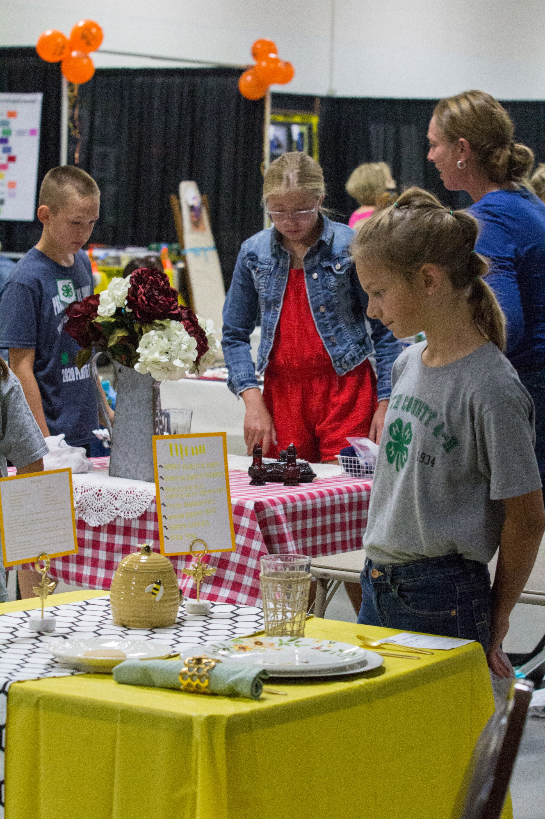
Participants select a theme and display one place setting, including table, table covering, dishes, glassware, silverware, centerpiece, menu, one food item, and recipe. 4-H’er prepares one of the menu foods that is appropriate to the level of foods project they are enrolled in and one that can be kept at room temperature.
Why participate in Favorite Foods Revue? It is a fun way to learn how to:
- properly set a table
- plan nutritious meals
- express originality and creativity in choosing a theme
- present to the judge
- express knowledge of food, nutrition and food safety
The contest is divided into divisions according to age as of January 1, Junior (ages 9 and younger), Intermediate (ages 10-13) and Senior (ages 13–18). This is a county contest only — there is no state contest.

Guidelines in Creating Your Table Setting
Do you know that you can be a designer each time you set the table? A designer chooses and arranges things according to a plan for beauty and order. A neat, interesting, clean and attractive table setting makes any meal more enjoyable. Actually, there is more than one way to set a table. The usual way to set a table is to put all the dishes, flatware, and food on the table before anyone sits down. When there is company or for a special meal, part of the food and dishes may be left in the kitchen and served later. Diners at a buffet or a picnic may fill their plates and glasses before they are seated. The way to set your table depends upon the way the meal is to be served. Be creative and have fun! Color texture, design and creativity are important.
For the Table Setting, one place setting is to be displayed. Include table covering, dinnerware, stemware, flatware, centerpiece and menu. You MUST bring a sturdy card table for the display. Plate and utensils must be safe and sanitized (non-toxic), (for example, do not paint utensils or use a hub cap).
Select a Theme - What is the occasion...a family dinner, a holiday, or lunch with friends? Select a theme which fits the occasion. Possibilities can run from a fishing party sack lunch to a formal Mother’s Day dinner.
Table Appointments – These include any item used to set a table: tablecloth, placemats, dinnerware, glassware, flatware, and centerpiece. Choose table appointments to fit the occasion and carry out the theme. Paper plates, plastic ware, and paper napkins may be used for a picnic but they would not be appropriate for a formal dinner. Flatware and dishware must be safe to eat from i.e., no glitter glue, glue, etc. is to be used on eating surfaces.

Nebraska Extension is a Division of the Institute of Agriculture and Natural Resources at the University of Nebraska–Lincoln cooperating with the Counties and the United Sates Department of Agriculture.

Nebraska Extension educational programs abide with the nondiscrimination policies of the University of Nebraska– Lincoln and the United States Department of Agriculture.
© 2026

Table Covering - This is the background for the food and table appointments placed on it. It protects the table and makes for less noise. Placemats and/or tablecloths may be used. Sometimes the table is left bare. Choose a covering which is appropriate for the occasion and the other table appointments. You may match or blend colors and textures in the dishes — or use something quite different for contrast.

Place Setting - Allow at least 20 inches for each person’s dishes. This is called a cover and each cover is set exactly the same. A cover contains the dinnerware and flatware for the meal served.
- Put the plate, china, pottery paper, glass, etc., in the center of the cover about one inch from the edge of the table. If a table is not used at the event, placement may vary.
- Place the knives and spoons on the right side, the forks (silver, plastic, etc.) on the left about one inch from the plate and one inch from the edge of the table. Turn the cutting edge of the knife towards the plate. If there is more than one piece in each cover, such as one dinner fork and a salad fork or one teaspoon and a soup spoon, place the one that will be used first outside the other.
- Napkins folded into oblongs are placed next to the forks with the fold to the left so it opens like book. Decorative and creative folds are encouraged. Placement of the napkin may vary.
- The first beverage glass is placed about one inch above the tip of the knife. If serving more than one beverage, place additional glass(es) to the right of first glass in order served.
- If coffee or tea is served, the cup is placed on the saucer and set to the right of the spoon. Have the handle pointing to the right.
- Salad, bread and/or dessert plate(s) — or bowl(s) — may be placed at the top of the fork(s).
- When selecting your cover, include a dish for each course. Placement may vary according to how and when food is served.

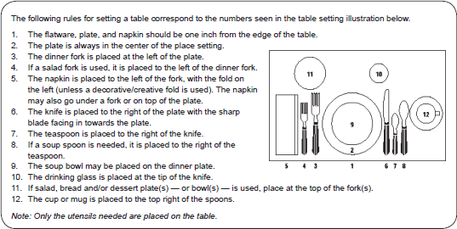

Centerpiece - The centerpiece should be coordinated with the table appointment and be appropriate for the occasion. Even though a single place setting is set, the centerpiece should be visible to all as if the entire table was set and should not obstruct anyone’s view of each other. Centerpiece candles are NOT to be lit.

Menu - When planning a menu, first decide on the main dish. Select appropriate vegetables, appetizer, soup or salad. Add a bread, dessert and beverage, if desired. Use My Pyramid to plan nutritious meals. Breakfast, party, and picnic menus should contain two or three food groups. Other meals should contain five food groups. Participants are encouraged to develop interesting and creative menus. For example, you might name a food to fit your theme. For more information about MyPyramid, go to http://mypyramid.gov
Note: The use of alcoholic beverages in any menu will disqualify table setting.

Attire
4-H’ers must wear 4-H Chevron or 4-H t-shirt. Participant’s attire can correspond with the theme/occasion of their table setting.

At the Contest
The judge spends 5 minutes with each participant. To alleviate some of the waiting, judging is divided into 45- minute time slots. Participants are assigned a time slot. Prior to the contest, you will be mailed your assigned half- hour time slot with the judge.
Registration & Set Up – Please arrive 15-30 minutes prior to your assigned time to setup your table (set up is not timed, only time with the judge). You MUST bring a sturdy card table for the display.
When you arrive, locate your assigned specific area to set up (names and time slot are taped to the floor).
Only contestants will be allowed to remain in the judging area. Parents and family members are only allowed to assist the 4-H’er in carrying their things to the judging area. NO parents, family members or viewers are allowed in the judging area until all contestants have been judged. This is being courteous and respectful to all contestants and judges.
Participants must have their table setting ready by their assigned time.
Judging & Interview – During judging, you PRESENT your table setting to the judge by telling about your ideas and why you chose this particular theme, choice of menu, food preparation and food handling. You should also demonstrate an understanding of table setting techniques. Following your presentation be prepared to answer questions. You should be able to describe the ingredients and preparation required for all menu items, as well as food safety. Questions with more difficulty will be asked in the Sr. Division and to help judges make Grand and Reserve Champion selections.

Writing the Menu
The menu should be displayed on a 4x6 recipe card or on your choice of medium (index card, ceramic tile, chalkboard, etc.) printed or typed by the participant. You may decorate and/or prop up the menu.
- (a) List the foods in the order in which they are served.
(Every menu will not include all the foods listed.) EXAMPLES FOR A FORMAL MEAL Appetizer
Broiled Ham Grilled Pineapple Slices
Cole Slaw
Hot Gingerbread with Applesauce Coffee Milk
Main Dish
Starchy Vegetable Other Vegetables Salad
Bread Dessert Beverage
(b) Group foods served in one course. Use single line spacing between food items and a double line spacing between courses.
- Use CAPITALS at the beginning of all words except articles, conjunctions, and prepositions. Correct spelling is important.
Cream of Broccoli Soup Curried Toast Fingers

Fresh Fruit Salad Plate with Lime Sherbet Crescent Rolls

Glazed Chocolate Roll Coffee Milk
- When an item on the menu has an accompaniment:
  - place the main item to the left and the accompaniment to the right,
Braised Pork Chops Applesauce
  - or you may center the main item and write the accompanying item underneath,
Braised Pork Chops Applesauce
  - if more than one accompaniment appears, place one at each side on the same line,
Sesame Seed Wafers Tomato Bouillon Saltines
  - or place both on the same line below.
Tomato Bouillon
Sesame Seed Wafers Saltines
- When a food is commonly prepared in more than one way, avoid confusion by describing the method of cooking,

such as: Roast Turkey or French Fried Potatoes.
- List each food with the exception of butter, cream, sugar, or salad dressing, unless it is something special, such as Honey Butter or Poppy seed dressing.
- List beverages last.
- Plan the spacing and arrangement of the items on the menu so that the written menu is symmetrical.
Common Errors in Planning Meals
NUTRITION
- Too many foods from one food group
- Missing food groups
- Contain a variety of foods
- Not meeting the nutritional needs of those for whom it is planned

TEMPERATURE
- Too many foods of the same temperature
- Not enough time allotted for preparation
PREPARATION AND TYPE OF FOOD
- No main dish
- More than one main dish
- Too many foods prepared
- In the same way, such as fried food, creamed food, or foods with sauces
- Too many starchy foods same fruit or vegetable more than once
- Too many high protein foods
- No contrast or variation
- Clashing or unpleasant color scheme

TEXTURE
- Too many soft foods
- Too many chewy foods
- Too many crispy or crunchy foods
- Lack of variety in texture

SIZE
- Too many mixtures
- Too many small pieces of the same size and shape
- Too many similar shapes
- Lack of variety in shape
- Need to keep hot foods hot and cold foods cold
- Food not stored at safe temperature (special consideration needed for picnics)

FLAVOR
- All bland flavor
- Too many strong flavors
- Repetition of food or flavor
- No tart or acid-flavor
- Too many sweet or too many sour foods

COLOR
- Too many foods of same color

Writing A Recipe
Many food entries for fairs call for the exhibitor to include the recipe used. The format used for writing the recipe is also considered in the judging. Guidelines for writing the recipe follow.
Characteristics for a good recipe:
- It should be accurate.
- It should be complete.
- It should be simple and clear.
- It should list all ingredients in the order used.
- It should give exact measurements in the easiest unit of measure (i.e., ¼ cup, not 4 Tablespoons).
- If possible in the space allowed, do not abbreviate.
- Use weights for meat, when possible
- Use weight or fluid measure of canned foods (don’t say “one can pineapple,” say “one 12 ounce can of pineapple”).
- Use short sentences and clear, simple descriptions of methods.
- Give word pictures, if possible (foamy, syrupy, lemon-colored).
- Specify pan size.
- Give 2 tests for doneness, if possible. For example, a thermometer reading and a cold water test for candy. Include baking temperature and baking time.
- Give total yield of number of servings, and state serving size.

Recipe Construction
Standard Form
- The most widely used and easily read form. Excellent for recipes containing many ingredients.
- List all ingredients first, include any modifications of the ingredients. For instance, if your recipe requires 1 cup chopped nuts – the nuts should be measured after chopping. However, if the ingredients is 1 cup nuts chopped – the nuts are measured first, then chopped.
- The method of combining the ingredients follows the listing. It may be stated in paragraph or numbered steps.

Example of a recipe written in Standard Form:

WAFFLES
1 ¾ cup sifted enriched flour 1 ¼ cups milk
3 teaspoons baking powder ½ cup melted shortening
½ teaspoon salt 2 stiff-beaten egg whites 2 beaten egg yolks
Preheat waffle iron. Sift dry ingredients; stir in combined egg yolk, milk and shortening. Fold in egg whites. Bake in hot waffle iron. Makes 8.

OR
- Preheat waffle iron.
- Sift dry ingredients into bowl.
- Combine egg yolks, milk and shortening
- Stir into dry ingredients.
- Fold in beaten egg whites.
- Bake in hot waffle iron. Makes 8 waffles
Action Form
- Takes more space than the standard form, but it is easy to follow.
- The narrative description of the “action” of combining ingredients is included with the list of ingredients.
- Ingredients are described the same way as the Standard Form.

Example of a recipe written in Action Form:

WAFFLES
Preheat waffle iron.

Narrative Form
Measure and sift together into mixing bowl: 1 ¾ cup sifted enriched flour
3 teaspoons baking powder
½ teaspoon salt Mix together:
2 beaten egg yolks 1 ¼ cups milk
½ cup melted shortening
Stir liquid ingredients into dry ingredients. Fold in 2 beaten egg whites.
Bake hot waffle iron.
Makes 8 waffles.

- The most difficult to follow. Requires very little space. Suited to simple recipes with few ingredients.
- Include the ingredients and amounts with the method in paragraph form.

Example of a recipe written in Narrative Form:

WAFFLES
Preheat waffle iron. Measure out 1 ¾ cups of sifted enriched flour. Add 3 teaspoons of baking powder and ½ teaspoon salt and sift again. Separate the yolks from the whites of 2 eggs. Beat the yolks slightly. Add to the yolks 1 ¼ cups milk and ½ cup of melted shortening. Stir the liquid ingredients into the dry ingredients. Beat the two egg whites until stiff but not dry. Fold the egg whites into the batter. Bake in a hot waffle iron.
Makes 8 waffles.

Descriptive Form
- Requires more space than other forms. Very easy to read and follow.
- Ingredients, amounts and mixing directions are listed in 3 separate columns. Each step in mixing is a separate paragraph.
- Ingredients are described the same as in the Standard Form.

Example of a recipe written in Descriptive Form:

WAFFLES
8 waffles

Flour, enriched, sifted 1 ¾ cups Preheated waffle iron.

Baking powder, double-acting 3 teaspoons Sift dry ingredients into bowl.

Salt ½ teaspoon Combine egg yolks, milk and shortening. Egg, separated 2 Stir liquid ingredients into dry ingredients.
Milk 1 ¼ cup Fold in egg whites which have been beaten until stiff but not dry.

Shortening, melted ½ cup Bake in hot waffle iron.

Additional Information
If you have any questions, call the Nebraska Extension – Platte County Office at (402) 563-4901.
NOTE: UNL Extension – Platte County and Platte County Agricultural Park are not responsible for any damages.


References:
Kinder, F., Green, N.R. and Harris, N. 1984. Meal Management, 6th Edition. Macmillan Publishing Company, New York, NY.
Holmberg, R. 1983. Meal Management Today. Waveland Press, Inc. Prospect Heights, IL.

