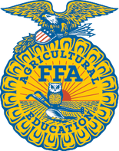
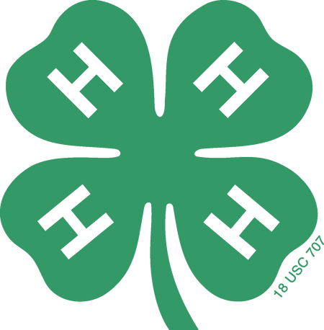
4-H & FFA MARKET SWINE
SEWARD COUNTY I.D. SHEET DEADLINE - JUNE 15
Last Name First Name(s) Age (Jan 1): YQCA #
Age (Jan 1): YQCA #
Age (Jan 1): YQCA #
Age (Jan 1): YQCA #

4-H Club FFA Chapter Premise ID#
Please draw in and write in universal numbers in the correct column. You must have notches in both ears. Refer to universal notching system for pig numbers. Only those animals identified with ear notches will be eligible for showing at State Fair.

Address Email Phone
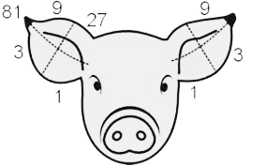
Numbering of Universal Ear Notching System: Up to two notches can be made in each quarter of the ear. Ex. To have a 6-2, put 2 notches in the quarter of the right ear where the 3 is located and put 2 notches in the quarter of the left ear where the 1 is located. To correctly identify the right and left ear, face the same direction as the pig and your right and the pigs right will be the same. If you stand looking at the face of the pig, its right ear is on your left.

4-H | FFA | Color | Right Ear | Left Ear | R Ear # | L Ear # | Sex | EID Tag - Five Digit # | EID Button – 15 Digit #
Signature of all 4-H Members: ______________________________________________________________________________________
Signature of Parent/Guardian:

SEWARD COUNTY 4-H & FFA ANIMAL EXHIBITOR & ANIMAL IDENTIFICATION INFORMATION

AGE OF EXHIBITOR
- 4-H: a 4-H animal owner/exhibitor 8 to 18 years old on January 1 of the current calendar show year is eligible to exhibit in 4-H sponsored events. Exhibitors who are 8 years old as of January 1 of the current year may exhibit at the State Fair. 4-H members may be certified for state and interstate shows if they meet age requirements for that event and have properly enrolled and identified animals.
- FFA: Only bona fide Nebraska FFA members aged 12-21 shall be eligible for FFA Division entries.

ANIMAL OWNERSHIP
All beef, swine, sheep, and meat goat project animals must be owned:
- Solely by the 4-H exhibitor, or
- The exhibitor in partnership with other member(s) of his or her immediate family. Only the name of the showman can be on the show entry. Immediate family is defined as members of a household, including parents, brothers and sisters, and youth in care of the head of the household.

REGISTRATION PAPERS
For County and State Fair, registration papers must show one of the following:
  - The member’s name as owner, or
  - The name of the exhibitor and/or a co-owner who is a member of the exhibitor’s immediate family (see immediate family definition above), or
  - The family farm or ranch name or parents’ name

4-H ENROLLMENT
- Seward County 4-H online enrollment is required by June 15.

YOUTH FOR THE QUALITY CARE OF ANIMALS (YQCA) – LIVESTOCK QUALITY ASSURANCE REQUIREMENTS
- The Nebraska 4-H Program requires 4-H and FFA members (8-18 years old) exhibiting BEEF, DAIRY CATTLE, DAIRY GOAT, MEAT GOAT, HOG, POULTRY, RABBITS, and SHEEP to be certified annually in Quality Assurance by June 15 of the current year.

OFFICIAL LIVESTOCK IDENTIFICATION
- All livestock with an EID tag are required to have a Premises ID. A Premises ID number can be obtained through the Nebraska Department of Agriculture. Call the Nebraska Department of Agriculture at 1-800-572-2437 or visit: nda.nebraska.gov/adt/premises.html .
- If market animals are already identified/tagged with USDA official EID tags, use existing EID tags for identification. DO NOT REMOVE. IT IS UNLAWFUL TO REMOVE EXISTING EID TAGS! Market animals with existing EID tags will use that tag number for the EID identification portion.
- 4-H and EID Tags are to be obtained from the Extension Office.

OBTAINING SCRAPIES TAGS for 4-H IDENTIFICATION
- The official 4-H identification for ALL classes of meat goats and sheep is a SCRAPIE TAG. If an animal has an existing EID tags - DO NOT REMOVE. It is UNLAWFUL to remove existing EID tags.
- To acquire official SCRAPIE TAGS at no cost, call the scrapie toll free number 866-USDA-TAG (866-873-2824 Select option 7 for Epidemiologist officer) or go to: http://www.eradicatescrapie.org/. To order additional tags, go to: http://www.eradicatescrapie.org/Tag%20Companies.html

NEBRASKA STATE FAIR ENTRY PROCESS
- 4-H/FFA livestock exhibitors/families are responsible for submitting their animal information into the stock show livestock database online by the nomination deadline at www.showstockmgr.com .
- Payments for the DNA process will be directly submitted by the 4-H/FFA Livestock exhibitor/family through the online database. Payments will NOT be made to the Extension Office.
- Families will have the ability to edit incorrect information (wrong tag number, wrong birth date, etc.) up to the nomination deadline.
- Extension 4-H Staff will validate nominations and deliver the DNA envelopes to the appropriate office by the respected deadline.
- Once the information is in the database and has been validated by the Extension Staff, it will be available for exhibitors to make State Fair entries.
- Any animal not entered in the Show Stock livestock database will be considered ineligible for Nebraska State Fair.
- All livestock nominations are required to have DNA envelopes submitted to the Extension Office by the entry deadline or they will be considered ineligible for State Fair. Extension staff/FFA advisors will submit DNA envelopes.
AKSARBEN LIVESTOCK SHOW: has transitioned to a junior livestock show format in 2019 for youth 9 to 19 years of age with no prerequisite of youth organization affiliation. Please go to https://www.aksarbenstockshow.com/ for information. Must submit AKSARBEN DNA.

