All non-animal exhibits are called static exhibits. Static exhibits are entered, judged and displayed under the grandstand
(clothing and foods exhibits are judged upstairs).
To exhibit in the 4-H project areas, members MUST be enrolled in the respective project by enrollment deadline. The Platte County fair book lists all static exhibit classes and gives detailed information on what each exhibit needs to make it complete. A specific project can only be entered in one category or class. Each individual is limited to only one entry per class number unless otherwise stated in the fair book.

All youth exhibiting at the county fair will receive a free t-shirt, stop by the 4-H Fair Office at Ag Park during the fair
to get yours!
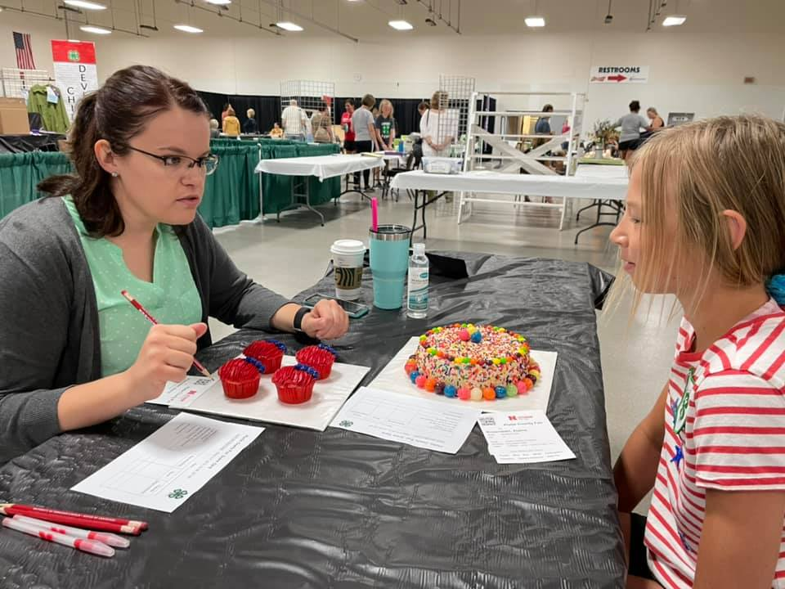
LABELING
The entry tag you receive from the office needs to be securely attached to the exhibit. This can be done using rubber band, string, safety pin, etc. Make sure to also include any supporting information required by project area, refer to fair book under each department for additional information.

It is important to label all pieces of the exhibit with exhibitor name, club name and class number. It is recommended to use a sticky label, sew on a label, or other means appropriate for the exhibit. This is very important to label exhibits in the event that the entry tag becomes unattached from the exhibit.

All exhibits (both static and not) are required to be pre-entered online by June 15th. If deadline is missed, our office will still accept entries for three business days after deadline with applicable late entry fees.

Entry cards will be created, printed, and distributed through club leaders beginning June 23rd. If your family is an Independent member, you are responsible for coming to the office to pick up your own tags.

PRE-ENTRY
How to Exhibit 4-H Static Exhibits at the Platte County Fair

RELEASE OF EXHIBITS

Exhibits will remain on display until the end of the fair. Release times are Sunday, July 12th 5:00 – 7:00 pm OR Monday, July 13th 8:30 -10:00 am. Please do not remove exhibits prior to this time. Individual 4-H’ers are responsible for picking up their projects during these times.

The Platte County Ag Society provides premium money for 4-H exhibits. Premiums will be available beginning Sunday, July 12th 5-7 pm and Monday, July 13th 8:30 am – 12:00 noon at the 4-H Adm. Building at Ag Park.

ENTERING AND INTERVIEWING
Refer to pages 5-8 in the fair book for specific department entry and interview schedule.

4-H’ers are HIGHLY encouraged to interview judge their exhibits when possible to further their skill development. 4-H’ers are required to wear the 4-H clover while interviewing. This can be a 4-H t-shirt or a 4-H Chevron pinned to your shirt. After entering and judging, the exhibits will be displayed and remain on the fairgrounds for the remainder of the fair.

