All exhibits are required to be pre-entered online by June 15th. If deadline is missed, our office will still accept entries for three business days after deadline with applicable late entry fees.

PRE-ENTRY
To exhibit in the 4-H livestock or animal project areas, members MUST be enrolled in the respective project by enrollment deadline. All 4-H livestock projects must be properly identified. Refer to the Platte County 4-H Animal Exhibitor Handbook for detailed information. If also exhibiting FFA project animals, contact your local FFA Advisor for identification information.

Families exhibiting 4-H or FFA livestock projects are highly encouraged to ownerships, exhibiting, dress code, ethics, testing, grooming and other rules and regulations starting on page 16 of the Platte County Fair Premium Book.

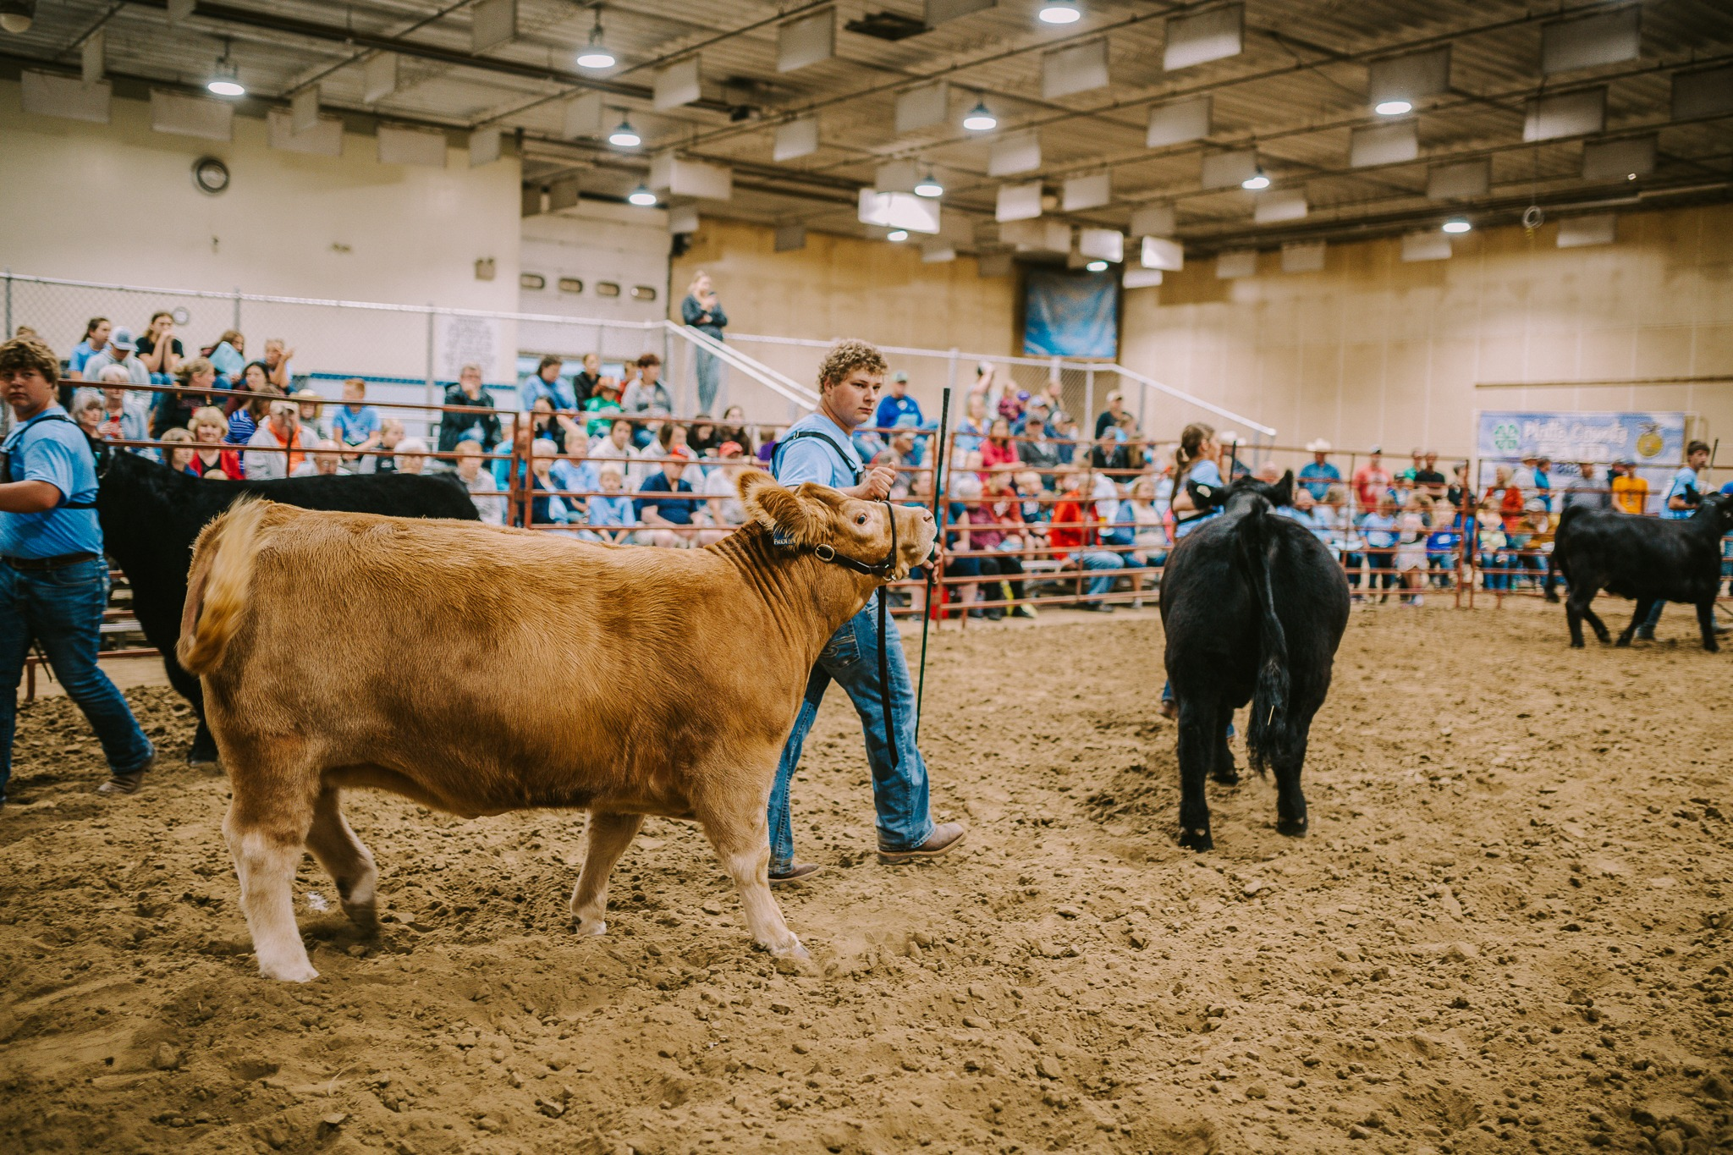

How to Exhibit 4-H Livestock Exhibits at the Platte County Fair
Market Animals
Beef, goats, pigs, broilers and sheep market animals can either go to harvest following the county fair or return home. It is the responsibility of the 4-H’er to ensure they communicate their plans for their livestock projects to 4-H staff located in the Fair Office at the fairgrounds. All breeding animals return home.

All youth exhibiting at the county fair will receive a free t-shirt, stop by the 4-H Fair Office at Ag Park during the fair to get yours! If exhibiting in the livestock sale, please wear the current fair year’s shirt.

Livestock Sale

All market beef, goats, pigs, sheep, and broiler exhibits receiving a purple are eligible to participate in the purple ribbon auction. Other livestock projects receiving blue or red ribbons will receive pool money from the livestock sale.

All 4-H livestock exhibitors are HIGHLY encouraged to review all livestock sale guidelines in the Platte County 4-H Animal Exhibitor handbook.

Record Books & Showmanship
Refer to page 19 of fair book for detailed information. All animal projects, except for Poultry, Companion Animal, and Rabbits are required to complete and return a record book at the time of weigh-in. Not turning in a record book will result in the lowering of one ribbon placing in respective showmanship class.

4-H’ers exhibiting livestock are required to participate in showmanship in at least one specie or will forfeit all premium money.

Livestock will remain on display until the end of the fair. Release time is Sunday, July 12th beginning at 5:00 pm.

The Platte County Ag Society provides premiums for 4-H exhibits. Premiums will be available beginning Sunday, July 12th 5-7 pm and Monday, July 13th 8:30 am – 12:00 noon at the 4-H Fair Office at Ag Park.

Release of Livestock

