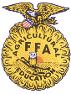

Dairy Goat Identification
Last Name______________________ First Name ______________________ 4-H Age _____ YQCA # ___________________
4-H Club _______________________ ______________________ 4-H Age ______ YQCA #__________________
Premise ID # ___________________ ______________________ 4-H Age ______ YQCA # __________________
______________________ 4-H Age ______ YQCA # ___________________

NEBRASKA 4-H/FFA DAIRY GOAT IDENTIFICATION AFFIDAVIT
See reverse side for important instructions and lease affidavit.

REGISTERED____________________________ GRADE____________________ BREED______________________
BRED BY EXHIBITOR: YES______ NO______
NAME OF ANIMAL ___________________________________________REGISTRY NO. ________________________________
TATTOO OR EAR TAG # RIGHT _____________________ LEFT ______________________ DATE BORN ___________________
VACCINATION TAG # _________________________________________________ 4-H ______ FFA _______ (mark one)
(Need at least one of these forms of ID (tattoo, tag or vaccination tag) for animals without distinct markings.)
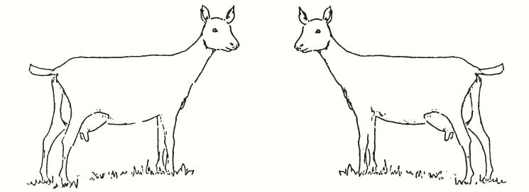
Sketch markings and include colors or attach photographs showing both sides of face.

Mailing Address: __________________________________________________________________________________________
Email Address: _____________________________________________Phone: ________________________________________
Signature(s) 4-H Members: __________________________________ __________________________________________
Signature of Parent/Guardian: ______________________________________________________________________________

SEWARD COUNTY 4-H & FFA ANIMAL EXHIBITOR & ANIMAL IDENTIFICATION INFORMATION

AGE OF EXHIBITOR
- 4-H: a 4-H animal owner/exhibitor 8 to 18 years old on January 1 of the current calendar show year is eligible to exhibit in 4-H sponsored events. Exhibitors who are 9 years old as of January 1 of the current year may exhibit at the State Fair. 4-H members may be certified for state and interstate shows if they meet age requirements for that event and have properly enrolled and identified animals.
- FFA: Only bona fide Nebraska FFA members aged 12-21 shall be eligible for FFA Division entries. There will be no discrimination because of race, color, sex, religion, or national origin.
ANIMAL OWNERSHIP
All beef, swine, sheep, goat, dairy and goat project animals must be owned:
- Solely by the 4-H exhibitor, or
- The exhibitor in partnership with other member(s) of his or her immediate family. Only the name of the showman can be on the show entry. Immediate family is defined as members of a household, including parents, brothers and sisters, and youth in care of the head of the household.
REGISTRATION PAPERS
For County and State Fair, registration papers must show one of the following:
- The member’s name as owner, or
- The name of the exhibitor and/or a co-owner who is a member of the exhibitor’s immediate family (see immediate family definition above), or
- The family farm or ranch name or parents name
4-H ENROLLMENT
- Seward County 4-H online enrollment is required by June 15.
YOUTH FOR THE QUALITY CARE OF ANIMALS (YQCA) – LIVESTOCK QUALITY ASSURANCE REQUIREMENTS
- The Nebraska 4-H Program requires 4-H and FFA members (8-18 years old) exhibiting BEEF, DAIRY CATTLE, DAIRY GOAT, MEAT GOAT, HOG, POULTRY, RABBITS and SHEEP to be certified in Quality Assurance by June 15 of the current year.
- This program is mandated by the Nebraska 4-H program and is implemented by the Seward County 4-H Program.
OFFICIAL LIVESTOCK IDENTIFICATION
- All livestock are required to have a Premises ID. A Premises ID number can be obtained through the Nebraska Department of Agriculture. Call the Nebraska Department of Agriculture at 1-800-572-2437 or visit: nda.nebraska.gov/adt/premises.html .
- If market animals are already identified/tagged with USDA official EID tags, use existing EID tags for identification. DO NOT REMOVE. IT IS UNLAWFUL TO REMOVE EXISTING EID TAGS! Market animals with existing EID tags will use that tag number for the EID identification portion.
- 4-H and EID Tags are to be obtained from the Extension Office.
OBTAINING SCRAPIES TAGS for 4-H IDENTIFICATION
- The official 4-H identification for ALL classes of meat goats and sheep is a SCRAPIE TAG. If an animal has an existing EID tags - DO NOT REMOVE. It is UNLAWFUL to remove existing EID tags.
- To acquire official SCRAPIE TAGS at no cost, call the scrapie toll free number 866-USDA-TAG (866-873-2824 Select option 7 for Epidemiologist officer) or go to: http://www.eradicatescrapie.org/. To order additional tags, go to: http://www.eradicatescrapie.org/Tag%20Companies.html
NEBRASKA STATE FAIR ENTRY PROCESS
- 4-H/FFA livestock exhibitors/families will be responsible for submitting their animal information into the stock show livestock database online by the nomination deadline at www.showstockmgr.com . This is NOT the responsibility of 4-H Extension Staff.
- Payments for the DNA process will be directly submitted by the 4-H/FFA Livestock exhibitor/family through the online database. Payments will NOT be made to the Extension Office.
- Families will have the ability to edit incorrect information (wrong tag number, wrong birth date, etc.) up to the nomination deadline.
- Extension Staff/FFA Advisors will deliver the DNA envelopes to the appropriate office by the respected deadline. Extension Staff will also have the ability to see what families have submitted and will be validating those nominations throughout the nomination process.
- Once the information is in the database and has been validated by the Extension Staff/FFA Advisor, it will be available for exhibitors to make State Fair entries.
- Any animal not entered in the Show Stock livestock data base will be considered ineligible for Nebraska State Fair.
- Market, breeding and feeder calves are required to have DNA envelopes submitted to the Extension Office by the entry deadline or they will be considered ineligible for State Fair. Extension staff/FFA advisors will submit DNA envelopes.
AKSARBEN LIVESTOCK SHOW: has transitioned to a junior livestock show format for 2019 for youth 9 to 19 years of age with no prerequisite of youth organization affiliation. Please go to https://www.aksarbenstockshow.com/ for information.

