Clover Kid exhibitors must be ages 5-7 (by January 1 of the current year)
and enrolled in 4-H as a Clover Kid.
Clover Kids may choose from any combination of static, small animal and livestock animal exhibits with a maximum of exhibits stated in fair book. These classes begin on page 78 of the 2026 Platte County fair book.
4-H Clover Kids receive participation ribbons only, which means they are not eligible for trophies, premiums, or any other awards.
4-H Clover Kids must pre-enter their exhibit online by June 15th. Entry tags will be made for each static exhibit. Entry tags are distributed to club leaders. If an Independent member, the tags are available beginning Tuesday, June 23rd.

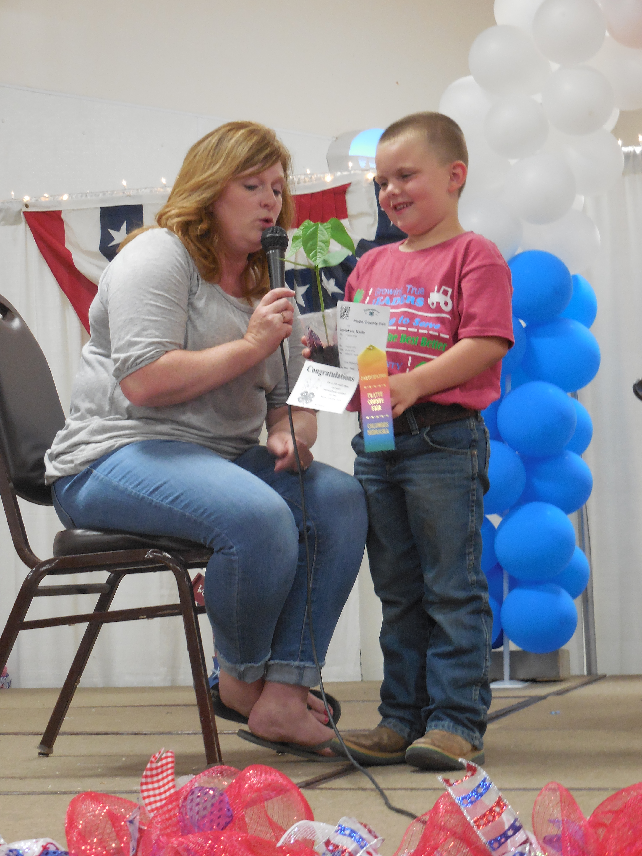
STATIC EXHIBITS
How 4-H Clover Kids
Participate in the Platte County Fair
Static Exhibit Check-in & Interviews:
Monday, July 6th 8:00 -12:00 pm or 12:30-1:30 pm under the grandstand at Ag Park.

Clover Kids are highly encouraged to interview judge their projects with the 4-H Junior Leaders. NO Live Animals entered at this time. Projects will remain at the check-in and interviewing area to be displayed. Clover Kids entering a decorated t-shirt can participate in the public Fashion Show, refer to page 63 of fair book for more details.
Static Exhibit Release:
Sunday, July 12th 5:00 – 7:00 pm OR
Monday, July 13th 8:30 -10:00 am
Please do not remove exhibits prior to this time.

4-H Clover Kids exhibiting at the county fair will receive a free t-shirt, stop by the 4-H Fair Office at Ag Park during the fair
to get yours!

ANIMAL EXHIBITS

What is the difference between PeeWee Showmanship and 4-H Clover Kids?
The PeeWee Showmanship classes held during some of the 4-H livestock shows are sponsored by the Platte County Ag Society. Youth are required to be age 5, but not enrolled in
4-H to participate. Refer to Animal Science Department in the Platte County fair book for more details.

SHOW & TELL
4-H Clover Kids exhibiting in the fair are invited to a Show & Tell experience on Wednesday, July 8th at 6:00 pm. Please check-in near the stage at 5:15 pm to sign up for a time slot. Clover Kids will be placed in small groups and brought on stage to tell more about an exhibit they brought to the fair.
Exhibits will come up on stage too!

Clover Kids may participate in the following small animal shows: dog, poultry, rabbits and small animal and livestock animal shows: bucket calf, dairy calf, lamb, goat, and swine. Refer to Clover Kid Department of the Platte County fair book for details.
A Clover Kid Livestock Animal Record book is required for bucket calf, dairy calf, lamb, goat and swine exhibits and to be handed in before the respective show.
Refer to fair schedule pages 5-8 of the Platte County fair book for specific animal/livestock show details.

