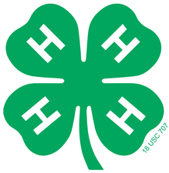
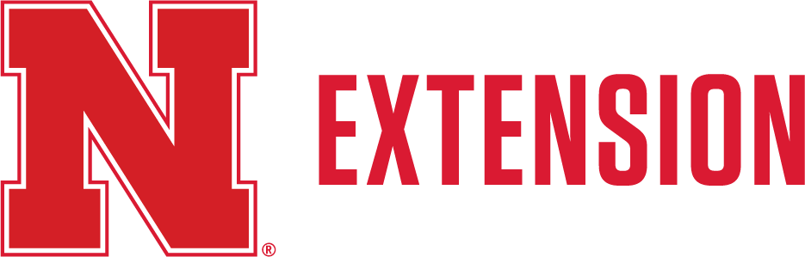

2026 CHECKLIST FOR LIVESTOCK FAMILIES
- Re-enroll in 4-H at https://v2.4honline.com
- Enrollment dues of $5 per 4-H member paid online
- County Fair: Turn in ID Sheets for ALL animals and DNA Envelopes (market beef, swine, sheep, and goat) to the Extension Office by May 15. (ID Sheets can be found on our website: https://extension.unl.edu/statewide/platte/4-h/platte-county-4-h-resources/ or at the Extension Office. For market beef, swine, sheep, and goat, a DNA sample must also be collected and returned to the Extension Office by May 15 using a Platte County DNA envelope.
- Complete Quality Assurance and turn in certificates by May 29. Access the YQCA course at yqcaprogram.org. *This includes ALL exhibitors (4-H Age 8-18) showing beef, bucket calves, sheep, goats, swine, dairy cattle, poultry, and rabbits* YQCA certificates can be sent to bwert3@nebraska.edu or dropped off at the Extension Office.

- State Fair: Enter nominations online at showstockmgr.com for any feeder calves, breeding beef, and market beef. State Fair DNA envelopes must be turned into the Extension Office by June 15 for all nominations. The deadline to nominate livestock online in Show Stock Manager is June 15th.
- Turn in Stall Reservation forms into the Extension Office by June 15th. All 4-H & FFA exhibitors showing Beef, Dairy, Goat, Horse, Poultry, Rabbit, Sheep and Swine must fill out this form to indicate how many stalls you are requesting for fair. This form can be found on platte.unl.edu or at the Extension Office.

Submit Platte County Fair entries into Show Works by the June 15th
deadline. Link found on platte.unl.edu along with all record books.
Please call the Extension Office at (402) 563-4901 if you have any questions.

