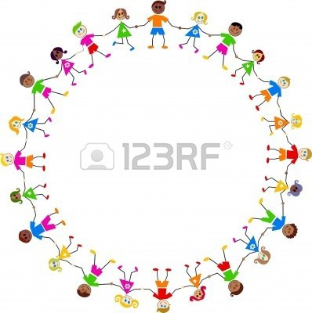

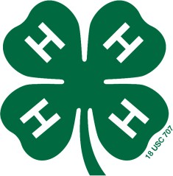

4-H
Clover Kid Record Book

(First & Last Name)

(4-H Club Name)

Due by October 1st

Who is your 4-H Club Leader(s)?

I like being a 4-H Clover Kid because:

List what you took to the County Fair: Put an check mark in the box if you:
- Went to 4-H Club meetings
- Helped with meeting set up and/or take down
- Brought treats to a club meeting
- Wore 4-H shirt to an activity
- Took projects to the County Fair

- Helped with community service project
- Attended a 4-H camp
- Attended a 4-H workshop or activity
- Participated in a County contest

- Participated in Clover Kid Pee Wee Showmanship
- Participated in an Open Class Animal Show

Next year I want to learn about:

Write a short story about what you have learned and what you did this year as a Clover Kid.

Member’s Signature:

Parent’s Signature:

4-H Leader’s Signature:

Extension Staff Signature:
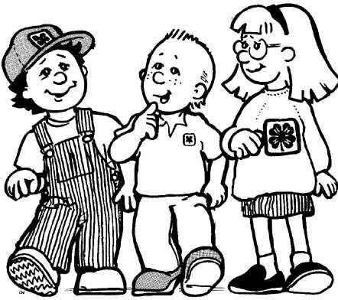

You may attach up to 2 pages of photos of your 4-H year or you may draw pictures of what you did as a Clover Kid. Try to write a description under the photos/pictures describing what you are doing.

