Fillmore County 4-H Clover Kid

Record Book

(First and Last Name)

(4-H Club)

Year

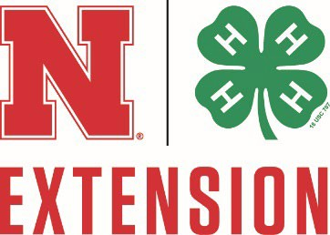

**University of Nebraska Lincoln-Extension Fillmore County**

Age: ____

This is my: 1st 2nd 3rd year as a Clover Kid (check one). Who is your club leader?

# PROJECT AREAS

Mark each one you took this year!

|  |  |
| --- | --- |
|  | Making Food For Me |
|  | Family Celebrations Around the  World |
|  | Just Outside Your Door |
|  | Theater Arts 1 |
|  | Decorate Your Duds |
|  | Exploring Farm Animals |
|  | Aerospace Unit 1 |
|  | Bicycle Adventures |
|  | Clover Kid Designs |
|  | A Space For Me |
|  | Pets |
|  | Design Your Own |

# Clover Kid Workshops Attended

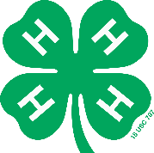

Circle the activities you were involved in:

Communication Event

Culinary Challenge

Talent Show

Fashion Show

Companion Animal Show

Pee Wee Showmanship at the County Fair

List the species:

Interview Judging at the County Fair

What did you bring to the fair?

Write a short story about being a 4-H Clover Kid or draw a picture on the next page!

Members Signature: Parent’s Signature:

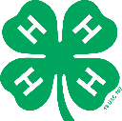This page is for 4-H photos or drawings!

Tell us under the photo or drawing what you were doing!

THANK YOU FOR BEING SUCH AN AWESOME 4-H CLOVER KID!