Lincoln-Logan-McPherson Counties
348 West State Farm Rd
North Platte NE 69101
308-532-2683, fax 532-2692
llm.unl.edu

4-H Horse Exhibitors Lincoln County Fair Details

Dear 4-H Exhibitor,

We are excited to see you at the 2021 Lincoln County Fair!

Please purchase any armbands/rulebooks you need when you pick up your packet. Packets will be available to pick up at the Extension Office starting July 14th. They will not be available on the fairgrounds for purchase this year. If you have not paid for fair entry fees you will need to do so before getting your packet.

Per the Lincoln County Ag Society, no trailers will be allowed to park in the fenced in area around the horse arena. The arena gate will open at 7:00 a.m. for check-in. Exhibitors will unload at the main north gate of the arena. Parking will be in the areas to the south and to the east of the arena. The Road Race – 5K/10K is going on Saturday morning as well and will be staged to the north of the Ag Building.

Show orders and patterns will be emailed to exhibitors & posted at the fairgrounds. There will not be paper copies to distribute this year. Final Show Orders will be posted on our website. Please use this web page or QR code to quickly access them:

https://go.unl.edu/lincolncountyshoworders

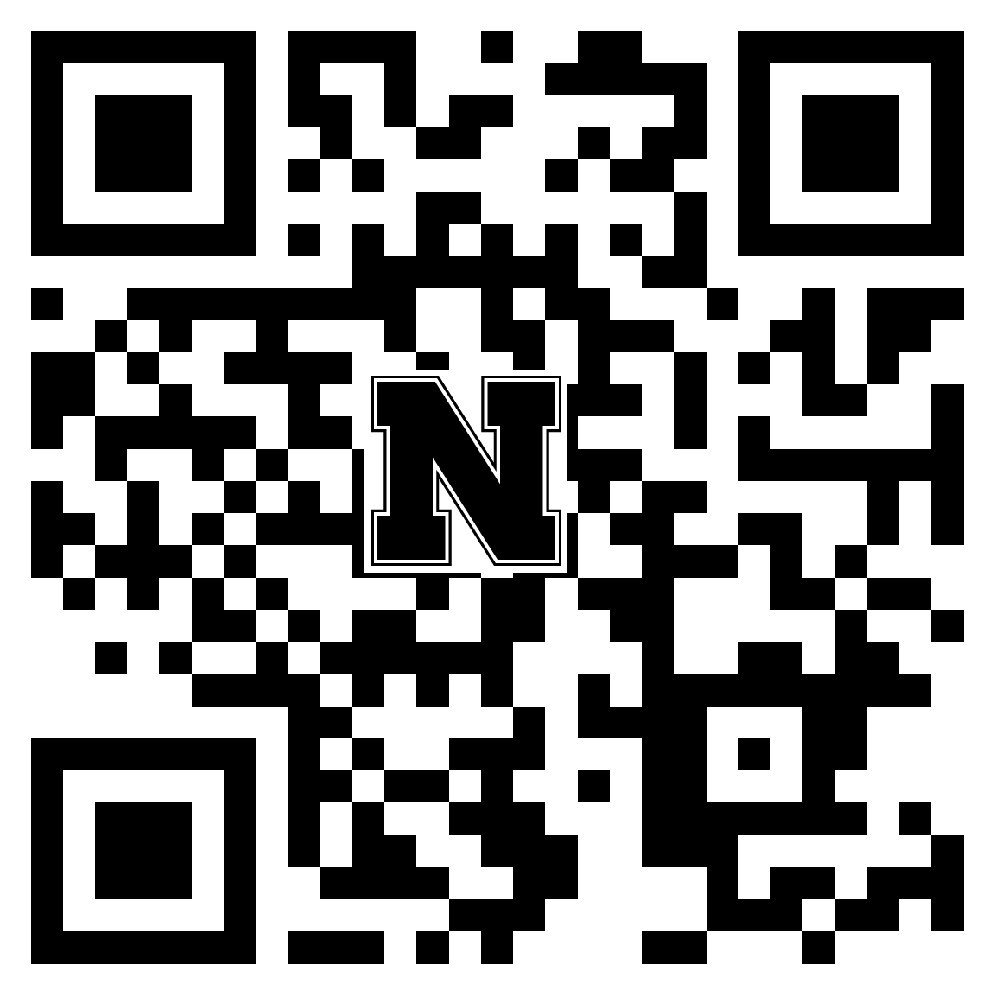

The Extension Office will be closed from noon July 19 – 25. It will be relocated to the Lincoln County Fairgrounds – Centennial Hall.

Sincerely,
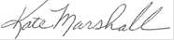

Kate Marshall
UNL Extension Educator
4-H & Youth Development

_________________________________________________________________
Extension is a Division of the Institute of Agriculture and Natural Resources at the University of Nebraska–Lincoln cooperating with the Counties and the United States Department of Agriculture.
University of Nebraska–Lincoln Extension educational programs abide with the nondiscrimination policies of the University of Nebraska–Lincoln and the United States Department of Agriculture.

