Lincoln-Logan-McPherson Counties
348 West State Farm Rd
North Platte NE 69101
308-532-2683, fax 532-2692
llm.unl.edu

Swine Exhibitors Lincoln County Fair Details

- General instructions and reminders to livestock exhibitors
  - Any unnatural means of providing an animal food, water, or other fluids (i.e. stomach pump, IV) with the exception of the drenching process will not be allowed. No artificial hair or hair-like substance will be allowed. (page 8 in fair book)
  - Any substitute showmen must be from the county in which the show is being held.
  - All manure waste must be put in the cement bunker outside the barn.
- Pigs will be stalled in the swine barn and each family will have an assigned pen that you MUST use. Nobody will be allowed to show from their trailer this year.
- Weigh-in will start on Friday, July 23rd at 6:00 p.m. Showmanship will be first on Show Day, at 8:00 a.m. Sunday.
- Shoes must be close toed when weighing, leading, or showing swine for your own safety.
- Review the general rules (starts on page 3) as well as the rules for your species section.
- Responsibility for grooming animals for show is primarily the responsibility of the exhibitor. The 4-H Council, extension staff and livestock superintendents ask all exhibitors to remember that the goals of the 4-H program is for the youth to learn by doing, and to develop skills related to their projects that will be useful not only now but later in life. This means that for the 4-H member to learn that they should first try to do work related to their project and request assistance and advice when needed from leaders, parents, and other experienced individuals, but not to expect those providing assistance to do all the work.
- State Fair livestock entries are due by August 10th. 4-H families will enter their livestock for State Fair via ShoWorks using the website https://www.statefair.org/competitions-and-participate/competitions/4-h-ffa-exhibitors The website will close at 8:00 pm August 10th. For more details, see statefair.org
- Ak-Sar-Ben entries are due by August 31. 4-H families will enter their livestock for Ak-Sar-Ben online this year at www.aksarbenstockshow.com.
- 4-H drug affidavit forms will be included in your packet and must be brought to the scale before weighing. Please bring this form completed with signatures to the scale at check in time. Packets will be available at the Extension Office on July 14th OR you can pick them up at the Fairgrounds before Weigh-In. This form will satisfy the requirements of the 4-H program.
- The Extension Office at 348 West State Farm Rd will be closed from noon July 19-July 25. It will be re-located to the Lincoln County Fairgrounds in Centennial Hall.
- Swine will be housed in the swine barn and will be shown in the beef arena. 4-H Clubs will be assigned pens for their pigs and will be unloaded on the north side of the swine barn.
- A reminder - No oil, powder, or hairdressing can be used on swine (p. 57 fair book). Violators’ exhibit’s placing will be lowered one ribbon placing.
- Maximum weight will be 320 pounds, minimum 230 pounds, no exceptions will be made. All underweight hogs will show in a pre-fair market class and will not sell. Pigs above the maximum weight will not be allowed to sell.
- Since the swine show is no longer a terminal show, all pigs will be removed from the grounds after 5:00 p.m. on Sunday, July 25th. You will need to let the sale committee know by the end of the show if you will be participating in the livestock ribbon sale.

- The livestock sale will be held Monday, July 26 at the Lincoln County Fairgrounds. Buyer registration starts at 11:30 with the sale following at 1:00 p.m. This will be a premium sale only.

16. There will be no paper copies of show orders to distribute this year. Final Show Orders will be posted on our website. Please use this web page or QR code to quickly access them:

https://go.unl.edu/lincolncountyshoworders

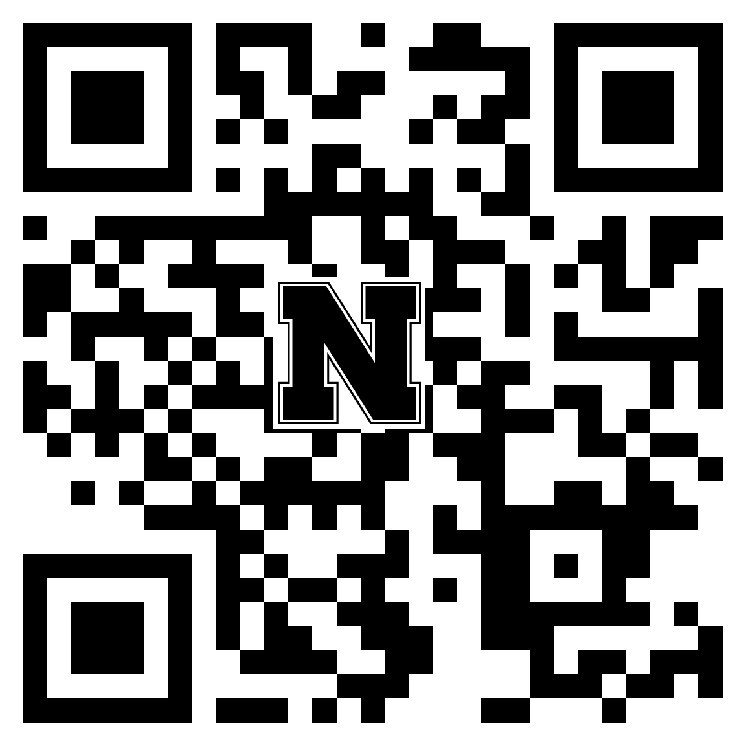

Production Pig Exhibitors
- Your record books will be due 5:00 PM Friday, October 1. This will give you time to complete your placings from the show and sale.
- The 4-H animal record book is available at our office or on our website.
- We will award the champions on Achievement night. The awards given are: Champion Production Hog, Reserve Champion Production Hog, and Champion Production Class Record.

Sincerely,

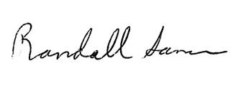

Randall Saner
Extension Educator

