Sheep Exhibitors Lincoln County Fair Details

1. General instructions and reminders to livestock exhibitors
a. Any unnatural means of providing an animal food, water, or other fluids (i.e. stomach pump, IV) with the exception of the drenching process will not be allowed. No artificial hair or hair-like substance will be allowed. (page 8 in fair book).
b. Muzzles are not allowed on sheep or goats.
c. Any substitute showmen must be from the county in which the show is being held
d. All manure waste must be put in the cement bunker outside the barn.
2. Weigh-in and check in will begin at 10:00 a.m. on Thursday, July 22nd. You will need to arrive by 5:00 p.m. Wednesday July 21st or you will be disqualified.
3. Sheep will stall in the west barn. You will not be allowed to show from your trailer this year.
4. The Sheep Show will be on July 23rd starting at 9:00a.m. and will start with showmanship.
5. Shoes must be close toed when weighing, leading, or showing sheep.
Review the general rules (starts on page 3) as well as the rules for your species section.
6. Responsibility for grooming animals for show is primarily the responsibility of the exhibitor. The 4-H Council, extension staff and livestock superintendents ask all exhibitors to remember that the goals of the 4-H program is for the youth to learn by doing, and to develop skills related to their projects that will be useful not only now but later in life. This means that for the 4-H member to learn that they should first try to do work related to their project and request assistance and advice when needed from leaders, parents, and other experienced individuals, but not to expect those providing assistance to do all the work.

7. State Fair livestock entries are due by August 10th. 4-H families will enter their livestock for State Fair via ShoWorks using the website https://www.statefair.org/competitions-and-participate/competitions/4-h-ffa-exhibitors The website will close at 8:00 pm August 10th. For more details, see statefair.org
8. Ak-Sar-Ben entries are due by August 31. 4-H families will enter their livestock for Ak-Sar- Ben online this year at www.aksarbenstockshow.com
9. 4-H drug affidavit forms will be included in your packet and must be brought to the scale before weighing. Please bring this form completed with signatures to the scale at check in time. This form will satisfy the requirements of the 4-H program. The packets may be picked up at the Extension Office starting Wednesday, July 14th.
10. The Extension Office at 348 West State Farm Rd will be closed from noon July 19- July 25. It will be re-located to the Lincoln County Fairgrounds in Centennial Hall.

11. There will be no paper copies of show orders available this year. Final Show Orders will be posted on our website. Please use this web page or QR code to quickly access them:

https://go.unl.edu/lincolncountyshoworders

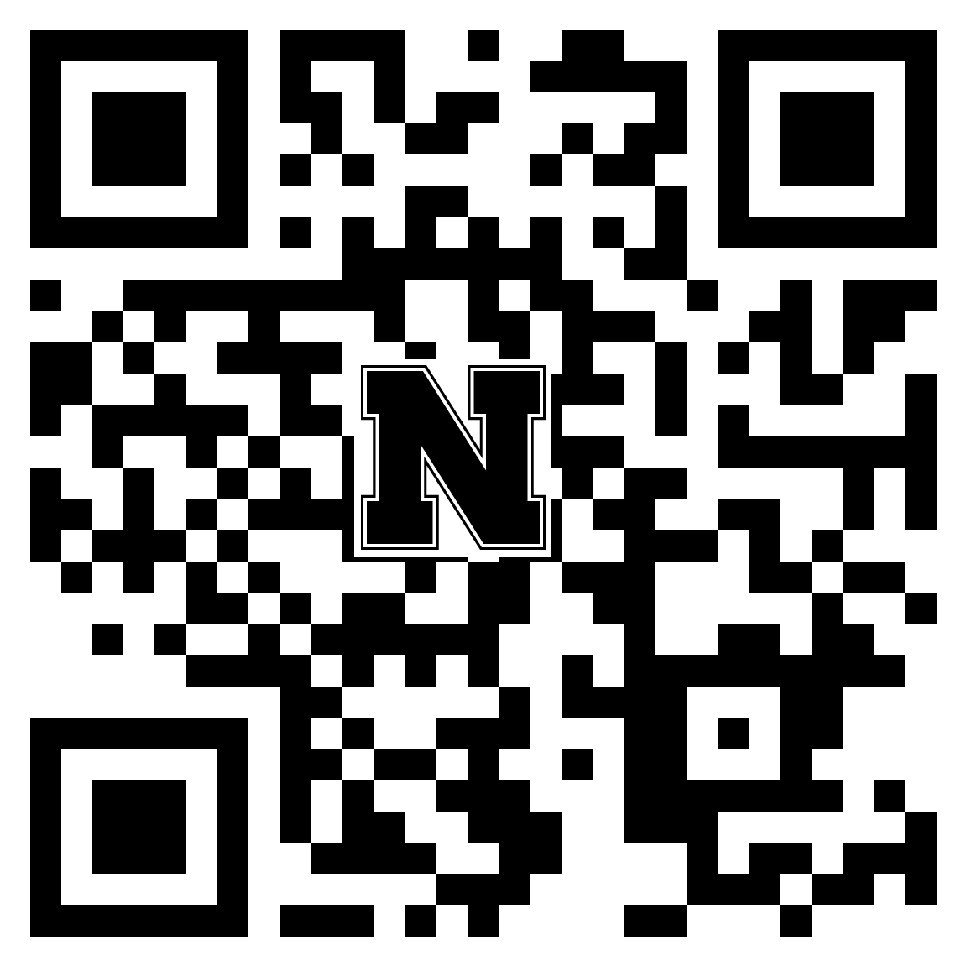

SHEEP SPECIFIC INFORMATION
- We will again be screening all lambs for club lamb fungus at the scale during weigh-in. If a lamb is rejected, you must take it to a veterinarian and get clearance.
- A reminder that on page 13, the rule regarding lifting the lamb’s feet off the ground will be enforced. It is permissible to lift to set the placement of the feet but then feet must be on the ground. Exhibitors may be warned once.
- All market ewe lambs and breeding stock are required to have a valid scrapie ID.
- All lambs will be released from the Fairgrounds on Sunday, July 25th at 5:00 p.m.
- The sale sign-up forms must be returned to the sale committee members at the end of the sheep show. The livestock sale will be held Monday, July 26 at the Lincoln County Fairgrounds. Buyer registration starts at 11:30 with the sale following at 1:00 p.m. This will be a premium sale only.
- Production Sheep Exhibitors record books will be due 5:00 PM Friday, October 1. The 4-H animal record book is available at our office or on our website.
- We will award the champions on Achievement night in October. The awards given are: Champion Production sheep, Reserve Champion Production sheep, and Champion Production Class Record.

Sincerely,

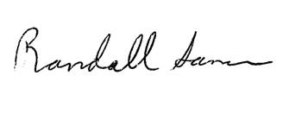
Randall Saner
Extension Educator

