Dog Exhibitors Lincoln County Fair Details

This year’s 4-H and Open Class fair dog show will begin at 8:00 am on Monday, July 19, with showmanship beginning at 8:00am. We will be running two show rings this year. We will run showmanship classes, followed by obedience and rally, then agility. We will ask for volunteers to help us change rally and agility courses throughout the day to ensure a smooth running show.

General instructions and reminders to dog exhibitors
- Shoes must be close toed when leading or showing dogs.
- 4-H’ers must have on a 4-H t-shirt while in the show ring. All Lincoln County 4-H’ers can pick up a free t-shirt at the extension office PRIOR to July 19. 4-H’ers, please also wear dark blue jeans, and a belt preferably.
- Things to remember for the show: water and bowl for your dog, lawn chairs and crate (if preferred), all leashes and collars necessary for the classes you entered.
- We will take a short lunch break if needed.
- Responsibility for grooming animals for show is primarily the responsibility of the exhibitor. The 4-H Council, extension staff and superintendents ask all exhibitors to remember that the goals of the 4-H program is for the youth to learn by doing, and to develop skills related to their projects that will be useful not only now but later in life. This means that for the 4-H member to learn that they should first try to do work related to their project and request assistance and advice when needed from leaders, parents, and other experienced individuals, but not to expect those providing assistance to do all the work.
- State Fair 4-H dog show is Sunday, August 29: 4-H animal entries (beef, sheep, swine, goats, poultry, rabbits and dogs) will be entered through ShoWorks online by the 4-H family. The entry deadline is August 10 at 8 PM central time. See the extension office for more information.
Times to remember – Monday, July 19: 8:00 am –dog show beginning with showmanship. Please plan to arrive by 7:30 am to ensure you are prepared.
Friday, July 23: 3:00 pm – Dog Costume contest in conjunction with Chicken Agility and Companion Animal contest. This should be a super fun afternoon so please plan to attend, even if you did not enter the costume contest.

ALL EXHIBITORS WILL NEED TO STOP BY THE EXTENSION OFFICE LOCATED AT 348 W STATE FARM RD NO LATER THAN JULY 16th AT 4:30 P.M. TO PICK UP EVERYTHING NEEDED TO SHOW AT FAIR, AND TURN IN VACCINATION RECORDS. WE WILL NOT BE HANDING OUT BACK TAGS OR T-SHIRTS AT THE FAIRGROUNDS.

The extension office at 348 West State Farm Road will be closed from noon July 19- July 25. It will be relocated to the Lincoln County Fairgrounds in Centennial Hall.

There will be no paper copies of show orders available this year. Final Show Orders will be posted on our website. Please use this web page or QR code to quickly access them:

https://go.unl.edu/lincolncountyshoworders

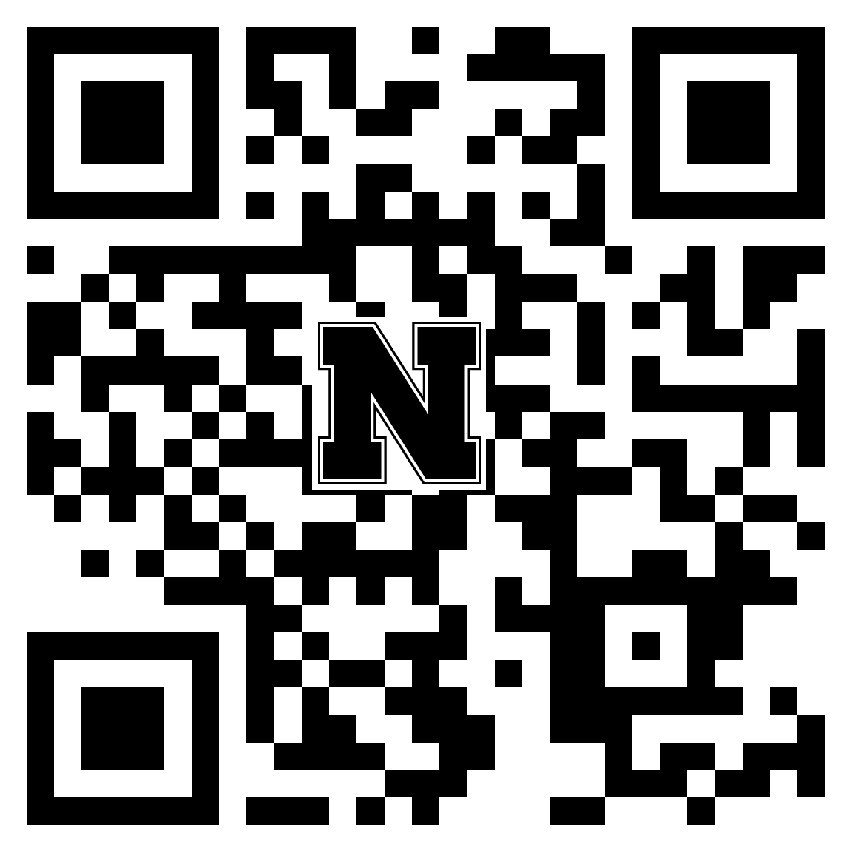

Sincerely,

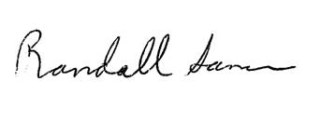
Randall Saner
Extension Educator

