Lincoln-Logan-McPherson Counties
348 West State Farm Rd
North Platte NE 69101
308-532-2683, fax 532-2692
llm.unl.edu

Beef Exhibitors Lincoln County Fair Details

- General instructions and reminders to livestock exhibitors
  - Any unnatural means of providing an animal food, water, or other fluids (i.e. stomach pump, IV) with the exception of the drenching process will not be allowed. No artificial hair or hair-like substance will be allowed. (page 8 in fair book)
  - Any substitute showmen must be from the county in which the show is being held.
  - All manure waste must be put in the cement bunker outside the barn.

- We will have assigned pens for each family that you MUST use. Nobody will be allowed to show from their trailer this year.
- The Beef show will only be on Saturday July, 24th starting with a No-Fit Showmanship show starting at 8:00 a.m. (only exception is Bucket Calves which will show on Friday).
- Shoes must be close toed when weighing, leading, or showing beef for your own safety. Please adhere to 4-H dress code; page 5 in fair book.
- Review the general rules (starts on page 3) as well as the rules for your species section.
- Responsibility for grooming animals for show is primarily the responsibility of the exhibitor. The 4-H Council, extension staff and livestock superintendents ask all exhibitors to remember that the goals of the 4-H program is for the youth to learn by doing, and to develop skills related to their projects that will be useful not only now but later in life. This means that for the 4-H member to learn, they should first try to do work related to their project and request assistance and advice when needed from leaders, parents, and other experienced individuals, but not to expect those providing assistance to do all the work.
- State Fair livestock entries are due by August 10th at 8:00 p.m. 4-H families will enter their livestock for State Fair via ShoWorks using the website https://www.statefair.org/competitions-and-participate/competitions/4-h-ffa-exhibitors The website will close at 8:00 pm August 10th. For more details, see statefair.org
- Ak-Sar-Ben entries are due by August 31. 4-H families will enter their livestock for Ak-Sar-Ben online this year at www.aksarbenstockshow.com.
- 4-H drug affidavit forms will be included in your packet and must be brought to the scale before weighing. Please bring this form completed with signatures to the scale at check in time. Packets will be available at the Extension Office on July 14th OR you can pick them up at the Fairgrounds before Weigh-In. This form will satisfy the requirements of the 4-H program.
- The extension office at 348 West State Farm Road will be closed from noon July 19-July 25. It will be re-located to the Lincoln County Fairgrounds in Centennial Hall.
- There will be no paper copies of show orders to distribute this year. Final Show Orders will be posted on our website. Please use this web page or QR code to quickly access them:

https://go.unl.edu/lincolncountyshoworders
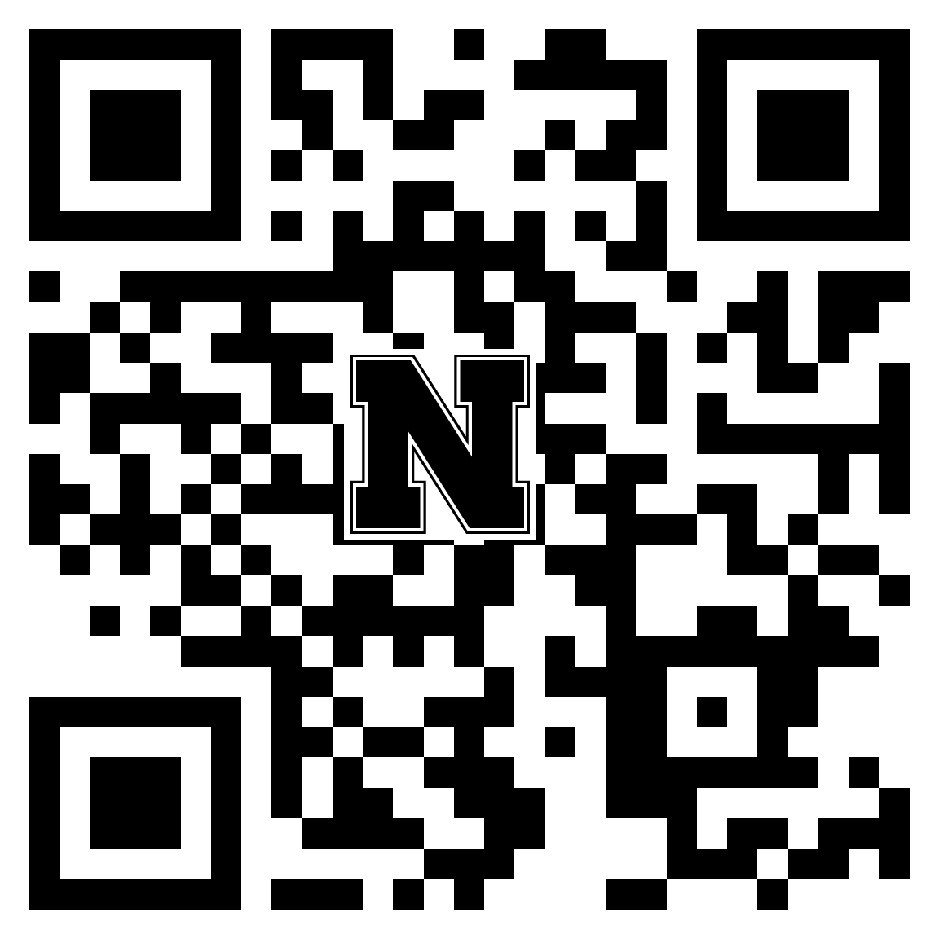

BEEF SPECIFIC INFORMATION:
- Beef exhibitors can bring beef animals starting Wednesday, July 21st through 8:00 a.m. on Thursday, July 22nd. Exhibitors will be disqualified if arriving after 8:00 a.m. Beef weigh-in will take place at 9:00 a.m. Thursday morning.
- For Bred and Fed Steer Division, the brand will be required at pre-fair entry.
- Stocker Feeders will show Saturday, July 24, 2021 after showmanship and before the Breeding and Market show. They will need to be brought to the scale for check in by club.
- Beef will be placed in the East barn prior to the show.
- Bucket Calf Show will begin Friday, July 23rd following the 4-H Sheep Show. Bucket calves must be in place by 12:00 p.m. Bucket calves may leave following the bucket calf show.
- Exhibits will be released at 5 p.m. on Sunday, July 25th.
- The sale sign-up forms must be returned to the sale committee members at the end of the beef show. The livestock sale will be held Monday, July 26 at the Lincoln County Fairgrounds. Buyer registration starts at 11:30 with the sale following at 1:00 p.m. This will be a premium sale only.
- If you wish to sell your Market Beef animal, there will be a base for all animals being sold.
- Production Beef Exhibitors record books will be due 5:00 PM Friday, October 1. The 4-H animal record book is available at our office or on our website.
- We will award the champions on Achievement night in October. The awards given are: Champion Production Beef, Reserve Champion Production Beef, and Champion Production Class Record.

Sincerely

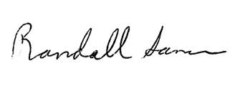
Randall Saner
Extension Educator

