May 2017
Fillmore County 4-H News

4-H Calendar
May
8 Community Garden Planting, 4:00 – 5 or 5:15 p.m., Garden Plot (weather permitting)
8 Animal Science 101 at the Extension Office starting at 6:00pm
12 District and State Horse Show entries due!!
12 Regional Public Speaking & Interview Contests
21 Strang 4-Bar-H Club Mtg., 5:00 p.m., Ext. Off.
23 Sheep Weigh-In, 4:00 -6:00 p.m., Fillmore County Fairgrounds
25 Ag Safety Day – Ag Hall, Fillmore County Fairgrounds
29 Office Closed – Memorial Day
31 Clover Kid Workshop 10:00-Noon Ext. Office
June
1-6 ESI Camp, Ext. Office 9:00-Noon
2 Photography Workshop 9 – Noon, Ext. Office
6 Plant Science Investigation 10-Noon, Meet at
the Garden & end at Ext. Office
6 Clover Kid Club Meeting 6:00pm, Ext. Office
12 QA Face to Face, 1:00pm-3:00pm, Ext. Office
13 Cupcake Creations Workshop, 10 – Noon, Ext Office
15 Code Camp Workshop, 9-Noon, Ext. Office
15 Pre-Entry Deadline: Static, Livestock, Horse
15 Animal ID Sheets Due!!!
16 Baking Science Workshop, 9-Noon, Ext. Office
22 Presentation Contest & Foods Contest
30 Clothing Day

Congratulations
Fillmore County 4-H Seniors!

Carley Swartzendruber, Chelsea Fessler, Garrett Whitley, Holden Stengel, John Alfs, Kale Kleinschmidt, Logan Peppard, Marissa Nun, Tyler O’Connor

Best of luck in all your future plans!

The 4-H Youth Development program abides with the nondiscrimination policies of the University of Nebraska–Lincoln and the United States Department of Agriculture.
Fillmore County
1340 G Street
Geneva NE 68361
402-759-3712
fillmore.unl.edu

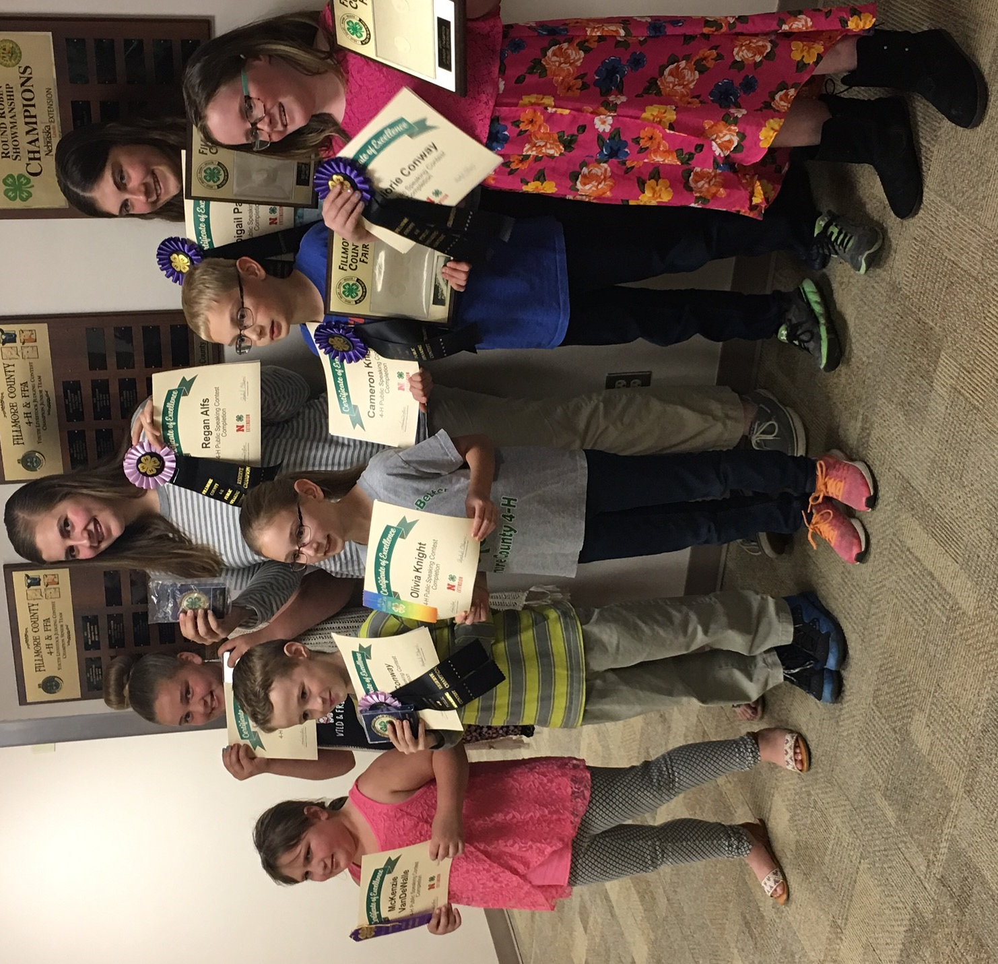
Public Speaking Contest Results
Congratulations to all participants of the Public Speaking Contest! Nine 4-H members participated in the 2017 Fillmore County 4-H Public Speaking Contest, held on April 27th at the Extension Office. The top youth in each age division has the opportunity to represent Fillmore County at the Southeast Regional Contest on May 18th at the Animal Science Building on the University of Nebraska – Lincoln East Campus.
Winners in each division were:
Clover Kid Speech Division:
Rainbow Ribbon: Olivia Knights
Novice Speech Division:
Purple Ribbon & Champion: Cameron Knight
Purple Ribbon & Reserve Champion: Eli Conway
Purple Ribbon: McKenzie VanDeWalle
Junior Speech Division:
Purple Ribbon & Champion: Malorie Conway
Purple Ribbon & Reserve Champion: Bailey Hafer
Intermediate Speech Division:
Purple Ribbon & Champion: Hannah Miller
Senior Speech Division:
Purple Ribbon & Champion: Abigail Parten
Purple Ribbon & Reserve Champion: Regan Alfs

County Fair Info

Fairbook
The 2017 Fillmore County Fairbook is available on our website: www.fillmore.unl.edu. Hard Copies are available at the Extension Office.

PRE-FAIR ENTRIES DUE JUNE 15TH!
4-H’ers bringing exhibits (including animals) to the fair must fill out and return PRE-FAIR ENTRY FORMS and LIVESTOCK ID sheets to the Extension Office by June 15th!
Pre-Fair entry forms and livestock ID sheets will be mailed separately to each family. Use the 2017 fair book to complete entry forms. An example is included on the form. Additional sheets are available on the 4-H page at www.fillmore.unl.edu. If you have questions about filling them out, stop by the office or give us a call.

4-H Cake Auction
Friday July 14th After Awards
The 4-H Cake Auction is an annual event at the Fillmore County Fair. 4-H members are invited to bring a homemade cake to auction off to the highest bidder. Half of the bid goes directly the 4-H’er and half goes to the 4-H Council for scholarships and program funds. Only one homemade cake per 4-Her is allowed. Sign-up by checking “Cake Auction” on your County Fair Pre-Entry Form.
Exhibitors are highly encouraged to enter their decorated cake auction cake as an exhibit at county fair in the “Cake Decorating” project. Cake exhibits will be preserved for the auction.
*All Participants - Please include a list of ingredients with your cake in case of allergies and limit exhibits to products which hold up well; items that require refrigeration are not recommended.

Outstanding Service Award
Nominate someone who goes the extra mile for Fillmore County 4-H for the Outstanding Service Award. 4-H families are encouraged to nominate worthy persons. To nominate individuals send a letter of recommendation, including years of service and contributions made to the 4-H program. Submit nominations to the Fillmore County Extension Office by June 15th. Multiple letters per nominee will be accepted.

4-H Food Stand
The 4-H Food Stand sign-up is available at the Extension Office. Time slots are filled on a first come basis, so sign up early!
ALL 4-H members (over the age of 10) need to sign up for a shift. Shifts not filled means the Food Stand is closed. At least 1-2 adults should work each shift as well. This year, it is the responsibility of parents and members to sign up for the time that works for them, NOT by clubs as in the past. The 4-H Food Stand is a huge fundraiser during County Fair for the 4-H Council and the 4-H program in Fillmore County. Without the money from the food stand, many 4-H activities and events would not be possible. Complete the online form found on our fillmore.unl.edu website to sign-up or call the office for available times.

Fashion Show
June 30, 2017
Ag Hall
Model and Clothing Construction Judging will take place at 9:00 a.m. at Ag Hall. The Public Fashion Show will take place at 7:00 p.m. that evening at the Rialto II Theater. Registrations are due June 23.
This county contest is open to any 4-H member enrolled in a clothing project. 4-H’ers are invited to model their clothing creations or purchased garments. 4-H members may have up to three outfits entered in the Fashion Show. Participation in the Fashion Show includes BOTH modeling for a judge during the day and participation in the public show in the evening. Advanced registration should be submitted via entry form to the Extension Office two weeks before the contest. One entry form should be submitted for each outfit.
Clothing construction judging will also be offered in conjunction with model judging during the morning events. 4-H’ers participating in the Fashion Show will have the opportunity to interview judge all of their sewn clothing items. See the fair book for program details.

4-H Contests

Presentation Contest

The contest will be Thursday, June 22 at 2:30 p.m. Gain valuable communication skills while sharing your favorite subject with others by participating in this event. You can even present with a friend. 4-H is about learning by doing, now you can teach someone else your skills, too! Check out the Fillmore County Fairbook under 4-H Communications Event for all the details. Pre-registration is due June 15 into the Extension Office

Culinary Challenge Contest
The 4-H Foods Contest will be held Thursday, June 22 beginning at 1:00. To register, check “4-H Foods Contest” on your Exhibit Entry Form under “Pre-Fair Contests”. Please confirm you are participating in the contest by June 15th to the Extension Office.
4-H’ers will plan an occasion for guests. They will plan and write the menu, decide on table service and present it to a judge. 4-Her will prepare at home one food item and bring it with a table service and table for display. Display will be set up independent of adults. Creativity is encouraged. Set-up begins at 12:30 pm. Judging begins at 1:00 p.m. A complete contest packet can be found at the Extension Office.
A challenge ingredient and occasion will be selected each year. The 2017 challenge ingredient is dried beans, peas and lentils. These may be used in any form, including dry-packaged or canned. Each participant must incorporate the challenge ingredient into one of the items on their menu. This may be the prepared food or another item on the menu. The menu item may creatively incorporate the challenge ingredient
Talent Contest
June 30, 2017
Now is the time to sign-up for the Fillmore County Talent Show. All 4-H’ers are invited to show off their special talent Friday, June 30th at 7PM at the Rialto II Theatre in Geneva. If you can sing, dance, play an instrument, recite a poem, practice magic or have another talent then the Talent Show is for you! Sign up by checking TALENT CONTEST on the pre-fair entry form! Also contact the Extension Office by June 23rd confirming you plan to participate.

PREMIER ANIMAL SCIENCE EVENT (PASE)
Each summer, over 500 4-H'ers convene at the University of Nebraska-Lincoln East Campus to test their skills in animal science and family and consumer sciences during PASE (Premier Animal Science Events). Teens compete in a variety of different contests including: livestock, meats and poultry judging, livestock skillathon,& livestock quiz bowl. While on campus, young people have the opportunity to take part in faculty-led workshops, campus tours, and special sessions by UNL recruiters.
Events held June 26&27, 2016. Contest entry timeline is May 3 through 5:00 p.m. June 3.

Camps & Workshops

Ag Safety Day
Thursday, May 25
Ag Hall – Fairgrounds
Area 1st through 6th graders are invited to attend Progressive Agriculture Safety Day on Thursday, May 25, 2017 at the Fillmore County Fairgrounds. Youth will participate in a variety of events designed to help them be aware of safety in potentially hazardous situations such as ATVs, agricultural settings, the internet and others. This event is hosted by UNL Extension in Fillmore County, Shickley and Fillmore Central FFA chapters, 4-H and W.I.F.E. For more info or to register, call 402-759-3712. Registration forms are available on our website fillmore.unl.edu.

Southern Plains Poultry
Judging Clinic & Contest
Tuesday, June 6, 2017
Thayer Co. Fairgrounds, Deshler
The camp will teach participants about a Poultry Judging Contest and will prepare them to participate in the State Poultry Judging Contest at PASE. Following the clinic a Poultry Judging Contest will be held and awards presented. For more information please contact the Thayer County Extension Office at 402-768-7212.
SUMMER CAMP SCHOLARSHIPS
4-H Summer Camp Scholarships
The Fillmore County 4-H Council is offering scholarships for any 4-H’ers attending 4-H summer camps or any of the UNL summer camps. There are 10, $100 scholarships available this summer. The scholarship, not exceeding the cost of the camp, can be used towards the cost of the camp you would like to attend. If you would like to apply, write a ½ - 1 page essay telling us which camp you are attending, why you want to attend the camp and what you could bring back to Fillmore County 4-H by attending. Call the Extension Office for more details!

Livestock
New Quality Assurance Training System!
Quality Assurance Training
We are excited to announce that the new QA Curriculum called Youth for the Quality Care of Animals (YQCA) is now active. Anyone who has not registered for the LQA online course for 2017 should now navigate to the NEW online YQCA course at yqca.learngrwo.io. You will use your FAMILY 4HOnline login and password information to access the courses for the ACTIVE youth in your family. Only ACTIVE members will show in the drop down menu for access to the course. All registration questions with YQCA should be directed to help@yqca.org. All 4-Hers need to use the 4-H tab and not the FFA tab even if they are members of both organizations. There is a button for families that have forgotten their password. 4-Hers that have started their QA training in the LQA site will be able to complete their modules and print off their certificate of completion and take it to the Extension Office. Rachel will be offering a Face to Face QA training on June 12th at the Extension office from 1:00pm – 3:00pm
*** QA must be completed by June 15th.

Sheep Weigh-In
Annual market sheep weigh-in and tagging will be Tuesday, May 23rd from 4-6:00 p.m. at the Fillmore County Fairgrounds. A DNA sample must be taken from any animal going to Aksarben or State Fair. DNA samples are $6/head. All 4-H market sheep showing at county fair must weigh-in at an official weigh-in. Hard copy ID affidavits must be completed for county fair, but DNA and Breeding Nomination Cards are required for State Fair and Aksarben.
Remember to have scrapies tags in your sheep.

County Fair Reminders:
Swine Ear-Tags
Since State Fair has moved away from ear notching as the identification system, Fillmore 4-H will continue the identification process as a visual tag for county fair. An E-ID is also acceptable, as that is required for State Fair. If you plan to attend Ak-Sar-Ben, ear notches are still needed.
To identify your hogs, stop in the office to pick up your tags. They must be in hogs by June 15th and will be checked randomly during spot checks and must be in place.
All ear tags not matching ID sheets will NOT be allowed to participate in the 4-H show; they will be allowed to participate in the open class show.
Breeding Gilt
Breeding gilts’ birth date should be on ID form turned into Extension Office by June 15th.
Breeding Sheep
Remember that to show in a specific breed class, registration papers are required and must be owned by the exhibitor or immediate family.
Home Born and Raised Animals
Remember to declare all animals that are Home Born and Raised on the livestock ID sheets. This must be done with all beef, sheep and swine exhibits if you want your animals recognized as such.
Breeding Beef Tattoos
Remember to have all breeding beef animals properly tattooed by June 15th. Tattoos will be checked at fair check-in. Also, to show in a specific breed class, registration papers are required and must be owned by the exhibitor or immediate family.
Bucket Calf Record Books.. NEW BOOKS FOR 2017
Youth exhibiting bucket calves at the county fair need to complete a record book and turn it into the Extension Office by July 1st. The books will be judged prior to the fair based on skills and knowledge gained by the 4-H’er. Record books are available at the Extension Office.

IMPORTANT COUNTY FAIR NOTICE:
ANIMAL WELFARE SHOULD ALWAYS BE PRACTICED.

This includes, caring for your animals until they are off the fairgrounds. In 2017: All species exhibitors who do not leave animals access to adequate water until loadout will NOT be allowed to show the following year. This means leaving waterers, tubs or buckets secured to the pen/stall that are available for your animal at all times, with the exception of beef. Market beef must be watered the afternoon and evening prior to loading and it is the exhibitor’s responsibility to ensure they are adequately cared for prior to loading. After load out, you are responsible for picking up your waterer, etc. Thanks for your cooperation!
This will be listed in your grooming and drug affidavits. NOTE: In previous year hog waterers were removed prior to loading and did NOT have access to water, thus the need for this change.

Educational Displays for Animal Entries
A new exhibit will be added to enhance agricultural literacy for livestock. Check the fairbook for more details. Here is a glimpse of what it entails!
4-H’ers are invited to create a poster highlighting an educational aspect of their animal project. The poster could focus on a current livestock issue, animal industry career, animal care or health, economic impacts of the livestock industry.
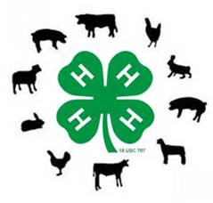
Posters will be displayed in the livestock buildings as a way to increase the educational experiences of both the 4-H member and the general public increasing agricultural literacy. Posters receiving a purple ribbon may advance their entry to the Nebraska State Fair.

Livestock Junior Superintendents
Receive more volunteer experience in 4-H, by being a junior superintendent. Superintendents will be selected on a first-come basis.
Sign up for the following shifts:
Horse Show: 2 superintendents at 7:45 – end of show
Sheep Show: 2 superintendents at 7:45 – 11:00 AM & 2 supt. 11:00 - end of show
Poultry/Rabbit Show: 2 superintendents at 2:45- end of show
Swine Show: 2 superintendents at 7:45 – 11:00 AM & 2 supt. At 11:00 - end of show
Beef Show: 2 superintendent at 7:45-10:30 AM & 2 supt. 10:30-end of show
Please call the office at (402) 759-3712 to sign up by June 15th.

Horticulture
Special Horticulture Project
Sunburst Summer Squash
The Special Garden Project is a way to offer 4-H members the chance to grow unusual and fun projects in their gardens. This year it is focused on the Sunburst Summer Squash. 4-H members are able to learn about growing the Squash, soil care and gardening! They also have the chance to enter the Squash at the County and State Fair! For more information on the project please contact the Extension Office at 402-759-3712.
There are still seeds available, so call the extension office to participate!!

Community Garden
A community garden is planned for the 6th year in a row in collaboration with the Farm Service Agency, local FFA Chapters, and other organizations interested in helping. Several popular vegetables will be planted and donated to the Senior Center, Blue Valley or made available to those helping in the garden. Youth volunteering at least 10 hours are eligible to exhibit produce at the fair. Call the extension office to get signed up. Weather permitting; the garden will be planted on May 8th at 4:00 p.m. until approximately 5 or 5:15 p.m. The rain date is set for May 11th at 4:00 p.m.
We will mulch the garden on June 6th at 10:00 a.m., weather permitting, followed by a Plant Science Investigation workshop at the Extension Office. Participants should meet at the garden at 10:00 and plan to walk over to the office, wrapping up the workshop at noon.

REGIONAL ID CONTESTS
Tuesday, June 13
Hall County Extension Meeting Rooms
College Park, Grand Island
10:00 am-noon information about the contest/practice
1:00-3:00 pm Contests available
Try your hand at these identification contests:
The Tree Identification Contest includes contestants looking at tree a sample, which consists of a branch with leaves, and picking the correct common name from a list.
The Weed and Grass Identification Contest includes contestants looking at weed or grass samples and picking the correct common name from a list.
The Insect Identification Contest will have contestants look at insects and identify them from a list of common names and their insect order.
The Horticulture Judging Contest consists of three parts. The first is identification of plant material, looking at plant parts, seeds, flowers, or vegetables and deciding what they are from a list of options. The second is a knowledge portion, a true/false or multiple choice quiz. The last portion is judging, just like with livestock, four different plants, plates of vegetables, or flowers are ranked from highest to lowest based on a set of criteria.
The number of samples identified will depend on the 4-Her’s age.
The lists of plants can be found at: http://4h.unl.edu/fairbook/plant-science under the contest links
For more information please contact the Extension office.

4-H Plant & Insect Identification Contests
June 22, 2017
Columbus NE
If you like plants and/or insects, here’s your opportunity to build skills and have fun too! Attend the horticulture judging and identification contest, tree identification, grass and week identification and entomology (insect) identification contest. For more information, contact the Extension Office!
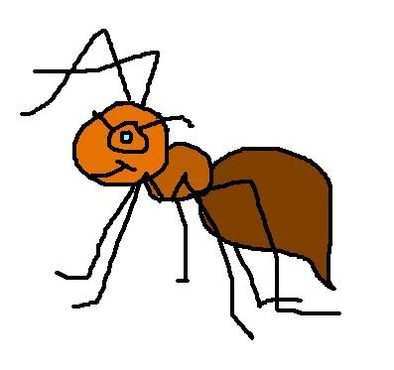

Additional Info

Tractor Safety Courses
University of Nebraska-Lincoln Extension Tractor Safety/Hazardous Occupations Courses will be offered at nine locations in Nebraska during May, June and July. Any 14 or 15-year-old teen that plans to work on a farm other than their parents’ should plan to attend. Certification through the course grants an exemption to the law allowing 14 and 15-year-olds to drive a tractor and to do field work with mechanized equipment. Pre-registration is strongly encouraged at least one week before a location’s start date to the Extension Office at the course site. Cost is $60.00, which includes educational materials, testing, supplies, lunches and breaks. For more information, contact Aaron Yoder at (402) 552-7240, aaron.yoder@unmc.edu or Ellen Duysen at (402) 552-3394, ellen.duysen@unmc.edu.

Date | City | Location
May 30-31 | Kearney | Fairgrounds
June 13-14 | North Platte | WCREC
June 19-20 | Wayne | Fairgrounds
July 10-11 | Grand Island | College Park

Big Red Camp: Discover Entrepreneurship
Sunday, June 11, 2017 to Friday, June 16, 2017
Got what it takes to launch your own idea? The answer is yes, you do! Whether you are thinking of launching the next Facebook or running a family business, the goal is to create a real startup company – to solve a real-world problem in a different way. You will start a company in teams of like-minded people, using the most up-to-date methodology that your favorite startups such as Snapchat and Instagram, and global companies like Amazon and Microsoft use. You will go through interactive classroom sessions and activities, powered by a team of mentors and many resources at University of Nebraska-Lincoln such as 3D printers, laser cutters, and many other prototyping equipment on Nebraska Innovation Studio. Taught by University of Nebraska-Lincoln, College of Education and Human Sciences and Nebraska Extension. Registration and more information: http://4h.unl.edu/big-red-camps.

Horse Enthusiast

District and State Horse Shows
The District and State horse show dates entry deadlines have been set for May 12th. Show information is located on the UNL Animal Science webpage under Equine Extension/4-H.
http://animalscience.unl.edu/web/anisci/anscdistrictandstate4hshows
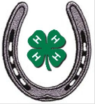
District Show Dates:
June 12th - Lexington
June 13th - Taylor
June 14th – Wayne
June 19th - Hemingford
June 20th - Lincoln
State Horse Show:
Fonner Park State 4-H Horse Show will take place on July 16-20, 2017.

Horse Exhibitor Levels
To ensure the safety of all horse exhibitors and spectra-tors, it is REQUIRED for ALL youth to pass the Beginning Horseman: Level One testing. This level is designed for riders who have little or no experience around horses. It emphasizes correct and safe handling and riding principles and should help develop the members' confidence concerning their ability to ride and guide a horse. The rider's balance, correct seat and use of hands' should be stressed.
Youth, 13 years old and up, need to complete Level 2.
Work with your horse leaders to complete this certification. Resources are available to study at http://4h.unl.edu/horse.

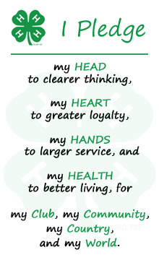

FRIENDLY FACE!

During the summer, you will see Fillmore County 4-H’er, Alexis Schmidt helping with the local 4-H program and other tasks starting May 24th!

