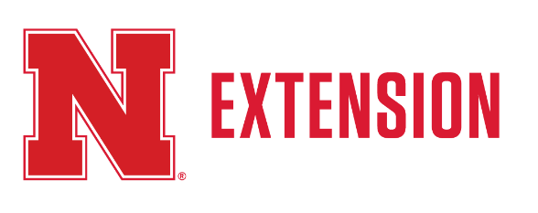
April, 2017

Fillmore County 4-H News

4-H Calendar

April
1 4-H Enrollment Deadline!
2 Animal Science Day, 1:30pm at Fairgrounds
12 4-H Council Meeting, 7:00pm
18 4-H Public Speaking Contest, 7:00pm at Extension Office
27 CSI: & Gardening Workshop, 4:30-6 pm, Extension Off.

May
13 District and State Horse Show entries due!
21 Regional Public Speaking & Interview Contests
24 Sheep Weigh-In, 4:00 - 6:00 p.m., Fillmore County Fairgrounds
26 Ag Safety Day – Ag Hall, Fillmore County Fairgrounds

June
15 Pre-Entry Deadline for Static, Livestock, and Horse exhibits
15 Animal ID Sheets Due!

Fair Books Arrive!

Printed Fair Books have hit the presses! They should be in the office by mid-April. Watch for a big email announcement. An electronic version of the Fairbook is NOW available on our website fillmore.unl.edu!

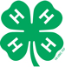

Fillmore County
1340 G Street
Geneva NE 68361
402-759-3712
fillmore.unl.edu

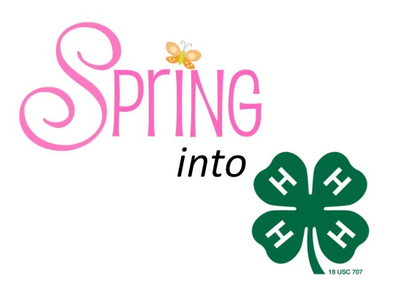

2016 Fair Dates

Dates have been set for the 2016 Fillmore County Fair. The fair will run from July 15-21. A schedule can be found online at www.fillmore.unl.edu.

2016 Fair Theme
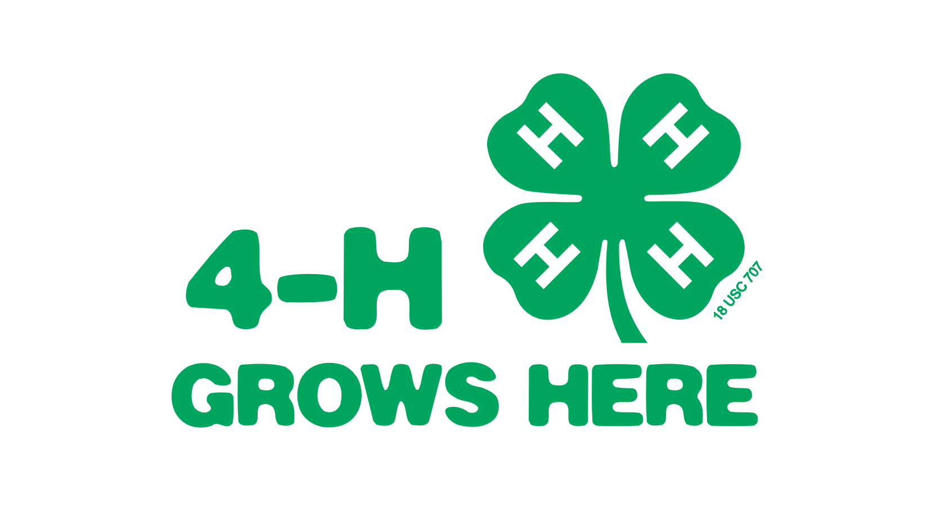

Camps & Workshops

This year we are hoping to offer these workshops so be looking for details in the next newsletter: Robotics, Foods and Nutrition, Clover Kid, Ziggadee Day and Horticulture.

Ag Safety Day
Thursday, May 26 8:30-3:30
Ag Hall – Fairgrounds Fee $3
Area 1st through 6th graders are invited to attend Progressive Agriculture Safety Day on Thursday, May 26 at the Fillmore County Fairgrounds. Older youth are welcome. Youth will participate in a variety of events designed to help them be aware of safety in potentially hazardous situations such as ATVs, agricultural settings, the internet and others. New this year is programs for adults! This event is hosted by UNL Extension in Fillmore County, Shickley and Fillmore Central FFA chapters, 4-H and W.I.F.E. For more info or to register, call 402-759-3712 or email brandy.vandewalle@unl.edu or registration forms are available at our website fillmore.unl.edu.

Winners Unlimited Livestock Judging Camp
Session I: June 7-9
Session II: June 11-13
This camp is designed for 4-H and FFA members (ages 12-18) looking to perfect their livestock evaluation and oral reasons skills. Brad Bennett, as well as 2016 team members will focus on proper evaluation with a special emphasis on reasons format, terminology, and delivery. This would be a great experience for those preparing for State Contests or the upcoming judging year. Year after year, students who have attended this camp have placed in the top-10 at the State 4-H or State FFA Livestock Judging Contests. For more information, visit: animalscience.unl.edu/unl-livestock-judging-team or contact the Extension Office.

Horticulture

Crop Science Investigation (CSI) & Community Garden
Have a green thumb? Interested in crops? If you answered yes to any of those questions, join the CSI and/or Community Garden teams this year. CSI and Community Garden will work together on a couple of workshops. If you have a CSI notebook from last year, please bring it to the workshops. There is no charge for either program this year. Here's what you can learn about in CSI:
-Learn about the importance of agriculture and how crops are used.
-Conduct cool, hands-on science experiments.
-Listen to speakers and learn about careers.
-Help conduct field plot research.
-Become a CSI investigator and detect plant problems.
The program will kick-off March 31st at the Extension Office from 4:30 -6:00 p.m. We will start some seeds for the community garden and also learn about seed selection for both gardening and crops so this will be a joint program! If you are interested in the Community Garden please let the Extension Office know by April 15th. Another workshop will occur April 27th from 4:30-6:00 p.m. RSVP by April 15th.

Special Horticulture Project
Jazzy Mix Zinnia
The Special Garden Project is a way to offer 4-H members the chance to grow unusual and fun projects in their gardens. This year it is focused on the colorful, Jazzy Mix Zinnia. 4-H members are able to learn about growing the Zinnias, soil care and gardening! They also have the chance to enter the zinnias at the County and State Fair! For more information on the project please contact the Extension Office at 402-759-3712.

Please let our office know by the first week in April if you’d like to reserve a packet, as supplies are limited!

Livestock

Quality Assurance Training
Quality Assurance training is required for all food producing animal or livestock project members. Food producing and livestock projects include market beef, sheep, swine, dairy cattle, dairy goat, meat goat, poultry and rabbit. Quality Assurance is continuing its move online for 2015. Youth are highly encouraged to participate in the online course which is available at http://campus.extension.org. To complete it, you will need your 4-H Access ID number which can be found by calling our office.
Livestock Quality Assurance is a self-directed course designed for youth ages 8-18. Participants will learn about good production practices and producing quality food products from taking this course.
The course has been divided into three levels, Junior (4-H Youth Ages 8-10), Intermediate (4-H Youth Ages 11-13), and Senior (4-H Youth Ages 14-18). Each year youth will be required to complete three modules within their age level. Youth are eligible to work ahead so that they will be done with Quality Assurance requirements until they reach the next age level.
Leaders can still do quality assurance for a club meeting if they'd like. They need to make arrangements with Brandy to do so. *** QA must be completed by June 15th.

Animal Science Day
Coming to Geneva on Sunday, April 3rd is a short animal science program (FREE) which will offer a livestock judging contest, a face to face quality assurance program, tips for your livestock projects and other fun hands-on animal science activities. This requires a lot of planning and assistance so if you are interested in participating, sign up by March 28th. There must be a minimum of 25 youth in order for this program to occur; invite your friends from neighboring counties too! RSVP to the Fillmore County Extension office at 402-759-3712 or by email Brandy at brandy.vandewalle@unl.edu.

2016 Animal Science Experience
Animal science Experience will be held Monday April 11th at the UNL Animal Science Complex Commons. This is a great opportunity for high school students to come and see what it’s like to be an animal science student for a day. They will have the opportunity to sit in on a lecture, do a hands-on lab with a faculty member, eat lunch in the union and tour the facilities. The registration link is http://goo.gl/forms/KeVJBHjXFq
For more information please call the Extension Office.

Sheep Weigh-In
Annual market sheep weigh-in and tagging will be Tuesday, May 24th from 4-6:00 p.m. at the Fillmore County Fairgrounds. A DNA sample must be taken from any animal going to Aksarben or State Fair. DNA samples are $6/head. All 4-H market sheep showing at county fair must weigh-in at an official weigh-in. Hard copy ID affidavits must be completed for county fair, but DNA and Breeding Nomination Cards are required for State Fair and Aksarben. .Affidavits can be found online at livestockaffidavit.unl.edu.
Remember to have scrapies tags in your sheep.

2016 State Fair & County Beef Show
The State Fair 4-H and FFA beef shows will be no-fit.

County Fair Beef Show - Blow & Go!
With a vote of 11-4, Fillmore County 4-H will also have a blow and go show. In short, this means, NO adhesives. Products that are alcohol and water based such as Kleen Sheen, Revive, Final Bloom and white show foam are allowed. Paint will be allowed on the hooves and dewclaws only. Any compounds that have adhesive qualities that when applied cannot be combed or brushed through or alter the color of the animal are forbidden (i.e. Prime Time, EZ Comb, Tail Adhesive, Ultra White Touch-Up, Black Touch-Up, Black Finisher and black show foam, etc.) Anyone found in violation of this will NOT be allowed to show that animal in any class!

County Fair Swine Identification
Since State Fair has moved away from ear notching as the identification system, the 4-H Council has approved the identification process as a visual tag for county fair. An E-ID is also acceptable, as that is required for State Fair. If you plan to attend Ak-Sar-Ben, ear notches are still needed.
To identify your hogs, stop in the office to pick up your tags. They must be in hogs by June 15th and will be checked randomly during spot checks and must be in place.

Educational Displays for Animal Entries
A new exhibit will be added to enhance agricultural literacy for livestock. Check the fairbook for more details. Here is a glimpse of what it entails!
4-H’ers are invited to create a poster highlighting an educational aspect of their animal project. The poster could focus on a current livestock issue, animal industry career, animal care or health, economic impacts of the livestock industry.
Posters will be displayed in the livestock buildings as a way to increase the educational experiences of both the 4-H member and the general public increasing agricultural literacy. Posters receiving a purple ribbon may advance their entry to the Nebraska State Fair.

Horse Enthusiast

District and State Horse Shows
The District and State horse show dates entry deadlines have been set for May 13th. Show information is located on the UNL Animal Science webpage under Equine Extension/4-H.
http://animalscience.unl.edu/web/anisci/anscdistrictandstate4hshows
District Show Dates:
June 13th - Kearney
June 16th - Leigh
June 17th - Bloomfield
June 21st - Lincoln
State Horse Show:
Fonner Park State 4-H Horse Show will take place on July 10-14, 2016.

Small Animals

Dog Show & Companion Animal Changes
The dog show will be done in collaboration with Clay County to provide more opportunities for youth, adding agility classes. Even numbered years will be hosted by Fillmore County and odd numbered years held in Clay County. For 2016, Dog Skillathon will be July 13th at 6:00 p.m. with dog showmanship, obedience and agility following. This will occur at the Fillmore County Fairgrounds.

The Companion Animal Show will move to Wednesday July 20, 2016 during the Fair. More information to follow.
Canine Companions for Life Dog Expo
The Canine Companions for Life 4-H Dog Expo will include a party at the Adams County Fairgrounds on Friday May 1 and a one day, educational event on Saturday May 2 that will allow for youth to learn more about dog care, careers, and dog training as well as to show their dogs in showmanship, agility, obedience, and rally. On the 1st, there will be the Quiz Bowl and snacks, with the events starting at 7PM. Events on the 2nd will begin at 9AM and will last until approximately 5:30PM. For more information and for the registration form, see the website at:
http://animalscience.unl.edu/ANSCExtensionCompAnimalsDogCanineCompanionsExpo

4-H Contests

4-H Public Speaking Contest
April 18, 2016 7:00 p.m.
Extension Office
The 4-H Public Speaking Contest will be held Monday April 18th at 7:00 PM. The contest will be held in the Fillmore Co. Extension Office. All 4-H’ers and Clover Kids can compete in the speech and public service announcement classes. A full description of the contest rules, age divisions and registration forms can be found on the 4-H page at www.fillmore.unl.edu. Contact Rachel or Brandy at (402) 759-3712 for any questions.

Additional Info

Nebraska Agricultural Youth Institute
NAYI is a five-day event that brings together high school juniors and seniors from across the state to help build leadership skills, explore new aspects of agriculture and encourage young people to become more involved with and remain in agriculture. The Institute will be held July 11-15, 2016, at UNL’s East Campus. All meals, lodging, and activities are sponsored by the Nebraska Department of Agriculture. Applications for the 2016 NAYI are now available from the Nebraska Department of Agriculture website at http://www.nda.nebraska.gov/nayi/index.html. The deadline to apply is April 15, 2016.

Science Saturdays at Raising Nebraska
Celebrate the International Year of the Pulse through Science Saturdays, a free and open to the public event, at Raising Nebraska located on the State Fairgrounds in Grand Island, NE. Science Saturday occurs the second Saturday of every month with the facility open from 10:00 to noon. The highlighted program consists of an educational, interactive and fun 25 minute session. Upcoming programs include:
- April 9th – Classify you Pulse by Jim Schild
- May 14th – Pollinator Power by Doug Golick
For more details about the Science Saturday program, visit www.raisingnebraska.net or contact Beth Janning at 308-385-3967 or ejanning2@unl.edu

Nebraska Youth Range Camp
The 53rd Nebraska Youth Range Camp will be held June 6 – 10, 2016 at the Nebraska State 4-H Camp in Halsey. The camp is held every summer to help youth increase their knowledge of rangeland management and plant identification. Eligible students need to be between the ages of 14 – 18. We have an online application available and we will also accept applications by mail or email. You can find the forms here: http://www.nesrm.org/YouthRangeCamp.html.
You will also be able to find an informational brochure on that same website.

Scholarships

Burke Scholarship
Upper Big Blue NRD
The Upper Big Blue NRD is offering the 2016 Raymond A. Burke Scholarship which will award $2,000 each to two qualified students who reside in the District to be used for their college/university education with a study emphasis in natural resources. The deadline for submitting the scholarship application is April 22, 2016. Application and information can be found at www.upperbigblue.org.

UNL Campus Corner

SCIENCE WITH A PURPOSE IN CASNR!
The University of Nebraska–Lincoln (UNL) is a place where students can be challenged, where their story starts and where their personal legacy begins.
In the College of Agricultural Sciences and Natural Resources, or CASNR for short, students will find an education with a goal. CASNR focuses on science with a purpose and is a place where students find people are concerned with their futures beyond their time on campus. Study in science positions students well for future jobs that address real-world problems, and a wealth of opportunities await students as they find their area of study to match their career dreams. CASNR has first-class faculty and staff which offer the opportunity for students to create their own businesses through the Engler Entrepreneurship program, get involved in an incredible line-up of clubs and organizations, conduct cutting-edge research with faculty mentors, or experience the world in far-flung locations through Education Abroad.
CASNR assists students as they discover their unique passions and talents and helps them find their place in the world. With 30 diverse academic programs, students are prepared for tomorrow’s great challenges through hands-on learning experiences. They will be taught by internationally recognized faculty who are conducting research and sharing valuable information from the lab or field to the classroom. Scholarship awards totaling more than $1 million are given to CASNR students each year. For more information on any of the programs in CASNR, contact Sue Ellen Pegg at 402-472-0615 or spegg2@unl.edu.

Holling Family Award
2016 Senior Faculty Award Winner
Please congratulate Brandy VanDeWalle on receiving the Holling Family Award which is a program that recognizes exceptional teaching. The Holling Family Award Program for Teaching Excellence in Agriculture and Natural Resources was established to celebrate imaginative educational programming and innovations (presentation and delivery) in IANR or NCTA educational programs.

Fillmore County 4-H
1340 G Street
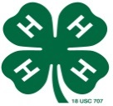
Geneva NE 68361

MONTHLY 4 – H NEWSLETTER

From Your Fillmore County Extension Staff

Brandy VanDeWalle, Extension Educator
brandy.vandewalle@unl.edu

Rachel Olson, Extension Assistant
rachel.olson@unl.edu

Holly Ackland, Office Manager
holly.neumeyer@unl.edu

website: fillmore.unl.edu

