Tuesday, February 23  8:30-10:30 am - Registration, Coffee & Exposition  10:30-12:00 pm - Technical Sessions 4, 5, & 2  12:00-1:00 pm - Lunch & General Session A  1:00-1:30 pm - Exposition  1:30-3:00 pm -Technical Sessions 2, 6, and 1  3:00-3:30 pm - Break and Exposition Open  3:30-5:00 pm - Technical Sessions 7, 3, & 8  5:00-6:30 pm - Social Hour - Exposition Open | Wednesday, February 24  7:30-8:30 am - Registration, Coffee & Exposition  8:30-10:00 am - Technical Sessions 3, 8, & 1  10:00-10:30 am - Break and Exposition Open  10:30-12:00 pm - Technical Sessions 4, 5, & 1  12:00-1:30 pm - Lunch & General Session B  1:30-3:00 pm - Technical Session 2, 6, and 7

General Session A – Review of the Nebraska Water Sustainability Fund - Kent Zimmerman, Neb. Dept. of Natural
Resources

General Session B – Irrigation Impacts on Crop and Energy Production – Don Kraus, Central Platte PP&ID

Technical Session 1 – Irrigation System Tools
Laboratory and field testing of water meters – Dean Eisenhauer, University of Nebraska
Crop water management with canopy temperature – Susan O'Shaughnessy, USDA-ARS-CPRL
Energy conservation using VFDs for pumping irrigation water – Dilshad Brar, University of Nebraska

Technical Session 2 – Irrigation System Performance
Performance of center pivots – Danny Rogers, Kansas State University
Longevity: An important aspect of SDI success – Freddie Lamm, Kansas State University
Economics and WP for corn as affected by irrigation and nitrogen fertilization – Daran Rudnick, University of Nebraska

Technical Session 3 – Center Pivot Updates
New sprinkler options (Senninger) – Ray Glaser, Senninger Irrigation
Center pivot track management options – Steve Melvin, Lindsay Irrigation
New sprinkler options (Nelson) – Gene Ross, Nelson Irrigation

Technical Session 4 – Soil Water Management Impacts of Crop Productivity
Impact of strip-, disk, and no-till practices on ET and crop productivity - Suat Irmak, University of Nebraska
Soil water sensor technologies for evaluation of crop water status – Robert Schwartz, USDA-ARS-CPRL
Irrigation management strategies for limited water - Derrel Martin, University of Nebraska

Technical Session 5 – Updates in Groundwater Monitoring
Airborne delineation of groundwater – Katie Cameron, University of Nebraska
Groundwater levels in Nebraska, seasonal and long-term changes – Aaron Young, University of Nebraska
Advantages of an automated irrigation water use data base – Lameck Odhiambo, University of Nebraska

Technical Session 6 – Impact of Cropping Systems on Irrigation Management
Impact of residue management on irrigated production – Joel Schneekloth, Colorado State University
Cover crop ET and crop coefficients and impact on water balance – Suat Irmak, University of Nebraska
Drought-tolerant corn hybrid response to water across Nebraska – Ali Mohammed, University of Nebraska

Technical Session 7 – Variable Rate Irrigation Mapping
Challenges and opportunities for site-specific irrigation management – Amir Haghverdi, University of Nebraska
Perspectives on VRI prescription map development with satellite imagery– Burdette Barker, University of Nebraska
Spatial mapping of root zone water holding capacity for site-specific management – Tsz Him Lo,
University of Nebraska

Technical Session 8 – Irrigation Management with Limited Water
Deficit Irrigation Management in the Great Plains: A Review – Daran Rudnick, University of Nebraska
Water allocation impacts – Derrel Martin, University of Nebraska
Corn hybrid response to deficit irrigation – Alan Schlegel, Kansas State University

CENTRAL PLAINS IRRIGATION
CONFERENCE & EXPOSITION

NAMES OF THOSE ATTENDING

_____________________________________

_____________________________________

_____________________________________

ADDRESS___________________________

_____________________________________

E-MAIL______________________________

COMPANY___________________________

_____________________________________

Registration postmarked by Jan 30, 2016
is $90; $100 if applying for CCA CEUS.

Registration after Jan 30, 2016
is $105; $115 if applying for CCA CEUs. Registration includes admittance to all sessions, the equipment exposition, a copy of the Proceedings, breaks, two lunches, and social hour.

Number of people attending ____________

Total amount enclosed is $ _____________

Please return this form with payment to:
Donna Lamm, executive assistant
760 N. Thompson
Colby, KS 67701
EIN/TIN 47-0761818

A block of rooms has been reserved at the Holiday Inn, Kearney, Nebraska. The cost is $94.95/night plus taxes. Please make your reservations directly with the motel at (308) 237-5971. Rooms are double queens with a few kings. Indicate you are with CPIA to get special rate. The block will be released Feb. 5, 2016.

Who Should Attend
The conference is for irrigators, irrigation managers, crop consultants, agri-business personnel, personnel from resource agencies, and state and federal agency personnel involved in water management. CEUs for Crop Consultant Advisors are being applied for.

What Will You Learn
Participants will receive the latest information on irrigation equipment and water management practices.

Equipment Exposition
Irrigation equipment manufacturers and dealer representatives from across the Central Plains will display and explain the latest equipment in the irrigation industry. The exposition will be open at various times on Tuesday and until 10:30 am on Wednesday.

Vendor Information
Vendors wishing to reserve space for the exposition should contact Donna Lamm, CPIA executive assistant, at 785-462-7574 (phone/fax) or 785-462-7140 (phone) or e-mail her at donnalamm@yahoo.com. Information is also available at www.ksre.ksu.edu/sdi/REvents/cpia.html.
Central Plains Irrigation Association
760 N. Thompson
Colby, Ks 67701

Location
The Kearney Holiday Inn is located at 110 2nd Ave, which is just north of I-80 at Exit 272.

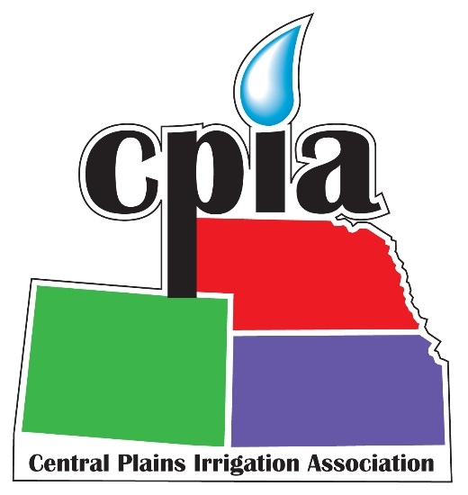

Central Plains
Irrigation
Conference
&
Exposition

February 23-24, 2016
Holiday Inn
Kearney, Nebraska

